ATTACHMENT V.2
staff TIME-USE SURVEY – screenshots

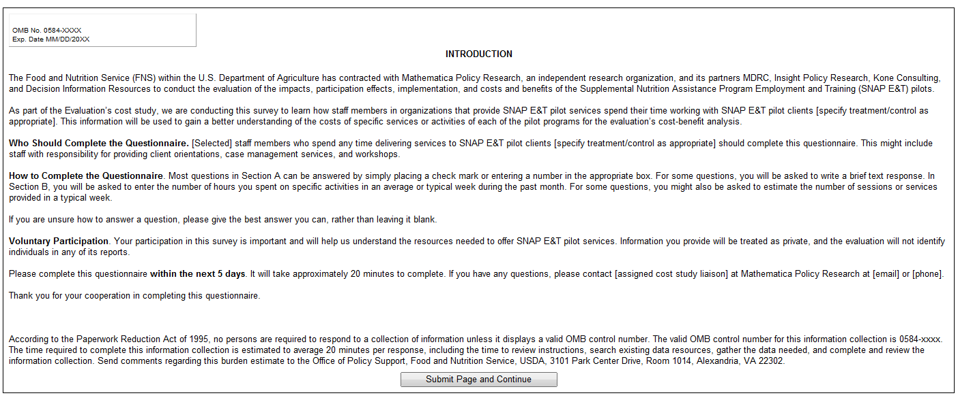
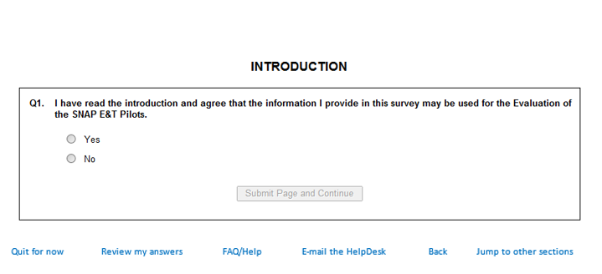
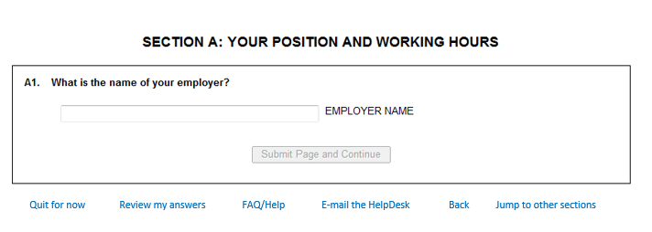
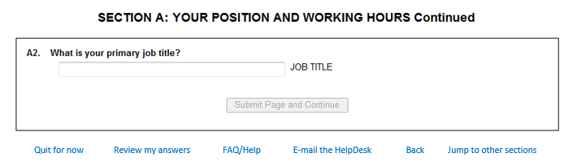
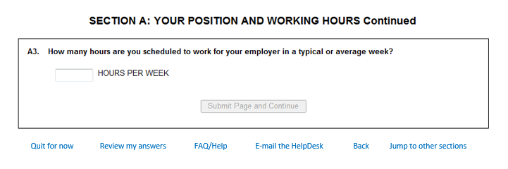
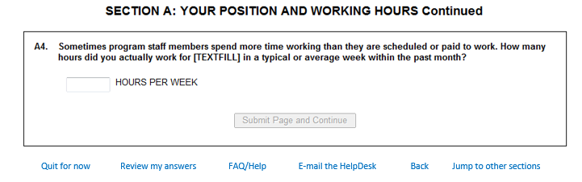

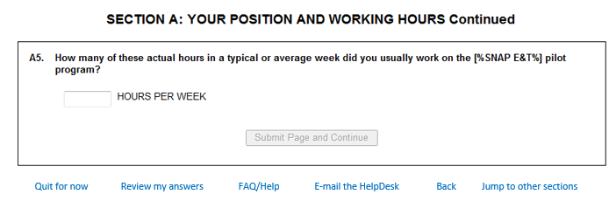
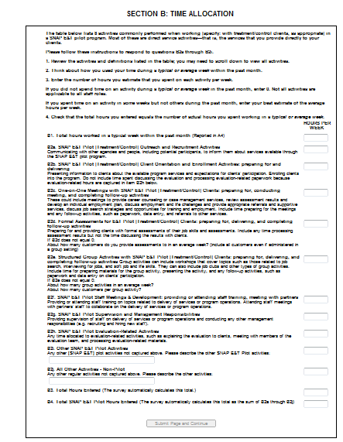
Quit for now Review my answers FAQ/Help E-mail the HelpDesk Back Jump to other sections

