CyberChain survey direct email #2 - 02a

edited 03 Dec 2016 – Michael Best

email #2: release date February 7, 2017

Subject Header:

**Assess and measure your cybersecurity before March 15**

Email body:

**Your cybersecurity – strong enough or vulnerable?**

At NIST, we champion the standards and best practices to support the US economy. And cybersecurity has not kept pace with the rapid diffusion of digital technology.

We’re fighting back by offering new standards to assess and measure cyber supply chain risks.

We’re sponsoring a nation-wide effort to protect critical IT systems. You can help. Join us and participate in our secure and anonymous research survey. It’s designed not only to facilitate development of predictive models that anticipate cyber breaches and attacks, it also allows you to use the NIST Cybersecurity Framework to gain actionable insights and bolster your defenses today.

**Your 1st reminder**

Last week, the National Institute of Standards and Technology, NIST, emailed you requesting your organization’s participation in our survey. We are reaching out again to encourage your participation. The survey can be accessed until March 15, 2017.

**Anonymously compare with your industry peers**

Go to CyberChain.rhsmith.umd.edu, read more, sign up, and take the survey.

We separate all user identification (username and email) from survey responses to anonymize data and ensure privacy. Once completed, this short and confidential survey will generate a *Performance Profile* and a *Tiers of Implementation Analysis* that will help your organization assess its degree of alignment with the risk management processes and outcomes as described in the NIST Cybersecurity Framework.

As a participant, your organization will also receive an early preview of our team’s research report prior to its general release. Thank you in advance for helping our team to take on this challenge and supporting this potentially game-changing research.

**Register and take the survey now**

Visit CyberChain to register and take the survey now! Go to <https://cyberchain.rhsmith.umd.edu/>

The survey is open for **45 days only**: January 30 - March 15, 2017

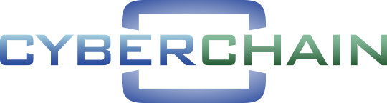

The CyberChain research team

