CyberChain survey direct email #4 - 02a

edited 03 Dec 2016 – Michael Best

email #4: release date March 1, 2017

Subject Header:

**Cybersecurity Framework survey completion needed**

Email body:

**Don’t stop now**

Your Cybersecurity Framework survey is important to us and can be useful for you. It will contribute not only to your own organization’s cybersecurity insights but will also contribute to potentially game-changing cybersecurity community research.

Please login to CyberChain to complete the sections of your survey that have not been checked. The entire research team thanks you!

**Login to complete your survey now**

Login to CyberChain to complete your survey now! Go to <https://cyberchain.rhsmith.umd.edu/>

The survey is open for **45 days only**: January 30 - March 15, 2017

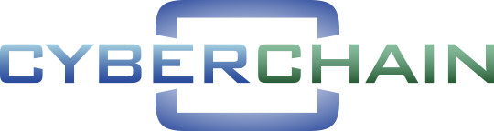

The CyberChain research team

