**ToxFAQs Before and After Testing Survey (online)**

# Welcome

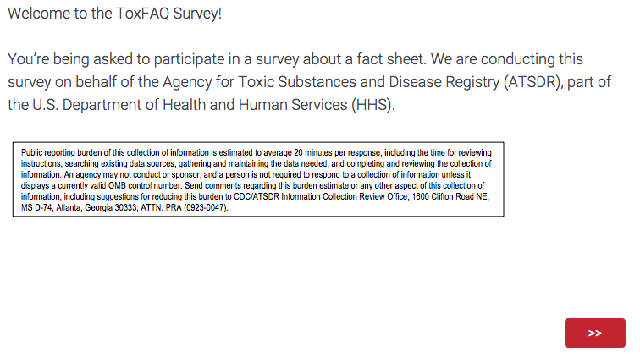

Form Approved

OMB No. 0923-0047

Exp. Date 05/31/2016

# Consent

# 

# Demographic Questions

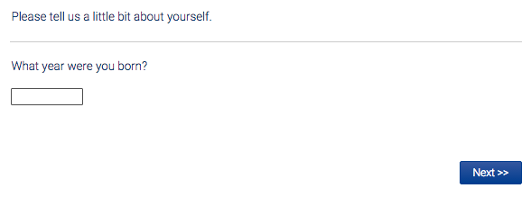

# 

# 

# 

# 

# 

# 

# Review Fact Sheet

**Control group:**

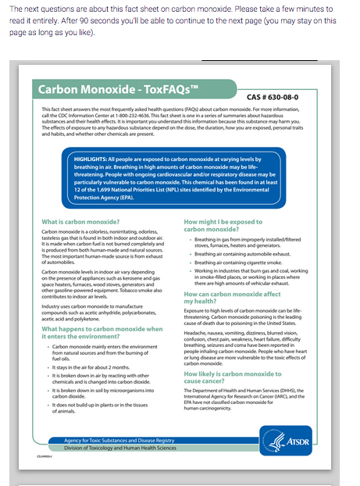

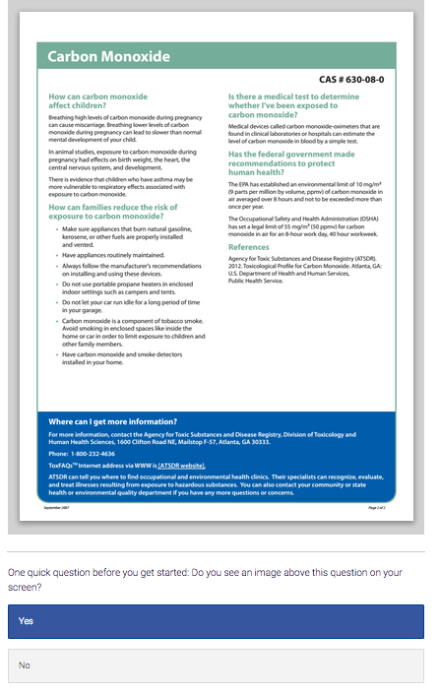

**Intervention group:**

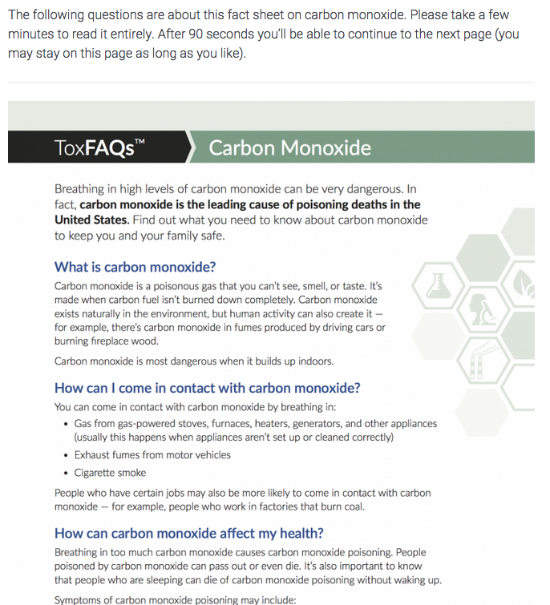

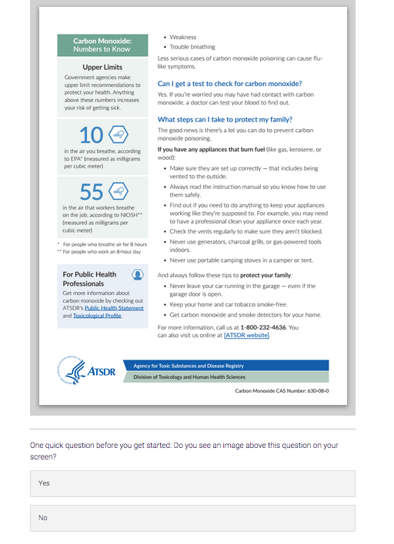

# Knowledge Questions

# Control group:

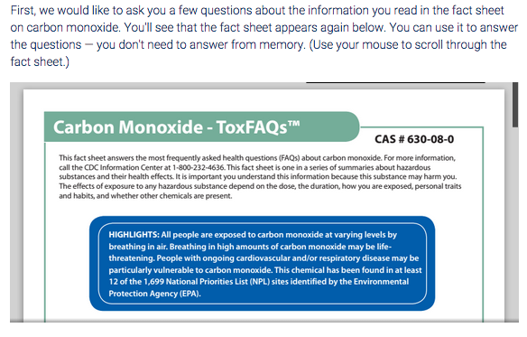

# Intervention group:

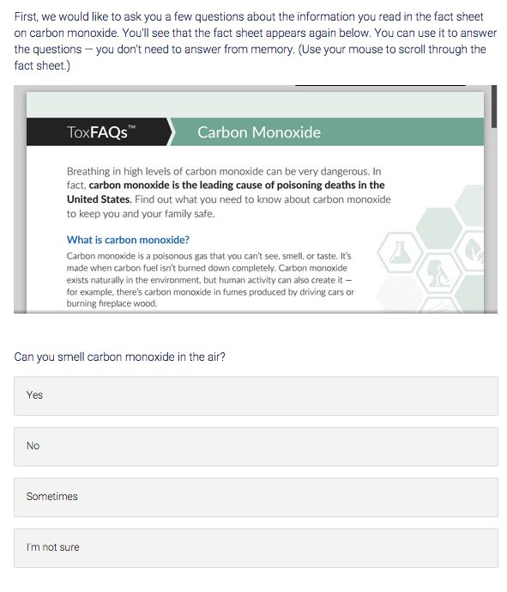

# All participants:



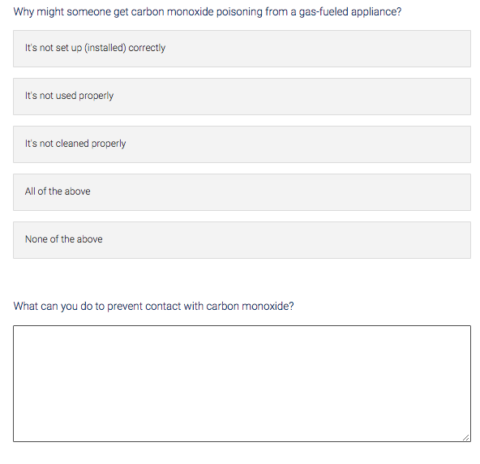

**Modified Consumer Information Rating Form (CIRF)**

**Control group:**

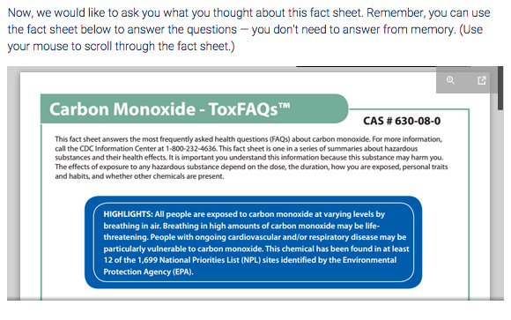

**Intervention group:**

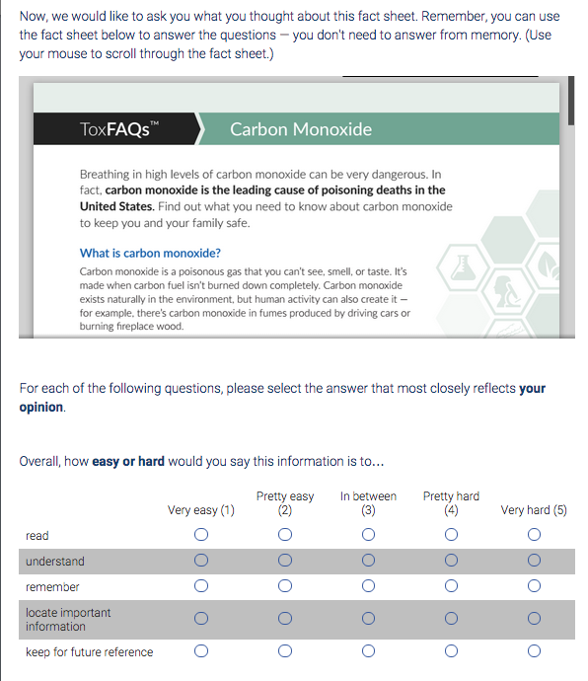

**All participants:**



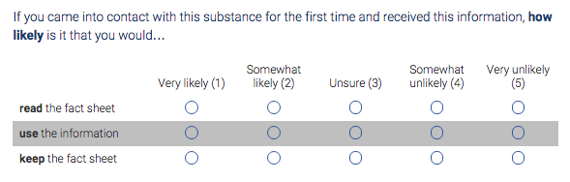

**Control group:**

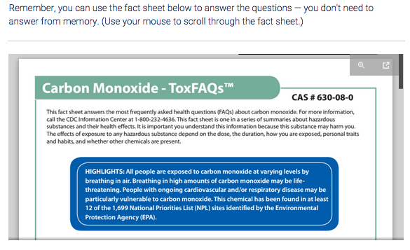

**Intervention group:**

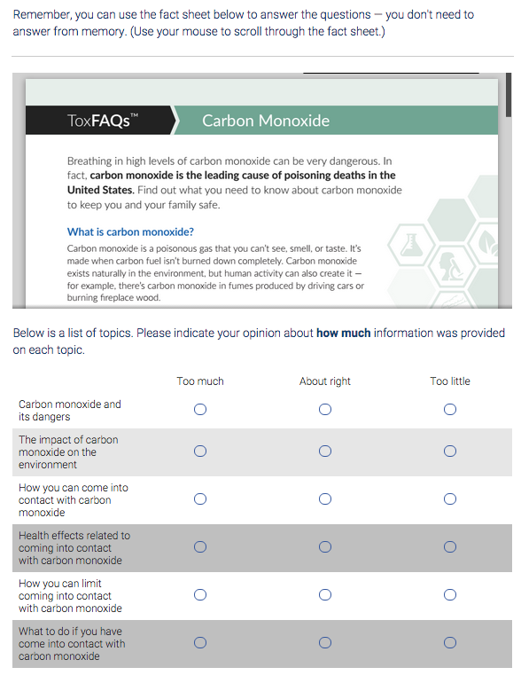

**All participants:**



**Control group:**



**Intervention group:**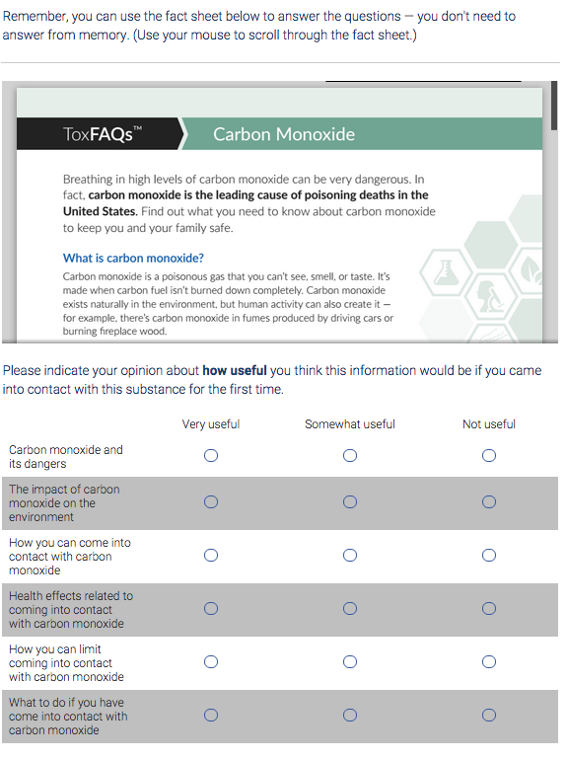

**All participants:**



**Control group:**



**Intervention group:**

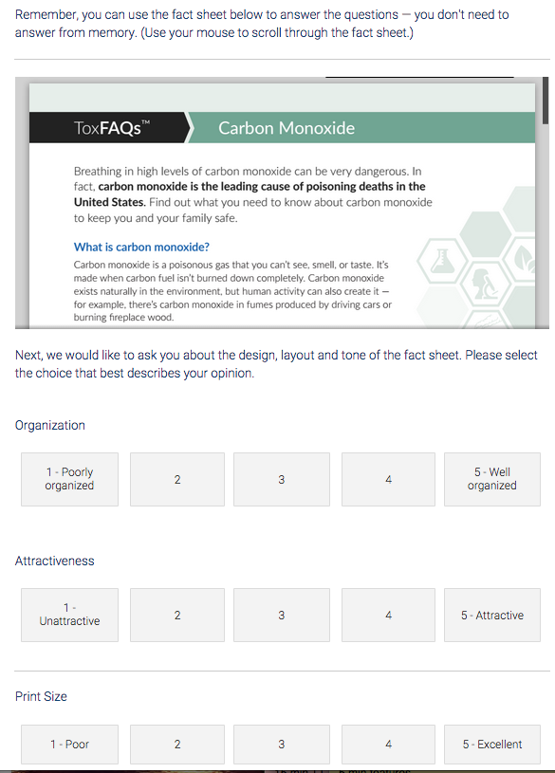

**All participants:**

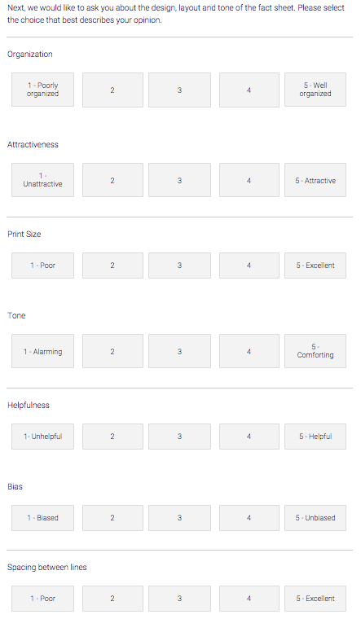

# Side-by-Side Comparison Questions

# 

Form Approved

OMB No. 0923-0047

Exp. Date 05/31/2016

# 

# 

# 

# End of Survey

