Attachment 4-

NIH Privacy Act Office Memo

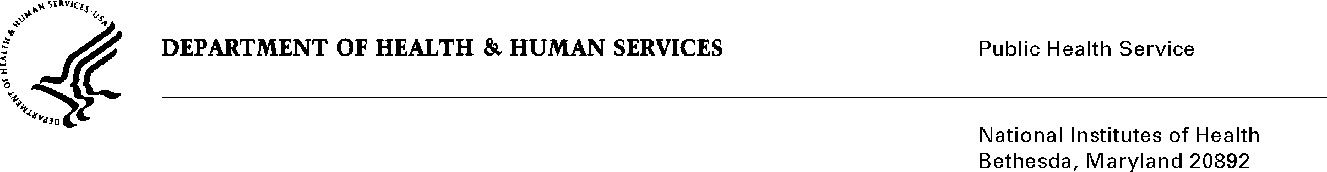
DATE: February 19, 2015

TO: Steve W. Gust, Ph.D.
Director, International Program
National Institute on Drug Abuse

FROM: NIH Privacy Act Officer

SUBJECT: Applicability of the Privacy Act: International Research and Fellowship Award Program

I have reviewed the National Institutes on Drug Abuse submission to OMB referenced above. The data collection involves the use of the U.S. PHS-398 grant application form which will permit foreign nationals to apply for training and research opportunities in an international fellowship program. The program will train new researchers, and support experienced researchers to advance the science of HIV and drug use while fostering multinational research.

I have determined that the Privacy Act will apply to this data collection, which includes the collection of personally identifiable information (PII) such as name, gender, birth year, citizenship, contact information, educational/employment history and other identifiers that will be stored in a record system designed to be retrieved by a personal identifier.

All of the application forms being used by the NIDA were developed in-house and will be hosted on the NIDA website. Applicants are provided a link to the application site, and will enter their information after establishing login credentials that include strong passwords that conform to standards used by the NIH Center for Information Technology. Applicants will only have access to their own applications. The collected information will be used to validate the applicant’s eligibility and qualifications, indicate their potential as future scientists, determine where mutual research interests exist, and enable decision-making. The information will also be used by the NIDA for strategic planning, performance analysis, and to provide reports to Congress, if needed.

Access will be granted to NIH science and program officials who will recommend or approve awards and administrative, human resources and financial officials who will prepare the necessary documentation to arrange for stipend payments and activate, renew, and terminate approved awards.

The data collection is covered by NIH Privacy Act Systems of Record 09-25-0036, “Extramural Awards and Chartered Advisory Committees (IMPAC 2), Contract Information (DCIS), and
Cooperative Agreement Information, HHS/NIH.” If you have questions, please contact me at (301) 402-6201.

Karen M. Plá

Enclosure
cc: Genevieve deAlmeida-Morris, NIDA PRA Liaison (w/o enclosure)

