AsiaLymph Study

Screener and Questionnaire

Screener

OMB #: 0925-0654
Expiration date: 10/31/2015

Public reporting for this collection of information is estimated to average 5 minutes per response, including the time for reviewing instructions, searching existing data sources, gathering and maintaining the data needed, and completing and reviewing the collection of information. An agency may not conduct or sponsor, and a person is not required to respond to, a collection of information unless it displays a currently valid OMB control number. Send comments regarding this burden estimate or any other aspect of this collection of information, including suggestions for reducing this burden, to: NIH, Project Clearance Branch, 6705 Rockledge Drive, MSC 7974, Bethesda, MD 20892-7974, ATTN: PRA (0925-0654). Do not return the completed form to this address.

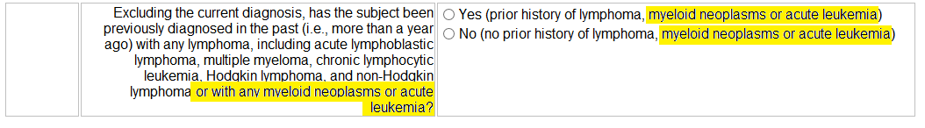

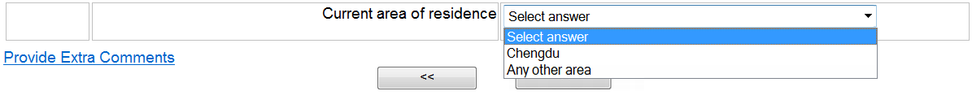

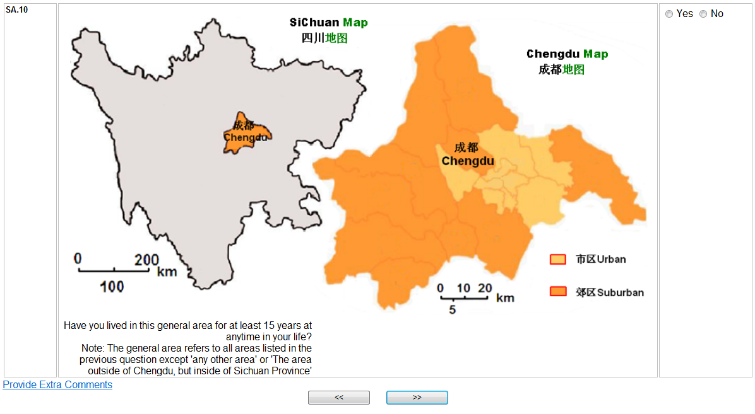
Have you lived in this general area for at least 15 years at anytime in your life?
Note: The general area refers to all areas listed in the previous question except ‘any other area’

Questionnaire

OMB #: 0925-0654
Expiration date: 10/31/2015

Public reporting for this collection of information is estimated to average 70 minutes per response, including the time for reviewing instructions, searching existing data sources, gathering and maintaining the data needed, and completing and reviewing the collection of information. An agency may not conduct or sponsor, and a person is not required to respond to, a collection of information unless it displays a currently valid OMB control number. Send comments regarding this burden estimate or any other aspect of this collection of information, including suggestions for reducing this burden, to: NIH, Project Clearance Branch, 6705 Rockledge Drive, MSC 7974, Bethesda, MD 20892-7974, ATTN: PRA (0925-0654). Do not return the completed form to this address.

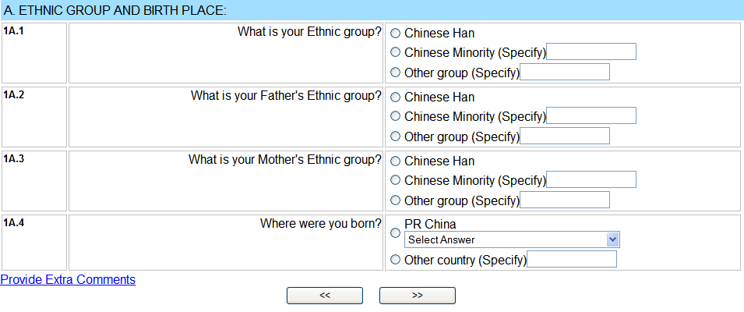

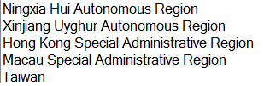

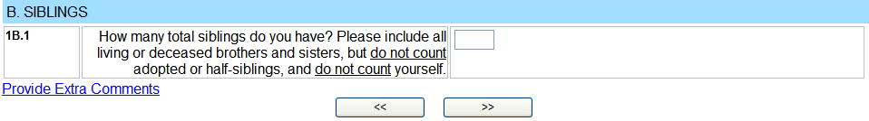
If No (0) Siblings, Go To 1C.1

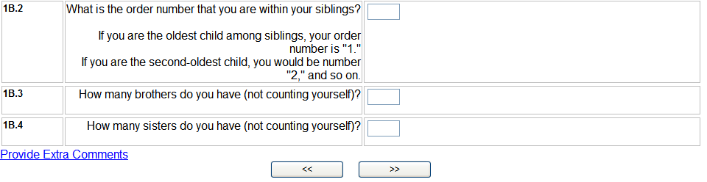
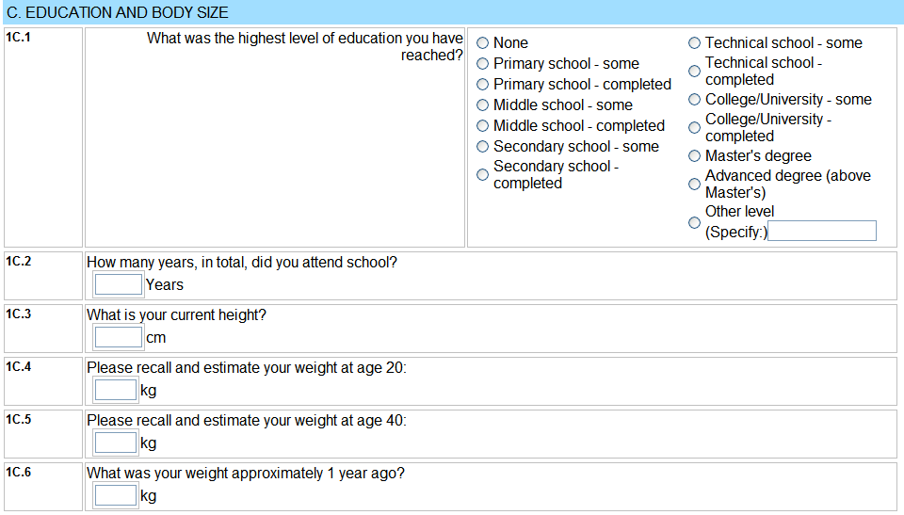
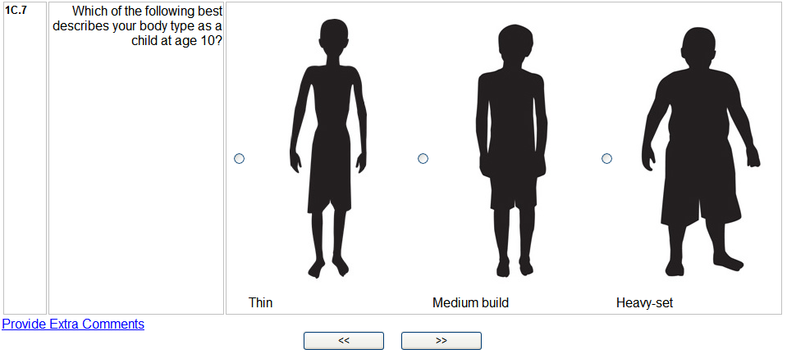
If <Age 40, Skip To 1C.6
If ‘None’ is selected,
Go to 1C.3

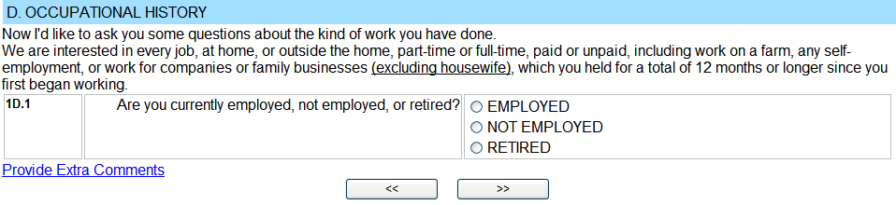
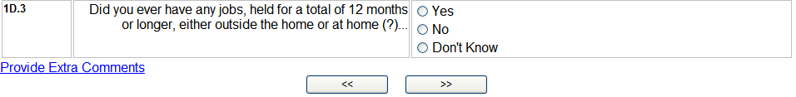
If Yes, Go To INTRO for 1D.4
If No or Don’t Know, Go To INTRO for 2A.1
INTRO for 1D.4

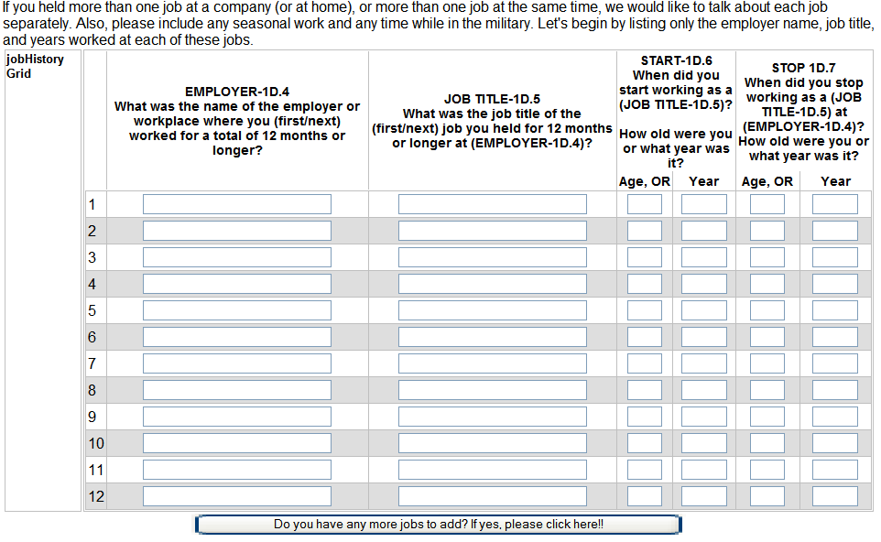
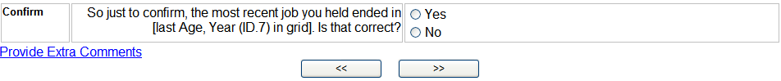

Go To 1D.4 and begin completing grid
When you have obtained 1D.4-1D.7 for all jobs (up to 12 total jobs available for entry on CAPI), GO TO 1D.8 for 1st job. Then ask 1D.8 through 1D.16 for the first job and then repeat for all additional jobs

1st Job Questions
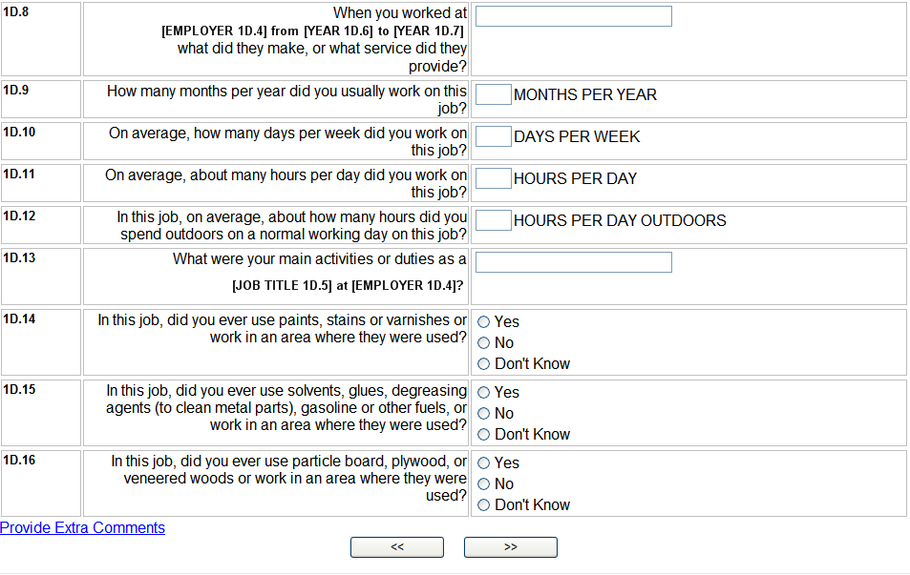
2nd Job Questions

3rd Job Questions
NOTE: After asking questions 1D.8 through 1D.16 for the last job, Go To 1D.17 INTRO.

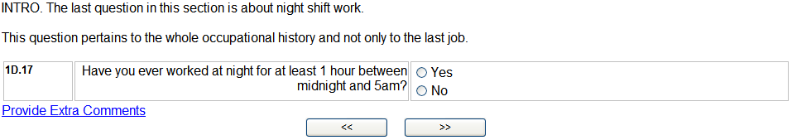
If NO, Go To OccIDEAS transition screen.
If NO, Go To OccIDEAS transition screen.

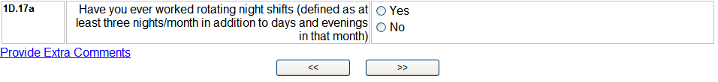

OccIDEAS Transition Screen

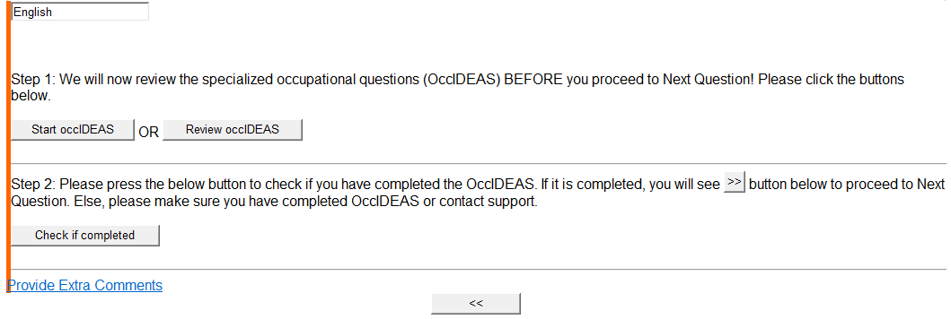

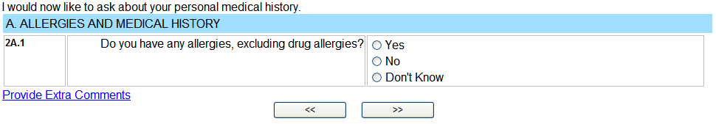
If No or Don’t Know
Go To 2A3.1
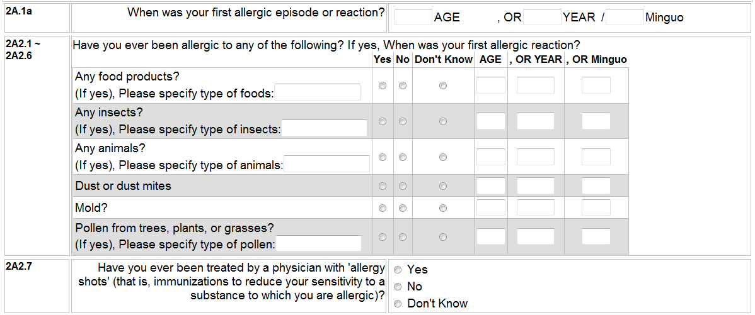

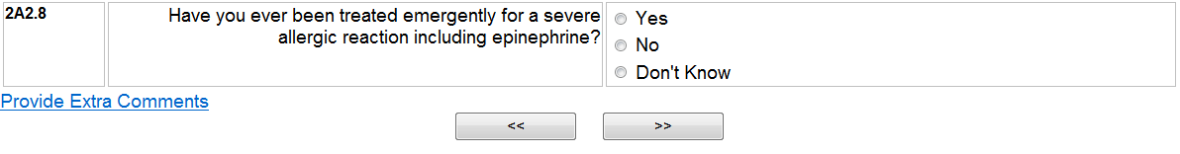
If No or Don’t Know, Go To 2A3.1

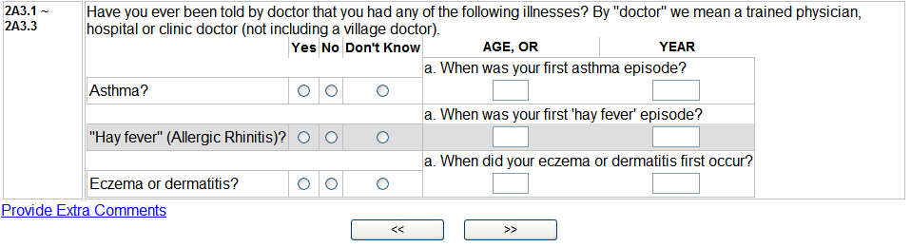

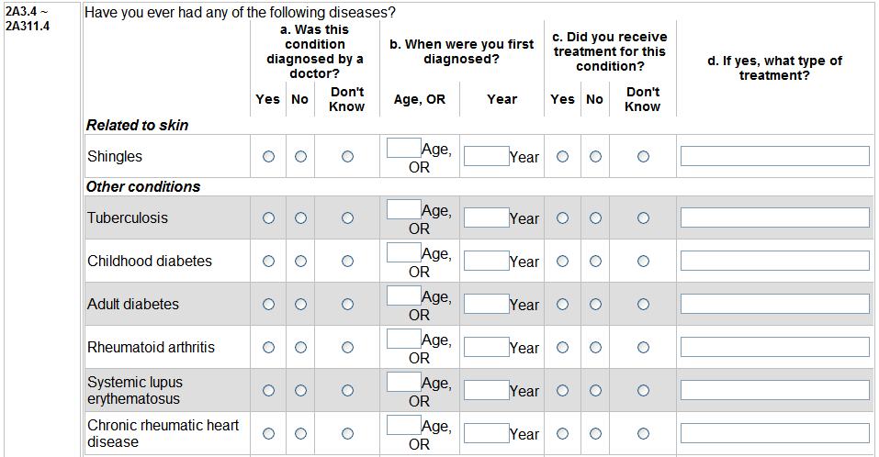
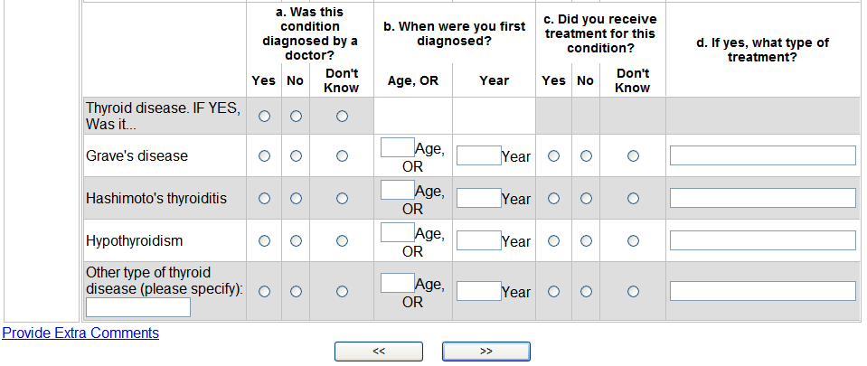
If No or Don’t Know
Go To 2A4.1
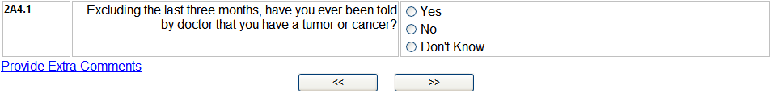
If No or Don’t Know Go to 2B.1

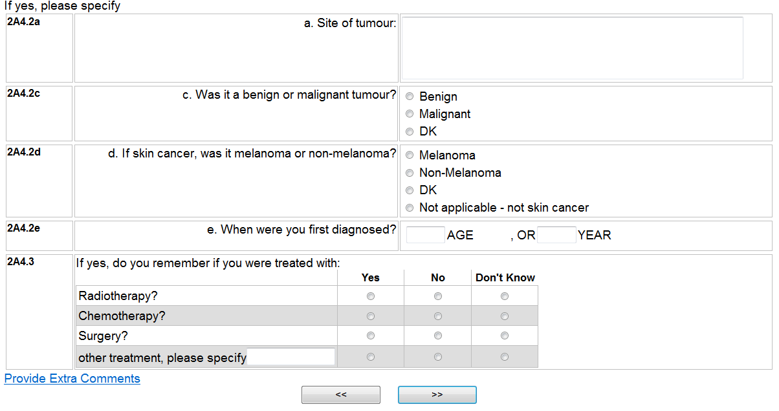
If No or Don’t Know, Go To 2B.1
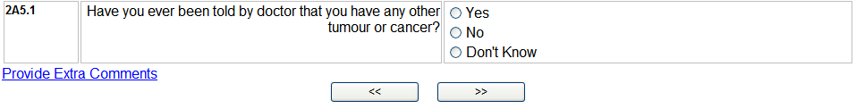

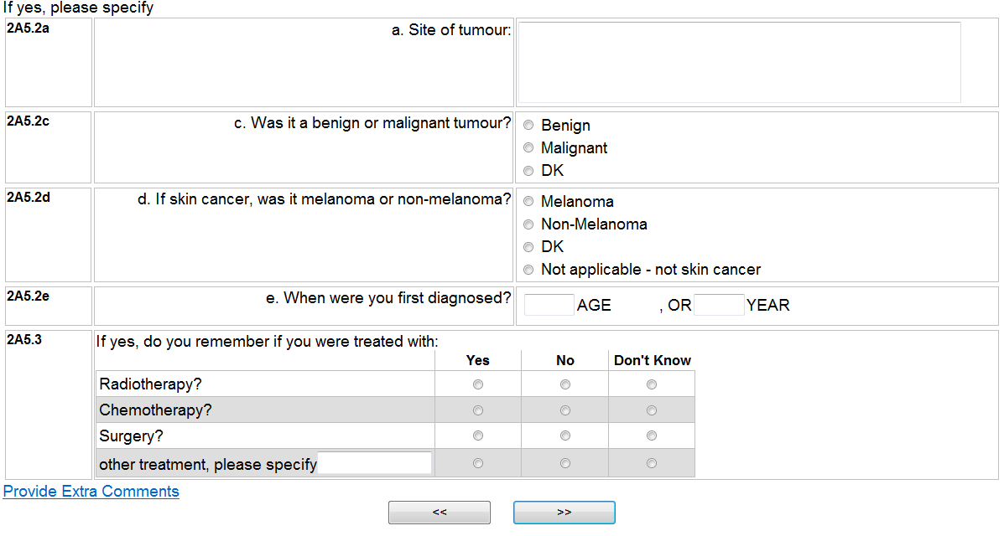

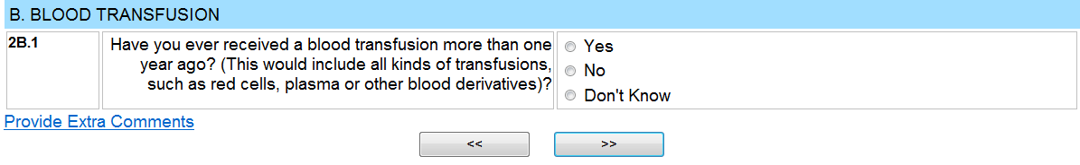
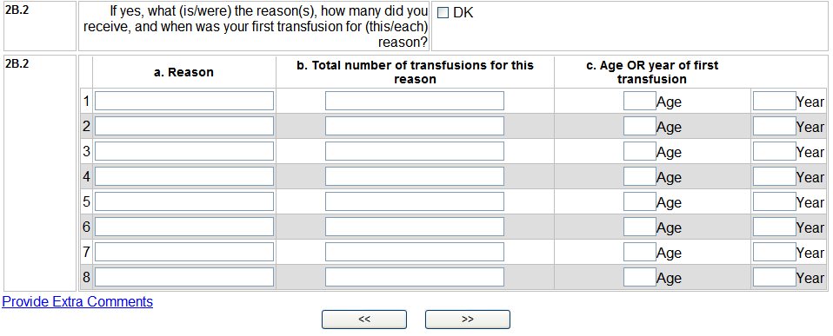
If No or Don’t Know, Go To 2C.1
NOTE: CAPI has fields to enter up to 8 different transfusions

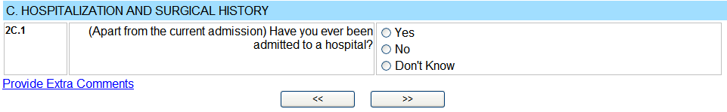
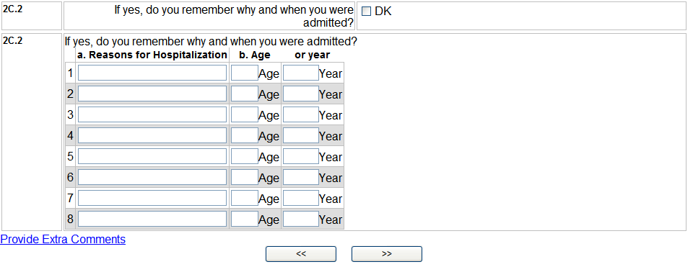
If No or Don’t Know, Go To 2D.1
CAPI NOTE: The CAPI has fields for 8 different hospitalizations.

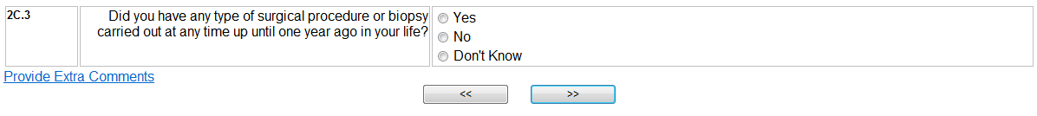
If No or Don’t Know, Go To 2D.1

For Females:

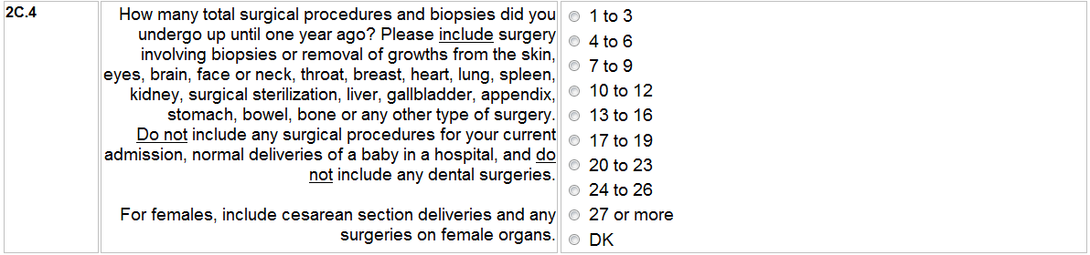

For Males

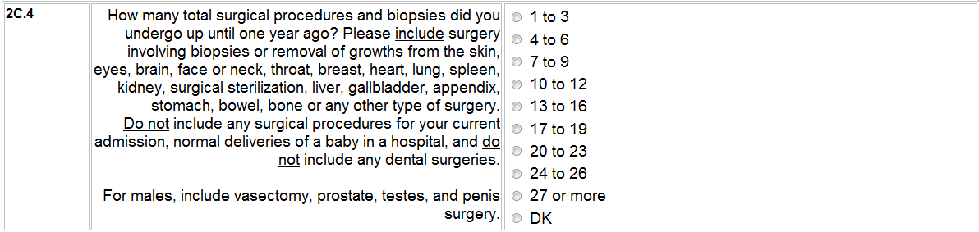
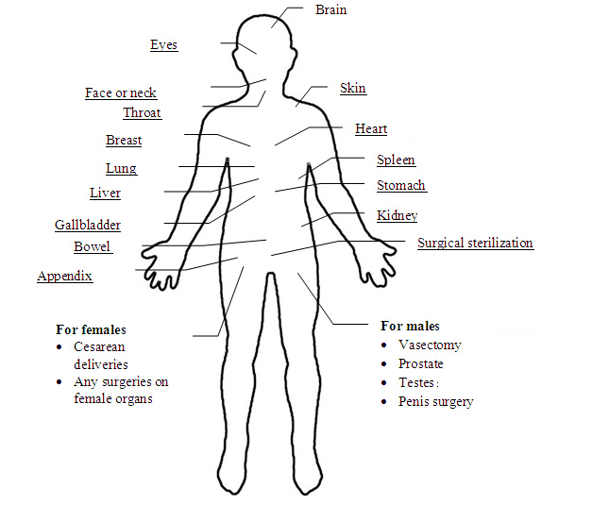
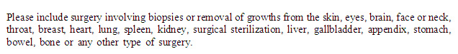
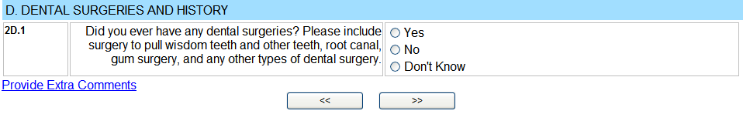
If No or Don’t Know, Go To 2D.3
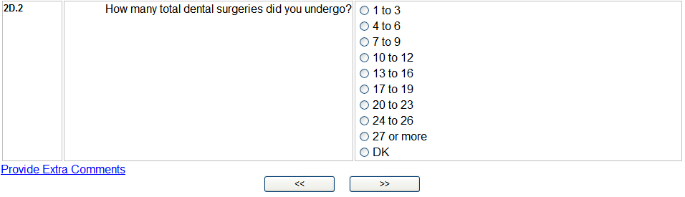

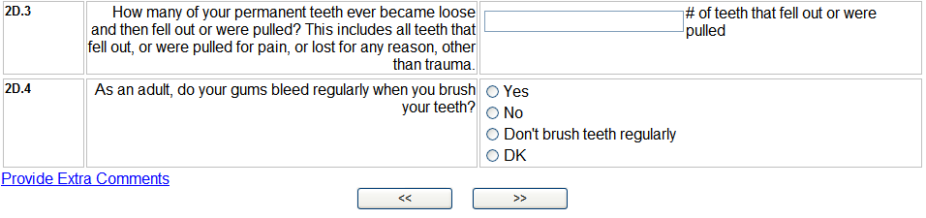
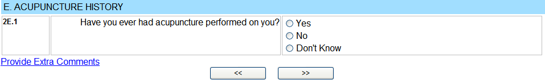
If No or Don’t Know, Go To Section F
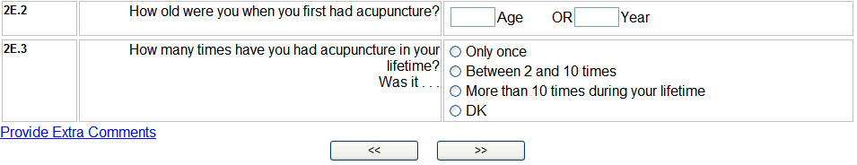
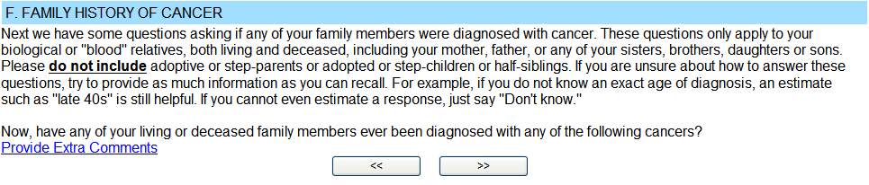
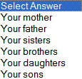
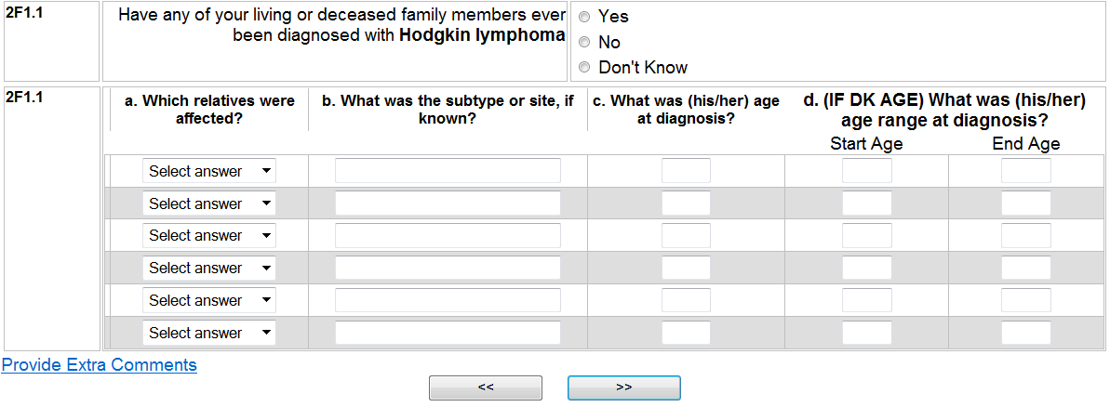
If No or Don’t Know, Go To 2F1.2
If No or Don’t Know, Go To 2F1.3

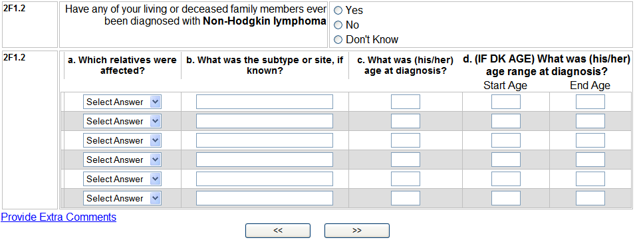

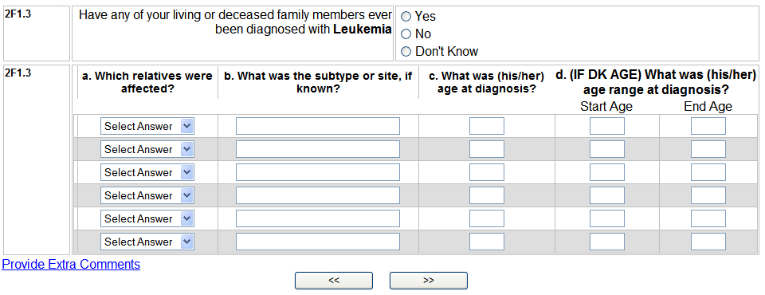
If No or Don’t Know, Go To 2F1.4

If No or Don’t Know, Go To 2F1.5

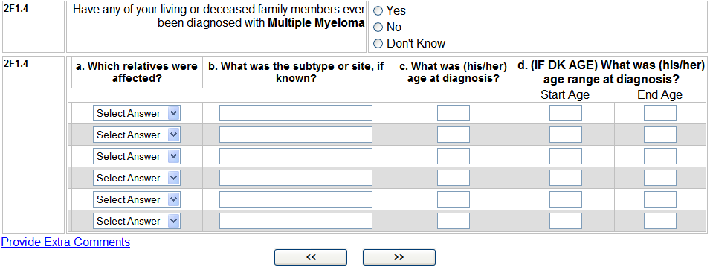

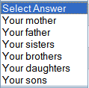
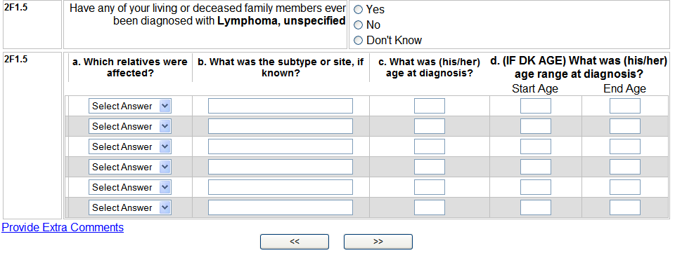
If No or Don’t Know, Go To 2F.2

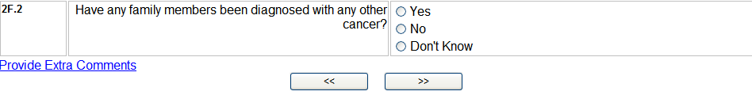
If No or Don’t Know, Go To INTRO for 3A.1
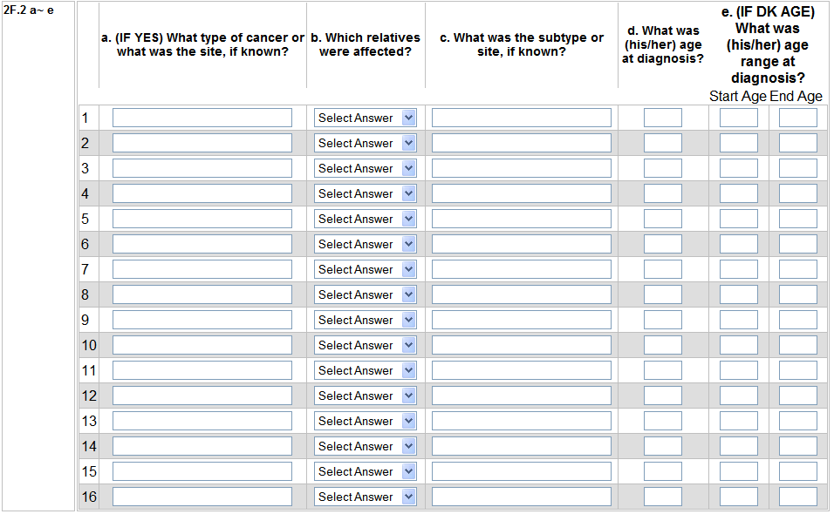
CAPI has fields to enter up to 16 family members

INTRO for 3A.1

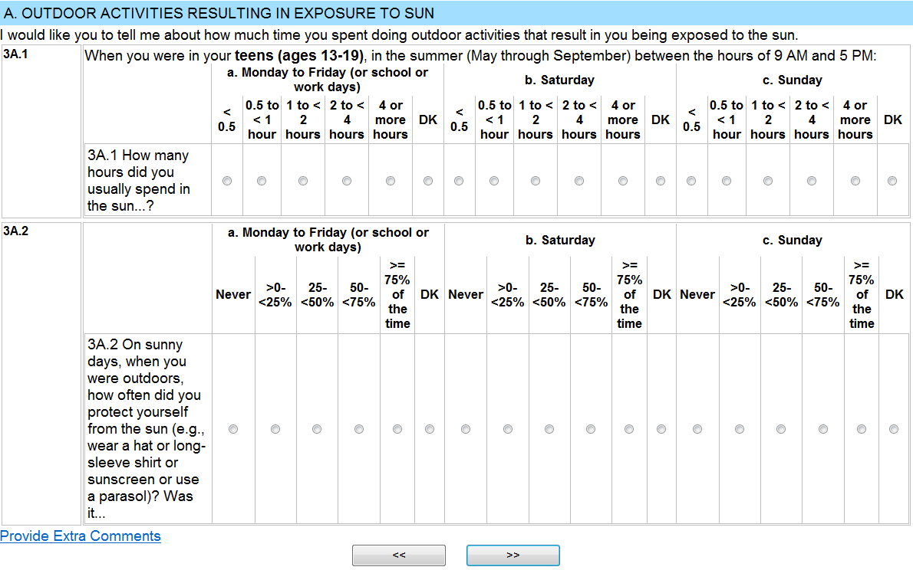

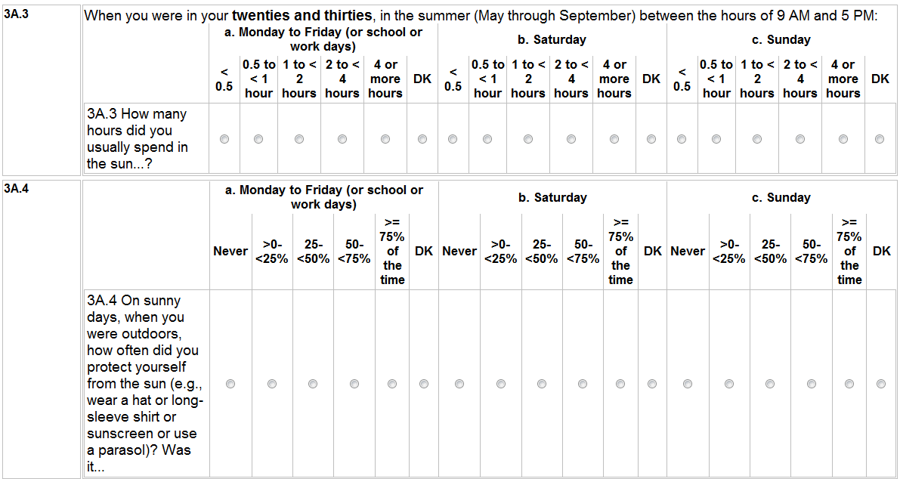

IF SUBJECT IS LESS THAN AGE 40, Go To Section 3B.
IF SUBJECT IS AGE 40-49, begin next question with “Since you became age 40, in the summer months…”
IF SUBJECT IS AGE 50+ ask the next question as shown below.

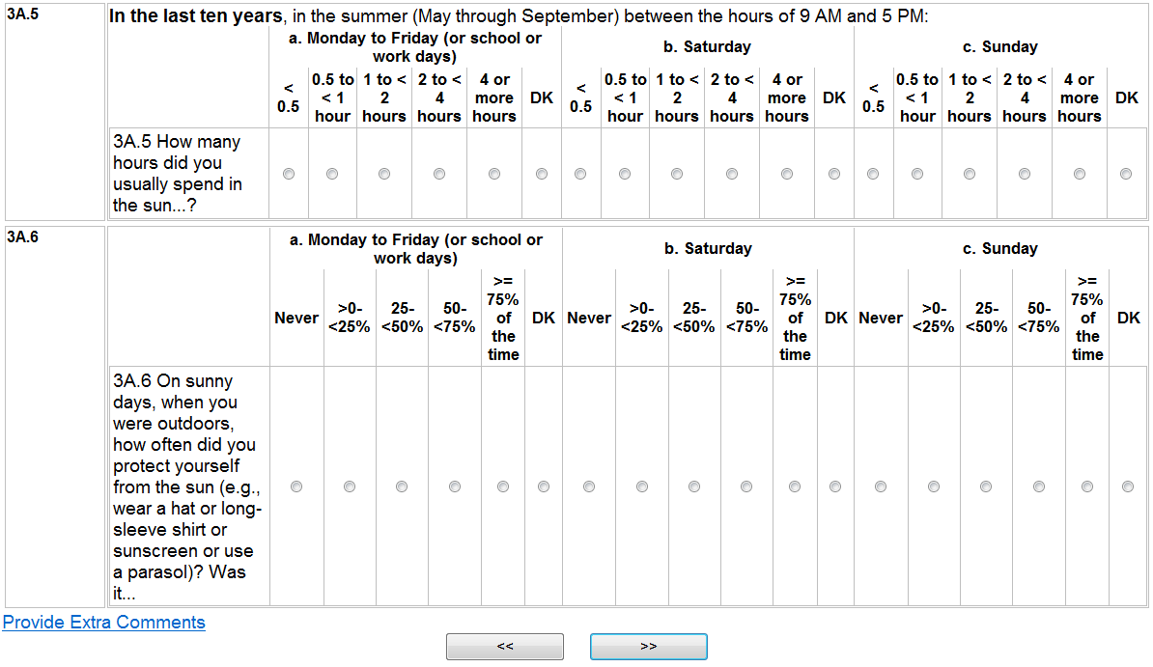

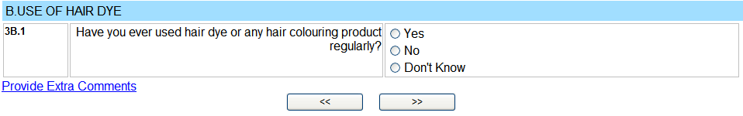
If No or Don’t Know, Go To 3C.1
If still using Go To 2a etc.

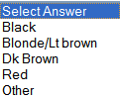
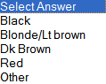
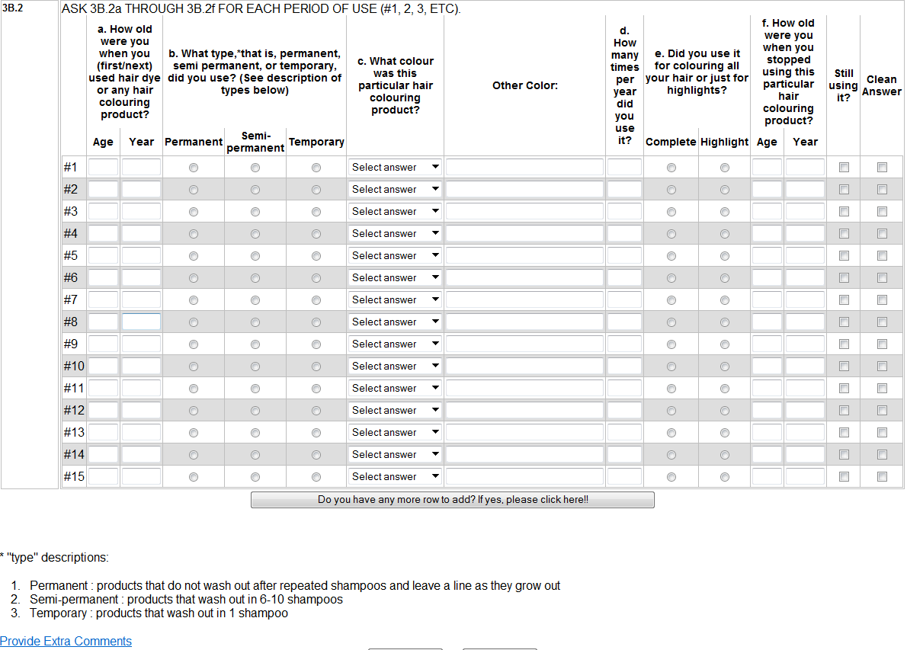
NOTE: In CAPI room for 15 different hair dyes or any hair colouring products
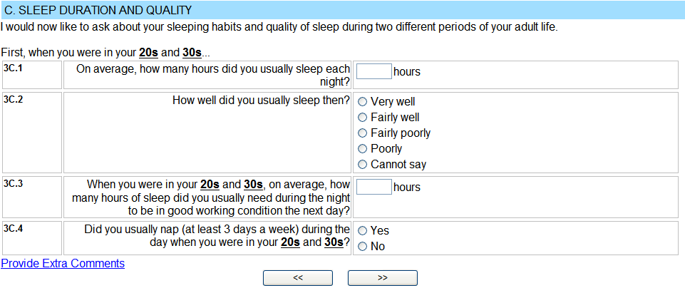
If No,
Go To 3C.6
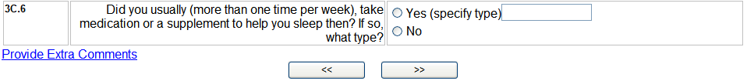
IF SUBJECT IS LESS THAN AGE 40, Go To SECTION 3D INTRO.
IF SUBJECT IS AGE 40-49, Continue.
IF SUBJECT IS AGE 50+, include “and fifties” in 3C.7 INTRO and 3C.9

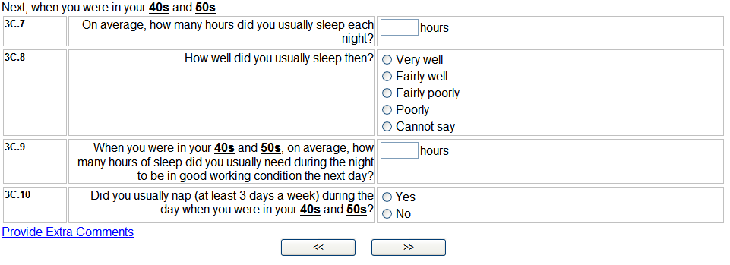
If No,
Go To 3C.12

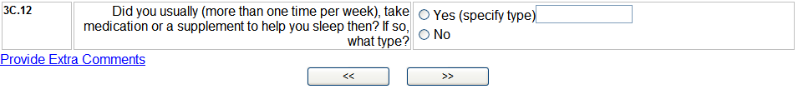
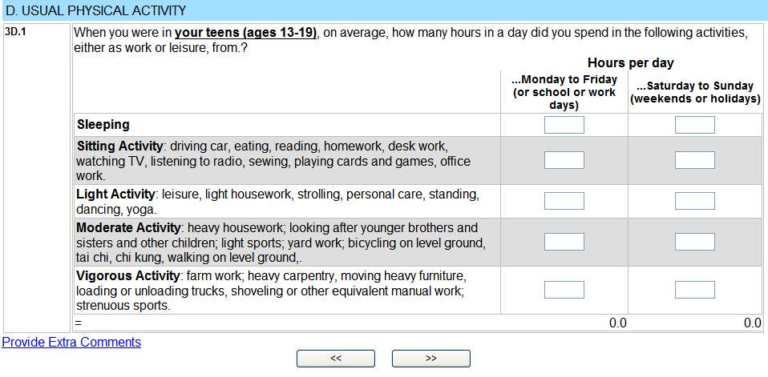
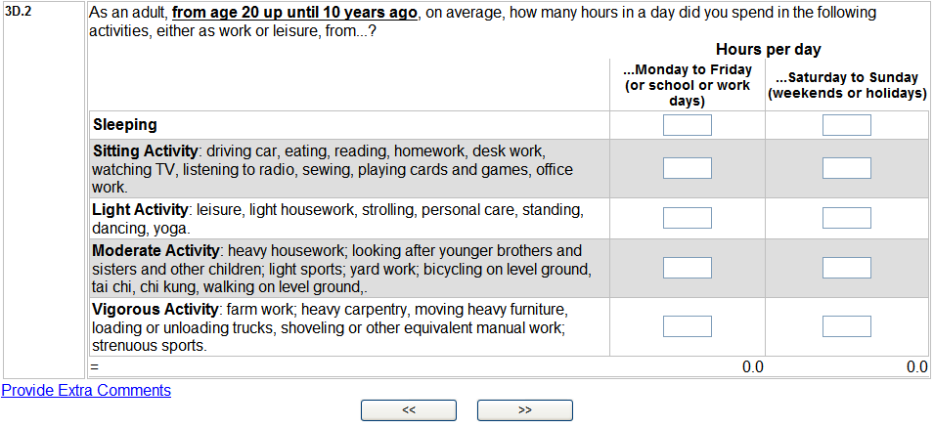
If subject is UNDER AGE 30, then ask 3D.3lt30

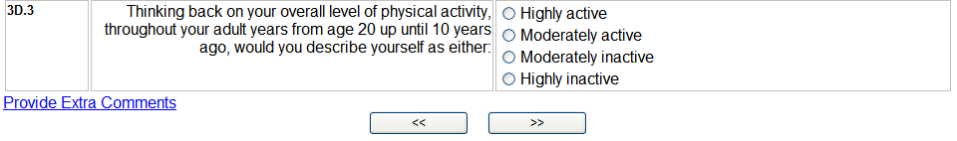

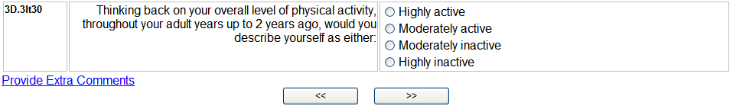
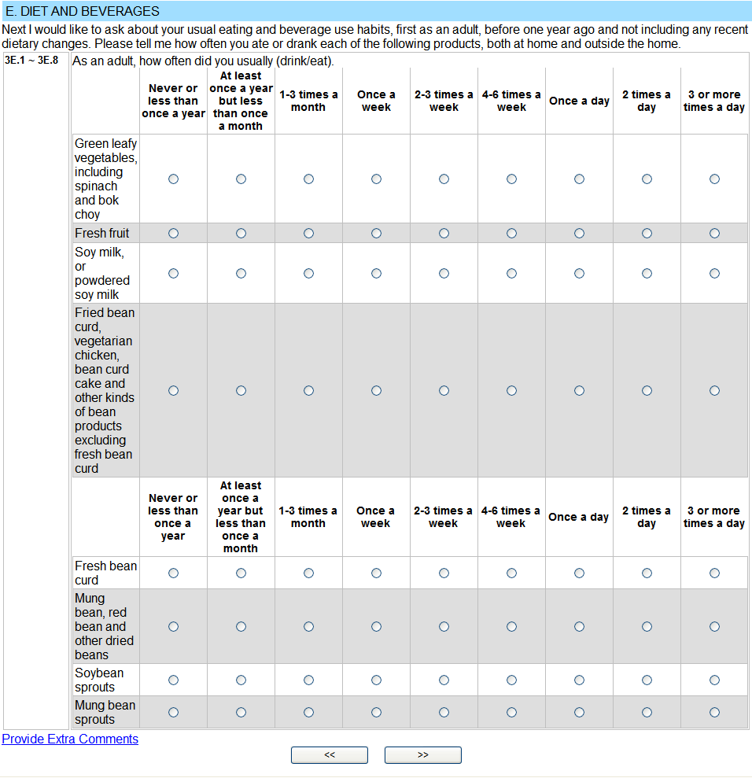

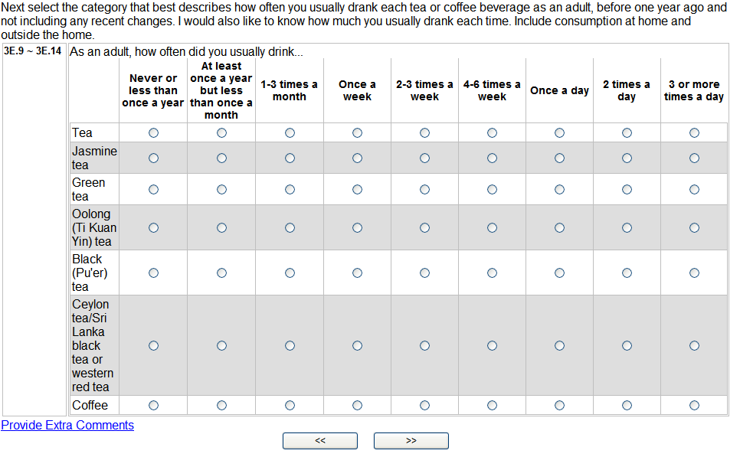

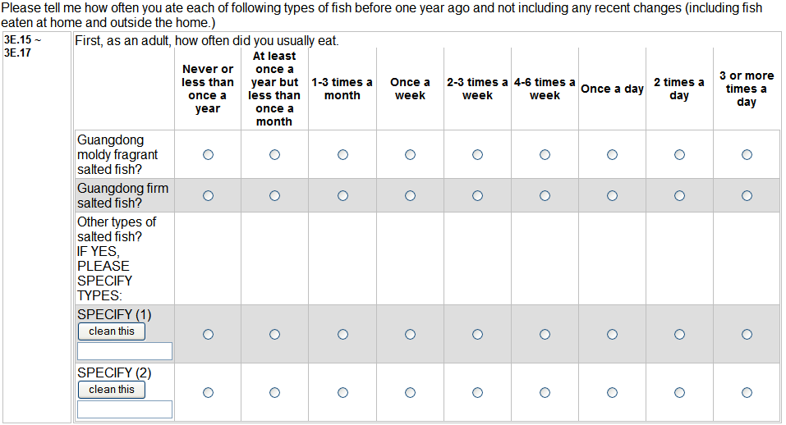
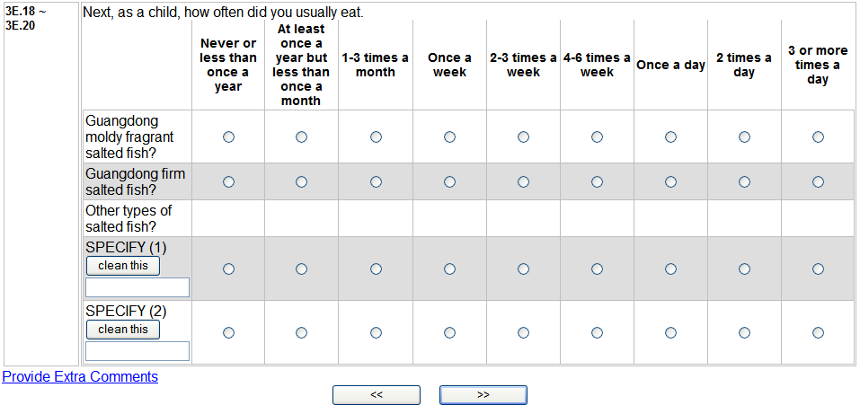

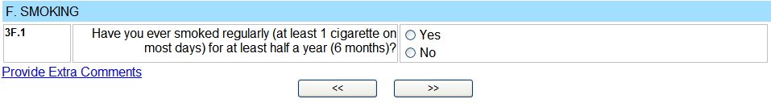
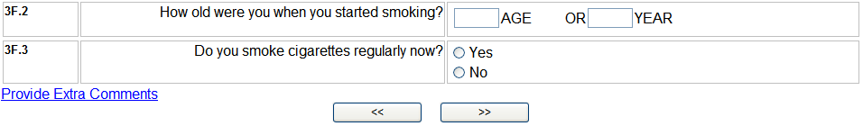
If No,
Go To 3G.1
If No,
Go To 3F.4
If Yes,
Go To 3F.6

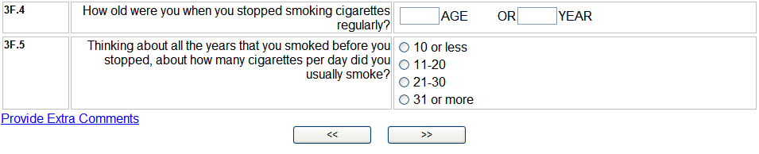
Go To 3F.12

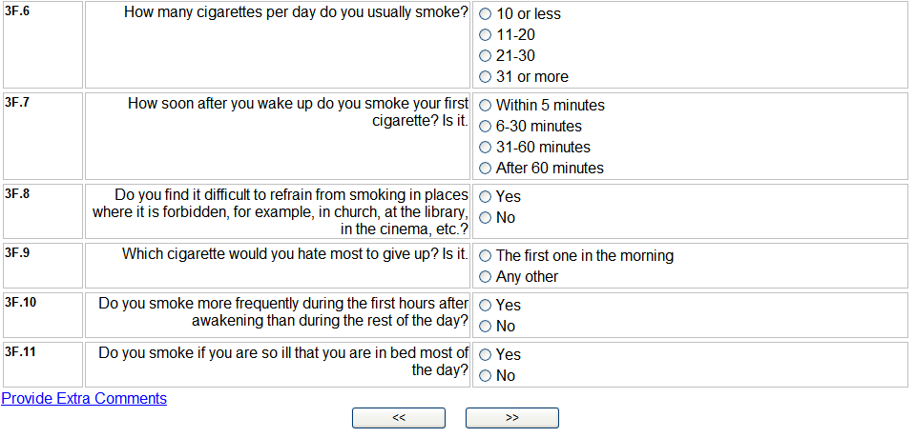
If No,
Go To 3F.14
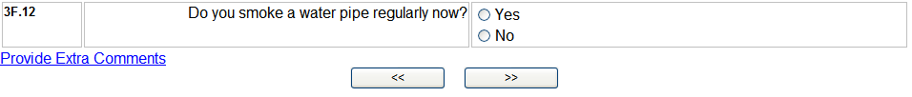

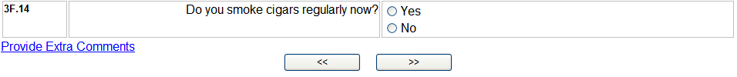
If No,
Go To 3F.16
If No,
Go To 3G.1
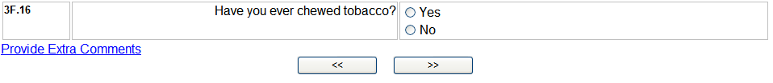
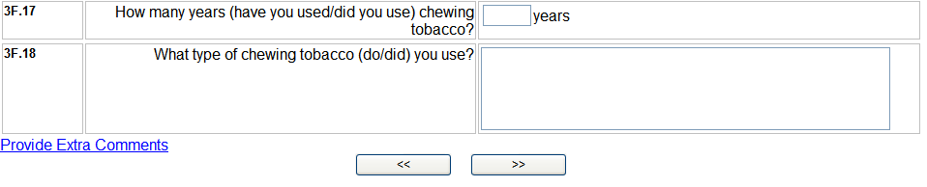
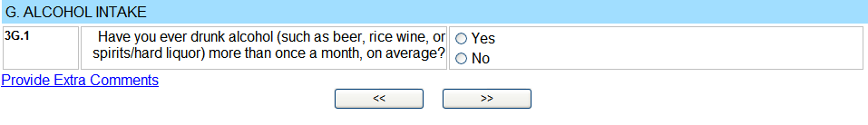
If No,
Go To 3H CAPI NOTE
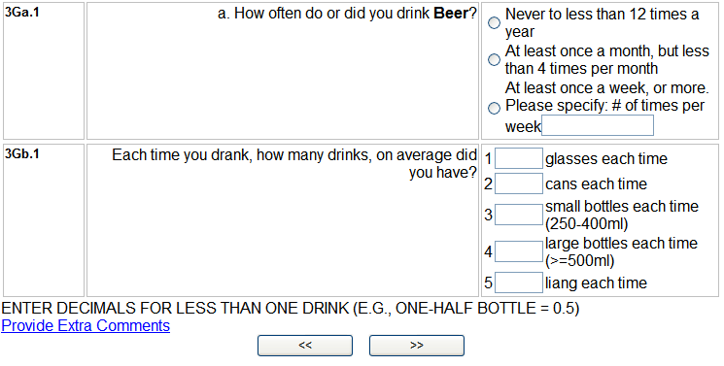
If Never,
Go To 3Ga.2
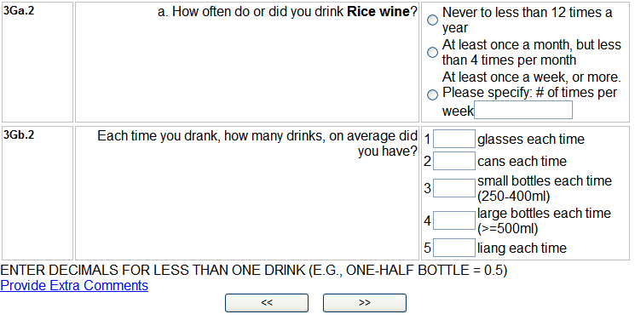
If Never,
Go To 3Ga.3

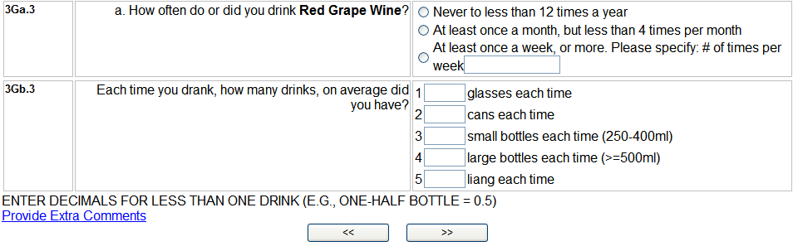
If Never,
Go To 3Ga.5
If Never,
Go To 3Ga.4

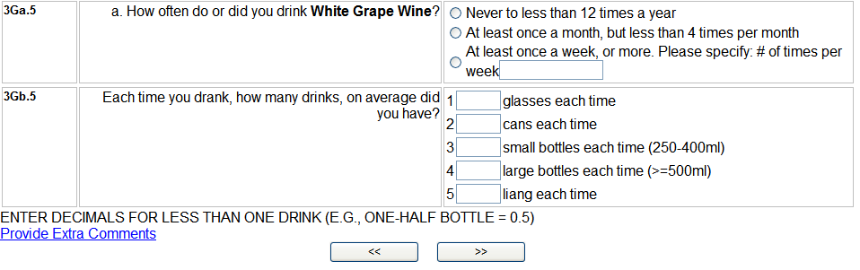
If Never,
Go To 3H CAPI NOTE

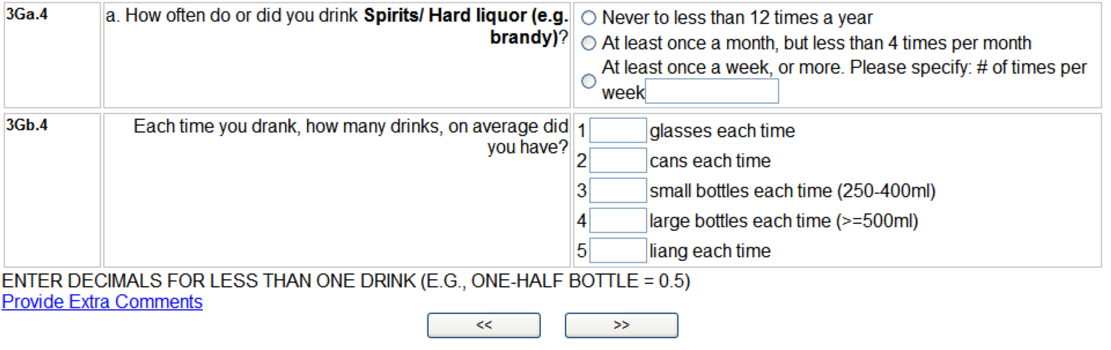

CAPI NOTE: For Women Only; Skip to Part IV for Male Subjects.

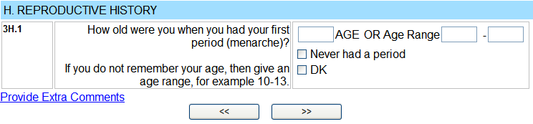
If Never had a period, Go To 3H.7

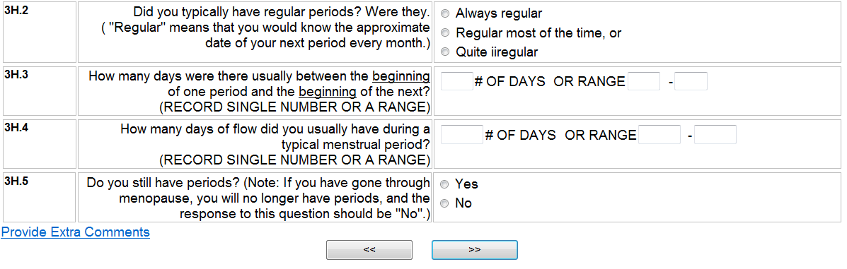
If Yes,
Go to 3H.7

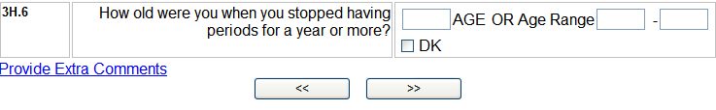

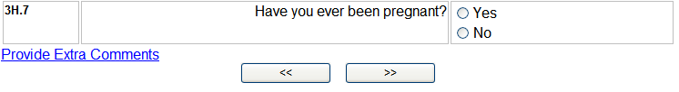
If No,
Go to PART IV

If 0 pregnancies,
Go To PART IV.
If 0 live births,
Go To PART IV. If 3H.9 is 1, answer 3H.10 then Go To 3H.12

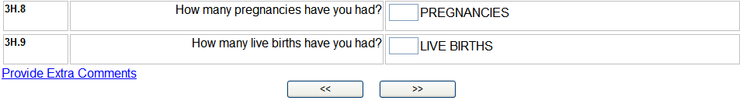

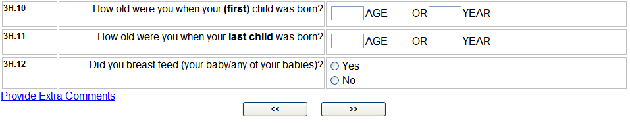
If No,
Go to PART IV

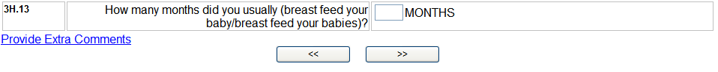
PART IV

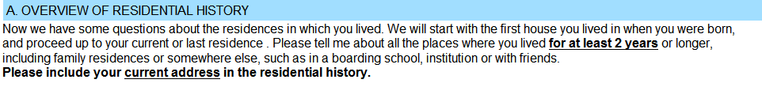

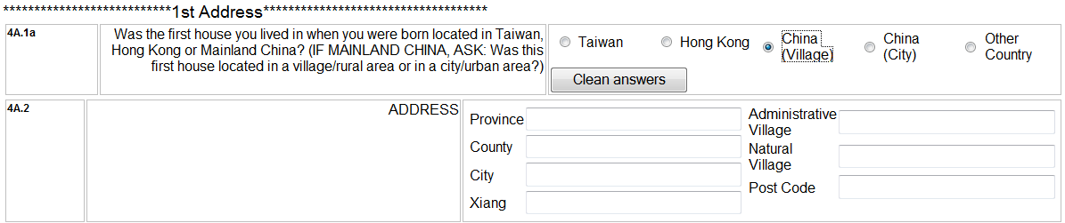
If China (Village) selected, these are the address fields.
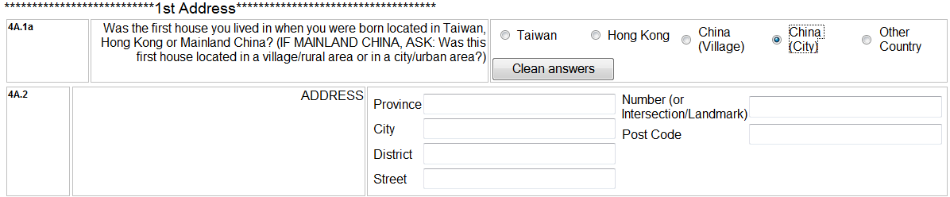
If China (City) selected, these are the address fields

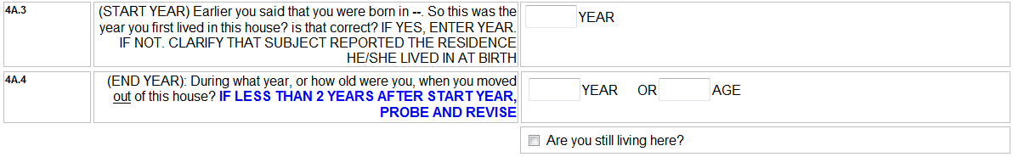
THE CAPI PROVIDES SPACE FOR UP TO 10 CHILDHOOD AND ADULT RESIDENCES.

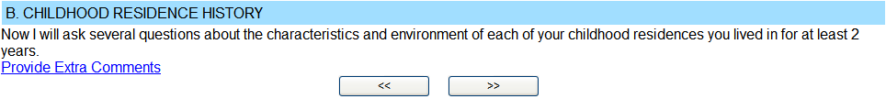
Residence

If Family,
Go To 4B1.6

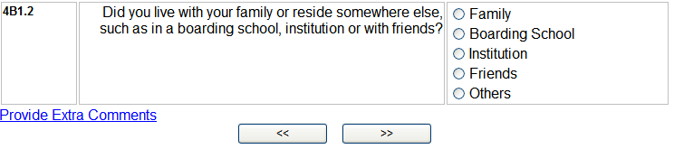
If Friends or Others,
Go To 4B1.6

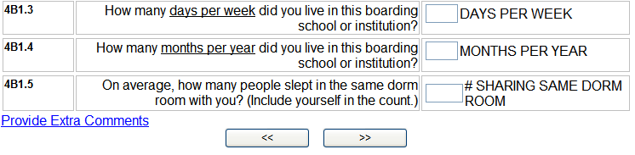
Go To 4B1.10 INTRO

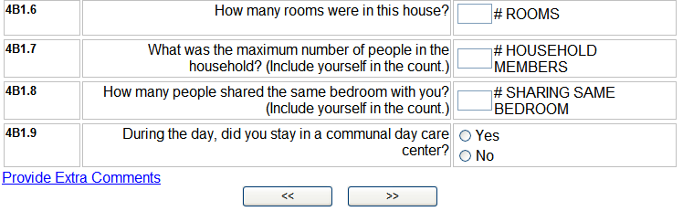
INTRO. 4B1.10
Residence



Check if this Residence was a Boarding School or Institution.
If Yes, (4B1.2 = 2 OR 3), SKIP TO QUESTION 4B1.11.
If No, (4B1.2 = 1, 4 OR 5), ASK QUESTION 4B1.10.

If No or Don’t Know
Go To 4B1.11

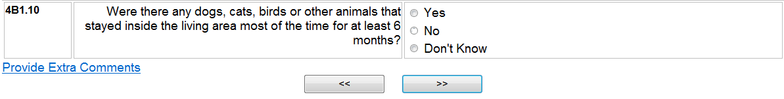
If No or Don’t Know
Go To 4B1.10.2a

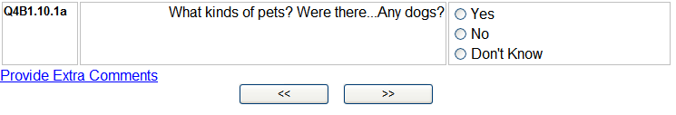

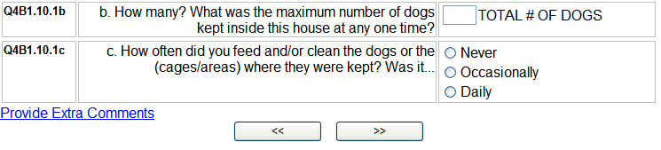
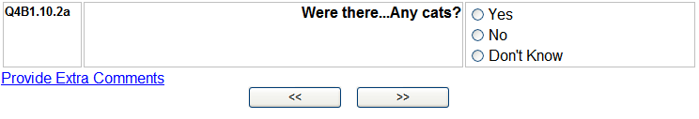
If No or Don’t Know
Go To 4B1.10.3a

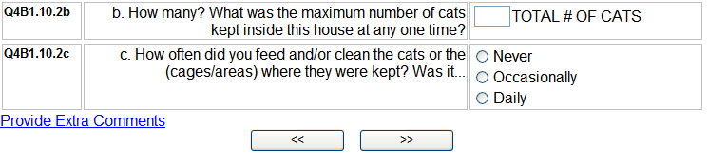
If No or Don’t Know
Go To 4B1.10.4a

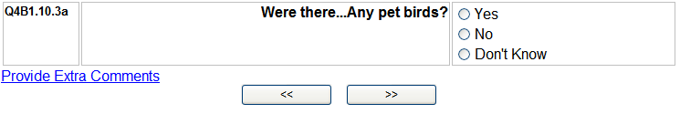

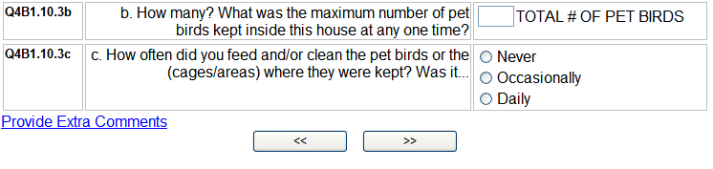
If No or Don’t Know
Go To 4B1.11

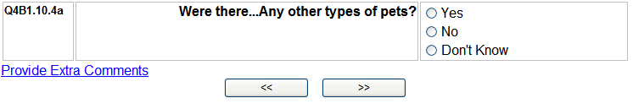

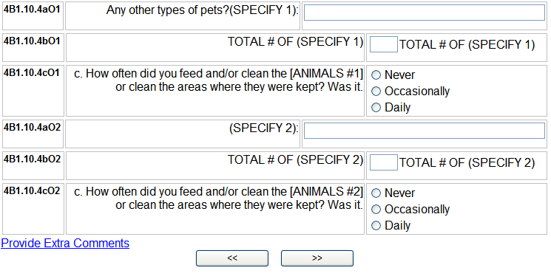
If No or Don’t Know,
Go To “Check Response Instruction” following Section 4B1.11.4

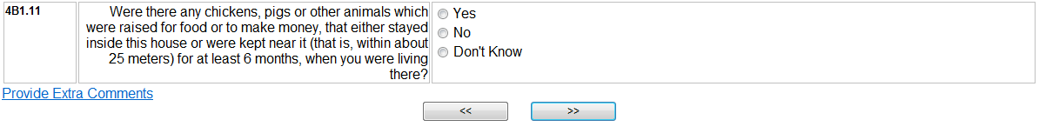

If No or Don’t Know,
Go To 4B1.11.2a

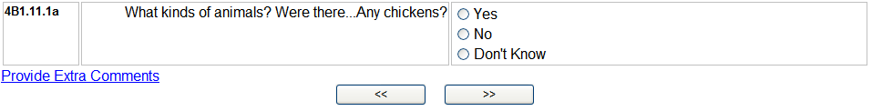

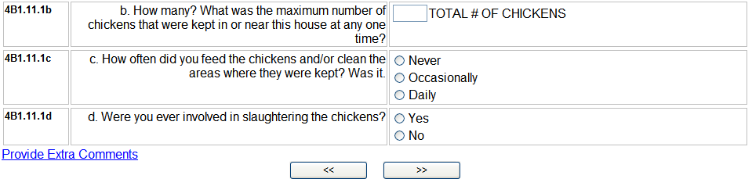

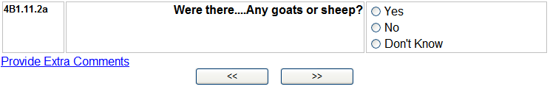
If No or Don’t Know,
Go To 4B1.11.3a

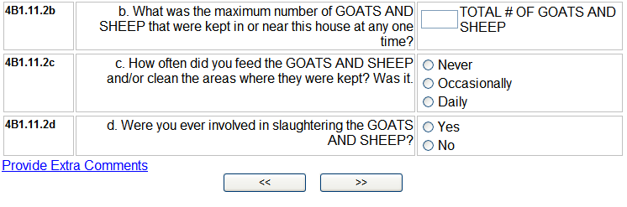
If No or Don’t Know,
Go To 4B1.11.4a
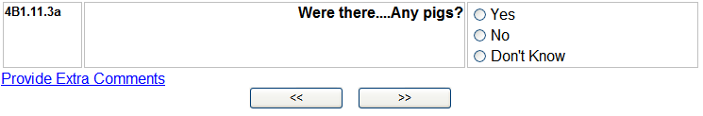
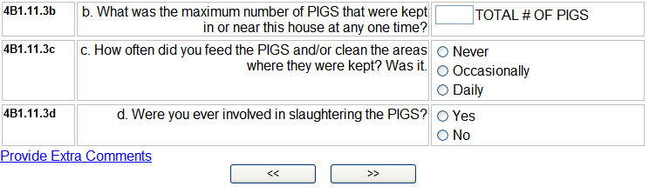
If No or Don’t Know,
Go To “Check Response Instruction” following Section 4B1.11.4

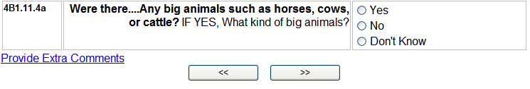
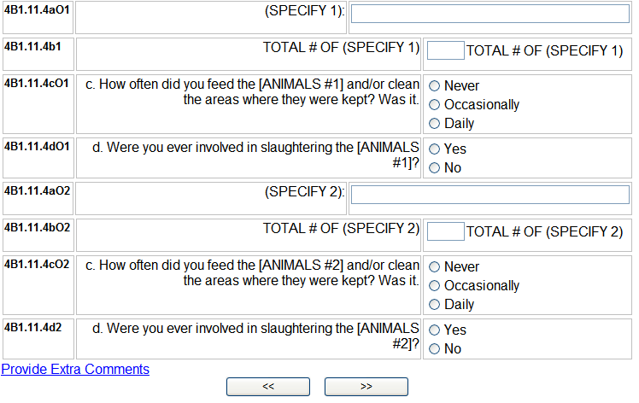

CHECK RESPONSE in Q4A.4 (end year). if this response indicates that respondent was
less than 18 years old, repeat this section for the next residence

If respondent was age 18 or older when he/she moved out of this house,
Go to Q4C INTRO.

4C1.1 INTRO
Start Year
End Year
Longest Adult Residence Address #1

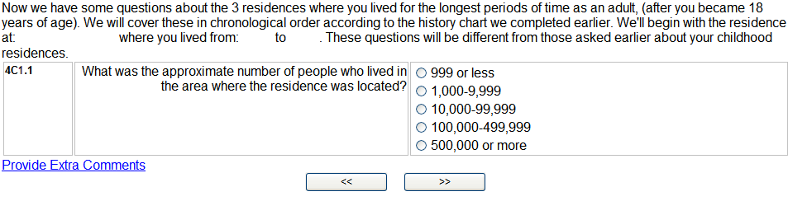
If 500,000 or more,
Go to 4C1.3

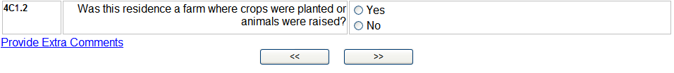
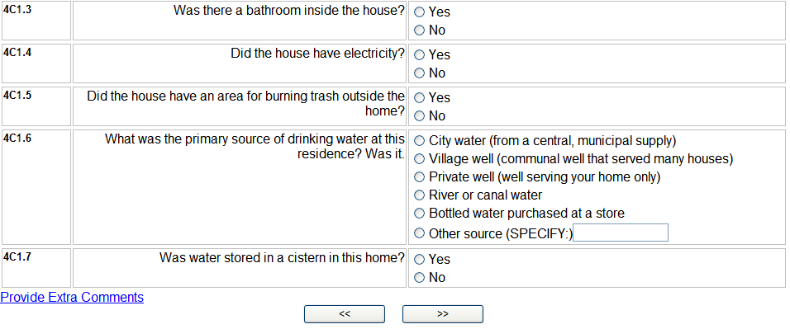
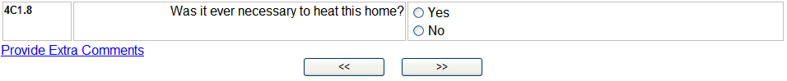
If No,
Go to 4C1.10
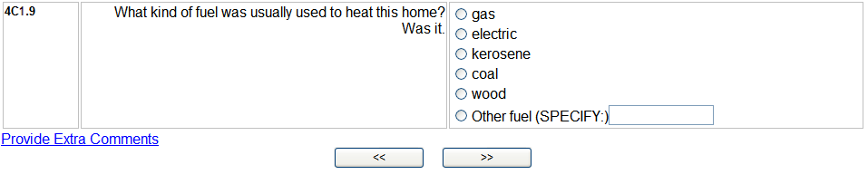

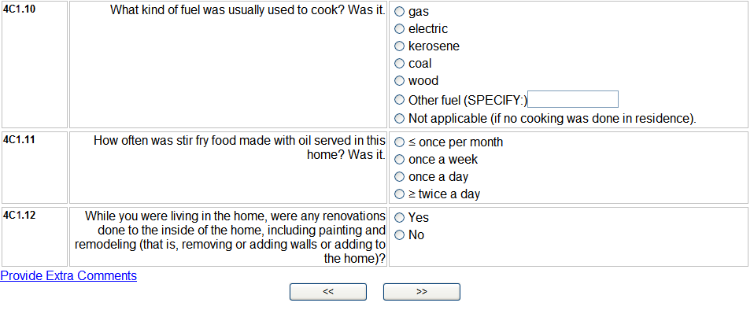
If No, Go to
instruction box below

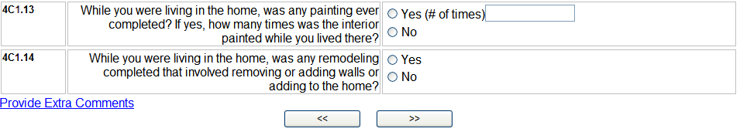

Repeat this section for the next 2 longest adult residences.

