July 2016

Dear Facility Director:

We have been attempting to contact you to gain your participation in the 2016 National Survey of Substance Abuse Treatment Services (N-SSATS) sponsored by the Substance Abuse and Mental Health Services Administration (SAMHSA). If you have already completed the questionnaire on the web or by phone, thank you for your response. If you have not yet completed your questionnaire, please do so at your earliest convenience.

In addition to informing policy and resource decisions, N-SSATS data are used to update SAMHSA’s online Behavioral Health Treatment Services Locator (https://findtreatment.samhsa.gov) and the National Directory of Drug and Alcohol Abuse Treatment Programs.

The 2016 N-SSATS is easy to complete on the web. If you completed the N-SSATS last year, you will find that your 2015 responses to questions that typically do not change from year to year have been pre-filled in your 2016 online questionnaire. Please see the enclosed Web flyer for your facility’s unique log in information.

If you prefer to fill out a hard copy questionnaire, please complete the enclosed survey and return it using the enclosed, self-addressed prepaid envelope.

If you have any questions regarding the survey, please contact the N-SSATS toll-free helpline at 1-888-324-8337 or send an email to nssatsweb@mathematica-mpr.com. Staff will be available to assist you Monday thru Friday 8 a.m. to 8 p.m. (Eastern Time).

Thank you for your participation in this important survey which will help assure that the information collected through the N-SSATS is as complete and accurate as possible.

Sincerely,
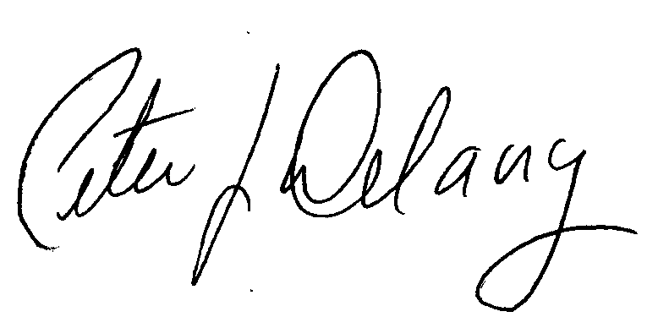

Peter J. Delany, Ph.D., LCSW-C
RADM, U.S. Public Health Service
Director, Center for Behavioral Health
Statistics and Quality, SAMHSA

Enclosures

NOTE: The N-SSATS questionnaire is designed to collect information about a single facility at a single location, that is, the facility whose name and address is printed on the enclosed pink flyer. Even if your organization offers treatment services at more than one location, please complete this on-line questionnaire for this location only.

