(NQF 1822) External Beam Radiotherapy for Bone Metastases Overview
This measure reports the percentage of patients, regardless of age, with a diagnosis of painful bone metastases and no history of previous radiation who receive external beam radiation therapy (EBRT) with an acceptable fractionation scheme.

*Final web design is subject to change as it is dependent on web real estate and IT capacity. Changes will not impact the data elements but rather the application layout.*

Accessing the Web-Based Application
The user enters their assigned User ID and password to access the secure site and information for their individual hospital.

Figure 1 Sign In
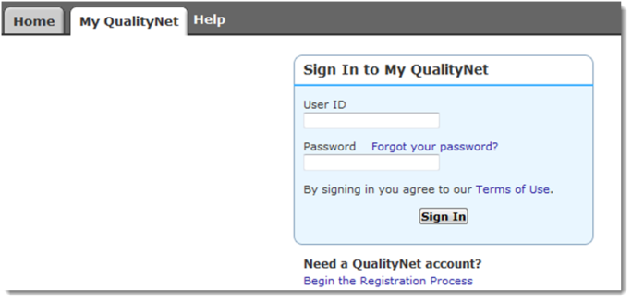

Q1 Q2 Q3 Q4

NUMERATOR
All patients, regardless of age, with painful bone metastases, and no previous radiation to the same anatomic site who receive EBRT with any of the following recommended fractionation schemes: 30Gy/10fxns, 24Gy/6fxns, 20Gy/5fxns, 8Gy/1fxn.

Q1 Q2 Q3 Q4

DENOMINATOR
All patients with painful bone metastases and no previous radiation to the same anatomic site who receive EBRT.

Q1 Q2 Q3 Q4

Percent of Total
Please refer to specifications on the National Quality Forum website: http://www.qualityforum.org/QPS/1822.
PRA Disclosure Statement
According to the Paperwork Reduction Act of 1995, no persons are required to respond to a collection of information unless it displays a valid OMB control number. The valid OMB control number for this information collection is 0938-1175. The time required to complete this information collection is estimated to average 10 minutes per response, including the time to review instructions, search existing data resources, gather the data needed, and complete and review the information collection. If you have comments concerning the accuracy of the time estimate(s) or suggestions for improving this form, please write to: CMS, 7500 Security Boulevard, Attn: PRA Reports Clearance Officer, Mail Stop C4-26-05, Baltimore, Maryland 21244-1850.

