Overview
This document provides instructions for using the CMS online web application for reporting the Population and Sampling data for the Surgical Care Improvement Project (SCIP) Measures.
The Population and Sampling application enables a PPS-Exempt Cancer Hospital user or their contracted vendor to enter the population data of Medicare and non-Medicare patients that meet the inclusion criteria for the Surgical Care Improvement Project (SCIP) measure set. The user or their contracted vendor can also indicate if they are submitting all of the records that meet the inclusion criteria, or if sending a sample, they can identify the frequency of sampling and the number of records that will be included in the sample.
CMS uses both Medicare claims counts and hospital self-reported total population (Medicare and Non-Medicare combined) counts to assess hospital compliance with submitting patient-level data in accordance with the minimum sampling requirements. The larger of the two numbers for each measure set/SCIP strata will be used to determine compliance with sampling requirements.

Accessing the Web-Based Application
The user enters their assigned User ID and password to access the secure site and information for their individual hospital.

Figure 1 Sign In
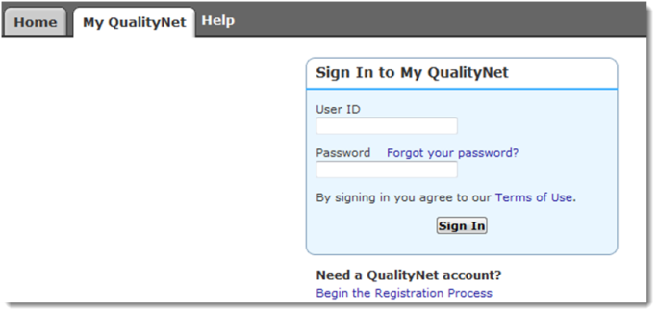

Manage Measures
After selecting the “View / Edit Population and Sampling” link under Manage Measures, the user selects the Reporting Period and selects the [Continue] button:
Figure 2 View/Edit Population & Sampling Selections

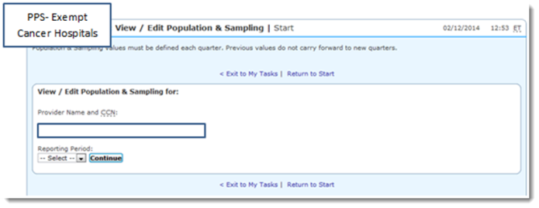

Sampling Frequency Selection
The user will insert their sampling frequency of Quarterly or Not Sampled.
The Surgical Care Improvement Project (SCIP) measure set is divided into 8 strata. Based on the selection above, the user will enter the population and sample size for each of the 8 stratum.

Reporting – Initial Inpatient Population and Sample Size
The reporting is identified as Medicare and Non-Medicare. The examples below are for a hospital performing quarterly sampling (Strata 1 through 5) and Not Sampling (Strata 6):
Figure 3 SCIP - Strata 1 (Coronary Artery Bypass Graft)
Sample Frequency: Quarterly
Initial Inpatient Population
Initial Inpatient Population | Quarter 1 | Quarter 2 | Quarter 3 | Quarter 4 | Total
Medicare | 29 | 22 | 16 | 10 | 77
Non-Medicare | 14 | 11 | 14 | 39 | 78
Total | 43 | 33 | 30 | 49 | 155

Sample Size
Sample Size | Quarter 1 | Quarter 2 | Quarter 3 | Quarter 4 | Total
Medicare | 10 | 11 | 11 | 9 | 41
Non-Medicare | 6 | 9 | 11 | 11 | 37
Total | 16 | 20 | 22 | 20 | 78
Figure 4 SCIP - Strata 2 (Other Cardiac Surgery)
Sample Frequency: Quarterly
Initial Inpatient Population
Initial Inpatient Population | Quarter 1 | Quarter 2 | Quarter 3 | Quarter 4 | Total
Medicare | 19 | 12 | 14 | 20 | 65
Non-Medicare | 13 | 17 | 11 | 39 | 80
Total | 32 | 29 | 25 | 59 | 145

Sample Size
Sample Size | Quarter 1 | Quarter 2 | Quarter 3 | Quarter 4 | Total
Medicare | 7 | 0 | 10 | 15 | 32
Non-Medicare | 12 | 13 | 10 | 18 | 53
Total | 19 | 13 | 20 | 33 | 85

Figure 5 SCIP - Strata 3 (Hip Arthroplasty)
Sample Frequency: Quarterly
Initial Inpatient Population
Initial Inpatient Population | Quarter 1 | Quarter 2 | Quarter 3 | Quarter 4 | Total
Medicare | 19 | 6 | 14 | 10 | 49
Non-Medicare | 13 | 17 | 11 | 39 | 80
Total | 32 | 23 | 25 | 49 | 129

Sample Size
Sample Size | Quarter 1 | Quarter 2 | Quarter 3 | Quarter 4 | Total
Medicare | 10 | 6 | 11 | 9 | 36
Non-Medicare | 10 | 14 | 10 | 20 | 54
Total | 20 | 20 | 21 | 29 | 90

Figure 6 SCIP - Strata 4 (Knee Arthroplasty)
Sample Frequency: Quarterly
Initial Inpatient Population
Initial Inpatient Population | Quarter 1 | Quarter 2 | Quarter 3 | Quarter 4 | Total
Medicare | 37 | 37 | 25 | 20 | 119
Non-Medicare | 15 | 16 | 11 | 10 | 52
Total | 52 | 53 | 36 | 30 | 171

Sample Size
Sample Size | Quarter 1 | Quarter 2 | Quarter 3 | Quarter 4 | Total
Medicare | 28 | 25 | 22 | 17 | 92
Non-Medicare | 12 | 10 | 9 | 7 | 38
Total | 40 | 35 | 31 | 24 | 130

Figure 7 SCIP - Strata 5 (Colon Surgery)
Sample Frequency: Quarterly
Initial Inpatient Population
Initial Inpatient Population | Quarter 1 | Quarter 2 | Quarter 3 | Quarter 4 | Total
Medicare | 37 | 33 | 35 | 45 | 150
Non-Medicare | 8 | 10 | 9 | 5 | 32
Total | 45 | 43 | 44 | 50 | 182

Sample Size
Sample Size | Quarter 1 | Quarter 2 | Quarter 3 | Quarter 4 | Total
Medicare | 20 | 18 | 9 | 25 | 72
Non-Medicare | 2 | 4 | 4 | 2 | 12
Total | 22 | 22 | 13 | 27 | 84
22
Figure 8 SCIP - Strata 6 (Hysterectomy)

Sample Frequency: Not Sampling
Not Sampled Patient Population | Number
Total Initial Patient Population | 30
Medicare Initial Patient Population | 11
Non-Medicare Initial Patient Population | 19

PRA Disclosure Statement
According to the Paperwork Reduction Act of 1995, no persons are required to respond to a collection of information unless it displays a valid OMB control number. The valid OMB control number for this information collection is 0938-1175. The time required to complete this information collection is estimated to average 15 minutes per response, including the time to review instructions, search existing data resources, gather the data needed, and complete and review the information collection. If you have comments concerning the accuracy of the time estimate(s) or suggestions for improving this form, please write to: CMS, 7500 Security Boulevard, Attn: PRA Reports Clearance Officer, Mail Stop C4-26

