***NOTE:*** *For the purposes of this review and submission the justifications for each question or section of questions is highlighted in a shaded text box above each question. These text boxes will not be printed on the final version of the surveys. The Topic Areas noted are consistent with the currently approved pool questions for the NPS Programmatic Review Process (1024-0224). The questions that are variations are denoted as such. Any questions that are outside the general scope of the programmatic review process have been carefully discussed and generally approved by the NPS Information Collection Review Coordinator with understanding that that those questions will require further review and consideration by OMB before full determination and approval can be granted.*

**OMB Control Number: ####-#### Current Expiration Date: ########**

Yellowstone National Park Visitor-Bison Survey

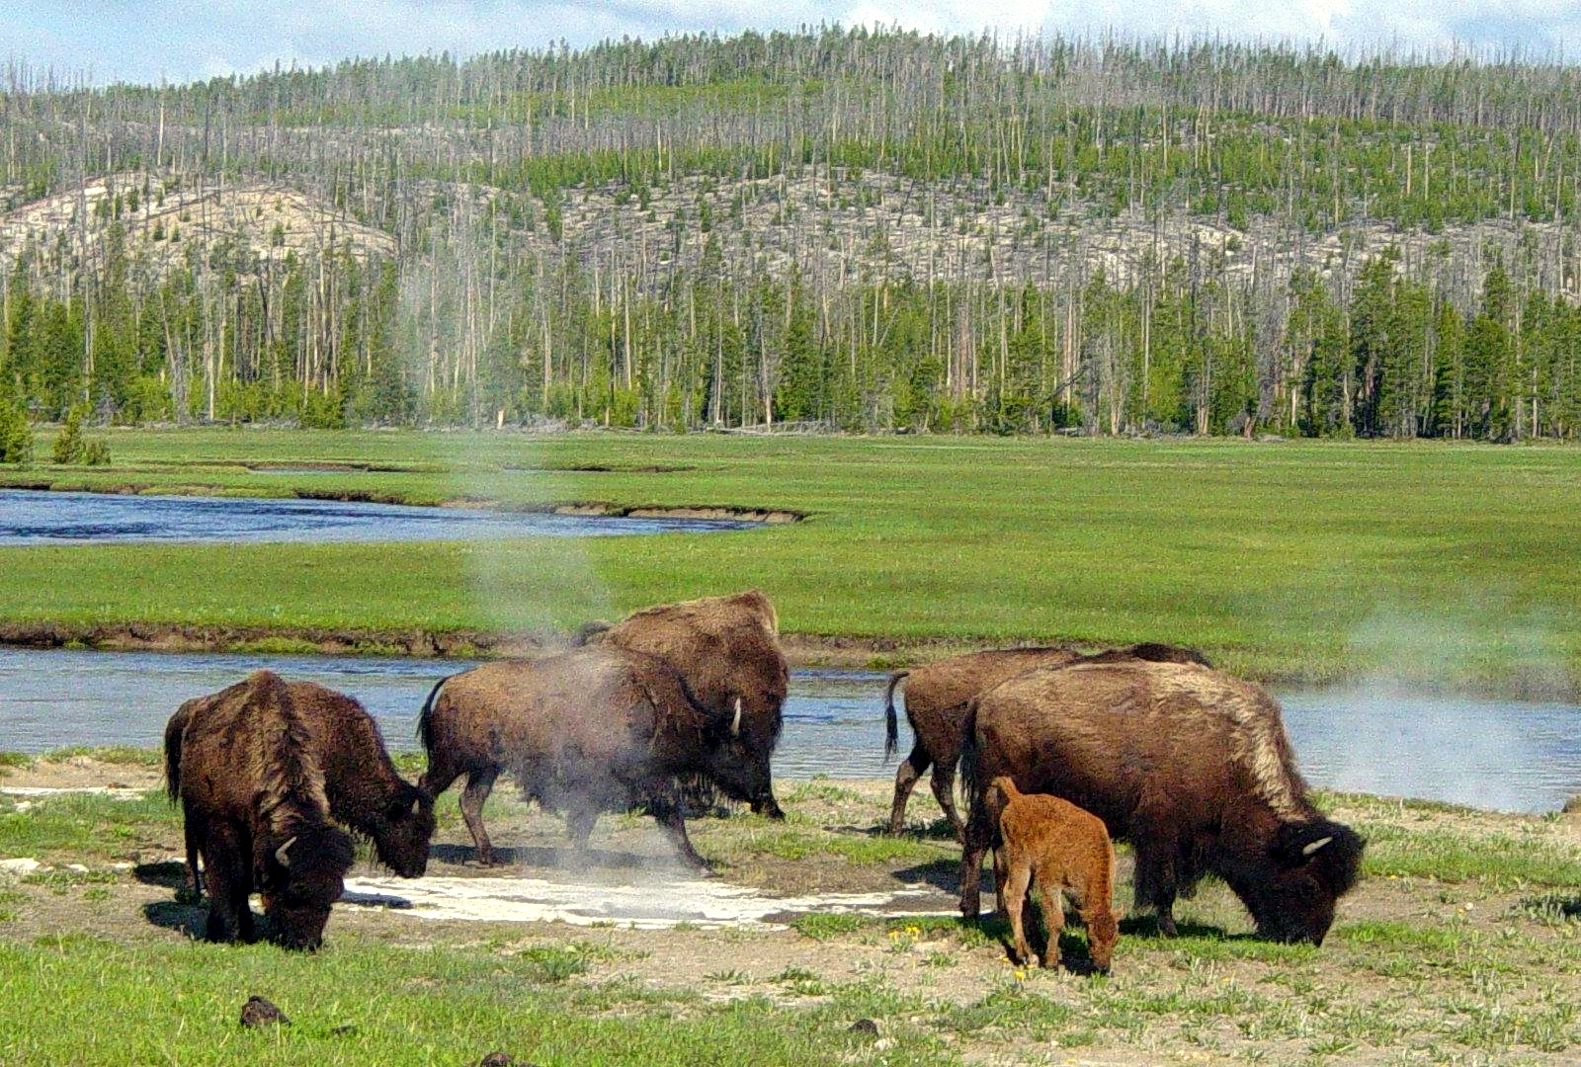

**PAPERWORK REDUCTION ACT STATEMENT:** The National Park Service is authorized by 54 USC 100702 to collect this information. This information will be used by park managers to understand visitors’ perceptions of bison-safety at Yellowstone National Park. Responses to this request are voluntary and anonymous. Your name will never be associated with your answers, and all contact information will be destroyed when the data collection is concluded. No action may be taken against you for refusing to supply the information requested. An agency may not conduct or sponsor, and a person is not required to respond to, a collection of information unless it displays a currently valid OMB control number and expiration date.

**BURDEN ESTIMATE STATEMENT**: Public reporting burden for this form is estimated to average 10 minutes per response. Direct comments regarding the burden estimate or any other aspect of this form to: Tami Blackford, Yellowstone National Park; P.O. Box 158; Yellowstone National Park, WY 82190; [tami_blackford@npg.gov](mailto:tami_blackford@npg.gov) (email).

**Introductory script**

Hello. My name is (name) and I am working for the University of Montana in cooperation with Yellowstone National Park. We are doing a survey for the park managers of visitors driving on the road today. Would you be willing to answer some questions? The questions I would like you to answer will only take about **10 minutes** to complete. All of your answers are voluntary and you will remain completely anonymous.

|  |
| --- |
| **TOPIC AREA 1 – VISITHIS1** |

We would like to know a little bit about your past experience in Yellowstone. Please answer the following questions to the best of your ability.

1. Have you visited Yellowstone National Park before today?

|  |  |
| --- | --- |
| ☐ Yes | ☐ No |

If **YES**, approximately how many times have you visited in the last 12 months?

Number of prior visits: _________________

|  |
| --- |
| **TOPIC AREA 3 – TRIPC31** |

The following questions are about visitors’ experiences with bison in Yellowstone National Park. Please answer the questions to the best of your ability.

1. How often do you use the following equipment while viewing bison in Yellowstone National Park?

|  |  |  |  |  |  |
| --- | --- | --- | --- | --- | --- |
| Equipment type | Never | Rarely | Sometimes | Often | Always |
| Binoculars | 1 | 2 | 3 | 4 | 5 |
| Smartphone camera | 1 | 2 | 3 | 4 | 5 |
| Point and shoot camera | 1 | 2 | 3 | 4 | 5 |
| D-SLR camera | 1 | 2 | 3 | 4 | 5 |
| Spotting scope | 1 | 2 | 3 | 4 | 5 |
| iPad or tablet device | 1 | 2 | 3 | 4 | 5 |
| Other: __________________ | 1 | 2 | 3 | 4 | 5 |

|  |
| --- |
| **TOPIC AREA 5 – VERP1** |

1. For this section of images, please assume the following:

* You are not in or near your vehicle.
* You are not using viewing equipment (e.g. binoculars, spotting scope, etc.).

Please rate the following images according to how unacceptable or acceptable the **distance to the bison** is while viewing them. Please use the scale below to indicate unacceptable or acceptable the images are to you.

**Bison at 50 yards with a large group of people**

|  |  |  |  |  |  |  |
| --- | --- | --- | --- | --- | --- | --- |
| Highly  unacceptable | Unacceptable | Slightly unacceptable | Neutral | Slightly  acceptable | Acceptable | Highly  acceptable |
| -3 | -2 | -1 | 0 | +1 | +2 | +3 |

**Bison at 15 yards with no people**

|  |  |  |  |  |  |  |
| --- | --- | --- | --- | --- | --- | --- |
| Highly  unacceptable | Unacceptable | Slightly unacceptable | Neutral | Slightly  acceptable | Acceptable | Highly  acceptable |
| -3 | -2 | -1 | 0 | +1 | +2 | +3 |

**Bison at 15 yards with a large group of people**

|  |  |  |  |  |  |  |
| --- | --- | --- | --- | --- | --- | --- |
| Highly  unacceptable | Unacceptable | Slightly unacceptable | Neutral | Slightly  acceptable | Acceptable | Highly  acceptable |
| -3 | -2 | -1 | 0 | +1 | +2 | +3 |

**Bison at 25 yards with a small group of people**

|  |  |  |  |  |  |  |
| --- | --- | --- | --- | --- | --- | --- |
| Highly  unacceptable | Unacceptable | Slightly unacceptable | Neutral | Slightly  acceptable | Acceptable | Highly  acceptable |
| -3 | -2 | -1 | 0 | +1 | +2 | +3 |

**Bison at 5 yards with a small group of people**

|  |  |  |  |  |  |  |
| --- | --- | --- | --- | --- | --- | --- |
| Highly  unacceptable | Unacceptable | Slightly unacceptable | Neutral | Slightly  acceptable | Acceptable | Highly  acceptable |
| -3 | -2 | -1 | 0 | +1 | +2 | +3 |

**Bison at 15 yards with a small group of people**

|  |  |  |  |  |  |  |
| --- | --- | --- | --- | --- | --- | --- |
| Highly  unacceptable | Unacceptable | Slightly unacceptable | Neutral | Slightly  acceptable | Acceptable | Highly  acceptable |
| -3 | -2 | -1 | 0 | +1 | +2 | +3 |

**Bison at 25 yards with a large group of people**

|  |  |  |  |  |  |  |
| --- | --- | --- | --- | --- | --- | --- |
| Highly  unacceptable | Unacceptable | Slightly unacceptable | Neutral | Slightly  acceptable | Acceptable | Highly  acceptable |
| -3 | -2 | -1 | 0 | +1 | +2 | +3 |

**Bison at 5 yards with no people**

|  |  |  |  |  |  |  |
| --- | --- | --- | --- | --- | --- | --- |
| Highly  unacceptable | Unacceptable | Slightly unacceptable | Neutral | Slightly  acceptable | Acceptable | Highly  acceptable |
| -3 | -2 | -1 | 0 | +1 | +2 | +3 |

**Bison at 5 yards with large group of people**

|  |  |  |  |  |  |  |
| --- | --- | --- | --- | --- | --- | --- |
| Highly  unacceptable | Unacceptable | Slightly unacceptable | Neutral | Slightly  acceptable | Acceptable | Highly  acceptable |
| -3 | -2 | -1 | 0 | +1 | +2 | +3 |

**Bison at 25 yards with no people**

|  |  |  |  |  |  |  |
| --- | --- | --- | --- | --- | --- | --- |
| Highly  unacceptable | Unacceptable | Slightly unacceptable | Neutral | Slightly  acceptable | Acceptable | Highly  acceptable |
| -3 | -2 | -1 | 0 | +1 | +2 | +3 |

**Bison at 5 yards with a small group of people**

|  |  |  |  |  |  |  |
| --- | --- | --- | --- | --- | --- | --- |
| Highly  unacceptable | Unacceptable | Slightly unacceptable | Neutral | Slightly  acceptable | Acceptable | Highly  acceptable |
| -3 | -2 | -1 | 0 | +1 | +2 | +3 |

**Bison at 50 yards with no people**

|  |  |  |  |  |  |  |
| --- | --- | --- | --- | --- | --- | --- |
| Highly  unacceptable | Unacceptable | Slightly unacceptable | Neutral | Slightly  acceptable | Acceptable | Highly  acceptable |
| -3 | -2 | -1 | 0 | +1 | +2 | +3 |

|  |
| --- |
| **TOPIC AREA 5 – VERP2** |

1. Which photograph shows the distance you would prefer to view bison from? (please select a photograph)

**Photograph of Bison**

**at 25 yards no people**

**Photograph of Bison**

**at 50 yards no people**

**Photograph of Bison**

**at 5 yards no people**

**Photograph of Bison**

**at 15 yards no people**

|  |
| --- |
| **TOPIC AREA 5 – VERP3** |

1. Please select the photograph that shows the distance you would feel unsafe viewing bison from? (please select a photo)



**Photograph of Bison**

**at 25 yards**

**Photograph of Bison**

**at 50 yards**

**Photograph of Bison**

**at 5 yards**

**Photograph of Bison**

**at 15 yards**

|  |
| --- |
| **TOPIC AREA 5 – VERP3** |

1. Please select the photograph that best represents Yellowstone National Park’s required distance from bison (25 yards)?

**Photograph of Bison**

**at 15 yards**

**Photograph of Bison**

**at 25 yards**

**Photograph of Bison**

**at 50 yards**

**Photograph of Bison**

**at 5 yards**

|  |
| --- |
| **TOPIC AREA 4 – PREFERENCES/MOTIVATIONS/ATTITUDES** |

1. Please indicate how much you disagree or agree with the following statements when considering the photographs above.

|  |  |  |  |  |  |  |  |
| --- | --- | --- | --- | --- | --- | --- | --- |
| I considered… | Strongly disagree | Disagree | Slightly disagree | Neither | Slightly agree | Agree | Strongly agree |
| My personal safety | 1 | 2 | 3 | 4 | 5 | 6 | 7 |
| The safety of others | 1 | 2 | 3 | 4 | 5 | 6 | 7 |
| The welfare of the bison | 1 | 2 | 3 | 4 | 5 | 6 | 7 |
| Impacts to the bison’s mobility | 1 | 2 | 3 | 4 | 5 | 6 | 7 |
| The impacts of visitors’ behavior | 1 | 2 | 3 | 4 | 5 | 6 | 7 |
| My ability to see the bison as well as I want to | 1 | 2 | 3 | 4 | 5 | 6 | 7 |
| My ability to hear the sounds of the bison | 1 | 2 | 3 | 4 | 5 | 6 | 7 |
| My ability to take the photograph I wanted | 1 | 2 | 3 | 4 | 5 | 6 | 7 |

|  |
| --- |
| **TOPIC AREA 6 – EVALSERV13** |

1. Did you use any of the following information sources to get information about **appropriate behaviors while viewing bison** in Yellowstone National Park?

|  |  |  |  |  |  |  |  |  |
| --- | --- | --- | --- | --- | --- | --- | --- | --- |
|  | | Not at all | Slightly | Moderately | Very | | | Extremely |
| Did you use the Yellowstone National Park brochure/map? **□ Yes □ No** | |  |  |  |  | | |  |
| How **important** is the brochure/map for obtaining information? | 1 | 2 | 3 | 4 | | | 5 |
| How **helpful** was the brochure/map? | 1 | 2 | 3 | 4 | | | 5 |
| Did you use the Yellowstone National Park newspaper? **□ Yes □ No** | |  |  |  |  | | |  |
| How **important** is the newspaper for obtaining information? | 1 | 2 | 3 | | 4 | | 5 |
| How **helpful** was the newspaper? | 1 | 2 | 3 | | 4 | | 5 |
| Did you use the Yellowstone National Park website? **□ Yes □ No** | |  |  |  | |  | |  |
| How **important** is the website for obtaining information? | 1 | 2 | 3 | | 4 | | 5 |
| How **helpful** was the website? | 1 | 2 | 3 | | 4 | | 5 |
| Did you have personal communication with Yellowstone National Park ranger/employee? **□ Yes □ No** | |  |  |  | |  | |  |
| How **important** is personal communication in obtaining information? | 1 | 2 | 3 | | 4 | | 5 |
| How **helpful** was the personal communication? | 1 | 2 | 3 | | 4 | | 5 |
| Did you attend a ranger-led interpretive program by Yellowstone National Park?  **□ Yes □ No** | |  |  |  | |  | |  |
| How **important** are interpretive programs for obtaining information? | 1 | 2 | 3 | | | 4 | 5 |
| How **helpful** was the website for obtaining information? | 1 | 2 | 3 | | | 4 | 5 |
| Did you use signs posted in Yellowstone National Park? **□ Yes □ No** | |  |  |  | |  | |  |
| How **important** are signs in obtaining information | 1 | 2 | 3 | | | 4 | 5 |
| How **helpful** signs in obtaining information? | 1 | 2 | 3 | | | 4 | 5 |
| Did you talk to other visitors? **□ Yes □ No** | |  |  |  | |  | |  |
| How **important** is talking to other visitors? | 1 | 2 | 3 | | | 4 | 5 |
| How **helpful** was talking to other visitors? | 1 | 2 | 3 | | | 4 | 5 |
| Did you use social media or apps? **□ Yes □ No** | |  |  |  | |  | |  |
| How **important** is social media or apps? | 1 | 2 | 3 | | | 4 | 5 |
| How **helpful** was social media or apps? | 1 | 2 | 3 | | | 4 | 5 |
| Did you talk with any educational groups (Yellowstone Association, Xanterra guides, other guides, etc.)? **□ Yes □ No** | |  |  |  | |  | |  |
| How **important** is talking with educational groups? | 1 | 2 | 3 | | | 4 | 5 |
| How **helpful** was talking with educational groups? | 1 | 2 | 3 | | | 4 | 5 |

|  |
| --- |
| **TOPIC AREA 6 – EVALSERV13** |

1. From the sources below, which information source did you use **most** to get information about **viewing bison**? (select one)

|  |  |  |  |
| --- | --- | --- | --- |
| **☐** Brochure/map | ☐ Ranger/employee | ☐ Other visitors | ☐ I did not use any of these |
| ☐ Newspaper | ☐ Interpretive program | ☐ Social media |  |
| ☐ Website | ☐ Signs | ☐ Educational groups |  |

|  |
| --- |
| **TOPIC AREA 4 – PREFERENCES/MOTIVES/ATTITUDES (*variation*)** |

1. Please answer the following questions regarding the information source you chose above as the **most** used information source about **viewing bison.**

|  |  |  |  |  |  |  |
| --- | --- | --- | --- | --- | --- | --- |
| How did the information make you feel about viewing bison in Yellowstone? | | | | | | |
| Very fearful | Fearful | Slightly fearful | Neutral | Slightly comforted | Comforted | Very comforted |
| -3 | -2 | -1 | 0 | +1 | +2 | +3 |
| Very stressed | Stressed | Slightly stressed | Neutral | Slightly relaxed | Relaxed | Very relaxed |
| -3 | -2 | -1 | 0 | +1 | +2 | +3 |
| Very reserved | Reserved | Slightly reserved | Neutral | Slightly excited | Excited | Very excited |
| -3 | -2 | -1 | 0 | +1 | +2 | +3 |

|  |
| --- |
| **TOPIC AREA 4 – PREFERENCES/MOTIVES/ATTITUDES (*variation*)** |

1. How much do you disagree of agree with the following statements regarding your **most** used information source about **viewing bison?**

|  |  |  |  |  |  |  |  |
| --- | --- | --- | --- | --- | --- | --- | --- |
| Statement | Strongly disagree | Disagree | Slightly disagree | Neutral | Slightly agree | Agree | Strongly agree |
| The information changed my behavior regarding **viewing bison** | 1 | 2 | 3 | 4 | 5 | 6 | 7 |
| The information made me aware of appropriate behaviors while **viewing bison** | 1 | 2 | 3 | 4 | 5 | 6 | 7 |
| The information made me think about appropriate behaviors while **viewing bison** | 1 | 2 | 3 | 4 | 5 | 6 | 7 |
| The information made me interested in appropriate behaviors while **viewing bison** | 1 | 2 | 3 | 4 | 5 | 6 | 7 |

|  |
| --- |
| **TOPIC AREA 1 – RES2** |

1. Are you a permanent resident or citizen of the United States?

☐ No What is your country of origin? _______________________

☐ Yes What is your zip code and state of residence

State_____________ Zip code ______________

|  |
| --- |
| **TOPIC AREA 1 – AGE2** |

1. In what year were you born?

________________

|  |
| --- |
| **TOPIC AREA 1 – GEND1** |

1. What is your gender?

☐ Male ☐ Female

|  |
| --- |
| **TOPIC AREA 1 – ED1** |

1. Please indicate your highest level of education completed (select one)

|  |  |  |
| --- | --- | --- |
| ☐ Less than high school | ☐ Some college | ☐ Master’s degree |
| ☐ Some high school | ☐ Associate’s degree | ☐ Ph.D., M.D., J.D., or equivalent |
| ☐ High school diploma or equivalent | ☐ Bachelor’s degree |  |

|  |
| --- |
| **TOPIC AREA 1 – RACE/ETH4 (*variation*)** |

1. Are you Hispanic or Latino?

☐ No

☐ Yes

1. What is your race/ethnicity? Answer only for yourself. (check all that apply)

|  |  |  |
| --- | --- | --- |
| ☐ American Indian or Alaska Native | ☐Hawaiian or Pacific Islander |  |
| ☐ Asian | ☐ Hispanic or Latino/Latina |  |
| ☐ Black or African-American | ☐ White |  |

**Thank you for agreeing to help Yellowstone National Park!**

Your input is important to park management. Response to this request is voluntary. While you are not required to respond, your cooperation is needed to make the survey results comprehensive, accurate, and timely. This survey is sponsored by the National Park Service and the information will be used to understand the visitor use and perceptions of wildlife viewing at Yellowstone National Park.