OMB Control Number: 1024-0224

Expiration Date: 10-31-2015

**GRAND TETON NATIONAL PARK VISITOR STUDY**

**MOOSE-WILSON CORRIDOR**

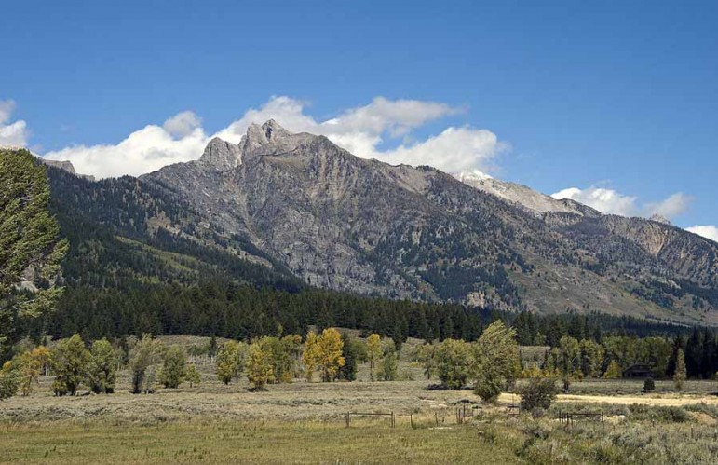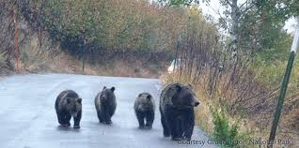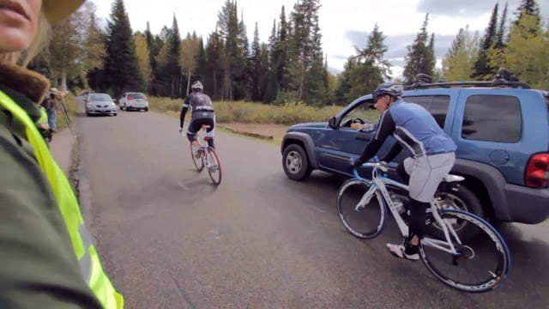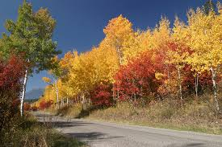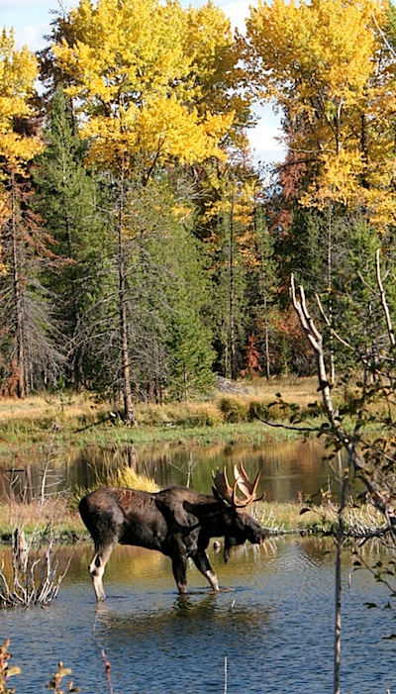

**Paperwork Reduction Act Statement:** The Paperwork Reduction Act requires us to tell you why we are collecting this information, how we will use it, and whether or not you have to respond. This information will be used by the National Park Service as authorized by *54 USC 100702*. We will use this information to evaluate visitor experiences and expectations in Grand Teton National Park, specifically within the Moose-Wilson corridor. Your response is voluntary. Your name and contact information have been requested for follow-up mailing purposes only. When analysis of the questionnaire is completed, all name and address files will be destroyed and will in no way be connected with the results of this survey. A Federal agency may not conduct or sponsor, and you are not required to respond to, a collection of information unless it displays a currently valid OMB Control Number.

We estimate that it will take about 10 minutes to complete and return this questionnaire. You may send comments concerning the burden estimates or any aspect of this information collection to: **Dr. Peter Newman**, **Department Head & Professor, Recreation, Park and Tourism Management**, **801 Ford Building, University Park, PA 16802**, **Penn State University, 814-863-7849** (phone) or **pbn3@psu.edu** (email).

The focus of this study is to better understand visitor experiences within the **Moose-Wilson corridor**, which is this area of Grand Teton National Park (*please see surveyor’s map if needed*).

Your participation in the study is voluntary. There are no penalties for not answering some or all questions, but because each participant will represent many others who will not be included in the study, your input is extremely important. The answers you provide will remain anonymous. Our results will be summarized so that the answers you provide cannot be associated with you or anyone in your group or household.

**TOPIC AREA 3: TRIPC41**

1.Where did you start your visit today? ________________

**TOPIC AREA 3: TRIPC41**

2.Please select one of the following that best describes your primary destination today.

🞎 The Moose-Wilson Corridor is my primary destination

🞎 My primary destination is outside Grand Teton National Park

🞎 My primary destination is within Grand Teton National Park but outside of the Moose-Wilson corridor

🞎 I am exploring the area, and have no specific primary destination

**TOPIC AREA 3: TRIPC41**

3.Please select one of the following that best describes your visit to the ***Moose Wilson-Corridor*** today.

🞎 I plan on stopping within the Moose-Wilson Corridor

🞎 I do not plan on stopping within the Moose-Wilson Corridor

🞎 I am unsure if I will stop within the Moose-Wilson Corridor

**TOPIC AREA 3: ACT3**

4.Which of the following activities did you take part in during this visit to the ***Moose-Wilson corridor*** of Grand Teton National Park?*Please mark all that apply*.

|  |  |
| --- | --- |
| Viewing the scenery | ☐ |
| Viewing wildlife | ☐ |
| Scenic driving | ☐ |
| Hiking or walking | ☐ |
| Cycling | ☐ |
| Photography | ☐ |
| Swimming | ☐ |
| Visiting the Laurance S. Rockefeller visitor center | ☐ |
| Attending ranger talk or program | ☐ |
| Other activity: __________________________________________________________________ | |

***See Appendix for Questions 5 through 12***

*There will be two versions of the same survey used in this collection (Survey A and Survey B). Questions 1 through 4 and 13 to 21 will be exactly the same for both surveys. However, questions 5 through 12 will contain a series of pictures and associated questions that will be different for Survey A and B. Participants will be randomly selected to complete either Survey A or Survey B. Every participant receiving Survey A will have the same series of questions and in the same order as listed in Appendix A – Survey A; alternately, every participant receiving Survey B will have the same series of questions and in the same order as listed in Appendix A – Survey B.*

**TOPIC AREA 6: EVALSERV13**

13. How important to you was each of the following reasons for your visit to the ***Moose-Wilson corridor*** today? *Please mark only one response for each item.*

|  |  |  |  |  |  |  |  |  |  |  |  |  |  |  |  |  |  |  |
| --- | --- | --- | --- | --- | --- | --- | --- | --- | --- | --- | --- | --- | --- | --- | --- | --- | --- | --- |
|  | Importance | | | | | | | | | | | | | | | | | |
|  | Not at all important | | Extremely unimportant | Very unimportant | | Moderately unimportant | | Somewhat unimportant | Neither important or unimportant | | | Somewhat important | Moderately important | | | Very important | Extremely important | |
| Importance of... |  |  | | |  |  |  | | |  |  | | |  |  | | |  |
| Opportunities to Learn  (e.g. learning about history, plants, and conservation) | 0 | 1 | | | 2 | 3 | 4 | | | 5 | 6 | | | 7 | 8 | | | 9 |
| Experiencing Nature  (e.g. viewing scenic beauty, enjoying natural quiet) | 0 | 1 | | | 2 | 3 | 4 | | | 5 | 6 | | | 7 | 8 | | | 9 |
| Wildlife Viewing  (e.g. viewing wildlife in nature) | 0 | 1 | | | 2 | 3 | 4 | | | 5 | 6 | | | 7 | 8 | | | 9 |
| Resting and Relaxation  (e.g. experiencing solitude and calmness) | 0 | 1 | | | 2 | 3 | 4 | | | 5 | 6 | | | 7 | 8 | | | 9 |
| Maintaining Physical Heath  (e.g. exercising and improving physical health) | 0 | 1 | | | 2 | 3 | 4 | | | 5 | 6 | | | 7 | 8 | | | 9 |
| Spending Time with Family  (e.g. spending time with family and friends) | 0 | 1 | | | 2 | 3 | 4 | | | 5 | 6 | | | 7 | 8 | | | 9 |

**TOPIC AREA 6: EVALSERV13**

14. Please rate the quality of your experience in the following areas based on today’s visit within the ***Moose-Wilson corridor***. *Please mark only one response for each item.*

|  |  |  |  |  |  |  |  |  |  |  |
| --- | --- | --- | --- | --- | --- | --- | --- | --- | --- | --- |
|  | Quality | | | | | | | | | |
|  | Not Applicable | Extremely poor | Very poor | Poor | Somewhat poor | Average | Somewhat good | Good | Very good | Excellent |
| Quality of… |  |  |  |  |  |  |  |  |  |  |
| Opportunities to Learn  (e.g. learning about history, plants, and conservation) | 0 | 1 | 2 | 3 | 4 | 5 | 6 | 7 | 8 | 9 |
| Experiencing Nature  (e.g. viewing scenic beauty, enjoying natural quiet) | 0 | 1 | 2 | 3 | 4 | 5 | 6 | 7 | 8 | 9 |
| Wildlife Viewing  (e.g. viewing wildlife in nature) | 0 | 1 | 2 | 3 | 4 | 5 | 6 | 7 | 8 | 9 |
| Resting and Relaxation  (e.g. experiencing solitude and calmness) | 0 | 1 | 2 | 3 | 4 | 5 | 6 | 7 | 8 | 9 |
| Maintaining Physical Heath  (e.g. exercising and improving physical health) | 0 | 1 | 2 | 3 | 4 | 5 | 6 | 7 | 8 | 9 |
| Having Family Time  (e.g. spending time with family and friends) | 0 | 1 | 2 | 3 | 4 | 5 | 6 | 7 | 8 | 9 |

**TOPIC AREA 2: TPLAN4**

15. What was your primary source for information about the visitor activities you plan to participate in within the ***Moose-Wilson corridor***? *Check all that apply.*

|  |  |
| --- | --- |
| Recommendation | ☐ |
| Previous experience | ☐ |
| Internet | ☐ |
| NPS website | ☐ |
| Maps | ☐ |
| Live locally | ☐ |
| Books | ☐ |
| Visitor Center | ☐ |
| NPS staff | ☐ |
| Brochures | ☐ |
| Entrance station information | ☐ |
| Signs | ☐ |
| Exploring | ☐ |
| Other: __________________________________________________________________ | |

**TOPIC AREA 1: GR3**

16. How many adults and how many children were in your personal group (spouse, family, friends) during this trip to the ***Moose-Wilson corridor*** today? *Please provide a number.*

# of Adults (Age 16 or older) _______ # of Children (Age 15 or younger) _______

**TOPIC AREA 1: RES3**

17. Do you live in the United States?

🞎 Yes (What is your zip code? __________)

🞎 No (What country do you live in? ______________________________)

**TOPIC AREA 1: VISITHIS1**

18. Including this visit, approximately how many times have you visited the ***Moose-Wilson corridor***?

Number of visits: ____________

**TOPIC AREA 1: AGE2**

19. In what year were you born?

Year Born: __________________

**TOPIC AREA 1: GEND**

20. What is your gender?

🞎 Male 🞎 Female

**TOPIC AREA 1: ED2**

21. What is the highest level of formal education you have completed?*Please check only one.*

🞎 Some high school

🞎 High school graduate or GED

🞎 Some college, business or trade school

🞎 College, business or trade school graduate

🞎 Some graduate school

🞎 Master’s, doctoral or professional degree

***Grand Teton National Park and the Pennsylvania State University would like to thank you for your assistance.***

**Appendix A**

*Below are the questions that are unique for Surveys A and B*

**Survey A TOPIC AREA 5: CROWD11, CROWD12, CRWDATT3, VERP1**

***In this section we would like know your opinions about a series of hypothetical management scenarios within the Moose-Wilson corridor of Grand Teton National Park. There are 9 questions and each question has two scenarios. Please read both scenarios and then select the one that you would most prefer to experience during a visit to the Moose-Wilson corridor. After that we would like for you to tell us about how safe you would feel in the scenario you selected.***

|  |  |  |  |  |  |
| --- | --- | --- | --- | --- | --- |
| 5a.Which description and scene below would best depict your most preferred experience in the ***Moose-Wilson corridor***? | | | | | |
| **☐ Scenario 1**   * You can enter the MWC after approximately 5 minutes * You can drive through the corridor in 20 minutes (average 25 mph) * Once at a designated parking lot, you are able to park in less than 5 minutes | | | **☐ Scenario 2**   * You can enter the MWC immediately * You can drive through the corridor in in 15 minutes (average 30 mph) * Once at a designated parking lot, you are able to park in approximately 15 minutes | | |
| 5b. Now, how concerned would you be about your safety if you were in the scenario you selected? *Please select one.* | | | | | |
| **Not at all concerned** | **Slightly Concerned** | **Moderately Concerned** | | **Very Concerned** | **Extremely Concerned** |
| ☐ | ☐ | ☐ | | ☐ | ☐ |

|  |  |  |  |  |  |
| --- | --- | --- | --- | --- | --- |
| 6a.Which description and scene below would best depict your most preferred experience in the ***Moose-Wilson corridor***? | | | | | |
| **☐ Scenario 1**   * You can enter the MWC after approximately 30 minutes * You can drive through the corridor in 25 minutes (average 20 mph * Once at a designated parking lot, you are able to park in approximately 15 minutes | | | **☐ Scenario 2**   * You can enter the MWC after approximately 5 minutes * You can drive through the corridor in 15 minutes (average 30 mph) * Once at a designated parking lot, you are able to park in approximately 30 minutes | | |
| 6b. Now, how concerned would you be about your safety if you were in the scenario you selected? *Please select one.* | | | | | |
| **Not at all concerned** | **Slightly Concerned** | **Moderately Concerned** | | **Very Concerned** | **Extremely Concerned** |
| ☐ | ☐ | ☐ | | ☐ | ☐ |
| 7a.Which description and scene below would best depict your most preferred experience in the ***Moose-Wilson corridor***? | | | | | |
| **☐ Scenario 1**   * You can enter the MWC after approximately 30 minutes * You can drive through the corridor in 20 minutes (average 25 mph) * You cannot find parking where you would like to park | | | **☐ Scenario 2**   * You can enter the MWC after approximately 15 minutes * You can drive through the corridor in in 15 minutes (average 30 mph) * Once at a designated parking lot, you are able to park in approximately 30 minutes | | |
| 7b. Now, how concerned would you be about your safety if you were in the scenario you selected? *Please select one.* | | | | | |
| **Not at all concerned** | **Slightly Concerned** | **Moderately Concerned** | | **Very Concerned** | **Extremely Concerned** |
| ☐ | ☐ | ☐ | | ☐ | ☐ |

|  |  |  |  |  |  |
| --- | --- | --- | --- | --- | --- |
| 8a.Which description and scene below would best depict your most preferred experience in the ***Moose-Wilson corridor***? | | | | | |
| **☐ Scenario 1**   * You can enter the MWC after approximately 15 minutes * You can drive through the corridor in 25 minutes (average 20 mph) * You cannot find parking where you would like to park | | | **☐ Scenario 2**   * You can enter MWC immediately * You can drive through the corridor in 30 minutes (average 15 mph) * Once at a designated parking lot, you are able to park in less than 5 minutes | | |
| 8b. Now, how concerned would you be about your safety if you were in the scenario you selected? *Please select one.* | | | | | |
| **Not at all concerned** | **Slightly Concerned** | **Moderately Concerned** | | **Very Concerned** | **Extremely Concerned** |
| ☐ | ☐ | ☐ | | ☐ | ☐ |

|  |  |  |  |  |  |
| --- | --- | --- | --- | --- | --- |
| 9a.Which description and scene below would best depict your most preferred experience in the ***Moose-Wilson corridor***? | | | | | |
| **☐ Scenario 1**   * You can enter MWC immediately * You can drive through the corridor in 15 minutes (average 30 mph) * You cannot find parking where you would like to park | | | **☐ Scenario 2**   * You can enter MWC after approximately 15 minutes * You can drive through the corridor in 30 minutes (average 15 mph) * Once at a designated parking lot, you are able to park in approximately 30 minutes | | |
| 9b. Now, how concerned would you be about your safety if you were in the scenario you selected? *Please select one.* | | | | | |
| **Not at all concerned** | **Slightly Concerned** | **Moderately Concerned** | | **Very Concerned** | **Extremely Concerned** |
| ☐ | ☐ | ☐ | | ☐ | ☐ |

|  |  |  |  |  |  |
| --- | --- | --- | --- | --- | --- |
| 10a.Which description and scene below would best depict your most preferred experience in the ***Moose-Wilson corridor***? | | | | | |
| **☐ Scenario 1**   * You can enter MWC after approximately 5 minutes * You can drive through the corridor in 20 minutes (average 25 mph) * Once at a designated parking lot, you are able to park in less than 5 minutes | | | **☐ Scenario 2**   * You can enter MWC after approximately 15 minutes * You can drive through the corridor in 30 minutes (average 15 mph) * You cannot find parking where you would like to park | | |
| 10b. Now, how concerned would you be about your safety if you were in the scenario you selected? *Please select one.* | | | | | |
| **Not at all concerned** | **Slightly Concerned** | **Moderately Concerned** | | **Very Concerned** | **Extremely Concerned** |
| ☐ | ☐ | ☐ | | ☐ | ☐ |

|  |  |  |  |  |  |
| --- | --- | --- | --- | --- | --- |
| 11a.Which description and scene below would best depict your most preferred experience in the ***Moose-Wilson corridor***? | | | | | |
| **☐ Scenario 1**   * You can enter MWC after approximately 15 minutes * You can drive through the corridor in 20 minutes (average 25 mph) * Once at a designated parking lot, you are able to park in approximately 15 minutes | | | **☐ Scenario 2**   * You can enter MWC after approximately 30 minutes * You can drive through the corridor in 30 minutes (average 15 mph) * You cannot find parking where you would like to park | | |
| 11b. Now, how concerned would you be about your safety if you were in the scenario you selected? *Please select one.* | | | | | |
| **Not at all concerned** | **Slightly Concerned** | **Moderately Concerned** | | **Very Concerned** | **Extremely Concerned** |
| ☐ | ☐ | ☐ | | ☐ | ☐ |

|  |  |  |  |  |  |
| --- | --- | --- | --- | --- | --- |
| 12a.Which description and scene below would best depict your most preferred experience in the ***Moose-Wilson corridor***? | | | | | |
| **☐ Scenario 1**   * You can enter MWC after approximately 5 minutes * You can drive through the corridor in 30 minutes (average 15 mph) * Once at a designated parking lot, you are able to park in less than 5 minutes | | | **☐ Scenario 2**   * You can enter MWC after approximately 30 minutes * You can drive through the corridor in 20 minutes (average 25 mph) * Once at a designated parking lot, you are able to park in approximately 30 minutes | | |
| 12b. Now, how concerned would you be about your safety if you were in the scenario you selected? *Please select one.* | | | | | |
| **Not at all concerned** | **Slightly Concerned** | **Moderately Concerned** | | **Very Concerned** | **Extremely Concerned** |
| ☐ | ☐ | ☐ | | ☐ | ☐ |

**Survey B** -**TOPIC AREA 5: CROWD11, CROWD12, CRWDATT3, VERP1**

***In this section we would like know your opinions about a series of hypothetical management scenarios within the Moose-Wilson corridor of Grand Teton National Park. There are 9 questions and each question has two scenarios. Please read both scenarios and then select the one that you would most prefer to experience during a visit to the Moose-Wilson corridor. After that we would like for you to tell us about how safe you would feel in the scenario you selected.***

|  |  |  |  |  |  |
| --- | --- | --- | --- | --- | --- |
| 5a.Which description and scene below would best depict your most preferred experience in the ***Moose-Wilson corridor***? | | | | | |
| **☐ Scenario 1**   * You can enter the MWC immediately * You can drive through the corridor in 25 minutes (average 20 mph) * Once at a designated parking lot, you are able to park in less than 5 minutes | | | **☐ Scenario 2**   * You can enter the MWC after approximately 15 minutes * You can drive through the corridor in 30 minutes (average 15 mph) * Once at a designated parking lot, you are able to park in approximately 15 minutes | | |
| 5b. Now, how concerned would you be about your safety if you were in the scenario you selected? *Please select one.* | | | | | |
| **Not at all concerned** | **Slightly Concerned** | **Moderately Concerned** | | **Very Concerned** | **Extremely Concerned** |
| ☐ | ☐ | ☐ | | ☐ | ☐ |

|  |  |  |  |  |  |
| --- | --- | --- | --- | --- | --- |
| 6a.Which description and scene below would best depict your most preferred experience in the ***Moose-Wilson corridor***? | | | | | |
| **☐ Scenario 1**   * You can enter the MWC after approximately 30 minutes * You can drive through the corridor in 15 minutes (average 30 mph) * Once at a designated parking lot, you are able to park in approximately 30 minutes | | | **☐ Scenario 2**   * You can enter the MWC after approximately 5 minutes * You can drive through the corridor in 30 minutes (average 15 mph) * You cannot find parking where you would like to park | | |
| 6b. Now, how concerned would you be about your safety if you were in the scenario you selected? *Please select one.* | | | | | |
| **Not at all concerned** | **Slightly Concerned** | **Moderately Concerned** | | **Very Concerned** | **Extremely Concerned** |
| ☐ | ☐ | ☐ | | ☐ | ☐ |
| 7a.Which description and scene below would best depict your most preferred experience in the ***Moose-Wilson corridor***? | | | | | |
| **☐ Scenario 1**   * You can enter the MWC after approximately 5 minutes * You can drive through the corridor in 25 minutes (average 20 mph) * Once at a designated parking lot, you are able to park in approximately 30 minutes | | | **☐ Scenario 2**   * You can enter the MWC after approximately 15 minutes * You can drive through the corridor in in 20 minutes (average 25 mph) * Once at a designated parking lot, you are able to park in less than 5 minutes. | | |
| 7b. Now, how concerned would you be about your safety if you were in the scenario you selected? *Please select one.* | | | | | |
| **Not at all concerned** | **Slightly Concerned** | **Moderately Concerned** | | **Very Concerned** | **Extremely Concerned** |
| ☐ | ☐ | ☐ | | ☐ | ☐ |

|  |  |  |  |  |  |
| --- | --- | --- | --- | --- | --- |
| 8a.Which description and scene below would best depict your most preferred experience in the ***Moose-Wilson corridor***? | | | | | |
| **☐ Scenario 1**   * You can enter the MWC after approximately 30 minutes * You can drive through the corridor in 15 minutes (average 30 mph) * You cannot find parking where you would like to park | | | **☐ Scenario 2**   * You can enter MWC immediately * You can drive through the corridor in 25 minutes (average 20 mph) * Once at a designated parking lot, you are able to park in approximately 15 minutes | | |
| 8b. Now, how concerned would you be about your safety if you were in the scenario you selected? *Please select one.* | | | | | |
| **Not at all concerned** | **Slightly Concerned** | **Moderately Concerned** | | **Very Concerned** | **Extremely Concerned** |
| ☐ | ☐ | ☐ | | ☐ | ☐ |

|  |  |  |  |  |  |
| --- | --- | --- | --- | --- | --- |
| 9a.Which description and scene below would best depict your most preferred experience in the ***Moose-Wilson corridor***? | | | | | |
| **☐ Scenario 1**   * You can enter MWC after approximately 15 minutes * You can drive through the corridor in 25 minutes (average 20 mph) * You cannot find parking where you would like to park | | | **☐ Scenario 2**   * You can enter MWC after approximately 30 minutes * You can drive through the corridor in 30 minutes (average 15 mph) * Once at a designated parking lot, you are able to park in approximately 15 minutes | | |
| 9b. Now, how concerned would you be about your safety if you were in the scenario you selected? *Please select one.* | | | | | |
| **Not at all concerned** | **Slightly Concerned** | **Moderately Concerned** | | **Very Concerned** | **Extremely Concerned** |
| ☐ | ☐ | ☐ | | ☐ | ☐ |

|  |  |  |  |  |  |
| --- | --- | --- | --- | --- | --- |
| 10a.Which description and scene below would best depict your most preferred experience in the ***Moose-Wilson corridor***? | | | | | |
| **☐ Scenario 1**   * You can enter MWC immediately * You can drive through the corridor in 30 minutes (average 15 mph) * Once at a designated parking lot, you are able to park in approximately 15 minutes | | | **☐ Scenario 2**   * You can enter MWC after approximately 5 minutes * You can drive through the corridor in 15 minutes (average 30 mph) * Once at a designated parking lot, you are able to park in approximately 15 minutes | | |
| 10b. Now, how concerned would you be about your safety if you were in the scenario you selected? *Please select one.* | | | | | |
| **Not at all concerned** | **Slightly Concerned** | **Moderately Concerned** | | **Very Concerned** | **Extremely Concerned** |
| ☐ | ☐ | ☐ | | ☐ | ☐ |

|  |  |  |  |  |  |
| --- | --- | --- | --- | --- | --- |
| 11a.Which description and scene below would best depict your most preferred experience in the ***Moose-Wilson corridor***? | | | | | |
| **☐ Scenario 1**   * You can enter MWC after approximately 5 minutes * You can drive through the corridor in 20 minutes (average 25 mph) * Once at a designated parking lot, you are able to park in less than 30 minutes | | | **☐ Scenario 2**   * You can enter MWC after approximately 15 minutes * You can drive through the corridor in 15 minutes (average 30 mph) * Once at a designated parking lot, you are able to park in less than 5 minutes | | |
| 11b. Now, how concerned would you be about your safety if you were in the scenario you selected? *Please select one.* | | | | | |
| **Not at all concerned** | **Slightly Concerned** | **Moderately Concerned** | | **Very Concerned** | **Extremely Concerned** |
| ☐ | ☐ | ☐ | | ☐ | ☐ |

|  |  |  |  |  |  |
| --- | --- | --- | --- | --- | --- |
| 12a.Which description and scene below would best depict your most preferred experience in the ***Moose-Wilson corridor***? | | | | | |
| **☐ Scenario 1**   * You can enter MWC after approximately 30 minutes * You can drive through the corridor in 25 minutes (average 20 mph) * Once at a designated parking lot, you are able to park in less than 5 minutes | | | **☐ Scenario 2**   * You can enter MWC immediately * You can drive through the corridor in 20 minutes (average 25 mph) * You cannot find parking where you would like to park | | |
| 12b. Now, how concerned would you be about your safety if you were in the scenario you selected? *Please select one.* | | | | | |
| **Not at all concerned** | **Slightly Concerned** | **Moderately Concerned** | | **Very Concerned** | **Extremely Concerned** |
| ☐ | ☐ | ☐ | | ☐ | ☐ |