NOTE: For the purposes of this review and submission the justifications for each question or section of questions is highlighted in a shaded text box above each question. These text boxes will not be printed on the final version of the surveys. The Topic Areas noted are consistent with the currently approved pool questions for the NPS Programmatic Review Process (1024-0224). The questions that are variations are denoted as such. Any questions that are outside the general scope of the programmatic review process have been carefully discussed and generally approved by the NPS Information Collection Review Coordinator with understanding that that those questions will require further review and consideration by OMB before full determination and approval can be granted.

OMB Control Number: 1024-0224 Current Expiration Date: ########

Yellowstone National Park Visitor-Bear Survey
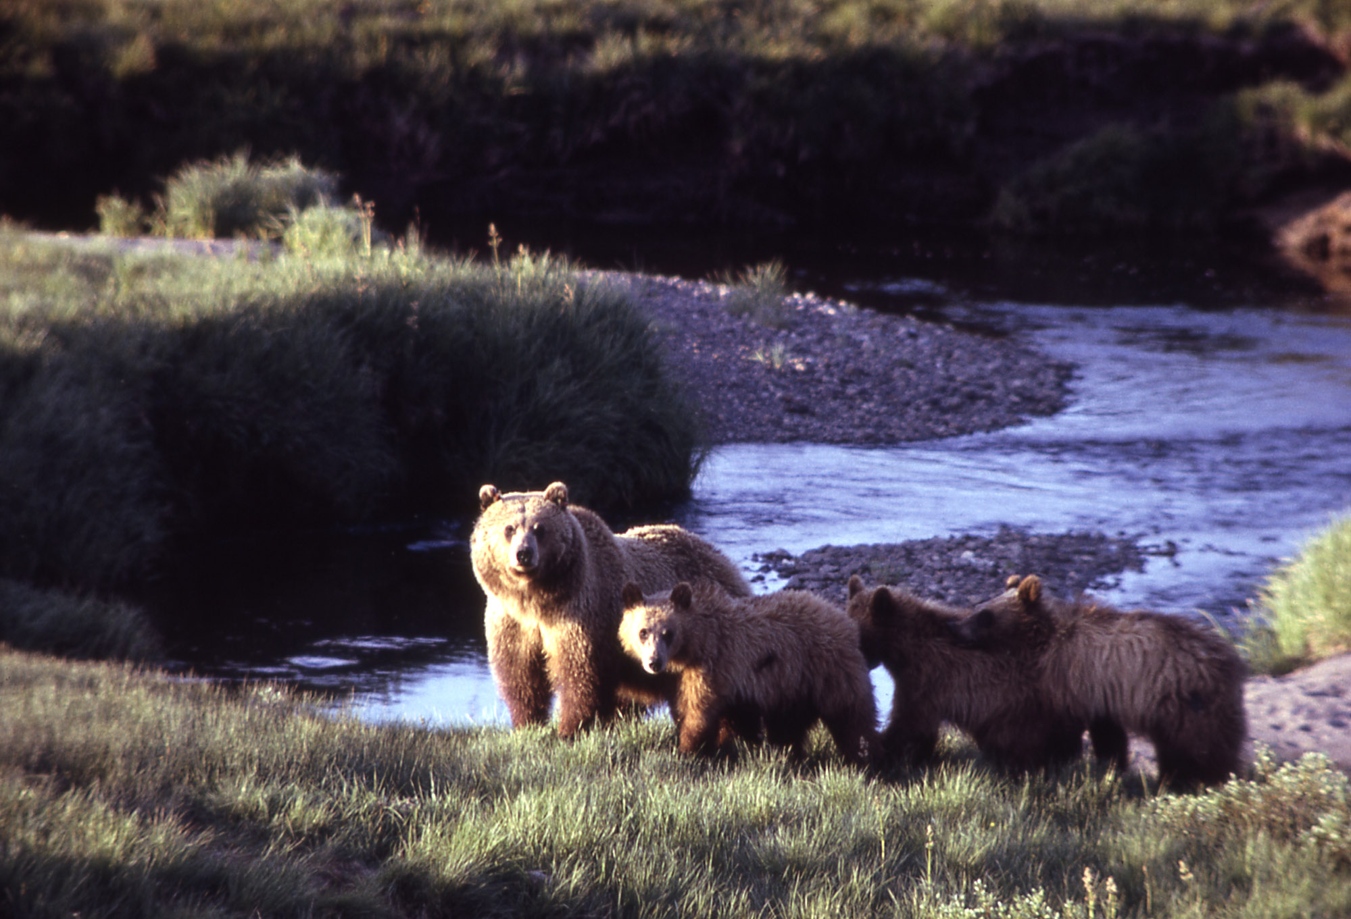

Thank you for agreeing to help Yellowstone National Park!
Your input is important to park management. Response to this request is voluntary. While you are not required to respond, your cooperation is needed to make the survey results comprehensive, accurate, and timely. This survey is sponsored by the National Park Service and the information will be used to understand visitor use and perceptions of bear-safety at Yellowstone National Park.

PAPERWORK REDUCTION ACT STATEMENT: The National Park Service is authorized by 16 U.S.C. 1a-7 to collect this information. This information will be used by park managers to understand visitors’ bear-safety behaviors at Yellowstone National Park. Responses to this request are voluntary and anonymous. Your name will never be associated with your answers, and all contact information will be destroyed when the data collection is concluded. No action may be taken against you for refusing to supply the information requested. An agency may not conduct or sponsor, and a person is not required to respond to, a collection of information unless it displays a currently valid OMB control number and expiration date.

BURDEN ESTIMATE STATEMENT: Public reporting burden for this form is estimated to average 10 minutes per response. Direct comments regarding the burden estimate or any other aspect of this form to: Tami Blackford, Yellowstone National Park; P.O. Box 158; Yellowstone National Park, WY 82190; tami_blackford@nps.gov (email).

TOPIC AREA 1 – VISITTHIS1
- Have you visited Yellowstone National Park before this trip?
☐ Yes | ☐ No
If YES, approximately how many times have you visited in the last 12 months?
Number of prior visits: _________________
TOPIC AREA
- How experienced are you with hiking in grizzly bear country?
Not at all experienced | Slightly experienced | Moderately experienced | Very experienced | Extremely experienced
1 | 2 | 3 | 4 | 5

We would like to know about some different aspects regarding bear-safety while hiking.
TOPIC AREA 8 – HDW20
- How interested are you in learning about the following items? (please select one response per item)
Item | Not at all interested | Somewhat  interested | Very  interested | Extremely interested | Completely interested
Staying safe while hiking in the presence of bears. | 1 | 2 | 3 | 4 | 5
Knowing how to act if you see a bear. | 1 | 2 | 3 | 4 | 5
Proper equipment while hiking in areas where bears may be present. | 1 | 2 | 3 | 4 | 5
Keeping wildlife safe from human disturbances while hiking. | 1 | 2 | 3 | 4 | 5
How to avoid bear encounters while hiking. | 1 | 2 | 3 | 4 | 5
How to interpret bear behaviors. | 1 | 2 | 3 | 4 | 5
How to increase my alertness to bears in an area. | 1 | 2 | 3 | 4 | 5
Trails in the park that may have higher bear risk. | 1 | 2 | 3 | 4 | 5

TOPIC AREA 3 PERSAFE25
- How aware are you of the following items?
Item | Not at all aware | Somewhat  aware | Very  aware | Extremely aware | Completely aware
Ways to increase your safety while hiking in bear country. | 1 | 2 | 3 | 4 | 5
Techniques that can help you avoid negative encounters with bears. | 1 | 2 | 3 | 4 | 5
Ways you can minimize impacts to wildlife while hiking. | 1 | 2 | 3 | 4 | 5
Resources you can use to help keep you safe while hiking in bear country. | 1 | 2 | 3 | 4 | 5
Things you can do to decrease your risk of a bear attack while hiking. | 1 | 2 | 3 | 4 | 5
How hiking in grizzly bear country is different than hiking in other areas. | 1 | 2 | 3 | 4 | 5
How to encourage animals in national parks to stay wild. | 1 | 2 | 3 | 4 | 5

TOPIC AREA 6 – PERSAFE26
- How much have you thought about the following items?
Item | Not at all | Somewhat | A moderate amount | Very Much | A great deal
Appropriate behaviors while hiking in the presence of bears. | 1 | 2 | 3 | 4 | 5
What hikers can do to stay safe from bears while hiking. | 1 | 2 | 3 | 4 | 5
How to have an enjoyable experience while hiking in bear country. | 1 | 2 | 3 | 4 | 5
The benefits of taking safety precautions while hiking in bear country. | 1 | 2 | 3 | 4 | 5
Encountering bears while hiking. | 1 | 2 | 3 | 4 | 5
How hikers can avoid bears while hiking. | 1 | 2 | 3 | 4 | 5
How important it is to be prepared for a bear encounter while hiking. | 1 | 2 | 3 | 4 | 5
How to tell if bears have been recently active in an area. | 1 | 2 | 3 | 4 | 5

TOPIC AREA 6 PERSAFE24
- How likely are you to do the following things while hiking in Yellowstone National Park?
 | Highly unlikely | Unlikely | Slightly unlikely | Neither | Slightly likely | Likely | Highly likely
Make noise by clapping or shouting. | 1 | 2 | 3 | 4 | 5 | 6 | 7
Personally carry bear spray. | 1 | 2 | 3 | 4 | 5 | 6 | 7
Look for signs of bears, like scat and tracks. | 1 | 2 | 3 | 4 | 5 | 6 | 7
Hike in a group of three or more people. | 1 | 2 | 3 | 4 | 5 | 6 | 7
Carry bear spray in an accessible place, like a hip holster. | 1 | 2 | 3 | 4 | 5 | 6 | 7
Run if you see a bear. | 1 | 2 | 3 | 4 | 5 | 6 | 7

TOPIC AREA 4 – TpB2
The next questions are about carrying bear-spray while hiking in Yellowstone. Please answer them to the best of your ability.
- Please rate the following statement: “For me, carrying bear spray while hiking in Yellowstone would be…”
Not at all pleasant | Somewhat pleasant | Moderately pleasant | Very pleasant | Extremely pleasant
1 | 2 | 3 | 4 | 5

Not at all favorable | Somewhat favorable | Moderately favorable | Very favorable | Extremely favorable
1 | 2 | 3 | 4 | 5

Not at all good | Somewhat good | Moderately good | Very good | Extremely good
1 | 2 | 3 | 4 | 5

TOPIC AREA 4 – TpB3
- How true do you find the following statements?
Statement | Not at all true | Slightly true | Moderately true | Very true | Completely true
People important to me think I should carry bear spray while hiking in Yellowstone. | 1 | 2 | 3 | 4 | 5
People who I value think I should carry bear spray while hiking in Yellowstone. | 1 | 2 | 3 | 4 | 5
People important to me would be carrying bear spray if they were hiking in Yellowstone. | 1 | 2 | 3 | 4 | 5
Other visitors support my decision to carry bear spray while hiking in Yellowstone. | 1 | 2 | 3 | 4 | 5

TOPIC AREA 4 – TpB (variation)
- How true do you find the following statements?
Statement | Not at all true | Slightly true | Moderately true | Very true | Completely true
If I wanted to, I could easily carry bear spray on my next hiking trip in Yellowstone. | 1 | 2 | 3 | 4 | 5
The factors that influence my decision to carry bear spray while hiking in Yellowstone are totally within my control. | 1 | 2 | 3 | 4 | 5
It is difficult to carry bear spray while hiking in Yellowstone. | 1 | 2 | 3 | 4 | 5

TOPIC AREA 4 – PREFERENCES/MOTIVES/ATTITUDES (variation)
- In general, how much do you disagree or agree with the following statements?
Statement | Strongly disagree | Disagree | Slightly disagree | Neither | Slightly agree | Agree | Strongly agree
We should strive for a world where humans and wildlife can live side by side without fear. | 1 | 2 | 3 | 4 | 5 | 6 | 7
I feel a strong emotional bond with animals. | 1 | 2 | 3 | 4 | 5 | 6 | 7
Wildlife has value, whether people are present or not. | 1 | 2 | 3 | 4 | 5 | 6 | 7
Wildlife are like my family and I want to protect them. | 1 | 2 | 3 | 4 | 5 | 6 | 7
The needs of humans should take priority over wildlife protection. | 1 | 2 | 3 | 4 | 5 | 6 | 7
I view all living things as part of one big family. | 1 | 2 | 3 | 4 | 5 | 6 | 7
Wildlife has as much right to exist as people. | 1 | 2 | 3 | 4 | 5 | 6 | 7
Wildlife is on earth primarily for people’s benefit. | 1 | 2 | 3 | 4 | 5 | 6 | 7
Humans should manage wildlife populations so that humans benefit. | 1 | 2 | 3 | 4 | 5 | 6 | 7
Wildlife is important because of what it can contribute to the pleasure and welfare of humans. | 1 | 2 | 3 | 4 | 5 | 6 | 7
Wildlife is only valuable if it produces human benefits. | 1 | 2 | 3 | 4 | 5 | 6 | 7

TOPIC AREA 6 – EVALSERV13
- Please rate the following statements according to how important they are to you.
Statement | Not at all important | Slightly important | Moderately important | Very  important | Extremely important
Even though the animals of Yellowstone seem tame they are still wild. | 1 | 2 | 3 | 4 | 5
In 2011 and 2015, in separate incidents, three visitors were killed by bears inside the park. | 1 | 2 | 3 | 4 | 5
All wildlife, especially bears, can be dangerous. | 1 | 2 | 3 | 4 | 5
Bear spray is proven to be highly successful at stopping aggressive behavior in bears. | 1 | 2 | 3 | 4 | 5
There is no guarantee of your safety in bear country. | 1 | 2 | 3 | 4 | 5
You are entering a place that is home to many bears. It is your responsibility to know how to behave. | 1 | 2 | 3 | 4 | 5
Taking safety precautions while hiking helps keep Yellowstone’s bears healthy, safe, and wild. | 1 | 2 | 3 | 4 | 5
You can help Yellowstone keep the “wild” in wildlife by being bear aware while hiking. | 1 | 2 | 3 | 4 | 5
Do your part to protect people and bears while hiking in Yellowstone. Be bear aware! | 1 | 2 | 3 | 4 | 5
Hiking in places where grizzly bears live, like Yellowstone, is different than hiking in other places. Know how to act! | 1 | 2 | 3 | 4 | 5

TOPIC AREA 3 – ACT (variation)
- Are you carrying bear spray on this hike?
☐ No
☐ Yes
Why or why not?

TOPIC AREA 1 – RES2
- Are you a permanent resident or citizen of the United States?
☐ No | - What is your country of origin? _______________________
☐ Yes | - What is your zip code and state of residence?  State_____________  Zip code ______________

TOPIC AREA 1 – AGE2
- In what year were you born?
________________

TOPIC AREA 1 – GEND1
- What is your gender? Please mark one.
☐ Male | ☐ Female

TOPIC AREA 1 – ED1
- Please indicate your highest level of education completed. (select one)
☐ Some high school | ☐ Bachelor’s degree
☐ High school diploma/GED | ☐ Graduate degree
☐ Some college

TOPIC AREA 1 – RACE/ETH2
- For you only, are you Hispanic or Latino?
☐ No | ☐ Yes

TOPIC AREA 1 – RACE/ETH4
- What is your race? Please mark one or more.
☐ American Indian or Alaska Native | ☐ White
☐ Asian | ☐ Native Hawaiian or other Pacific  Islander
☐ Black or African-American

Introductory script

Hello. My name is and I am working for the University of Montana in cooperation with Yellowstone National Park. We are doing a survey of visitors hiking for park managers to improve information about bear-safety. Would you be willing to answer some questions? The questions I would like you to answer will only take about 10 minutes to complete. All of your answers are voluntary and you will remain completely anonymous.

If YES – then ask, “has any member of your group been asked to participate in this survey before?”
If “YES” (already asked to participate) then, “Thank you for agreeing to participate in this study we hope that you will return the questionnaire soon. Have a great day.”
If “NO” (have not been previously asked to participate) then,
“Thank you for agreeing to participate. Who in your group is at least 18 years old and has the next birthday?

The surveyor will start by asking ask them if they are hiking for the day or staying overnight.
Are you hiking for the day or overnight?

If day hiker - the survey will begin with the first question on the survey
If overnight – the survey will????

If NO– (soft refusal) - ask them if they would be willing to answer the non-response bias questions (listed below) and then thank them for their time. [The surveyor will record responses in spaces provided on the tracking sheet].
If NO– (hard refusal) - end the contact and thank them for their time.

(Note the following question will be used to determine if the respondent is a day hiker)
- Are you hiking for the day or overnight?

Thank you.

Non-response bias questions

- Have you visited Yellowstone before today?
No | Yes
- What is your state of residence? –[or Country of Origin]

_________________________________

If completely refused to answer any questions, please mark the box below:

