Buffalo National River

Visitor Survey

(Preferences)

2016/2017

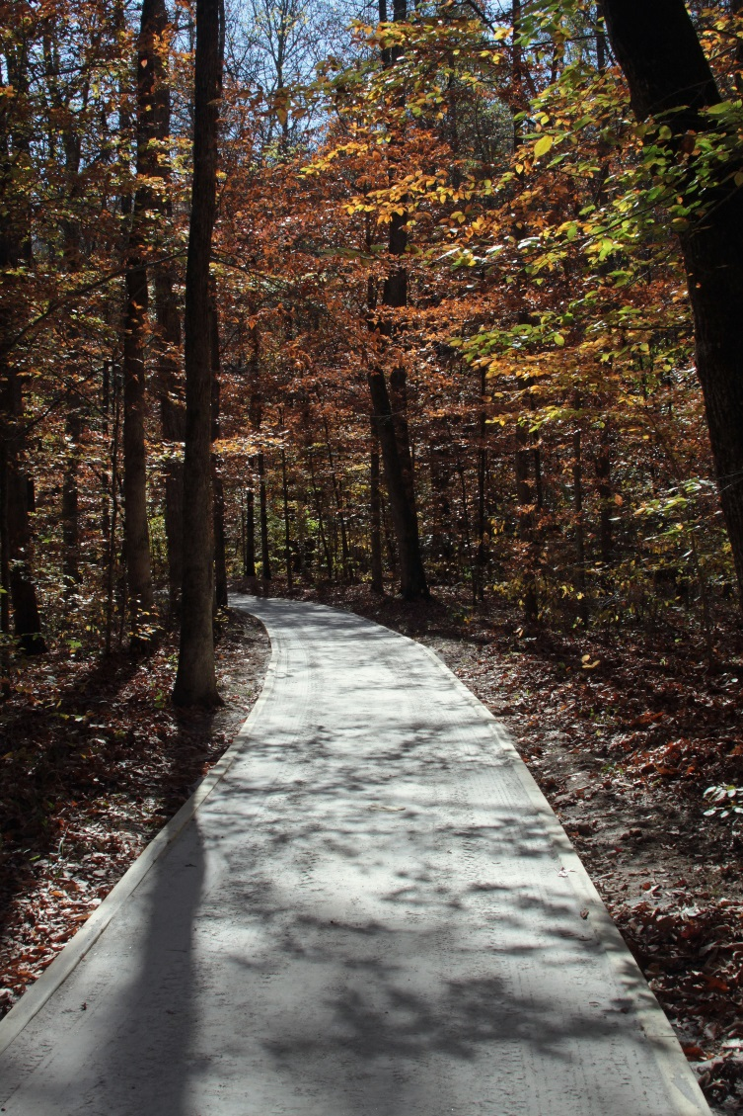

ID ______ Date ________ Location ________Tracker ______ Field staff

Notes______________________________________________________________

**PAPERWORK REDUCTION ACT STATEMENT:** The National Park Service is authorized by 54 USC 100702 to collect this information. This information will be used by park managers to understand visitors’ preferences for outdoor recreation experiences at Buffalo National River. Responses to this request are voluntary and anonymous. Your name will never be associated with your answers, and all contact information will be destroyed when the data collection is concluded. No action may be taken against you for refusing to supply the information requested. An agency may not conduct or sponsor, and a person is not required to respond to, a collection of information unless it displays a currently valid OMB control number and expiration date.

**BURDEN ESTIMATE STATEMENT**: Public reporting burden for this form is estimated to average 10 minutes per response. Direct comments regarding the burden estimate or any other aspect of this form to Laura Miller, Buffalo National River; 402 N. Walnut, Suite 136, Harrison, AR 72601; Laura_a_miller@nps.gov (email).

|  |
| --- |
| **SECTION 1: YOUR PAST AND CURRENT EXPERIENCE AT BUFFALO NATIONAL RIVER** |

1. Please tell us about your past use history at Buffalo National River. The term “outdoor recreation

activities” refers to recreation-based activities at Buffalo National River (for example, fishing, hiking, swimming, canoeing, kayaking, rafting, tubing, wildlife watching, etc.):

1. Including today, how many **days in the last month** (30 days) have you used Buffalo National River for outdoor recreation activities? ___________
2. Including today, how many **days in the last year** (12 months) have you used Buffalo National River for outdoor recreation activities? ___________
3. Including today, how many **years (total)** have you used Buffalo National River for outdoor recreation activities? _____________

|  |
| --- |
| **SECTION 2: PREFERENCES AT BUFFALO NATIONAL RIVER** |

|  |  |  |  |  |  |  |  |
| --- | --- | --- | --- | --- | --- | --- | --- |
| 1. Please indicate your level of opposition or support for the potential expansion or creation of the following within the Lost Valley/Boxley area at Buffalo National River. **The list of items below are not necessarily actions that are definitely going to occur in the Lost Valley/Boxley area.** However, we are interested in your opinions about these potential actions. A rating of -3 means that you ‘strongly oppose’ and a rating of +3 means that you ‘strongly support’ the potential expansion or creation of the specific items below. (*Please circle one number for each row*) | | | | | | | |
|  | Strongly oppose | Oppose | Somewhat oppose | Neither oppose or support | Somewhat support | Support | Strongly support | |
| Establish additional parking options at Lost Valley Trailhead | -3 | -2 | -1 | 0 | +1 | +2 | +3 | |
| Create a new campground | -3 | -2 | -1 | 0 | +1 | +2 | +3 | |
| Increase size of roadside pullouts for elk viewing | -3 | -2 | -1 | 0 | +1 | +2 | +3 | |
| Create new roadside pullouts for elk viewing | -3 | -2 | -1 | 0 | +1 | +2 | +3 | |
| Establish a visitor center | -3 | -2 | -1 | 0 | +1 | +2 | +3 | |
| Expand existing restroom facilities at Lost Valley Trailhead | -3 | -2 | -1 | 0 | +1 | +2 | +3 | |

1. Please allocate 100 “preference points” for the potential expansion or creation of the following within the Lost Valley/Boxley area at Buffalo National River. For example, you might assign 100 points to one item and zero to all the others, or assign 50 points to one, 25 to another and 25 yet to another. Regardless of how you assign points, the points you assign should total 100. Please read through the list below and use the boxes to assign 100 preference points any way you would like. If you oppose any and all expansion or creation of infrastructure within the Lost Valley/Boxley area at Buffalo National River, you may indicate that below.

|  |  |
| --- | --- |
|  | |
|  | **Preference points** |
| Establish additional parking options at Lost Valley Trailhead |  |
| Create a new campground |  |
| Increase size of roadside pullouts for elk viewing |  |
| Create new roadside pullouts for elk viewing |  |
| Establish a visitor center |  |
| Expand existing restroom facilities at Lost Valley Trailhead |  |
| **TOTAL** | **100** |

❑ I am choosing not to assign preference points to the list above because I oppose all expansion or creation of infrastructure within the Lost Valley/Boxley area at Buffalo National River.

1. If you could choose only one of the following to be potentially created or expanded within the Lost Valley/Boxley area at Buffalo National River which one would you choose? *(please select only one*

|  |  |
| --- | --- |
|  | |
|  | **Select one** |
| Establish additional parking options at Lost Valley Trailhead | ❑ |
| Create a new campground | ❑ |
| Increase size of roadside pullouts for elk viewing | ❑ |
| Create new roadside pullouts for elk viewing | ❑ |
| Establish a visitor center | ❑ |
| Expand existing restroom facilities at Lost Valley Trailhead | ❑ |
| ❑ I am choosing not to select one item from the list because I oppose any and all expansion or creation of infrastructure within the Lost Valley/Boxley area at Buffalo National River | |

1. Please indicate your level of satisfaction with the following services at Buffalo National River. A rating of -3 means that you are ‘very dissatisfied’ and a rating of +3 means that you are ‘very satisfied’ with the following services at Buffalo National River. (Please circle one number for each row)

|  |  |  |  |  |  |  |  |
| --- | --- | --- | --- | --- | --- | --- | --- |
|  | Very dissatisfied | Dissatisfied | Somewhat dissatisfied | Somewhat satisfied | Satisfied | Very satisfied | |
| Cleanliness of restrooms | -3 | -2 | -1 | +1 | +2 | +3 | |
| Cleanliness of parking lots | -3 | -2 | -1 | +1 | +2 | +3 | |
| Cleanliness of trails | -3 | -2 | -1 | +1 | +2 | +3 | |
| Cleanliness of picnic areas or other gathering spots | -3 | -2 | -1 | +1 | +2 | +3 | |
| Condition of park roads | -3 | -2 | -1 | +1 | +2 | +3 | |
| Condition of trails | -3 | -2 | -1 | +1 | +2 | +3 | |
| Condition of parking lots | -3 | -2 | -1 | +1 | +2 | +3 | |
| Condition of signs | -3 | -2 | -1 | +1 | +2 | +3 | |
| Amount of restrooms available | -3 | -2 | -1 | +1 | +2 | +3 | |
| Amount of information available about the park | -3 | -2 | -1 | +1 | +2 | +3 | |
| Quality of information available about the park | -3 | -2 | -1 | +1 | +2 | +3 |

|  |
| --- |
| **SECTION 3: ABOUT YOU** |

1. What is your zip code? ____________
2. What year were you born? ________________
3. What is your gender? *(select one)*  ❑ Male ❑ Female
4. What is the highest level of school you have completed? *(select one)*

|  |  |  |
| --- | --- | --- |
| ❑ Less than high school | ❑ Some college | ❑ Graduate or professional degree |
| ❑ Some high school | ❑ Two-year college graduate | ❑ Do not wish to answer |
| ❑ High school graduate | ❑ Four-year college graduate |  |

1. Are you Hispanic or Latino/Latina? ❑ Yes ❑ No
2. What is your race? *(select all that apply)*

|  |  |  |
| --- | --- | --- |
| ❑ American Indian or Alaska Native | ❑ Hawaiian or Pacific Islander |  |
| ❑ Asian | ❑ White |
| ❑ Black or African American | ❑ Do not wish to answer |

1. Which category best describes your total household income in U.S. dollars during 2015 before taxes? *(select one)*

|  |  |  |
| --- | --- | --- |
| ❑ Less than $24,999 | ❑ $50,000 to $74,999 | ❑ $150,000 to $199,999 |
| ❑ $25,000 to $34,999 | ❑ $75,000 to $99,999 | ❑ $200,000 or more |
| ❑ $35,000 to $49,999 | ❑ $100,000 t $149,999 | ❑ Do not wish to answer |

**Thank you for your help with this survey!**

**Please return it to the person who gave it to you.**