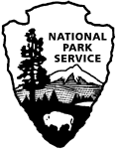 | National Park Service  U.S. Department of the Interior  OMB Approval XXXX-XXXX  Current Expiration Date: X-XX-XXXX

The Narrows
Visitor Study
Zion National Park

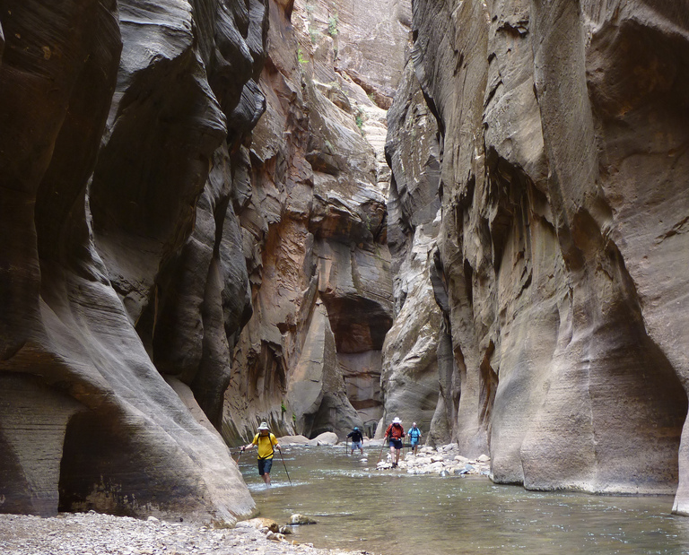

2017

ID: Date:

Time: : ○ AM ○ PM Location: ________________________

Weather: ○ Sunny ○ Partly Cloudy ○ Overcast/Rain ○ Storm

Special Event: ○ No ○ Yes (Specify) ________________________________________

Binder #: _______

Paperwork Reduction and Privacy Act Statements: The Paperwork Reduction Act requires us to tell you why we are collecting this information, how we will use it, and whether or not you have to respond. This information will be used by the National Park Service as authorized by 54 USC 100702. We will use this information to evaluate visitors’ perceptions of crowding and overall experiences in the Narrows. Your responses are voluntary and anonymous. Your name and address will not be collected. At the completion of this collection all personal information will be destroyed and in no way be connected with the results of this survey. A Federal agency may not conduct or sponsor and you are not required to respond to, a collection of information unless it displays a currently valid OMB Control Number.

Burden Estimate: We estimate that it will take an average of 12 minutes to complete this questionnaire. You may send comments concerning the burden estimates or any aspect of this information collection to the Social Science Program Chief, National Park Service, 1201 Oakridge Drive, Fort Collins, CO, 80525-5596; nps_nrss_social_science@nps.gov (email).

Topic Area 1 – GROUP5
- Including yourself, how many people were in your personal group during your visit to the Narrows today?
Number of adults (18 years or older)
Number of children (under 18 years)

Topic Area 1 – GROUP4
- Which of the following best describes your personal group? Please mark (●) one.
O Alone
O Family
O Friends
O Family and friends
O Other (Please specify): ____________________________

Topic Area 10 – ECON5
- Are you completing a day trip or an overnight trip in the Narrows?
O Day trip
➔ Number of hours in the Narrows, if day trip (Please list partial hours as ¼, ½, or ¾): ______
O Overnight trip

Topic Area 4 – DEST22
- Where did you start this trip in the Narrows?
O Chamberlain’s Ranch
O Temple of Sinawava/Riverside Walk
O Other (Please specify): _______________________________

Topic Area 4 – VISHIS3
- Including today, approximately how many times have you visited the Narrows in your lifetime?

Number of day trips: ____________, including today

Number of overnight trips: ____________, including today

Topic Area 2 – ITIN2
- When did you decide to make this visit to the Narrows? Please mark (●) one.
O Today
O In the last week
O More than a week ago, but in the last month
O More than a month ago, but in the last year
O More than a year ago
O Don’t know/can’t recall
Topic Area 2 – INFOSOURCE9
- Prior to this visit to the Narrows, how did you obtain information about the Narrows? Please mark (●) all that apply.
O Previous visit
O Friends/relatives/word of mouth
O Inquiry to park via phone, mail, or email
O Zion National Park website (nps.gov/ZION)
O Other website (Please specify):
O Local businesses (hotels, motels, restaurants, outdoor stores, etc.)
O The Mighty 5 advertisements
O Maps/brochures
O Newspaper/magazine articles
O Other units of the National Park System (NPS)
O School class/program
O Social media (such as Facebook, Twitter, etc.)
O State welcome center/visitors bureau/chamber of commerce
O Television/radio programs/DVDs
O Travel guides/tour books (such as AAA, etc.)
O Other (Please specify):

OR

O Did not obtain information prior to this trip today

Topic Area 6 – PERSAFE6
- On this visit to the Narrows, did you feel prepared for the following common safety situations that you may have encountered? Please mark (●) one for each row.

 | Yes | No
Exposure to sun | O | O
Heat | O | O
Adequate drinking water | O | O
Proper footwear for the terrain | O | O
Cold | O | O

NOTE TO REVIEWER: For Question 9, respondents will be asked to review a series of six photographs used to depict various levels of crowding at a location in the Narrows. Respondents will be shown one photograph at a time in a pre-determined order. For Question 12a, the respondent will be asked to view each photo and indicate (yes or no) if they would feel crowded with the number of people in the photographed area. The respondent will then reference the photographs to answer Questions 9b, 9c, 9d, 9e, and 9f.
Topic Area 6 – CROWD35
- We would like to know how many other people you think is acceptable to see in the Narrows without it being too crowded. To help judge this, we have a series of photographs that show different numbers of people in a section of the Narrows. Please ask the survey administrator to show you these photos to answer the following questions.

- For each photograph, please tell us if you would feel crowded if you were in the Narrows with the number of people depicted in the photograph. Please mark (●) one for each photograph.

 | …I would feel crowded
 | Yes | No
Photo 1 | O | O
Photo 2 | O | O
Photo 3 | O | O
Photo 4 | O | O
Photo 5 | O | O
Photo 6 | O | O

Topic Area 6 – CROWD35
- Which photograph shows the number of people would prefer to see in the Narrows?

Photo number: ________

Topic Area 6 – CROWD36
- Which photograph shows the maximum number of people you think Zion National Park should allow? In other words, at what point should people be restricted from visiting the Narrows? If you think use should not be restricted at any point represented in the photographs, or not restricted at all, you may indicate that.

Photo number: ________ ➔ GO ON TO PART D

OR

O None of the photographs show a high enough number of people to restrict people from visiting the Narrows. ➔ GO ON TO PART D

OR

O The number of people visiting the Narrows should not be restricted regardless of the number of people there. ➔ GO ON TO PART E

Topic Area 6 – CROWD7
- Should the number of people allowed to visit the Narrows each day be limited if it is needed for any of the following reasons, even if it limits when you can visit the Narrows? Please mark (●) one for each row.

Should the number of people
per day be limited?
Reason for Limit | Yes | No | Don’t Know/ Not Sure
To protect the quality of visitors’ experiences  (i.e., prevent crowding) | O | O | O
To protect visitors’ safety | O | O | O
To reduce environmental impacts | O | O | O

Topic Area 6 – CROWD38 (Variation) – This variation asks the respondent to indicate which photo they find unacceptable, as opposed to the respondent writing in a number of people that would represent the maximum number of visitors that would be so unacceptable to cause them to delay or discontinue their planned hike in the Narrows.
- Which photograph shows the number of people that would be so unacceptable you would no longer visit the Narrows? If none of the photographs represent this condition, you may indicate that.

Photo number: ________

OR

O None of the photographs are so unacceptable that I would no longer visit the Narrows.

Topic Area 6 – CROWD37
- Which photograph looks most like the number of people you typically saw today in the Narrows?

Photo number: ________

Topic Area 6 – CROWD37
- Did you feel crowded at any of the following locations today? Please mark (●) one for each row.

 | …I felt crowded
 | Yes | No | Did not  visit today | Don’t know if visited today
In the Narrows as a whole | O | O | O | O
Riverside Walk paved trail | O | O | O | O
End of the Riverside Walk paved trail | O | O | O | O
Mystery Falls | O | O | O | O
Orderville Canyon | O | O | O | O
Big Spring | O | O | O | O
Topic Area 6 – CROWD16
- To what extent do you agree or disagree with each of the following statements related to the Narrows? Please circle one for each row.

 | Highly Disagree | Slightly Disagree | Neither Agree or Disagree | Slightly Agree | Highly Agree
I generally found the Riverside Walk to be too crowded. | -2 | -1 | 0 | +1 | +2
I generally found the Narrows to be too crowded. | -2 | -1 | 0 | +1 | +2
There should be a limit on the number of people allowed to visit the Narrows at any one time. | -2 | -1 | 0 | +1 | +2
The number of people visiting the Narrows is about right. | -2 | -1 | 0 | +1 | +2
The number of people visiting Zion National Park is about right. | -2 | -1 | 0 | +1 | +2

Topic Area 9 – OPMGMT13
- To what extent would you support or oppose each of the following potential management practices for the Narrows? Please circle one for each row.

 | Strongly Oppose | Slightly Oppose | Neither Support nor Oppose | Slightly Support | Strongly Support
Increase informational signs regarding potential safety/crowding/natural hazards of the Narrows | -2 | -1 | 0 | +1 | +2
Require an orientation (e.g., a short video) that reinforces safety and Leave No Trace principles | -2 | -1 | 0 | +1 | +2
Implement a mandatory use etiquette education program regarding use of the Narrows | -2 | -1 | 0 | +1 | +2
Limit the number of visitors allowed to visit the Narrows each day by means of first come, first served permit system | -2 | -1 | 0 | +1 | +2
Limit the number of visitors allowed to visit the Narrows each day by means of a reserve in advance permit system | -2 | -1 | 0 | +1 | +2
Hourly limits of people allowed to visit the Narrows, to ensure the number of people in the Narrows does not exceed a certain number | -2 | -1 | 0 | +1 | +2
Provide more rangers in the Narrows to enforce Leave No Trace principles, rules, and regulations | -2 | -1 | 0 | +1 | +2
Require all hikers in the Narrows to use proper footwear for the terrain | -2 | -1 | 0 | +1 | +2
Require all hikers to be of a certain age to visit the Narrows | -2 | -1 | 0 | +1 | +2
Limit promotion of the Narrows (remove interpretive photos, work with the concessionaire and interpretive association to minimize related souvenir sales, reduce tourism marketing, etc.) | -2 | -1 | 0 | +1 | +2

Topic Area 5 – RecBACK18
- Did you encounter any of the following in the Narrows today? Please mark (●) one for each row.

 | No | Yes, Some | Yes, A Lot
Graffiti | O | O | O
Litter | O | O | O
Visible human waste | O | O | O
Human waste odor | O | O | O
Trampled vegetation | O | O | O
Dangerous behavior | O | O | O
Loud noises created by other visitors | O | O | O

Topic Area 2 – INFOSOURCE14
- a. Did you encounter a ranger on the hike today?
O Yes
O No

b. If YES, did you gain information regarding the Narrows from them?
O Yes
O No

Topic Area 5 – RecACT17
- What did you like most about visiting the Narrows today?

___________________________________________________________________________________________________
___________________________________________________________________________________________________
___________________________________________________________________________________________________

Topic Area 5 – RecACT18
- What did you like least about visiting the Narrows today?

___________________________________________________________________________________________________
___________________________________________________________________________________________________
___________________________________________________________________________________________________
___________________________________________________________________________________________________

Topic Area 4 – DEST5
- What other areas of the park have you visited or do you plan to visit today? Please mark (●) all that apply.
O Angels Landing
O Hidden Canyon
O Upper Emerald Pools
O Observation Point
O Watchman
O Other (Please specify): ____________________________

O R

O The Narrows is my only destination for today.

Topic Area 10 – ECON5
- On this trip, how much total time do you plan to spend visiting Zion National Park? For this question, a visit is defined as the day in which you were contacted to complete this questionnaire. A trip is defined as the total extent of time away from your personal residence that could include multiple visits to Zion National Park.
Number of hours, if a day trip to the park
Number of days, if greater than 1-day trip to the park

Topic Area 4 – LOCALSERV3 (Variation) – The purpose of this question similar to the original: to determine support services used during the visit. This variation is a simplified version that asks only about equipment rental used during this visit and requires respondents to answer with just “yes” or “no”.
- Did you rent equipment for your hike today?
O Yes
O No

Topic Area 1 – AGE1
- What is your age? _________

Topic Area 1 – GEND1
- What is your gender? Please mark (●) one.
O Male
O Female

Topic Area 1 – RES2
- Where do you live?
US ZIP ____________
Country (if not US) _______________________

Topic Area 1 – RACE/ETH1
- Are you Hispanic or Latino? Please mark (●) one.
O Yes
O No
O I prefer not to answer.

Topic Area 1 – RACE/ETH2
- What is your race? Please mark (●) all that apply.
O American Indian or Alaska Native
O Asian
O Black or African American
O Native Hawaiian or other Pacific Islander
O White
O I prefer not to answer.

Topic Area 1 – EDUC1
- What is the highest level of formal education you have completed? Please mark (●) one.
O Less than high school
O Some high school
O High school graduate or GED
O Some college, business, or trade school
O College, business, or trade school graduate
O Some graduate school
O Master’s, doctoral, or professional degree
O I prefer not to answer.

Topic Area 9 – OPMGMT10
- Is there anything else you would like to tell us about your visit to Zion National Park?

Thank you for your help! Please return the survey to the administrator.

