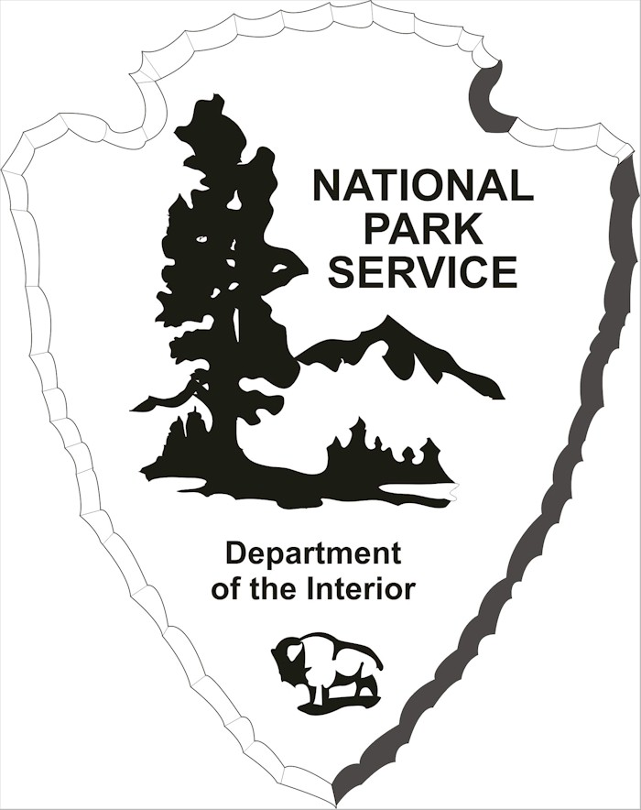
OMB Control Number: 1024-0224
Expiration Date August 2018

DRAFT Santa Monica Mountains National Recreation Area
Visitor-Use Survey
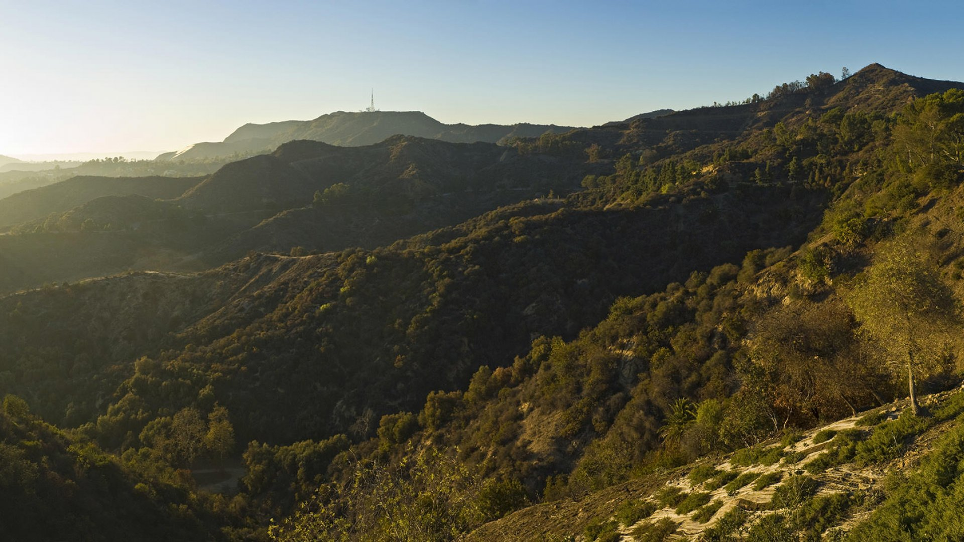

PAPERWORK REDUCTION and PRIVACY ACT STATEMENT: The Paperwork Reduction Act requires us to tell you why we are collecting this information, how we will use it, and whether or not you have to respond. We are authorized by the National Park Service Protection Interpretation and research in System (54 USC §100702) to collect this information. The information from this collection will be used by park managers for the purposes of management planning for the Santa Monica Mountains National Recreation Area. The data collected will be summarized to evaluate visitor use and satisfaction. Your responses to this collection are completely voluntary and will remain anonymous. You can stop at any time and will not be penalized in any way for choosing to do so. No personally identifiable records will be maintained or stored for any purposes. Data collected will only be reported in aggregates and no individually identifiable responses will be reported. A Federal agency may not conduct or sponsor, and you are not required to respond to, a collection of information unless it displays a currently valid OMB Control Number (1024-0224). We estimate that it will take about 15 minutes to complete this questionnaire. You may send comments concerning any aspect of this information collection to: Jerald Weaver, Jerald_weaver@nps.gov (email); or Phadrea Ponds, NPS Information Collection Coordinator, Fort Collins, CO 80525, pponds@nps.gov (email).

We will begin this survey by asking you a few questions about your experience visiting the park today and how you planned your visit.
Topic Area 2: INFOSOURCE7
1. How did you learn about the trailhead you visited (or plan to visit) today? (select all that apply)
- Facebook
- Twitter
- Instagram
- Agency website (National Park Service, California State Parks, LA Mountains, LA County, etc.)
- Other website or online media
  - Please list ______________
- Friends, family, and/or acquaintances
- Guidebook
- Newspaper or other printed media

Topic Area 5: RecEXP20
2a. Did you have trouble finding the trailhead? y/n
Topic Area 5: ITIN22
2b. What navigation strategy did you use? (select all that apply)
- Maps (digital or paper)
- Directions from social media
- Road signs
- Directions from friends/acquaintances
- Asked a stranger for directions
- Park ranger(s) or other park staff gave directions
- I know the route
- Other ____________________
** If you are not a Southern California resident, SKIP now to question 5
Topic Area 3: TRANSMODE1
3. If you are a resident of the southern California region, approximately how long did it take for you to get from home to the trail today?
___________ minutes _________________ hours
Topic Area 1: RES6
4. To estimate the distance you live from the trail, how far would you say you are away from your home?
_____________________________ (approximate number of miles)
Topic Area 1: RES10
5. What is your residential zip code? ___________________________
Topic Area 3: TRANSMODE6
6. How did you travel to the trail today? (select one only)
- Car/truck/SUV/van
- Public transportation
- Group transportation (club/organization)
- Motorcycle/scooter
- Bicycle
- Walk/jog
- Horseback
- Other (type) ________________________________
Topic Area 10: ECON20
7. Did you pay for parking today? Yes No
- If yes, how much? ________________
Topic Area 5: ITIN11
8. From the list below, which three activities have you engaged in today or plan to engage in today? (please rank the three you select on a scale of 1-3; 1=least important, 3=most important)
 |  |  |  | Of the three activities, rank their importance from 1 to 3
Place an X by the 3 activities  you plan to do today. |  |  |  | Least Important = 1 |  | Moderately Important=2 | Most Important = 3
 | Sightseeing
 | Hiking
 | Picnicking
 | Mountain Biking
 | Bird Watching
 | Walking dog(s)
 | Jogging
 | Camping
 | Horseback Riding
 | Rock Climbing
 | Painting/Crafts
 | Photographing
 | Sunbathing
 | Wading/Swimming
 | Other (Type) ________________________

Topic Area 2: ITIN17
9. In light of your three chosen activities, what other destinations did you rule out before deciding to visit this trailhead today?
- Please list
  - _______________________________
  - _________________________________
  - __________________________________
  - __________________________________
  - ___________________________________

Topic Area 7: EVALSERV12
10. In deciding whether to visit this location, how would you rate your consideration of each of the following? (1=unimportant, 5=very important)
 |  |  |  | How would you rate your consideration of each aspect
 |  |  |  | Unimportant | Of Little  Importance | Neither unimportant or important | Important | Very Important
 |  |  |  | 1 | 2 | 3 | 4 | 5
Cost of parking |  |  |  | 1 | 2 | 3 | 4 | 5
Cost of traveling to the site |  |  |  | 1 | 2 | 3 | 4 | 5
Avoiding crowds |  |  |  | 1 | 2 | 3 | 4 | 5
Disability Access |  |  |  | 1 | 2 | 3 | 4 | 5
Safety of park and/or trailhead |  |  |  | 1 | 2 | 3 | 4 | 5
Sufficient level of trail quality |  |  |  | 1 | 2 | 3 | 4 | 5
Cleanliness of park and/or trailhead |  |  |  | 1 | 2 | 3 | 4 | 5
Other _________________ |  |  |  | 1 | 2 | 3 | 4 | 5

Topic Area 7: EVALSERV12
11a. Which of the following amenities did you or will you use during your visit today? (Select all that apply)
- Parking  - Bathrooms  - Maps of trailheads and trails (individual paper maps or posted maps)  - Educational information/Interpretive services  - Benches  - Barbeques  - Camp grounds  - Trash cans  - In-person staff/rangers  - Shade structures  - Visitor Center  - Drinking fountains  - Vending machines or other food providers  - First aid services | - Wi-Fi connectivity  - Telephones  - Cellular Service  - Programs put on by the park or other entity  - Sports facilities (e.g. soccer fields, bocce ball fields)  - Bike racks  - Fire pits  - Picnic tables  - Electrical hookups  - Law enforcement personnel onsite  - Hitching post  - Overlook/viewpoint  - Dog off-leash area/access

Topic Area 7: EVALSERV15
11b. If you could improve only two of the amenities you selected in the previous question (11a) that would significantly impact your park experience, which two would they be? (Select two from the list below)
- Parking  - Bathrooms  - Maps of trailheads and trails (individual paper maps or posted maps)  - Educational information/Interpretive services  - Benches  - Barbeques  - Camp grounds  - Trash cans  - In-person staff/rangers  - Shade structures  - Visitor Center  - Drinking fountains  - Vending machines or other food providers  - First aid services | - Wi-Fi connectivity  - Telephones  - Cellular Service  - Programs put on by the park or other entity  - Sports facilities (e.g. soccer fields, bocce ball fields)  - Bike racks  - Fire pits  - Picnic tables  - Electrical hookups  - Law enforcement personnel onsite  - Hitching post  - Overlook/viewpoint  - Dog off-leash area/access

Topic Area 4: FVIS13
11c. Which three of the following amenities (listed below) that are not already provided at this trailhead would significantly improve your experience of the park if they were made available? (Select three from the list below)
- Parking  - Bathrooms  - Maps of trailheads and trails (individual paper maps or posted maps)  - Educational information/Interpretive services  - Benches  - Barbeques  - Camp grounds  - Trash cans  - In-person staff/rangers  - Shade structures  - Visitor Center  - Drinking fountains  - Vending machines or other food providers  - First aid services | - Wi-Fi connectivity  - Telephones  - Cellular Service  - Programs put on by the park or other entity  - Sports facilities (e.g. soccer fields, bocce ball fields)  - Bike racks  - Fire pits  - Picnic tables  - Electrical hookups  - Law enforcement personnel onsite  - Hitching post  - Overlook/viewpoint  - Dog off-leash area/access
Topic Area 5: PART52
12a. How likely is it that you would recommend the Santa Monica Mountains National Recreation Area (SAMO) to a friend or colleague? Where 1 is not likely at all and 9 is extremely likely. (Select one number from 1-Not Likely at All to 9-Extremely Likely)
Not Likely At All | Very unlikely | Unlikely | Somewhat unlikely | Equally likely and unlikely | Somewhat Likely | Likely | Very Likely | Extremely Likely
1 | 2 | 3 | 4 | 5 | 6 | 7 | 8 | 9

12b. Please tell us why you chose that score. _____________________________
___________________________________________________________________

Topic Area 5: PART52
13a. How likely is it that you would recommend this particular trailhead to a friend or colleague? Where 1 is not likely at all and 9 is extremely likely. (Select one number from 1 to 9)
Not Likely At All | Very unlikely | Unlikely | Somewhat unlikely | Equally likely and unlikely | Somewhat Likely | Likely | Very Likely | Extremely Likely
1 | 2 | 3 | 4 | 5 | 6 | 7 | 8 | 9

13b. Please tell us why you chose that score. _____________________________
___________________________________________________________________

Topic Area 4: USETECH3
14. Did you have internet access at the trailhead and/or while on the trail? (select one answer)
- Yes
- No
- Some of the time
- Don’t know
Topic Area 4: USETECH6
15. Would you find it valuable for any of the following reasons to have internet access? (Check all that apply)
- To communicate with other members of your party | - To post photos or comments from your trip to social media
- To access emergency medical services | - To navigate the trail
- To deal with car difficulties | - To learn about trail and trailhead features and amenities
- To alert rangers to hazardous conditions  onsite | - Other ____________________________________

Topic Area 4: DEST1
16. Did you have trouble navigating the park? y/n
If yes, explain ______________
Topic Area 2: INFOSOURCE13
17. Did you have trouble learning about features and amenities that this trailhead and trail offer?
Yes No
If yes, explain ______________
Topic Area 1: GROUP4
18. What type of group are you here with? (Select one)
- Alone | - Religious organization/church
- Family | - Youth club
- Friends | - Educational
- Family & friends | - Other organization or club  - Other (type) _____________________

Topic Area 1: GROUP5
19. How many pets/animals are in your group today? (Write a number below)
Dogs _____________________
Horses __________________
Topic Area 1: GROUP3
20. What are the ages and gender (the gender to which the person most identifies) of the people in your group today? (Fill out estimated age and gender for as many people as are in your group or up to 15* people in your group)
 | Age | Gender
Person 1
Person 2
Person 3
Person 4
Person 5
(*more rows will be added as needed)

Topic Area 10: ECON5
21. About how long will/did you spend in the park today? _______________ hrs.
Topic Area 4: VISHIS1
22. Is this your first visit to SAMO? Yes No
**If this is your first visit to SAMO, please skip to question 25.
Topic Area 4: VISHIS7
23. Is this the trail you normally visit in the SAMO? Yes No

Topic Area 4: VISHIS3
24. Have you visited any trailhead repeatedly in the last year? Yes No
- If yes, list the trailheads you visited and identify how many times you visited each one in the last year.
Name of Trail | Number of visits

- If not, which other trails have you visited in the last year? And when did you last visit?
 | Name of Trail | Date Visited | Day of the Week (if remembered) | Time of Day (if remembered)
Trail #1
Trail #2
Trail #3

Topic Area 9: OPMGMT11
25. In your opinion, the most important reason to protect the Santa Monica Mountains is (select one):
- To provide recreational opportunities
- To provide habitat for plants and wildlife
- No opinion
- Other (type) ____________________________________
Topic Area 1: GROUP7
26a. Do you have a physical condition that could interfere with your ability to recreate or your choice of recreational activities?
Yes No
26b. If yes, please explain ________________________________________________
Topic Area 11: USMIN3
27. Which of the following factors have kept you (or would keep you) from visiting this trailhead again or more frequently? Select all that apply and please rank your answers on a scale of 1-3; 1=least important, 3=most important).
 |  |  | How would you rate the importance of each to deciding whether to visit or not
 |  |  | Least Important | Moderately Important | Most Important
 |  |  | 1 | 2 | 3
No Parking |  |  | 1 | 2 | 3
Cost of parking |  |  | 1 | 2 | 3
Cost of entrance fee |  |  | 1 | 2 | 3
Don't feel welcome |  |  | 1 | 2 | 3
Don't feel safe |  |  | 1 | 2 | 3
Congestion at park |  |  | 1 | 2 | 3
Concern about the presence of a ranger |  |  | 1 | 2 | 3
Concern about the lack of a ranger presence |  |  | 1 | 2 | 3
Couldn't find a babysitter |  |  | 1 | 2 | 3
Too difficult to get to the trailhead |  |  | 1 | 2 | 3
No signs or information in appropriate language |  |  | 1 | 2 | 3
Lack of amenities that I want to use |  |  | 1 | 2 | 3
Lack of activities that I want to participate in |  |  | 1 | 2 | 3
Other ______________ |  |  | 1 | 2 | 3

Topic Area 2: ITIN17
28. Have you ever arrived at the trailhead and decided to leave and not do your planned activity?
No Yes If yes, why?___________________________
Topic Area 4: FVIS1
29a. Would you come back again to this trailhead? Yes No
29b. Why or why not? ___________
If yes, when? ____________________
Now we would like to know a few things about you.
Topic Area 1: AGE1
30. What is your age? ________________
Topic Area 1: GEND 1
31. To which gender identity do you most identify?
- Female | - Male | - Choose not to Answer

Topic Area 10: ECON13
32. What are the ages, gender (the gender to which they most closely identify), and relationships to you of the people that live with you in your household?
 | Gender | Age | Relationship
Person 1
Person 2
Person 3
Person 4
Person 5

Topic Area 1: EDUC1
33. What is the highest level of education you have completed (or achieved)? (Select one)
- High school student
- No high school diploma or GED
- High school graduate or GED
- College
Topic Area 1: RACE/ETH1
34. Are you Hispanic or Latino? (select one)
- Yes, Hispanic or Latino
- No, not Hispanic or Latino
Topic Area 1: RACE/ETH2
35. What is your race? (select one or more)
- American Indian or Alaska native | - Native Hawaiian or other Pacific Islander
- Asian | - White
- Black or African-American | - Do not wish to answer

Topic Area 1: LANG3
36. What language(s) do you speak at home? __________________ (write language(s) here)
Topic Area 10: ECON12
37. What is your household income? (Select one)
- Less than $25,000 | - $50,001 – $75,000 | - 150,001 – $175,000
- $125,001 - $150,000 | - $75,001 - $100,000 | - $175,001 - $200,000
- $25,000 - $50,000 | - $100,001 - $125,000 | - More than $200,000
- Do not wish to answer

Topic Area 8: PART5
38. If you needed to report litter, potentially hazardous conditions, vandalism, etc., which of the following entities would you contact? (Select all that apply)
- National Park Service (NPS) | - The City of Los Angeles
- Mountains Recreation and Conservation Authority (MRCA) | - The City of Santa Monica
- California State Parks | - Neighborhood Councils
- Santa Monica Mountains Conservancy | - Other __________________________
- Santa Monica Mountains Fund | - Don’t know

Topic Area 8: PART2
39. Who do you think funds the upkeep and maintenance of this trailhead and trail? (select all that apply)
- National Park Service (NPS) | - The City of Los Angeles
- Mountains Recreation and Conservation Authority (MRCA) | - The City of Santa Monica
- California State Parks | - Neighborhood Councils
- Santa Monica Mountains Conservancy | - Other __________________________
- Santa Monica Mountains Fund | - Don’t know

Topic Area 8: PART3
40. Would you be willing to contribute financially to the future upkeep and provision of services of this trailhead and trail? y/n

That’s all the questions in the survey. Do you have any questions? Thank you very much for your time and participation. Hope you enjoy (or enjoyed) your trail visit.

