OMB Control Number 1024-0224

2018 Grand Canyon National Park

Rim2Rim Visitor Survey

# **PAPERWORK REDUCTION and PRIVACY ACT STATEMENT: The Paperwork Reduction Act requires us to tell you why we are collecting this information, how we will use it, and whether or not you have to respond. We are authorized by the National Park Service Protection Interpretation and research in System (54 USC §100702) to collect this information. The routine uses of this information will be used to better understand visitor use, experiences and expectations within the Rim to Rim Corridor of the Grand Canyon National Park. The data collected will be summarized and your responses to this collection are completely voluntary and will remain anonymous. You can end the process at any time and will not be penalized in any way for choosing to do so. There are no paper versions of the information collected to be destroyed at the end of the collection period and no personal identifiable records will be maintained or electronically stored for any purposes. Data collected will only be reported in aggregates and no individually identifiable responses will be reported. A Federal agency may not conduct or sponsor, and you are not required to respond to, a collection of information unless it displays a currently valid OMB Control Number. We estimate that it will take about 15 minutes to complete this questionnaire. You may send comments concerning any aspect of this information collection to: Dr. Ryan Sharp, Kansas State University, Manhattan, KS 66506, ryansharp@ksu.edu (email) or Phadrea Ponds, NPS Information Collection Coordinator, Fort Collins, CO 80525, pponds@nps.gov (email).**

**Grand Canyon National Park Rim to Rim Corridor Visitor Survey**

We are conducting this survey to better understand visitor use within the Rim to Rim Corridor of the Grand Canyon National Park.  Thank you for your participation in this study.  By completing this survey you are providing useful information for park managers in order to help create a better visitor experience within the corridor.   This survey will take about 10 minutes to complete and is completely anonymous.

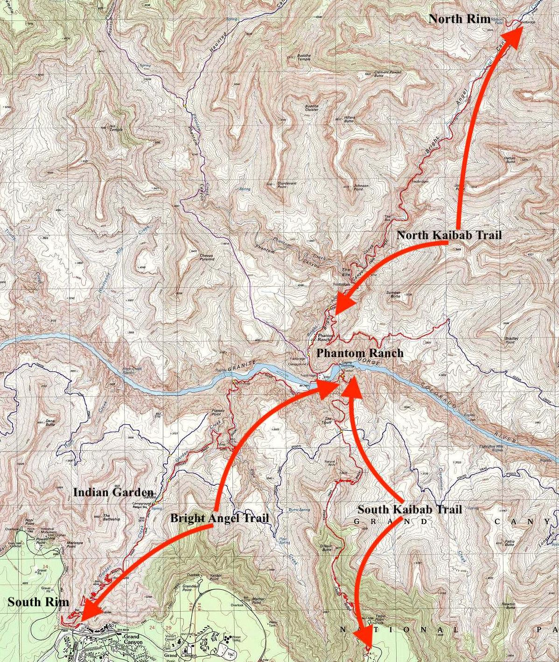

Throughout the survey, the word corridor refers to trail segments and landmarks associated with rim to rim travel displayed above (Bright Angel Trail, South Kaibab Trail, North Kaibab Trail, and Phantom Ranch).  Please ask the surveyor if any clarification is needed throughout the survey.

**Section 1 – Visitor Use History**

Q1.1 Including yourself, how many people are you traveling with in the corridor?

________________________________________________________________

Q1.2 Including this visit, how many times have you traveled within the corridor **in the last month**?

________________________________________________________________

Q1.3 Including this visit, how many times you have traveled within the corridor **in the last year?**

________________________________________________________________

Q1.4 Where are you/did you begin your trip into the corridor today? (Please choose one)

* Bright Angel Trailhead
* South Kaibab Trailhead
* North Kaibab Trailhead
* Phantom Ranch
* Other ________________________________________________

Q1.5For this visit, are you part of any of the following organized groups? (check all that apply)

|  |  |
| --- | --- |
|  | Yes |
| Commercial Guided Tour Group |  |
| School/Educational Group |  |
| Running/Adventure Club |  |
| Meet up Group |  |
| Other |  |

Q1.6 Are you traveling Rim to Rim on this visit (from one rim to the other, e.g., North Rim to South Rim)?

* Yes
* No (Skip to Q1.12)
* I am not sure

Q1.7Please indicate the **primary reason** for deciding to travel Rim to Rim.

* Physical Challenge
* Repeat Rim to Rim trip
* Unable to camp at Bright Angel Campground
* "Bucket List" Trip
* Part of a running/hiking club trip
* Don't Know

Q1.8 What was the primary resource you used to plan for your visit to Grand Canyon National Park? **Please select only one.**

* National Park Service Website
* Websites (not associated with National Park Service)
* Pamphlets/Brochures
* Social Media (Facebook, Instagram, Twitter, etc)
* Magazine ________________________________________________
* Word of mouth
* Knowledge from a previous visit
* Did not do any planning
* Other ________________________________________________

**Section 2 – Activity Experience While in the Corridor**

Q2.1 For this question, please think about the activities you participated in during this, or past travels, within the corridor.  In column **A**, mark activities that apply during **past** visits.  In column B, mark all activities that apply during this visit.

|  |  |  |
| --- | --- | --- |
|  | **A**  Past Visit | **B**  Current Visit |
| Day Hiking |  |  |
| Overnight Backpacking |  |  |
| Overnight Lodging at Phantom Ranch |  |  |
| Trail Running |  |  |
| Mule Riding |  |  |
| River Rafting |  |  |
| Other |  |  |

Q2.2 During **this visit,** which **one** activity from Column B, current visit, was the most important to your experience at Grand Canyon National Park?  **Please select only one.**

* Day Hiking
* Overnight Backpacking
* Overnight Lodging at Phantom Ranch
* Trail Running
* Mule Riding
* River Rafting
* Other ________________________________________________

Q2.3 Which of the above activities was the **primary reason** for your visit to Grand Canyon National Park?  **Please select only one.**

* Day Hiking
* Overnight Backpacking
* Overnight Lodging at Phantom Ranch
* Trail Running
* Mule Riding
* River Rafting
* Other ________________________________________________

Q2.4 Did any other visitors interfere with your activity during this visit?

* Yes
* No (Skip to Q 2.6)
* Not Sure

Q2.5 How did other visitors interfere with your activity during **this visit**? **Select all that apply**.

* Being asked to move to one side so others can pass
* Too many trail runners
* Other visitors too loud
* Other visitors did not make space to safely pass
* Other visitors leaving trash on the trail
* Mules were difficult/unsafe to pass on the trail
* Other visitors did not interfere in any way with my visit
* Cell phone use (talking)
* Cell phone use (selfies)
* Human Waste
* Graffitti
* Other ________________________________________________

Q2.6 At any point did you have to adjust your desired speed while engaging in your activity because of other visitors?

* Yes
* No (Skip to Q 2.8)

Q2.7 How did you adjust your speed?

* Was mostly slowed down
* Was mostly sped up
* I was unable to take a break when I wanted/needed to
* I took more breaks than I wanted to
* Other ________________________________________________

Q2.8 How did the number of other trail users (hikers and runners) you encountered relate to the number you *expected* to encounter?

|  |  |  |  |  |
| --- | --- | --- | --- | --- |
| * Many fewer | * Slightly fewer | * About the same | * Slightly more | * Many more |

Q2.9 Would the number of encounters you experienced along the trail influence your decision to return?

* Yes, I would go somewhere else
* Yes, I would return
* No influence

Q2.10 What was your biggest problem you encountered in the park today?

________________________________________________________________

Q2.11 Based on the current conditions in the park today, did you change your activity plans?

* Yes
* No (Skip to Q13)

Q2.12 If you answered yes to the previous question, what made you change your plans?

* Weather, too hot
* Weather, too cold
* Too crowded
* Infrastructure issues (e.g. road closures, trail closures)
* Other ________________________________________________

Q2.13 Below is a list of characteristics often associated with backcountry and wilderness areas.  Please indicate how important each of the characteristics listed below were to you during your trip in the corridor today.

|  |  |  |  |  |  |  |
| --- | --- | --- | --- | --- | --- | --- |
|  | Extremely important | Very important | Moderately important | Slightly important | Not at all important | Don't Know |
| Solitude/Avoiding Crowds |  |  |  |  |  |  |
| Primitive Recreation/Limited Facilities |  |  |  |  |  |  |
| Pristine natural environment |  |  |  |  |  |  |
| Physical Challenge |  |  |  |  |  |  |
| Hearing sounds of nature |  |  |  |  |  |  |
| Natural quiet |  |  |  |  |  |  |
| Unrestricted recreation |  |  |  |  |  |  |
| Taking risks |  |  |  |  |  |  |
| To have an adventure |  |  |  |  |  |  |

Q2.14 Please indicate to what extent you experienced solitude during your visit within the corridor today.

|  |  |  |  |  |
| --- | --- | --- | --- | --- |
| * Not at all | * Slightly r | * Somewhat | * Moderately | * Very Much |

Q2.15 How much of a problem do you think the following issues are in the corridor?

|  |  |  |  |  |
| --- | --- | --- | --- | --- |
|  | Not a Problem at All | A Small Problem | A Big Problem | Don't Know |
| Too many other visitors |  |  |  |  |
| Rude and inconsiderate visitors |  |  |  |  |
| Too many day hikers |  |  |  |  |
| Too many trail runners |  |  |  |  |
| Too many overnight backpackers |  |  |  |  |
| Poorly maintained facilities/restrooms |  |  |  |  |
| Unacceptable impacts to park resources (litter/human waste) |  |  |  |  |
| Too many rules and regulations |  |  |  |  |
| Safety conditions |  |  |  |  |
| Too many facilities |  |  |  |  |
| Too little information about the corridor |  |  |  |  |
| Information about the corridor is inappropriate |  |  |  |  |

Q2.16 Please indicate the extent to which you agree or disagree with each of the following statements regarding management of recreational travel in the corridor.

|  |  |  |  |  |  |  |
| --- | --- | --- | --- | --- | --- | --- |
|  | Strongly Agree | Agree | Neutral | Disagree | Strongly Disagree | Don't Know |
| If people feel crowded, access should be reduced |  |  |  |  |  |  |
| If visitor-caused resource impacts are high, access should be reduced |  |  |  |  |  |  |
| If solitude is lost, access should be reduced |  |  |  |  |  |  |
| Access should never be reduced, even if visitor-use is high |  |  |  |  |  |  |

Q2.17 Please indicate the extent to which you would support or oppose each of the potential management actions in the corridor.

|  |  |  |  |  |  |  |
| --- | --- | --- | --- | --- | --- | --- |
|  | Strongly Support | Support | Neither Support nor Oppose | Oppose | Strongly Oppose | Don't Know |
| More education regarding trail etiquette/appropriate behavior |  |  |  |  |  |  |
| Registration required for day use (no limits and no fees) |  |  |  |  |  |  |
| Registration required for day use (limits and no fees) |  |  |  |  |  |  |
| Permits required for day use (limits and an $8 fee) |  |  |  |  |  |  |
| Permits required for day use (limits except for two weekends/year) |  |  |  |  |  |  |
| Registration required for Rim to Rim travel (no limits and no fees) |  |  |  |  |  |  |
| Registration required for Rim to Rim travel (limits and no fees) |  |  |  |  |  |  |
| Permits required for Rim to Rim travel (limits and an $8 fee) |  |  |  |  |  |  |

**Section 3 – Preparation and Points of Fatigue**

Q3.1 Which option best describes how prepared you were for your visit in the corridor trails?

* I was underprepared
* I was appropriately prepared (Skip to Q 3.3)
* I was over prepared (Skip to Q 3.3)

Q3.2 How were you unprepared for your trip?**Please select all that apply.**

* Did not bring enough water
* Did not bring enough food/snacks
* Did not bring the right kind of food
* Was not prepared for the heat
* Underestimated the distance of the hike
* Did not wear appropriate footwear
* I was completely prepared for the activity I participated in
* I did not have enough information before my trip
* Other ________________________________________________

Q3.3 At roughly what location during your visit did you begin to feel fatigued?

* Ooh Aah Point (South Kaibab Trail)
* Cedar Ridge (South Kaibab Trail)
* Skeleton Point (South Kaibab Trail)
* Tip Off (South Kaibab Trail)
* Phantom Ranch
* River Resthouse (Bright Angel Trail)
* Indian Garden (Bright Angel Trail)
* Three Mile Resthouse (Bright Angel Trail)
* Mile and a Half Resthouse (Bright Angel Trail)
* Coconino Overlook (North Kaibab Trail)
* Roaring Springs (North Kaibab Trail)
* Manzanita Resthouse (North Kaibab Trail)
* Cottonwood Campground (North Kaibab Trail)
* I did not experience any fatigue until the end of my trip
* I did not experience any fatigue during my trip

Q3.4 How concerned are you for your safety when traveling within the corridor?

* Not at all concerned
* Slightly concerned
* Neutral
* Moderately concerned
* Extremely concerned

Q3.5 Please indicate, to the best of your ability, where on the map you began to feel fatigued.

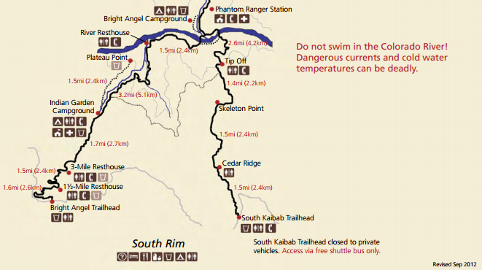

Q3.6 Please indicate, to the best of your ability, where on the map where you felt the most unsafe.



Q3.8 If you hiked to Phantom Ranch, did you use the flush toilets?

* Yes
* No
* I did not hike to Phantom Ranch

Q3.9 Did you use any of the vault toilets (e.g. outhouses) along the corridor trail?  Please check each location you used an outhouse.

* Cedar Ridge (South Kaibab Trail)
* The Tipoff (South Kaibab Trail)
* 1 1/2 Mile Resthouse (Bright Angel Trail)
* 3 Mile Resthouse (Bright Angel Trail)
* Indian Garden (Bright Angel Trail)
* River Resthouse (Bright Angel Trail)
* Cottonwood (North Kaibab Trail)
* Manzanita Rest Area (North Kaibab Trail)
* Roaring Springs Day Use Area (North Kaibab Trail)
* Supai Tunnel (North Kaibab Trail)

Q3.10 Did you utilize any of the water facilities along the corridor trail?

* Yes
* No (Skip to Q12)

Q3.11 Approximately how much water did you use from those facilities?

|  |  |  |  |
| --- | --- | --- | --- |
| * Liter | * 1-2 Liters | * 2-3 Liters | * More than 3 Liters |

Q3.12 At any time during your visit, did you consider seeking assistance from NPS staff for safety reasons?

* No
* Yes (and why) ________________________________________________

Q3.13 At any time during your visit, did you consider seeking assistance from NPS staff for comfort reasons?

* No
* Yes ( and why) ________________________________________________

|  |  |  |  |  |  |
| --- | --- | --- | --- | --- | --- |
| Q3.14 Please state your level of agreement with the following statements | | | | | |
|  | Strongly disagree | Somewhat disagree | Neither agree nor disagree | Somewhat agree | Strongly agree |
| **I am solely responsible for my own safety** when traveling within the corridor of Grand Canyon National Park. |  |  |  |  |  |
| **Rangers at Grand Canyon National Park is solely responsible for my safety** while traveling within the corridor of the park. |  |  |  |  |  |
| **Both the Rangers at Grand Canyon National Park and myself have a shared responsibility regarding my safety** while traveling within the corridor of the park. |  |  |  |  |  |
| If I have a minor emergency, a ranger will respond |  |  |  |  |  |
| Rangers will ensure that I am safe in the corridor. |  |  |  |  |  |
| I can call for help if I need it and a Ranger will respond |  |  |  |  |  |
| I am more prepared than the typical visitor |  |  |  |  |  |
| I am safer than the typical visitor |  |  |  |  |  |
| Technology (e.g. phone, GPS) will keep me safe |  |  |  |  |  |

**Section 4 - About You**

Q4.1 What is your zip code? (if you are not from the U.S.A, please see the next question) ____________

Q4.2 In which country do you currently reside? ________________________________

Q4.3 What year were you born?____________________________________________

Q4.4 What is your gender?

* Male
* Female

Q4.5 What is the highest level of school you have completed?

* Less than high school
* Some high school
* High school graduate
* Some college
* Two-year college graduate
* Four-year college graduate
* Graduate or professional degree
* Do not wish to answer

Q4.6 What is your race? (select all that apply)

* American Indian or Alaska Native
* Asian
* Black or African American
* White
* Do not wish to answer

Q4.7 Are you Hispanic or Latino? (A person of Cuban, Mexican, Puerto Rican, South or Central American, or other Spanish culture or origin, regardless of race)

* Yes, Hispanic or Latino
* No, not Hispanic or Latino

Q4.8 What category best describes your total household income in U.S. dollars during 2016 before taxes? (select one)

* Less than $24,999
* $25,000 to $34,999
* $35,000 to $49,999
* $50,000 to $74,999
* $75,000 to $99,999
* $100,000 to $149,999
* $150,000 to $199,999
* $200,000 or more
* Do not wish to answer

Q4.9 Is there anything else about your corridor experience that you would like to share?

________________________________________________________________

Q4.10 If you were a Ranger at Grand Canyon National Park, what would you do differently?

Thank you for your help with this survey!   
Please return the tablet to the person who gave it to you.   
    
If you have any questions or concerns, please contact:   
Dr. Ryan Sharp - ryansharp@ksu.edu   
 