**OMB Control Number 1024:0224**

**Grand Teton Pre-trip Survey: String and Leigh Lakes**

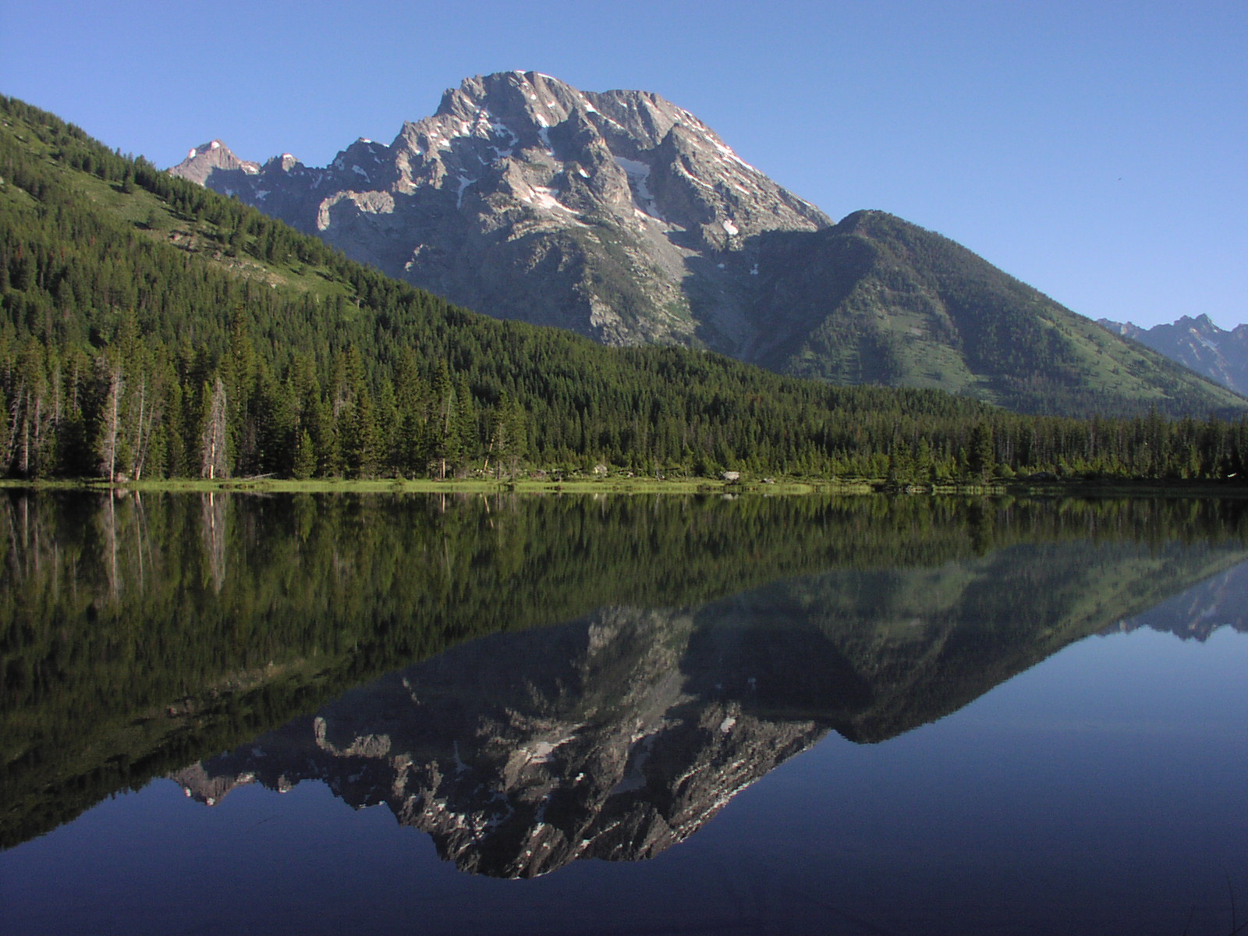

**PAPERWORK REDUCTION and PRIVACY ACT STATEMENT: The Paperwork Reduction Act requires us to tell you why we are collecting this information, how we will use it, and whether or not you have to respond. We are authorized by the National Park Service Protection Interpretation and research in System (54 USC §100702) to collect this information. The routine uses of this information will be for the benefit of NPS Managers and Planning staff Grand Teton National Park (GRTE) in future initiatives related to the visitor use and resource management within the String and Leigh Lakes area. The data collected will be summarized to evaluate visitor uses and expectations during their visit at GRTE. Your responses to this collection are completely voluntary and will remain anonymous. You can end the process at any time and will not be penalized in any way for choosing to do so. Data collected will only be reported in aggregates and no individually identifiable responses will be reported. A Federal agency may not conduct or sponsor, and you are not required to respond to, a collection of information unless it displays a currently valid OMB Control Number (1024-0224). We estimate that it will take about 5 minutes to complete and return this on-site questionnaire. You may send comments concerning the burden estimates or any aspect of this information collection to: Dr. Peter Newman, Department Head & Professor, Recreation, Park and Tourism Management, 801 Ford Building, University Park, PA 16802, Penn State University (address) or pbn3@psu.edu (email); or Phadrea Ponds NPS Information Collection Coordinator at** [**pponds@nps.gov**](mailto:pponds@nps.gov) **(email).**

**String and Leigh Lakes Water-User Pre-Survey - 2018**

|  |
| --- |
| **VISHIS7** |

1. Including this visit, how many times have you visited the String and Leigh Lakes area? (Please insert your number of visits)

________Number of Visits

|  |
| --- |
| **ITIN1** |

1. How would you describe your planning for this visit to the String and Leigh Lakes area? (Please select only one response)

|  |  |  |  |
| --- | --- | --- | --- |
| Spontaneous;  no planning | Very little pre-  planning | Some pre-planning | Carefully planned |

|  |
| --- |
| **RecACT15** |

1. Which of these activities do you plan on participating in at the String and Leigh Lakes area today? (Please select all that apply)

Canoeing

Kayaking

Stand-up Paddle boarding

Hiking

Wildlife Viewing

Photography

Swimming

Beach Using

Picnicking

Scenic Driving

Other (Please Specify) ___________________

|  |
| --- |
| **RecACT15** |

1. From the activities you have selected, please indicate the **primary activity** you plan on participating in during today’s visit. (Please select only one response)

Canoeing

Kayaking

Stand-up Paddle boarding

Hiking

Wildlife Viewing

Photography

Swimming

Beach Using

Picnicking

Other (Please Specify) ___________________

|  |
| --- |
| **RecAct24** |

1. Please rate your current experience level in the **primary activity** you selected above? (Please select only one response)

|  |  |  |  |  |
| --- | --- | --- | --- | --- |
| Beginner | Novice | Intermediate | Advanced | Expert |
| 1 | 2 | 3 | 4 | 5 |

|  |
| --- |
| **PA4** |

1. Please indicate your level of agreement or disagreement with each of the statements. (Please select only one response for each item)

|  |  |  |  |  |  |
| --- | --- | --- | --- | --- | --- |
|  | Strongly Disagree | Disagree | Neither | Agree | Strongly Agree |
| I wouldn’t substitute any other place for doing the type of things I do at the String and Leigh Lakes area | 1 | 2 | 3 | 4 | 5 |
| The String and Leigh Lakes area is the best place for the things I like to do | 1 | 2 | 3 | 4 | 5 |
| What I do at the String and Leigh lakes area is more important to me than doing it at any other place | 1 | 2 | 3 | 4 | 5 |

|  |
| --- |
| **PREF5** |

1. Below is a list of statements related to your primary activity at the String and Leigh Lakes area. Please rate how true the following statements are according to your visit today.

|  |  |  |  |  |  |  |
| --- | --- | --- | --- | --- | --- | --- |
| During my primary activity at the String and Leigh Lake area, I am motivated to… | Not at all True | Slightly True | Moderately True | Very True | Completely True | Not Applicable |
| …view scenic beauty. | 1 | 2 | 3 | 4 | 5 | 0 |
| …be close to nature. | 1 | 2 | 3 | 4 | 5 | 0 |
| …view wildlife. | 1 | 2 | 3 | 4 | 5 | 0 |
| ...experience tranquility. | 1 | 2 | 3 | 4 | 5 | 0 |
| ...feel independent from rest of society. | 1 | 2 | 3 | 4 | 5 | 0 |
| ...be away from crowds of people. | 1 | 2 | 3 | 4 | 5 | 0 |
| …physically relax. | 1 | 2 | 3 | 4 | 5 | 0 |
| ...have my mind move at a slower pace. | 1 | 2 | 3 | 4 | 5 | 0 |
| ...get away from the noise back home. | 1 | 2 | 3 | 4 | 5 | 0 |
| ...enjoy the sounds of nature. | 1 | 2 | 3 | 4 | 5 | 0 |
| ...experience natural quiet. | 1 | 2 | 3 | 4 | 5 | 0 |
| ...take risks. | 1 | 2 | 3 | 4 | 5 | 0 |
| ...have thrills. | 1 | 2 | 3 | 4 | 5 | 0 |
| ...experience a sense of exploration. | 1 | 2 | 3 | 4 | 5 | 0 |
| ...bring my family closer together. | 1 | 2 | 3 | 4 | 5 | 0 |
| ...have fun with my family. | 1 | 2 | 3 | 4 | 5 | 0 |
| ...share the outdoors with my children. | 1 | 2 | 3 | 4 | 5 | 0 |
| ...be with friends. | 1 | 2 | 3 | 4 | 5 | 0 |
| ...be with people who share similar values. | 1 | 2 | 3 | 4 | 5 | 0 |
| ...be with others who enjoy the same things I do. | 1 | 2 | 3 | 4 | 5 | 0 |
| ...gain a sense of self-confidence. | 1 | 2 | 3 | 4 | 5 | 0 |
| ...learn what I am capable of. | 1 | 2 | 3 | 4 | 5 | 0 |
| ...show others my abilities. | 1 | 2 | 3 | 4 | 5 | 0 |
| ...share photos on social media. | 1 | 2 | 3 | 4 | 5 | 0 |
| ...tell others about my trip. | 1 | 2 | 3 | 4 | 5 | 0 |
| ...have others know that I have been here. | 1 | 2 | 3 | 4 | 5 | 0 |

|  |
| --- |
| **PARKING5** |

1. On this trip to the String and Leigh Lakes area, how difficult did you did you **expect it** to be to find parking when you arrived? (Please select only one response)

|  |  |  |  |  |
| --- | --- | --- | --- | --- |
| Not at all difficult | Slightly difficult | Moderately difficult | Very difficult | Extremely difficult |
| 1 | 2 | 3 | 4 | 5 |

|  |
| --- |
| **PARKING3** |

1. How difficult **was it** to find parking at String and Leigh Lakes when you arrived? (Please select only one response)

|  |  |  |  |  |
| --- | --- | --- | --- | --- |
| Not at all difficult | Slightly difficult | Moderately difficult | Very difficult | Extremely difficult |
| 1 | 2 | 3 | 4 | 5 |

|  |
| --- |
| **ITIN17** |

1. During this trip to Grand Teton National Park, were there any places you intended to visit, but did not? (Please respond “yes” or “no”)

|  |  |
| --- | --- |
| No | Yes- please describe the places you avoided and why  ___________________________________________________________________________ |
|  |  |

|  |
| --- |
| **ITIN17** |

1. During this trip to String and Leigh Lakes, were there any visitation times you avoided? (Please respond “yes” or “no”)

|  |  |
| --- | --- |
| No | Yes- please describe the times you avoided and why  ___________________________________________________________________________ |

|  |
| --- |
| **FVIS18** |

1. If Grand Teton National Park offered a voluntary shuttle bus system to popular park locations during peak periods with parking outside the park, how likely would you be to ride the shuttle?

|  |  |  |  |  |
| --- | --- | --- | --- | --- |
| Not at all likely | Slightly likely | Very likely | Extremely likely | Completely likely |
| 1 | 2 | 3 | 4 | 5 |

|  |
| --- |
| **ITIN6** |

1. Why did you choose the String and Leigh Lakes area as the setting to do your primary activity today?

__________________________________________________________________________

|  |
| --- |
| **RES2** |

1. Are you a permanent resident or citizen of the United States? (Please respond “yes” or “no”)

NO - What is your country of origin? _______________________

YES - What is your primary zip code

Zip code ______________

|  |
| --- |
| **AGE 1** |

1. In what year were you born? (Please respond in the blank below)

_______________________