|  |  |
| --- | --- |
| 556043 | |
| w npslogo | Social Science Program OMB Control Number: 1024-0224  Expiration Date: National Park Service **U.S. Department of the Interior** |

**Wind Cave National Park**

**Visitor Study**

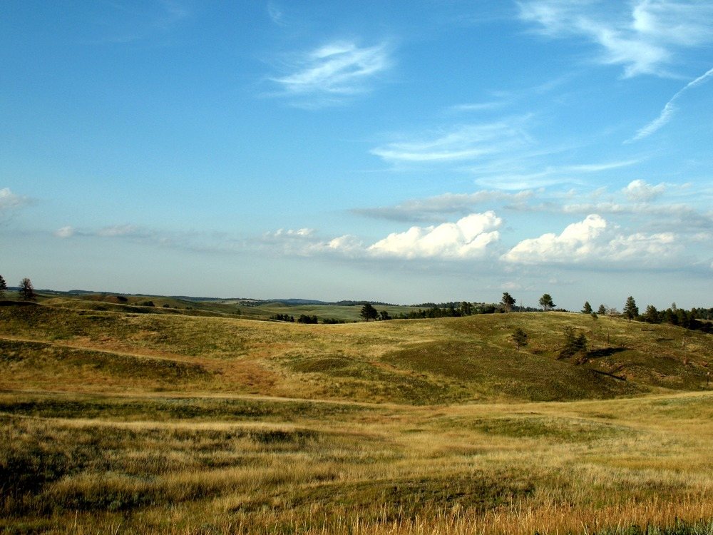

**2018**

**PAPERWORK REDUCTION and PRIVACY ACT STATEMEN**T: The Paperwork Reduction Act requires us to tell you why we are collecting this information, how we will use it, and whether or not you have to respond. We are authorized by the National Park Service Protection Interpretation and research in System (54 USC §100702) to collect this information. The routine uses of this information will be for the benefit of NPS Managers and planning staff of Wind Cave National Park (WICA) in future initiatives related to the visitor use and resource management within the site. The data collected will be summarized to evaluate visitor uses and expectations during their visit at WICA. Your responses are voluntary and anonymous. You can end the process at any time and will not be penalized in any way for choosing to do so. All contact information collected will be for the purpose of the follow-up survey only and will be destroyed at the end of the collection period. This information will not be stored or used for any other purposes. All data from this collection will be aggregated so that no responses will be individually identifiable. A Federal agency may not conduct or sponsor, and you are not required to respond to, a collection of information unless it displays a currently valid OMB Control Number (1024-0224). We estimate that it will take about 20 minutes to complete and return this mail-back questionnaire. You may send comments concerning the burden estimates or any aspect of this information collection to: Social Science Program Chief, National Park Service, 1201 Oakridge Drive, Fort Collins, CO, 80525-5596; nps_nrss_social_science@nps.gov (email); or Phadrea Ponds NPS Information Collection Coordinator at pponds@nps.gov (email).

|  |  |  |
| --- | --- | --- |
| C:\Users\brett\Pictures\RSG\720px-US-DeptOfTheInterior-Seal.svg.png | **United States Department of the Interior**  **NATIONAL PARK SERVICE**  1849 C Street, N.W.  Washington, DC 20240 | w npslogo |
| Summer, 2018  Dear Wind Cave National Park Visitor:  Thank you for participating in this study. Our goal is to learn about the expectations, opinions, and interests of visitors to the National Park System. This information will assist us in understanding how visitors experience Wind Cave National Park and the surrounding area, motivations for visiting, to inform planning and management efforts to better serve you.  This questionnaire is only being given to a select number of visitors, so your participation is very important. It should take about 20 minutes to complete after your visit.  When your visit is over, the adult in your group who will have the next birthday should complete this questionnaire. Seal it in the postage-paid envelope provided and drop it in any U.S. Postal Service mailbox.  If you have any questions, please contact William Valliere, consultant at Resource Systems Group, 55 Railroad Row, White River Junction, VT 05001; (802) 295-4999.  We appreciate your help.  Sincerely,  Superintendent | | |

|  |
| --- |
| **RETURN PROCEDURE**  At the end of your visit:  1. Please have the adult in your group (at least 18 years old) who will have the next birthday complete this questionnaire. That will help give us a statistically reliable sample.  2. For questions that use circles (O), please mark your answer by filling in the circle with ***black or blue ink***. Please do not use pencil.  Description: bubble-fill-example  3. Seal it in the postage-paid envelope provided.  4. Drop it in a U.S. Postal Service mailbox. |

**DIRECTIONS**

In this questionnaire, your **personal group** is defined as you and anyone with whom you visited Wind Cave National Park on this trip, such as a spouse, family, friends, etc. This does not include the larger group that you might have traveled with, such as a school, church, scout, or tour group.

A **visit** is defined as the day in which you were contacted to complete this questionnaire. A **trip** is defined as the total extent of time away from your personal residence that could include multiple visits to Wind Cave National Park.

**TRIP DESCRIPTION**

1.Including yourself,how many people were in your personal group during your visit to Wind Cave National Park on the day you were contacted for this survey? (Please include only direct travel companions; do not include people that are part of a larger tour group)

Number of adults (18 years or older)

Number of children (under 18 years)

2. What type of group were you with, during your visit to Wind Cave National Park on the day you were contacted for this survey? Please mark (●) **one**.

O Alone

O Friends

O Family

O Family and friends

O Other (Please specify)

3. Please indicate all of the forms of transportation you personally used to travel from your home to Wind Cave National Park, on this trip. Please mark (●) **all** **that apply**.

O Car, truck, or SUV (Number of people in vehicle, including you)

O Recreational vehicle or motorhome

O Airplane

O Tour bus or tour van

O Train or long-distance passenger bus

O Bicycle

O Walk/hike

O Other (Please specify)

4. Approximately how many hours and miles from home did you travel one way to get to Wind Cave National Park on this trip?

Number of hours **AND**  Number of miles

5. On this trip, how much total time did you spend within Wind Cave National Park?

Number of hours, if you only spent 1 day or less at Wind Cave National Park

Number of days, if you spent multiple days at Wind Cave National Park

→ If you spent multiple days at Wind Cave National Park, on how many different **days** did you pass through the park entrance? _______

6. On this trip, if you had not chosen to visit Wind Cave National Park, what other recreation site would you have visited instead? ______________________________________________________

b) How far is this alternative site from your home? ________ miles

**TRIP PLANNING AND MOTIVATIONS**

7. Prior to this trip, how did you obtain information about Wind Cave National Park? Please mark (●) **all** **that apply**.

O Did not obtain information prior to this visit

O Previous visits

O Friends/relatives/word of mouth

O Inquiry to park via phone, mail, or email

O Wind Cave National Park website (nps.gov/wica)

O Other website (Please specify)

O Local businesses (hotels, motels, restaurants, etc.)

O Maps/brochures

O Newspaper/magazine articles

O Other units of the National Park System (NPS)

O School class/program

O Social media (such as Facebook, Twitter, etc.)

O State welcome center/visitors bureau/chamber of commerce

O Television/radio programs/DVDs

O Travel guides/tour books (such as AAA, etc.)

O Other (Please specify)

8. Did you have the information about Wind Cave National Park you needed on this trip? Please mark (●) **one**.

O Yes

O No (Please specify information you needed but didn’t have on this trip.)

9. When did you and your personal group make the decision to visit Wind Cave National Park? Please mark (●) **one**.

O On the same day of the visit

O 2-7 days before the visit

O 8-30 days before the visit

O 1-6 months before the visit

O More than 6 months but less than a year before the visit

O A year or more before the visit

O Don’t know/can’t recall

**PARK ACTIVITIES, PROGRAMS, AND SERVICES**

10. On this trip, in which of the following activities did you (or a member of your personal group) participate within Wind Cave National Park? Please mark (●) **all** **that apply**.

|  |  |
| --- | --- |
| O Viewing wildlife, natural features, scenery, wildflowers, etc. | O Day hiking (1 hour or more) |
| O Creative arts (photography/drawing/painting/writing) | O Bicycling |
| O Cave tour | O Horseback riding |
| O Shopping | O Camping in developed sites |
| O Driving for pleasure | O Backcountry camping |
| O Walking/short hike (less than 1 hour) | O Picnicking |
|  |  |
| O Other (Please specify) | |
| O Other (Please specify) | |
| O Other (Please specify) | |

11. Of the activities listed in Question 10, which was your primary activity during your visit to Wind Cave National Park on the day you were contacted for this survey?

**OR**

O I did not have a primary activity on this trip to Wind Cave National Park.

12. On this trip, in which of the following programs and services did you or a member of your personal group participate within Wind Cave National Park? Please mark (●) **all** **that apply**.

O Attending a ranger-led activity, such as a cave tour or talk

(Please specify)

O Talking informally with a ranger

O Visiting the park store in the Visitor Center

O Viewing outdoor exhibits

O Viewing indoor exhibits

O Watching a video in the Visitor Center auditorium

O Reading the park brochure or newspaper

O Going to the Visitor Center

O Participating with a child in your group in the Junior Ranger program

O Obtaining National Park passport stamp

O Other (Please specify)

13. On this visit to Wind Cave National Park, did you participate in a cave tour? Please mark (●) **one**.

O Yes (Please specify tour(s) in which you participated.)

O No - 🡺 **Go to Question 17.**

14. If you were to visit Wind Cave National Park in the future, would you prefer to have a pre-visit reservation system to obtain tickets for a cave tour? Please mark (●) **one**.

O Yes

O No

15. Why did you and your personal group choose the cave tour you did?

16. Concerning the cave tour you took, please explain the parts of the experience that were especially meaningful to you.

17. a) Did anyone in your personal group have a physical condition that made it difficult to access or participate in park activities or services (such as cave tours), during your visit to Wind Cave National Park? Please mark (●) **one**.

O Yes

O No 🡺 **Go to Question 18.**

b) If YES, what activities, services, or facilities did the person(s) have difficulty participating in or accessing? Please be specific.

c) Because of the physical condition, which specified difficulties did the person(s) have? Please mark (●) **all** **that apply**.

O Hearing (difficulty hearing ranger programs, bus drivers, audio-visual exhibits or programs, or information desk staff even with hearing aid)

O Visual (difficulty in seeing exhibits, directional signs, visual aids that are part of programs even with prescribed glasses or due to blindness)

O Mobility (difficulty in accessing facilities, services, or programs even with walking aid and/or wheelchairs)

O Other (Please specify)

18. If you did not take a cave tour in Wind Cave National Park, what reasons prevented you from taking those tours. Please mark (●) **all** **that apply**.

O Had to wait too long

O Took cave tour on a previous visit

O Tours were full

O Fees were too high

O Physical limitations

O Did not know about the tours

O Lack of interest

O Other (Please specify)

O Not applicable (I was able to take a cave tour)

**EXPENDITURES**

**Please answer the following questions for your time within Wind Cave National Park *and* its surrounding local area.** The local area includes all communities **within approximately 60 miles of Wind Cave National Park** including Hot Springs, Custer, Edgemont, Keystone, Hill City, and the Rapid City area.

***Note: If you are a permanent or seasonal resident of the local area, answer the questions only for this visit to Wind Cave National Park.***

19. Do you live within the defined 60-mile local area surrounding Wind Cave National Park? Please mark (●) **one**.

O Yes, I reside in the local area (**skip to question 25**)

O No, I reside outside of the local area

20. What was the primary reason for this trip to the area? Please mark (●) **one**.

O Visiting Wind Cave National Park was the main reason I came to the local area

O Visiting Wind Cave National Park was one of several equally important reasons that I came to the local area

O I came to the local area (within 60 miles of the park) for other reasons and happened to visit Wind Cave National Park while I was in the area

21. During this trip, how much total time did you spend within Wind Cave National Park ***and*** the park’s 60 mile local area? Please mark (●) **one**.

O I was on a day trip to the area (**skip to question 25**)

O I stayed overnight within Wind Cave National Park and/or within the park’s local area.

**→** How many **total nights** did you spend in the local area? ________

Include nights spent within Wind Cave National Park ***and*** nights spent lodging or camping outside of the park but within the park’s 60 mile local area.

22. Name the town/city where you and your personal group stayed the night before your arrival at Wind Cave National Park?

Town/city ____________________ State _________________

23. In what town/city did you and your personal group stay on the night after your departure from Wind Cave National Park?

Town/city ____________________ State _________________

24. What type(s) of accommodations did you use during your stay in the local area? (Please mark (●) all that apply)

O Paid lodged outside of Wind Cave National Park but within the park’s 60 mile local area

O Stayed in unpaid lodging within the surrounding 60 mile local area (e.g., stayed in the home of friends or family)

O Stayed in my permanent or seasonal residence (owned or rented)

O Camped (campgrounds or backcountry) within Wind Cave National Park

O Camped (campgrounds or backcountry) outside of Wind Cave National Park but within the park’s 60 mile local area

🡺 Why did you choose to camp outside the park?

__________________________________________________

25. Please estimate how much shared expenses you and your personal group (e.g., other family members, traveling companions) spent at Wind Cave National Park ***and*** in the local communities surrounding the park. **This includes your time in the park *and* the** surrounding communities within approximately 60 miles of Wind Cave National Park (e.g., *Hot Springs, Custer, Edgemont, Keystone, Hill City, and the Rapid City area)*.

**Local Area Residents (only)**: If you are a permanent or seasonal resident, please only include expenditures that were directly related to this trip to Wind Cave National Park.

|  |  |
| --- | --- |
| **Expenses** | **Amount spent at Wind Cave National Park and surrounding 60 mile area** |
| Gas and oil (e.g., auto, RV, boat, etc.) | $ |
| Rental cars | $ |
| Taxis, shuttles, and public transportation | $ |
| Restaurants and bars | $ |
| Groceries and convenience foods | $ |
| Hotels, motels, resorts | $ |
| Specialty lodging (e.g., B&Bs, hostels, cabins, vacation rentals) | $ |
| Camping fees (tent, RV) | $ |
| Cave tour fee | $ |
| Guides and other tour fees | $ |
| Recreation and entertainment expenses (e.g., movies, bowling, miniature golf, etc.) | $ |
| Souvenirs, clothing, supplies, other retail | $ |
| Equipment rental | $ |
| National Park annual pass | $ |
| Other (Please list) | $ |

**OR**

O Don’t know/Not sure

O I did not spend money at Wind Cave National Park or the surrounding 60 mile area

26. a) Including yourself, how many people in your personal group were covered by the expenses for this time in the park and the surrounding 60 mile local area?

Number of adults (18 years or over)

Number of children (under 18 years)

b) Including yourself, how many people in your group split these trip expenses?

Number of people

**BACKGROUND**

27. For your personal group during your visit to Wind Cave National Park on the day you were contacted for this survey, please provide the following information. (**If you don’t know the answer, enter “DK.”**)

|  |  |  |  |  |
| --- | --- | --- | --- | --- |
|  | **Current Age** | **U.S. ZIP code or name of country other than U.S.** | **Number of visits to Wind Cave National Park in last 5 years, including this trip** | **Number of visits to other NPS sites in the last 5 years** |
| **Yourself** |  |  |  |  |
| **Member #2** |  |  |  |  |
| **Member #3** |  |  |  |  |
| **Member #4** |  |  |  |  |
| **Member #5** |  |  |  |  |

28. For your personal group during your visit to Wind Cave National park on the day you were contacted for this survey, what is the gender and ethnicity of each member of your group? Please mark (●) **one for each group member, including yourself, for gender and Hispanic or Latino. (If you don’t know the answer, mark** (●) **“Don’t know.”)**

|  |  |  |  |  |  |  |
| --- | --- | --- | --- | --- | --- | --- |
|  | |  | **Additional members of your personal group** | | | |
|  | | **Yourself** | **#2** | **#3** | **#4** | **#5** |
| Male | | O | O | O | O | O |
| Female | | O | O | O | O | O |
| Hispanic or Latino | | O | O | O | O | O |
| Not Hispanic or Latino | | O | O | O | O | O |
| **Don’t know** | O | | O | O | O | O |

29. For your personal group during your visit to Wind Cave National Park on the day you were contacted for this survey, what is the race of each member of your group? Please mark (●) **one or more for each group member, including yourself**. **(If you don’t know the answer, mark** (●) **“Don’t know.”)**

|  |  |  |  |  |  |
| --- | --- | --- | --- | --- | --- |
|  | **Yourself** | **#2** | **#3** | **#4** | **#5** |
| American Indian or Alaska Native | O | O | O | O | O |
| Asian | O | O | O | O | O |
| Black or African American | O | O | O | O | O |
| Native Hawaiian or other Pacific Islander | O | O | O | O | O |
| White | O | O | O | O | O |
| **Don’t know** | O | O | O | O | O |

30. For your personal group during your visit to Wind Cave National Park on the day you were contacted for this survey, what is the highest level of formal education completed by each member of your group? Please mark (●) **one for each group member, including yourself**. **(If you don’t know the answer, mark** (●) **“Don’t know.”)**

|  |  |  |  |  |  |
| --- | --- | --- | --- | --- | --- |
|  | **Yourself** | **#2** | **#3** | **#4** | **#5** |
| Less than high school | O | O | O | O | O |
| Some high school | O | O | O | O | O |
| High school graduate or GED | O | O | O | O | O |
| Some college, business, or trade school | O | O | O | O | O |
| College, business, or trade school graduate | O | O | O | O | O |
| Some graduate school | O | O | O | O | O |
| Master’s, doctoral, or professional degree | O | O | O | O | O |
| **Don’t know** | O | O | O | O | O |

31. Which category best represents your (personal) annual household income? Please mark(●) **one**.

O Less than $24,999

O $25,000-$34,999

O $35,000-$49,999

O $50,000-$74,999

O $75,000-$99,999

O $100,000-$149,999

O $150,000-$199,999

O $200,000 or more

O Do not wish to answer

32. Including yourself, how many people contribute to this household income?

_________ Number of people

33. Employment Status: Are you currently…? Please mark(●) **one**.

O Employed for wages

O Self-employed

O Out of work and looking for work

O Out of work but not currently looking for work

O A homemaker

O A student

O Military

O Retired

O Unable to work

34. Did your household take any unpaid vacation or take unpaid time off from work to come on this trip? Please mark(●) **one**.

O Yes

O No

35. Including yourself,how many people are in your household?

Number of people

36. When visiting an area such as Wind Cave National Park, what language do you personally prefer to use? Please mark(●) **one for speaking and one for reading**.

|  |  |  |
| --- | --- | --- |
|  | **Speaking** | **Reading** |
| English | O | O |
| Spanish | O | O |
| Other (Please specify) | O | O |

37. Is there anything else you would like to tell us about Wind Cave National Park facilities, services, or recreational opportunities?

**Thank you for your help!**

**Please place the questionnaire in the envelope provided and drop it in any U.S. Postal Service mailbox.**