OMB Number:1024-0224
Expiration Date:

Glacier Bay National Park
2018 Visitor Survey

[Backcountry/Wilderness Survey]

Paperwork Reduction and Privacy Act Statements: The Paperwork Reduction Act requires us to tell you why we are collecting this information, how we will use it, and whether or not you have to respond. We are authorized by the National Park Service Protection Interpretation and research in System (54 USC §100702) to collect this information.. The routine uses of this information will be for the benefit of NPS Managers and Planning staff Glacier Bay National Park in future initiatives related to existing visitor use patterns, experiences, and perspectives about backcountry recreation within the park. Your participation is completely voluntary and can end the process at any time without being penalized in any way for choosing to do so. All paper versions of the information collected will be destroyed at the end of the collection period and no personal identifiable records will be maintained or stored for any purposes. Data collected will only be reported in aggregates and no individually identifiable responses will be reported. A Federal agency may not conduct or sponsor, and you are not required to respond to, a collection of information unless it displays a currently valid OMB Control Number (1024-0224). We estimate that it will take about 10 minutes to complete this questionnaire. You may send comments concerning any aspect of this information collection to Chris Monz, Department of Environment and Society, Utah State University; chris.monz@usu.edu (email);; or Phadrea Ponds, NPS Information Collection Coordinator, Fort Collins, CO 80525, pponds@nps.gov (email).

1) In the past 5 years, how many trips have you made to Glacier Bay National Park, including this trip?

Once, this is my first time. | 2 | 3 | 4-10 | > 10

If you answered >10, please specify how many times you have visited.__________________________
(Numeric value only)

2) Over your lifetime, how many trips have you made to Glacier Bay National Park, including this trip?

Once, this is my first time. | 2 | 3 | 4-10 | > 10

If you answered >10, please specify how many times you have visited. ___________________________
(Numeric value only)

3) During your current visit, did you spend more than one day in the backcountry wilderness of Glacier Bay National Park (GBNP) by foot or vessel (outside of Bartlett Cove)?

 NO —If NO, for how long?
Hours __________________________

 YES— If YES, for how long?
Days _________________________
4) Please indicate the backcountry locations you visited during your trip to GBNP by indicating the location and modes:
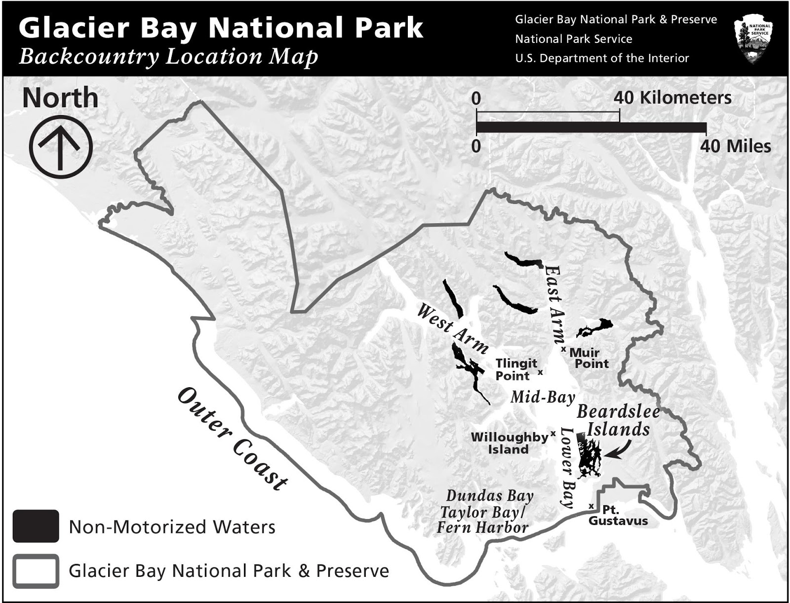

Areas Below Correspond to Reference Map Locations | Not Sure | No | Yes
Beardslee Islands | ☐ | ☐ | ☐
Non-motorized waters of Glacier Bay | ☐ | ☐ | ☐
East Arm Glacier Bay (north of Muir Point) | ☐ | ☐ | ☐
West Arm Glacier Bay (northwest of Tlingit Point) | ☐ | ☐ | ☐
Mid Bay (Willoughby Island north to Tlingit Point and Muir Point) | ☐ | ☐ | ☐
Lower Bay (north of Pt. Gustavus, south of Willoughby Island, and excluding the Beardslee Islands ) | ☐ | ☐ | ☐
Inland areas of the park (more than one mile inland from the shoreline) | ☐ | ☐ | ☐
Icy Strait/Cross Sound (Dundas Bay, Taylor Bay/Fern Harbor) | ☐ | ☐ | ☐
Outer Coast | ☐ | ☐ | ☐

Other location(s): ________________________________________________________________

5) What types of transportation did you use while visiting GBNP? (Check all that apply.)

Check all that apply
Hiking/Walking
Kayaking (personal kayak)
Kayaking (rental kayak)
Tour Boat/Charter Boat
Pack raft or other non-motorized vessel (besides kayak)
Personal Motor Boat
Personal Aircraft
Air Taxi/Charter
Other (please specify):__________________

6) What about your direct interaction with the backcountry wilderness added most to your experience?

7) What about your direct interaction with the backcountry wilderness detracted most from your experience?

8) What about your Glacier Bay National Park backcountry wilderness experience added to your ability to experience adventure?

9) Were you able to experience a connection to nature and a sense of renewal during your backcountry wilderness visit in GBNP?
- NO
If no, why not? _____________________________________________________________
- YES
If yes, how? _________________________________________________________________

10) Indicate your level of agreement or disagreement with each of the statements.
Please select only one response for each item.

 | Strongly Disagree | Disagree | Neutral | Agree | Strongly Agree
Glacier Bay National Park means a lot to me. |  |  |  |  | 
I enjoy [recreating] in Glacier Bay National Park more than in any other park |  |  |  |  | 
I am very attached to Glacier Bay National Park |  |  |  |  | 
I wouldn't substitute any other [park, wilderness area] for [what] I do in Glacier Bay National Park. |  |  |  |  | 
I identify strongly with Glacier Bay National Park. |  |  |  |  | 
I get more satisfaction out of visiting Glacier Bay National Park than from visiting any other [wilderness] area |  |  |  |  | 
A [wilderness experience] in Glacier Bay National Park is more important than a [wilderness experience] in any other place. |  |  |  |  | 
No other place can compare to Glacier Bay National Park |  |  |  |  | 

11) Please rate the quality of your experience in the following areas based on your visit within Glacier Bay National Park (GBNP). Please select only one response for each item.

 | QUALITY
Quality of…. | Not Applicable | VERY POOR | POOR | AVERAGE | GOOD | VERY GOOD
Natural Connection & Renewal  (e.g., experiencing a spiritual connection with nature; experiencing a positive change in mood | 0 | 1 | 2 | 3 | 4 | 5
Opportunities for Adventure  (e.g., experiencing a sense of challenge; being  self-reliant in the wilderness) | 0 | 1 | 2 | 3 | 4 | 5
Solitude & Natural Sounds  (e.g., being away from crowds of people; enjoying the sounds of nature) | 0 | 1 | 2 | 3 | 4 | 5
Experience Glaciers  (e.g., viewing scenic beauty and glaciers; experiencing a recently glaciated, dynamic landscape) | 0 | 1 | 2 | 3 | 4 | 5
Opportunities to View Wildlife  (e.g., viewing and photographing wildlife in nature) | 0 | 1 | 2 | 3 | 4 | 5
12) Please indicate whether you saw any of the following during your Glacier Bay National Park visit. If you did, please indicate how many and if you were bothered by what you saw.
 |  |  |  | If seen, how much did this bother you?
 | Seen during  your trip |  | Total number seen during trip | Not at All | Slightly | Moderately | Very | Extremely
Cruise ships | NO | YES |  | 1 | 2 | 3 | 4 | 5
Kayaks | NO | YES |  | 1 | 2 | 3 | 4 | 5
Tents on the beach | NO | YES |  | 1 | 2 | 3 | 4 | 5
Motorized boats (other than cruise ships) | NO | YES |  | 1 | 2 | 3 | 4 | 5
People on the beach | NO | YES |  | 1 | 2 | 3 | 4 | 5
NPS backcountry staff (such as law enforcement and researchers) | NO | YES |  | 1 | 2 | 3 | 4 | 5
Human waste | NO | YES |  | 1 | 2 | 3 | 4 | 5
Campfire rings | NO | YES |  | 1 | 2 | 3 | 4 | 5
Litter | NO | YES |  | 1 | 2 | 3 | 4 | 5
Cut bushes or trees | NO | YES |  | 1 | 2 | 3 | 4 | 5
Hiker-made trails | NO | YES |  | 1 | 2 | 3 | 4 | 5
Hiker-made campsites (e.g. soil compaction, vegetation trampling due to tents, tent rocks) | NO | YES |  | 1 | 2 | 3 | 4 | 5
Groups you saw who were on land | NO | YES |  | 1 | 2 | 3 | 4 | 5
Groups you saw who were on the water | NO | YES |  | 1 | 2 | 3 | 4 | 5
Propeller-driven aircraft | NO | YES |  | 1 | 2 | 3 | 4 | 5

13) Please indicate how the quantity of each of the following items during your visit affected the quality of your wilderness experience. Please select  only one for each item.

 | How might it affect the quality of your wilderness experience?
 | Not Applicable | Detracted  Greatly | Detract Somewhat | Had No Effect | Added Somewhat | Added Greatly
Kayaking groups encountered
Tents on beaches
Motorized boats you heard (other than cruise ships)
Vessel wakes you saw, heard or felt
Cruise ships you saw and/or heard
Scientific research signs, including people and equipment
NPS backcountry staff (law enforcement, researchers)

14) Did the actions or behavior of any other group or individual interfere with your enjoyment of the wilderness on this trip?

- NO
- YES
If YES, how did they specifically interfere with your enjoyment of this trip?
______________________________________________________________________________________________________________________________________________________________________

15) Did you have difficulty finding a place to camp or anchor based on the number or location of other groups you encountered? (Check one.)

- NO
- YES
If yes, where? _____________________________________________________
- Not Applicable

16) Please indicate if you heard the following sound during your wilderness trip. If so, how was your backcountry wilderness experience affected, compared to what you expected? Please select  only one response for each item.

 |  |  | If seen, how much did this bother you?
 | Seen during  your trip |  | Not at All | Slightly | Moderately | Very | Extremely
Sound of generators | NO | YES | 1 | 2 | 3 | 4 | 5
Vessel wake crashing on the beach | NO | YES | 1 | 2 | 3 | 4 | 5
People shouting or speaking loudly | NO | YES | 1 | 2 | 3 | 4 | 5
Loud music | NO | YES | 1 | 2 | 3 | 4 | 5
Public address system aboard commercial vessels | NO | YES | 1 | 2 | 3 | 4 | 5
Boat motors | NO | YES | 1 | 2 | 3 | 4 | 5
Aircraft | NO | YES | 1 | 2 | 3 | 4 | 5
Other

NOTE TO REVIEWER: For Questions 17 and 18 the respondent will be asked to review a series of photographs used to depict various levels of environmental impacts due to recreational activities. Respondents will be shown one photograph at a time in a pre-determined order. For both questions the respondent will be asked to view each photo and indicate their level acceptable for each the condition depicted in each photo. The first photo will be the base photo and we will add an increasing level of impacts totaling 5 photos.

17) Please rate the following images according to how unacceptable or acceptable the number of tents on the beach is while in wilderness. Please use the scale below to indicate how unacceptable or acceptable the images are to you.

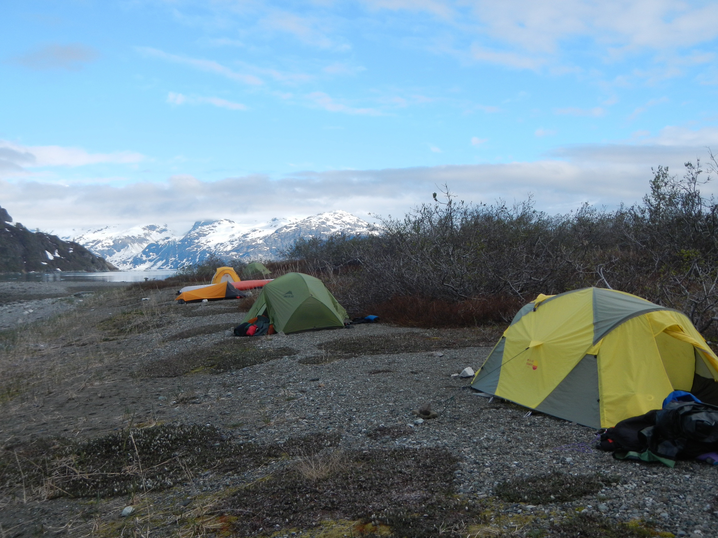

PHOTO 2

PHOTO 4

PHOTO 3

PHOTO 5

 | Highly unacceptable | Unacceptable | Slightly unacceptable | Neutral | Slightly acceptable | Acceptable | Highly acceptable
Photo 1 | -3 | -2 | -1 | 0 | +1 | +2 | +3
Photo 2 | -3 | -2 | -1 | 0 | +1 | +2 | +3
Photo 3 | -3 | -2 | -1 | 0 | +1 | +2 | +3
Photo 4 | -3 | -2 | -1 | 0 | +1 | +2 | +3
Photo 5 | -3 | -2 | -1 | 0 | +1 | +2 | +3

18) Please rate the following images according to how unacceptable or acceptable the coastal conditions are while in wilderness. Please use the scale below to indicate how unacceptable or acceptable the images are to you.
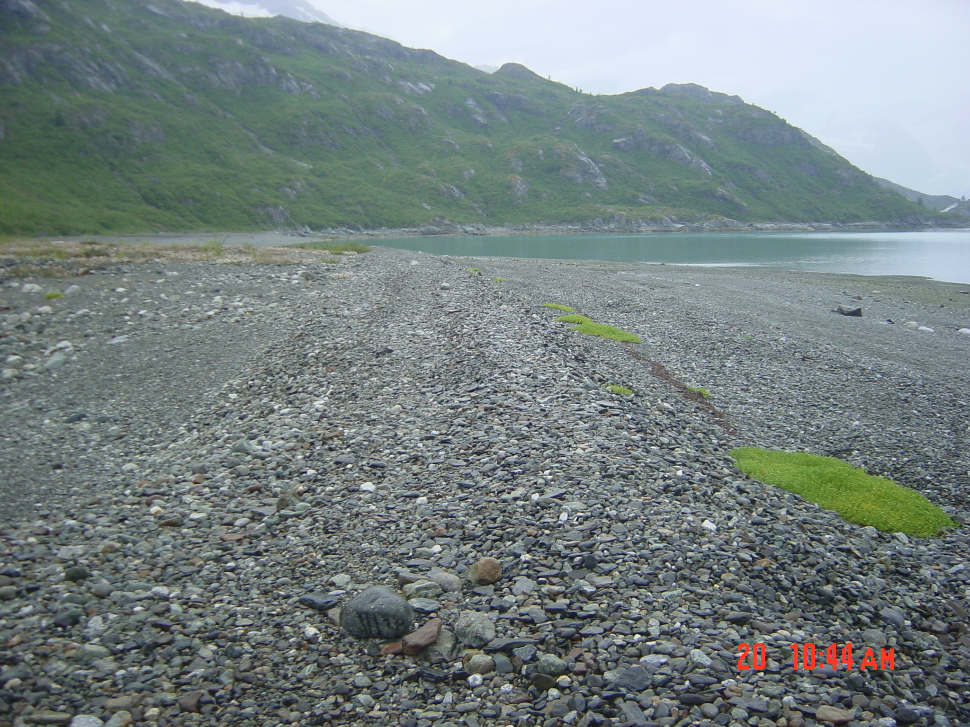

PHOTO 2

PHOTO 4

PHOTO 3

PHOTO 5
 | Highly unacceptable | Unacceptable | Slightly unacceptable | Neutral | Slightly acceptable | Acceptable | Highly acceptable
Photo 1 | -3 | -2 | -1 | 0 | +1 | +2 | +3
Photo 2 | -3 | -2 | -1 | 0 | +1 | +2 | +3
Photo 3 | -3 | -2 | -1 | 0 | +1 | +2 | +3
Photo 4 | -3 | -2 | -1 | 0 | +1 | +2 | +3
Photo 5 | -3 | -2 | -1 | 0 | +1 | +2 | +3

19) While visiting wilderness areas, how might experiencing each of the following items affect the quality of your backcountry wilderness experience? Please select  only one for each item.

 | How might it affect the quality of your wilderness experience?
 | Detract Greatly | Detract Somewhat | No Effect | Add Somewhat | Add Greatly
Encountering NPS backcountry staff |  |  |  |  | 
Being required to use bear cans |  |  |  |  | 
Presence of designated campsites |  |  |  |  | 
Presence of developed facilities (e.g. …rain shelters, bridges over rivers) |  |  |  |  | 
Presence of outhouses |  |  |  |  | 
Presence of floating cabins or rafts |  |  |  |  | 
Presence of developed trails |  |  |  |  | 

20) How would you describe your current knowledge of “Leave No Trace” practices? Please select only one number.

No Knowledge | Very Limited | Limited | Fair | Above Average | Extensive
0 | 1 | 2 | 3 | 4 | 5

21) What, if anything, prevented you from following Leave No Trace practices while traveling in the backcountry? ________________________________________________________________________________________
________________________________________________________________________________________

22) How did the amount of information provided by the backcountry orientation video at the Visitor Information Station affect your backcountry wilderness experience?

 | Detract Greatly | Detract Somewhat  (way too much information) | No Effect | Add Somewhat | Added Greatly  (the right amount of information)
Tides | 1 | 2 | 3 | 4 | 5
Routes | 1 | 2 | 3 | 4 | 5
Bears/Food Storage | 1 | 2 | 3 | 4 | 5
Selecting campsites | 1 | 2 | 3 | 4 | 5
NPS regulations on what you can do | 1 | 2 | 3 | 4 | 5
NPS regulations on where you can go | 1 | 2 | 3 | 4 | 5
Day boat transportation | 1 | 2 | 3 | 4 | 5
Potential challenges | 1 | 2 | 3 | 4 | 5
Importance of self-reliance | 1 | 2 | 3 | 4 | 5
Human waste | 1 | 2 | 3 | 4 | 5
Other

23 a) Are there any gaps in the information provided in the backcountry orientation video and the NPS staff presentation that would have added to your backcountry wilderness experience?
 YES
 NO

b) What would you [and your personal group] recommend to improve the current backcountry orientation video and the NPS staff presentation provided by GBNP? Please be specific.

_____________________________________________________________________________________

_____________________________________________________________________________________

24) Please provide the following information:

a) What is your home ZIP code? ____________________________
OR, what country are you from? __________________________________

25) How many people were in your group, including you? _______ [Number of people]

26) What is your age? _________

27) What is your gender?
Male
Female

28) Are there any other comments you would like to provide the park regarding your wilderness experience or the way the park manages wilderness in Glacier Bay National Park?

_____________________________________________________________________________________

_____________________________________________________________________________________

