Bryce Canyon Visitor Transportation Survey

2019

National Park Service

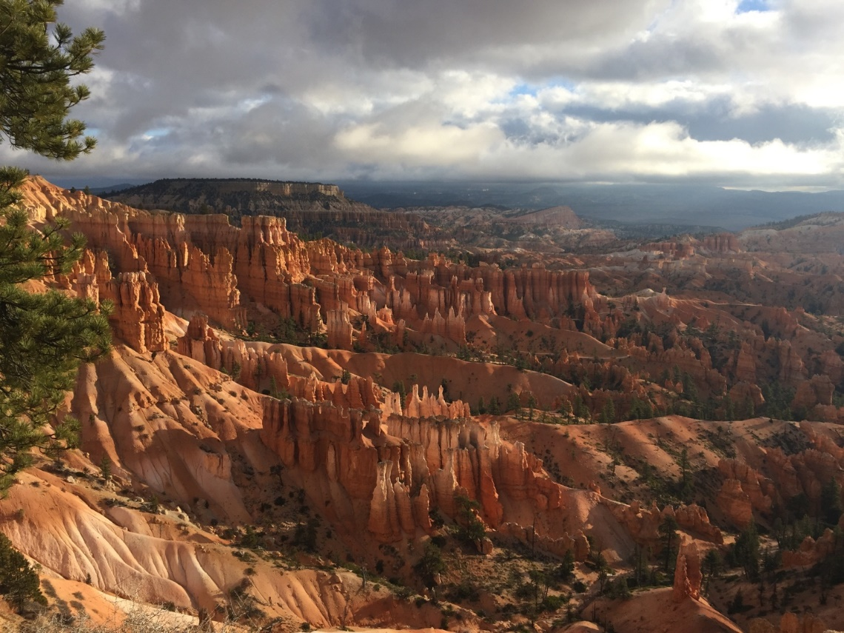

Survey ID: ____________ Date: ______________ Attendant: _________________________

Location Administered:

|  |  |  |  |
| --- | --- | --- | --- |
| * Fairyland Point | * Sunset Point | Inspiration Point | Mossy Cave |
| * Sunrise Point | * Rainbow Point | Bryce Point |  |

**Paperwork Reduction and Privacy Act Statements:** The Paperwork Reduction Act requires us to tell you why we are collecting this information, how we will use it, and whether or not you have to respond. The data collected in this study will assist mangers in understanding visitor’s level transportation experience in *Bryce Canyon National Park*. Additional your input will be critical in understand possible future management scenarios at the park. Your responses are voluntary and anonymous. Your name and address will not be collected. At the completion of this collection all personal information will be destroyed and in no way be connected with the results of this survey. A Federal agency may not conduct or sponsor and you are not required to respond to, a collection of information unless it displays a currently valid OMB Control Number.

**Burden Estimate:** We estimate that it will take an average of 10 minutes to complete this questionnaire. You may send comments concerning the burden estimates or any aspect of this information collection to: Linda Mazzu, Superinrtendent Bryce Canyon National Park, linda_mazzu@nps.gov (email) or the Social Science Branch, National Park Service, 1201 Oakridge Drive, Fort Collins, CO, 80525-5596; nps_nrss_social_science@nps.gov (email).

*Dear Bryce Canyon National Park Visitor,*

*The National Park Service is conducting this survey to learn more about our visitors’ experiences traveling in the park so that we can improve our service to you. You are one of a select number of people randomly chosen for this survey, so your feedback is important to us. Participation is voluntary and you may skip any question you do not wish to answer. This survey takes about 10 minutes to complete and all the information collected will be anonymous. Please read each question carefully.*

**TA1: AGE1**

What is your age? ____________

**TA1: EDUC1**

What is the highest level of formal education you have completed? (Please select only one response)

|  |  |
| --- | --- |
| * Less than high school | * Two-year college degree |
| * Some high school | * Four-year college degree (or Bachelor’s degree) |
| * High school graduate | * Master’s Degree (or Graduate degree) |
| * Vocational/trade school certificate | * Ph.D., M.D., J.D., or equivalent |
| * Some college |  |

**TA1: GEND1**

What is your gender? Please select one.

|  |  |
| --- | --- |
| * Male | * Female |

**TA1: RACE/ETH1**

For you only, are you Hispanic or Latino?

|  |  |
| --- | --- |
| * YES | * NO |

**TA1: RACE/ETH2**

Which of these categories best indicates your race? Answer only for yourself. Please select **one or more**.

* American Indian or Alaska Native
* Asian
* Black or African American
* Native Hawaiian or other Pacific Islander
* White

**TA1: RES2**

Are you a permanent resident or citizen of the United States?

* NO – What is your country of origin? __________________________
* YES – What is your ZIP code and state of residence?  
  State______________________ ZIP code_________________________

**TA1: GROUP1**

Please select the choice below that best describes your traveling party. (Please select only one choice)

|  |  |
| --- | --- |
| * Individual | * Family plus friends |
| * Family only | * Tour or other group |
| * Friends only |  |

**TA1: GROUP7**

Does anyone in your personal group have physical conditions that made it difficult to access or participate in park activities or services?

* NO
* YES

🡪 If **YES**, on this visit what activities or services did the person(s) have difficulty accessing or participating in?

(Please describe): _______________________________________________

🡪 Because of the physical condition, which specific difficulties did the person(s) have? Please select **all** that apply.

* Hearing (difficulty hearing ranger programs, bus drivers, audio-visual exhibits or programs, or information desk staff even with hearing aid)
* Visual (difficulty in seeing exhibits, directional signs, visual aids that are part of programs even with prescribed glasses or due to blindness)
* Mobility (difficulty in accessing facilities, services, or programs even with walking aid and/or wheelchairs)
* Other (Please specify): __________________________________________

**TA2: ITIN1**

How would you describe your planning for this trip? (Please select only one response)

* Carefully planned
* Some pre-planning
* Very little pre-planning
* Spontaneous; no planning

**TA2: ITIN2**

When did you make the decision to visit Bryce Canyon National Park? (Please select only one response)

* On the same day of the visit
* A week before the visit
* 1 month before the visit
* 2-6 months before the visit
* More than 6 months but less than a year before the visit
* A year or more before the visit
* Don’t know/Can’t recall

**TA2: ITIN4**

How did your visit to Bryce Canyon National Park fit into your travel plans? (Please select only one)

* This park is my primary destination
* This park is one of several destinations
* I am passing through the park to my primary destination
* I did not plan to visit this park

**TA2: ITIN14**

What was the main source that you used for planning your trip to Bryce Canyon National Park? (Please select one)

* National Park Service website or other materials
* Commercial tour group
* Bryce Canyon National Park tickets website
* Travel agent
* Hotel concierge
* Word-of-mouth
* Other (please specify): _________________________________________________

**TA2: ITIN22**

Prior to your trip, how did you and your personal group obtain information to plan the transportation and travel-related details of your trip? (Check all that apply) For each source used, how helpful was the information you received? (Please select one response for each source used or check the box if you did not use any of the sources to plan your trip)

|  |  |  |  |  |  |  |
| --- | --- | --- | --- | --- | --- | --- |
|  | **Not at all Helpful** | **Slightly Helpful** | **Moderately Helpful** | **Very Helpful** | **Extremely Helpful** | **Did not use to plan trip** |
| Federal or State websites | 1 | 2 | 3 | 4 | 5 |  |
| Other websites | 1 | 2 | 3 | 4 | 5 |  |
| Social media (e.g. Facebook, Twitter, etc.) | 1 | 2 | 3 | 4 | 5 |  |
| Visitor bureaus, Visitor centers | 1 | 2 | 3 | 4 | 5 |  |
| Maps, brochures or pamphlets | 1 | 2 | 3 | 4 | 5 |  |
| Previous visits | 1 | 2 | 3 | 4 | 5 |  |
| Travel guides and tour books | 1 | 2 | 3 | 4 | 5 |  |
| Newspaper/magazine article | 1 | 2 | 3 | 4 | 5 |  |
| Radio/TV broadcasts | 1 | 2 | 3 | 4 | 5 |  |
| Package tour companies | 1 | 2 | 3 | 4 | 5 |  |
| Word of mouth (e.g. friends or relatives) | 1 | 2 | 3 | 4 | 5 |  |
| Other (please specify) ___________________ | 1 | 2 | 3 | 4 | 5 |  |

**TA2: ITIN17**

In planning the itinerary for this trip, were there any places or times you avoided because of conditions you have encountered in the past?

* NO
* YES – please describe the conditions you wanted to avoid ________________________________________________________________________________________________________________________________________________________________________________________________________________________

**TA2: INFOSOURCE8**

How likely would you have been to use each of the following sources of information to plan your trip to Bryce Canyon National Park, if you could have gotten information about parking and crowding conditions at Bryce Canyon National Park? (Check one box for each item)

|  |  |  |  |
| --- | --- | --- | --- |
|  | **Likely** | **Not Likely** | **Don’t Know/Not Sure** |
| Website |  |  |  |
| Smartphone app |  |  |  |
| Social media (e.g. Facebook, Twitter) |  |  |  |
| Text updates on cellular phone/smartphone |  |  |  |
| AM radio station |  |  |  |
| Telephone information line (message updated daily) |  |  |  |
| Tourist information center |  |  |  |
| Other (Please specify): _____________________________ |  |  |  |

**TA2: ITIN8**

Before your most recent visit to Bryce Canyon National Park, which mode(s) of transportation did you plan to use when you visit, and which did you actually use once you arrived? (Please check ALL that apply)

|  |  |  |
| --- | --- | --- |
| **Planned to use** | **Actually used** |  |
|  |  | Personal vehicle (car, RV, motorcycle) |
|  |  | Rented vehicle |
|  |  | Visitor Shuttle/Bus |
|  |  | Bicycle |
|  |  | Walking/Hiking |
|  |  | Tour Bus |

**TA3: TRANSMODE4**

If you arrived in a private passenger vehicle (not a bus or shuttle), how many people were in the vehicle, including yourself?

Number of passengers ________________

**TA4: DEST9**

On this visit, how long did you and your personal group stay at Bryce Canyon National Park? Please list partial hours as 1/4, 1/2, or 3/4.

Number of **hours**, if less than 24 hours _________

**OR**

Number of **days**, if 24 hours or more __________

**TA4: DEST17**

What time of day did you arrive at Bryce Canyon National Park on the first day of your visit? (Please select **only one** response)

|  |  |  |  |  |  |
| --- | --- | --- | --- | --- | --- |
| **Early Morning Before 8 a.m.** | **Morning (8 a.m. to 10 a.m.)** | **Mid-day (10 a.m. to 2 p.m.)** | **Late afternoon (2 p.m. to 4 p.m.)** | **Early Evening (4 p.m. to 6 p.m.)** | **Evening (after 6 p.m.)** |
|  |  |  |  |  |  |

**TA3: TRANSEVAL6**

To what extent did the following factors impact your visit to Bryce Canyon National Park? (Check one box for each statement)

|  |  |  |  |  |  |
| --- | --- | --- | --- | --- | --- |
|  | **Level of Impact** | | | | |
|  | **Not at all** | **Very little** | **Somewhat** | **To a great extent** | **Not applicable** |
| Traffic congestion on roads |  |  |  |  |  |
| Traffic congestion at entrance stations |  |  |  |  |  |
| Lack visual indication of arrival |  |  |  |  |  |
| Parking congestion/shortages |  |  |  |  |  |
| Traffic congestion at scenic overlooks |  |  |  |  |  |
| Lack of shuttle service/options |  |  |  |  |  |
| Unacceptable shuttle wait times |  |  |  |  |  |
| Passenger crowding on shuttles |  |  |  |  |  |
| Parking in unendorsed areas |  |  |  |  |  |
| Intersection and roadway safety |  |  |  |  |  |
| Lack of accessibility for people with disabilities |  |  |  |  |  |
| Pedestrian/vehicle conflicts |  |  |  |  |  |
| Wildlife/vehicle conflicts |  |  |  |  |  |
| Other (Please specify: ______________________________) |  |  |  |  |  |

**TA3: PARKING15**

On this visit to Bryce Canyon National Park, did you and your group experience any parking problems?

* NO
* YES

🡪 If **YES**, how did you respond to the parking problem?

* Waited until a parking spot opened near my intended destination
* Parked some distance away from my intended destination and walked
* Went to alternative destination
* Parked somewhere else and took the park shuttle to my destination
* Other (please specify): _______________________________________

**TA3: TRANSERV2**

Did you and your personal group use the Bryce Canyon Shuttle on this visit?

* NO
* YES

**TA3: TRANSERV5**

How long did you have to wait for the Bryce Canyon Shuttle?

Number of minutes __________

**TA3: TRANSERV6**

In your opinion, at what point is the wait time for the Bryce Canyon Shuttle no longer acceptable?

Number of minutes __________

**TA3: TRANSERV8**

If you used the Bryce Canyon Shuttle, how would you rate your overall travel experience on your trip?

* Excellent
* Good
* Fair
* Poor
* Very Poor

**TA3: TRAFFIC7**

During your recent visit, how much of a problem, if any, do you think the following travel issues were at Bryce Canyon National Park? Please read each question carefully and select the number that best describes your opinion. (Please select one number to rate each item)

|  |  |  |  |  |
| --- | --- | --- | --- | --- |
|  | **Not a problem** | **Small Problem** | **Moderate Problem** | **Big Problem** |
| Not enough travel and traffic information to help visitors plan for trips in Bryce Canyon National Park | 1 | 2 | 3 | 4 |
| Too many autos in Bryce Canyon National Park that impacts my experience | 1 | 2 | 3 | 4 |
| Ability to fully access desired recreation opportunities and attractions in Bryce Canyon National Park | 1 | 2 | 3 | 4 |
| Too many recreational vehicles in Bryce Canyon National Park that impacts my experience | 1 | 2 | 3 | 4 |
| Too many tour buses in Bryce Canyon National Park that impacts my experience | 1 | 2 | 3 | 4 |
| Seeing electronic bus signs in Bryce Canyon National Park | 1 | 2 | 3 | 4 |
| Too many autos having a negative impact on air quality | 1 | 2 | 3 | 4 |
| Too many people in Bryce Canyon National Park that impacts my experience | 1 | 2 | 3 | 4 |
| Vehicles parked along main roads causing unsafe conditions | 1 | 2 | 3 | 4 |
| Too many autos outside Bryce Canyon National Park that impacts my experience | 1 | 2 | 3 | 4 |

**TA3: TRAFFIC4**

Compared to what you expected, how much traffic congestion did you experience during your visit to Bryce Canyon National Park?

* I didn’t know what to expect
* Less traffic congestion than I expected
* About the same as I expected
* More traffic congestion than I expected

**TA3: TRAFFIC11**

Approximately what time of day did you first encounter traffic congestion problems? (Check one box)

|  |  |
| --- | --- |
| * 9:00 am | * 1:00 pm |
| * 10:00 am | * 2:00 pm |
| * 11:00 am | * 3:00 pm |
| * Noon | * Other ______________________ |

**TA6: CROWD23**

How crowded did you feel while at the following locations at Bryce Canyon National Park? (Please select one number for each location, or indicate that it was not applicable)

|  |  |  |  |  |  |  |
| --- | --- | --- | --- | --- | --- | --- |
|  | **Not at all Crowded** | **Slightly Crowded** | **Moderately Crowded** | **Very Crowded** | **Extremely Crowded** | **Not Applicable** |
| At the Visitor Center | 1 | 2 | 3 | 4 | 5 | N/A |
| On trails | 1 | 2 | 3 | 4 | 5 | N/A |
| In parking lots | 1 | 2 | 3 | 4 | 5 | N/A |
| On park roads | 1 | 2 | 3 | 4 | 5 | N/A |
| At view points | 1 | 2 | 3 | 4 | 5 | N/A |
| At the picnic area | 1 | 2 | 3 | 4 | 5 | N/A |
| During your entire visit | 1 | 2 | 3 | 4 | 5 | N/A |

**TA3: TRANSEVAL1**

Please rate your level of support or opposition for the following transportation management options for managing visitor use in Bryce Canyon National Park. (Please select one response for each item)

|  |  |  |  |  |  |
| --- | --- | --- | --- | --- | --- |
|  | **Strongly support** | **Slightly support** | **Neither** | **Slightly oppose** | **Strongly oppose** |
| Provide additional pull-outs for scenic views/attractions | 1 | 2 | 3 | 4 | 5 |
| Temporarily close congested park roads | 1 | 2 | 3 | 4 | 5 |
| Develop more parking at key attractions | 1 | 2 | 3 | 4 | 5 |
| Divert visitor traffic away from congested roads or attractions | 1 | 2 | 3 | 4 | 5 |
| Offer more frequent park shuttle bus service (free) | 1 | 2 | 3 | 4 | 5 |
| Increase hours of operation for the shuttle bus | 1 | 2 | 3 | 4 | 5 |
| Limit the number of private vehicles entering the park | 1 | 2 | 3 | 4 | 5 |
| Add shuttle bus service (free) to more areas of the park | 1 | 2 | 3 | 4 | 5 |
| Require use of park-and-ride shuttle system with automobile parking inside the park | 1 | 2 | 3 | 4 | 5 |

**TA9:** **OPMGMT9**

What could the managers at Bryce Canyon National Park do as they plan for the future? Please be specific.

____________________________________________________________________________________________________________________________________________________________

**TA9: OPMGMT10**

Is there anything else you would like to tell us about your visit to Bryce Canyon National Park?

____________________________________________________________________________________________________________________________________________________________

*Thank you for your help with this study! Please return this questionnaire to the Research Assistant.*

Paperwork Reduction Act Statement Here