
OMB Control Number: xxxxx
Expiration Date: xxxxx

National Park Service
U.S. Department of the Interior

Denali National Park and Preserve Winter-Month Visitor Survey
Your perspective matters!

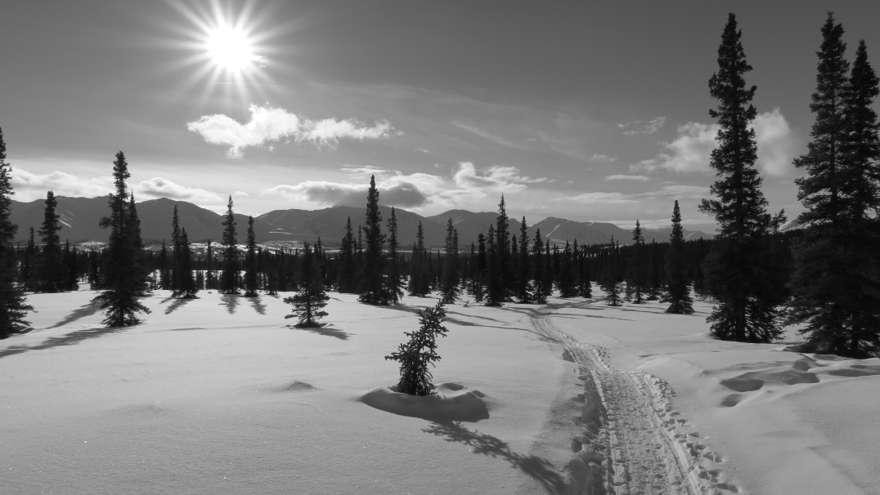

Paperwork Reduction Act Statement: PAPERWORK REDUCTION ACT STATEMENT: The National Park Service is authorized by the NPS Research Mandate (54 USC 100702) to collect this information. This information will be used by park managers to understand experiences with trails and roads in Denali during the late winter season of the Park. in Denali National Park and Preserve. Responses to this request are voluntary and anonymous. Your name will never be associated with your answers, and all contact information will be destroyed when the data collection is complete. No action may be taken against you for supplying or refusing to supply the information requested. An agency may not conduct or sponsor, and a person is not required to respond to, a collection of information unless it displays a currently valid OMB control number and expiration date.
BURDEN ESTIMATE: We estimate that it will take about 10 minutes to complete this questionnaire. You may send comments concerning the burden estimates or any aspect of this information collection to: Dr. Rose Keller, Denali National Park &Preserve Social Scientist; rose_keller@nps.gov (email).

Please put your survey code number here ____ ____ ____ ____
OR
If you no longer have your survey code number, please provide the email address you used to receive this survey ________________________________________

Welcome to Denali National Park and Preserve! You have been selected to help park management understand more about the experiences of winter-month Denali visitors. We would like to hear your motivations for visiting Denali during winter months. Your responses will provide us with insight that we may use in our management strategies to provide world-class arctic recreational opportunities. Please take the time to complete the survey and return it before you leave the park.

TOPIC AREA 2: TRIP PLANNING (ITIN 4)
1. In your lifetime, how many visits have you made to Denali National Park?
_______ Visits (write the number of visits in the space provided)
This is my first visit
TOPIC AREA 7: EVALUATION OF SERVICES (EVALSERV6-VARIATION)
2. From the options given, what is your primary motivation for visiting Denali? (check one)
Experience the quiet of nature of the sub-arctic winter | Explore my sense of self
Experience a sense of adventure/challenge  View wolves  View other wildlife  View Denali | Ski  Snowshoe  Hike  Skijour
TOPIC AREA 4: TRIP CHARACTERISTICS (DEST 9)
3. How long is your trip in Alaska?
Number of Days _______ I live here
TOPIC AREA 4: TRIP CHARACTERISTICS (Variant of DEST 9)
4. How long do you plan to stay in Denali?
Only today
1 night
2 nights
3 or more nights
TOPIC AREA 4: TRIP CHARACTERISTICS (DEST 9)
5. Was your stop in Denali an unplanned stop on your way to Fairbanks/Anchorage?
Yes No
TOPIC AREA TOPIC AREA 2: TRIP PLANNING (VARIATION OF ITIN 16)
6. Are you aware that the Denali Park Road is open to Mountain Vista?
Yes No (if NO, skip to Question # 10)

TOPIC AREA TOPIC AREA 2: TRIP PLANNING (ITIN 14)
7. If YES, when did you learn that?
Before you planned a trip to Denali
While in Alaska but before reaching Denali
During your trip planning to Denali
During your trip within Denali
TOPIC AREA 2: TRIP PLANNING (INFOSOURCE29)
8. If YES, how did you learn that? (Check all that apply)
Online article/blog
Tourism publication (print)
Called the park ahead of trip
Other ________________________
TOPIC AREA 3: TRIP BEHAVIOR: LEARN (LEARN 5)
9. If YES, were you aware that the road being open to Mountain Vista in winter is a new Denali service?
Yes No
TOPIC AREA TOPIC AREA 3: TRIP BEHAVIOR: FUTURE VISIT (FVIS 3)
10. If NO, would you have changed your trip had you known the road was open to Mountain Vista?
Yes No
TOPIC AREA 5: RECREATION HISTORY: (RecEXP1)
11. How did you/would you have change(d) your trip because the road is open to Mountain Vista (check all that apply)?

Brought or would have brought snow sport equipment (e.g. snowshoes, skis, etc.)
Planned/would have planned a winter backpacking or ski trip
Planned/would have planned more time in Denali (explain) ____________________
Planned/would have planned less time in Denali (explain) _____________________
Other (write) _________________________________________________________
TOPIC AREA 5: RECREATION HISTORY: (RecBACK5)
12. Do you use Denali’s formal trails?
Yes No
TOPIC AREA 9: OPINIONS ABOUT MANAGEMENT (OPMGMT 9)
13. If you answered NO to # 12, what changes should the Park consider that you would use formal trails?
_______________________________________________________________________________________________________________________________________________________________
TOPIC AREA 9: OPINIONS ABOUT MANAGEMENT OPMGMT 4)
14. Do you support having formal trails in the following areas? Check the area(s) that you support.
Wonder Lake/Kantishna
Southside
Entrance Area
Park Road Corridor
Park Hwy Corridor
I do not support formal trails
Don’t know/No opinion
TOPIC AREA 9: OPINIONS ABOUT MANAGEMENT OPMGMT 4)
15. Do you support having formal winter trails?
Yes No Don’t Know/No opinion
TOPIC AREA 4: TRIPCHARACTERISTICS: (FVIS 11)
16. Which of the following programs would improve your experience of formal trails? (Check all that apply).
Provided information for a self-guided tour
Provided season specific (winter/summer) trail markers
Provided trail maps at junctions
Trails digital app
A day hiker information desk
TOPIC AREA 3: TRIP PURPOSE (TPURPOSE1)
17. Do you visit the park to specifically hike off-trail (avoiding all formal and informal trails)?
Often Sometimes Never
TOPIC AREA 6: EVALUATION/OPINIONS OF SERVICES (Variation OPMGMT 6)
18. To what extent do you agree or disagree that Denali should maintain a “primary no trails in designated Wilderness” policy?
Agree No Opinion Disagree

TOPIC AREA 6: EVALUATION/OPINIONS OF SERVICES (Variation OPMGMT 8)
19. How would you like park managers to address informal trails?
Close and revegetate them
Leave them as they are
Formalize them as maintained trails
Other (Please Specify): _______________________________________________________
TOPIC AREA 1: RESPONDANT CHARACTERISTICS
20. What is your gender? (Please write in) _________

21. What is your age? (Please write in) _________

22. Which category best describes your household’s total income in the past 12 months?
under 25,000 70,000—99,999 200,000 or more
26,000—39,999 100,000—150,000 prefer not to answer
40,000– 69,999 150,000—200,000

TOPIC AREA 7: ECONOMIC IMPACT and BENEFIT
23. What is the total anticipated cost of this trip to Denali? (Estimate from when you left home to when you return) ($)__________________

TOPIC AREA 1: RESPONDANT CHARACTERISTICS (RES 1)
24. From where are you visiting? (Check one, and write in)
Alaska (provide zip code) ________________
Other U.S. State (provide State) ________
International (provide Country) _______________________________

TOPIC AREA 1: RESPONDANT CHARACTERISTICS LANG 1
25. Do you speak English fluently? Yes No

TOPIC AREA 1: RESPONDANT CHARACTERISTICS (Variation LANG 1)
26. What is your native language? _________________

TOPIC AREA 1: RESPONDANT CHARACTERISTICS (ED 2)
27. What is your level of formal education? (Check one)
Some high school
High school graduate
Vocational/trade school certificate
Some college
Two-year college degree
Four-year college degree [or bachelor’s degree]
Master’s degree [or graduate degree]
Ph.D., M.D., J.D., or equivalent

TOPIC AREA 1: RESPONDANT CHARACTERISTICS (GR 1)
28. How many are in your group? (Write in) ___________________

TOPIC AREA 1: RESPONDANT CHARACTERISTICS (GR 2)
29. What kind of group are you travelling with on this trip? (Check one)
Family
Friends
Family and friends
Guided tour (which one?) ___________________________________________________
Traveling alone

Please use the space below to provide additional comments

THANK YOU for your help and feedback. Your experience in Denali’s Backcountry truly matters!

