 | National Park Service  U.S. Department of the Interior  OMB Approval Number 1024-0224  Expiration Date 5-31-2019

Hot Springs National Park
Visitor Study

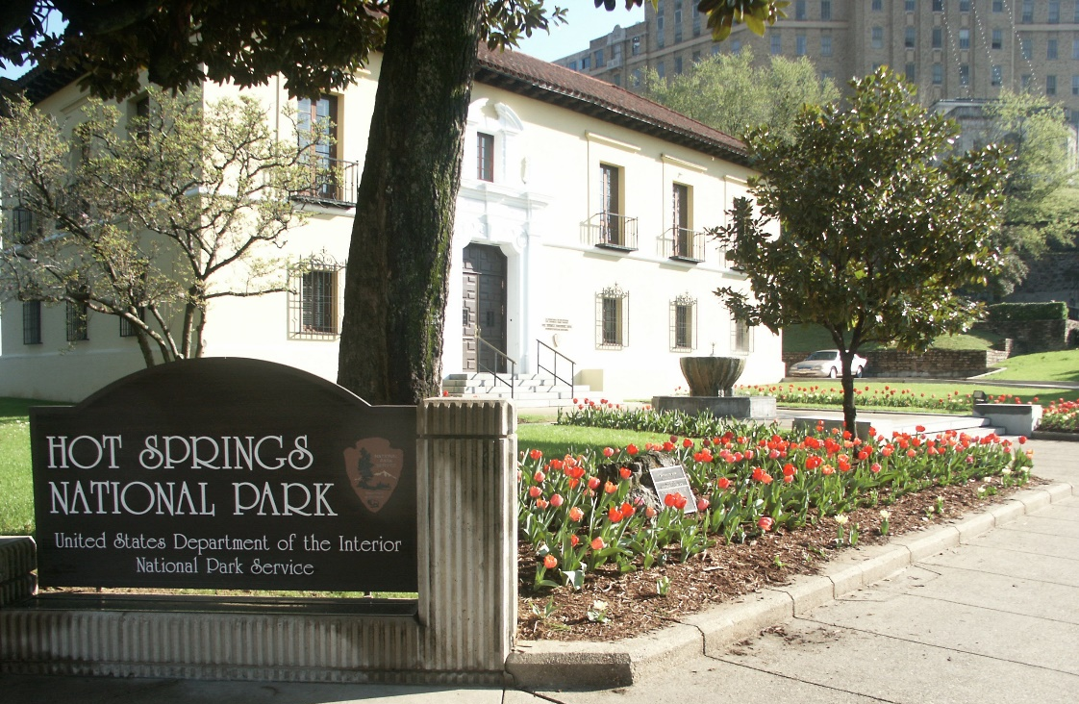

Downtown District

2017

ID: Date:

Time: AM PM Location: ________________________

Weather: Sunny Partly Cloudy Overcast/Rain Storm

Noteworthy Event? No Yes (Specify) ________________________________________

Paperwork Reduction and Privacy Act Statements: The Paperwork Reduction Act requires us to tell you why we are collecting this information, how we will use it, and whether or not you have to respond. The National Park Service is authorized by the NPS Research Mandate (54 USC 100702) to collect this information. This information will be used by park managers to refine the NPS public use statistics counting procedures for Hot Springs National Park. Your responses are voluntary and anonymous. A Federal agency may not conduct or sponsor, and you are not required to respond to, a collection of information unless it displays a currently valid OMB Control Number.

Burden Estimate: We estimate that it will take an average of 8 minutes to complete this questionnaire. You may send comments concerning the burden estimates or any aspect of this information collection to the Social Science Program Chief, National Park Service, 1201 Oakridge Drive, Fort Collins, CO, 80525-5596; nps_nrss_social_science@nps.gov (email).

DIRECTIONS
Please have the adult in your group (at least 18 years old) having the next birthday complete this questionnaire.
A visit is defined as the day in which you were contacted to complete this questionnaire. A trip is defined as the total extent of time away from your personal residence that could include multiple visits to Hot Springs National Park.
For questions that use circles (O), please mark your answer by filling in the circle with black or blue ink. Please do not use pencil.

SECTION 1
Group and Trip Characteristics

GROUP5:
1. Including yourself, how many people are in your personal group during your visit to Hot Springs National Park (NP) today?
Number of adults (18 years or older)
Number of children (under 18 years)

GROUP1:
2. On this trip to Hot Springs NP, what type of group are you with? Please mark (●) one.
O Alone
O Family
O Friends
O Family and friends
O Other (Please specify)

TPURPOSE1:
3. Please select your primary reason for visiting Hot Springs NP today? Please mark (●) one.
O For recreation, education, or pleasure, including visits of any duration
O To travel to work, home, or some other location outside of the Hot Springs NP
O To use park facilities (e.g., shops, bathrooms, bathhouses, jug fountains)
O To work, volunteer, or conduct business
O Other (Please specify): ________________________________________________________

DEST9:
4. How many hours did or will you spend within Hot Springs NP in total on your visit today? Please list partial hours as ¼, ½, or ¾.
Number of hours

DEST7:
5. On this trip, did or will you visit the Hot Springs NP on more than one day? Please mark (●) one.
O Yes
O No (SKIP TO QUESTION 11)

DEST7:
6. Please list the number of days you will visit Hot Springs NP on this trip?
Number of days

ACCOM1:
7. On this trip to Hot Springs NP, did or will you stay overnight in the Gulpha Gorge Campground? Please mark (●) one.
O Yes, tent camping
O Yes, RV camping
O No (SKIP TO QUESTION 11)

ACCOM4:
8. What date and time did you or will you arrive to the Gulpha Gorge Campground at the beginning of your camping trip to Hot Springs NP?
____ / ____ / ____ Date
____ : ____ AM / PM

ACCOM4:
9. What date and time did you or will you leave the Gulpha Gorge Campground at the end of your camping trip to Hot Springs NP?
____ / ____ / ____ Date
____ : ____ AM / PM

TRIPC3:
10. How many people from your personal group, including yourself, were or will be with you in your campsite in the Gulpha Gorge Campground?
Number of people

NOTE TO REVIEWER: There are seven distinct questionnaires proposed for this collection. Sampling for this collection will occur at six locations and at special events in the Park during the sampling period. The Appendix that follows contains all of the inserts that will replace in Sections 2 and 3 for each subsequent version of the questionnaire.

SECTION 2
Location 1 - Downtown District of Hot Springs National Park

Questions in the following section of the questionnaire are about your visit today to the Downtown District of Hot Springs NP. The Downtown District includes Bathhouse Row, as well as the sidewalk in front of Bathhouse Row, Arlington Lawn, and the Grand Promenade. The Downtown District is highlighted in dark grey in the map below.

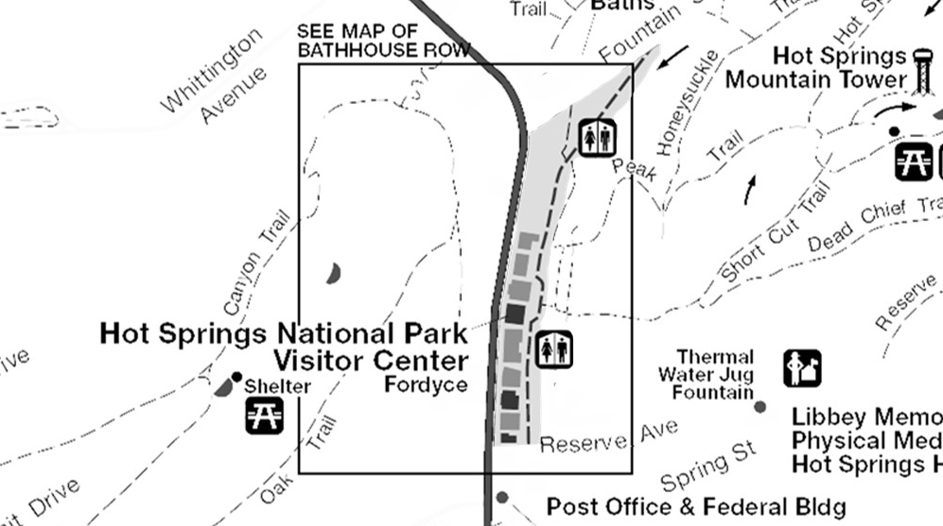

DEST9:
11. How many hours did or will you spend within the Downtown District of Hot Springs NP today? Please list partial hours as ¼, ½, or ¾. (See map for reference)
Number of hours
DEST8:
12. Did or will you enter the Hot Springs NP Visitor Center in the Fordyce Bathhouse today? Please mark (●) one. (See map for reference)
O Yes
O No (SKIP TO QUESTION 14)

DEST7:
13. How many times did or will you enter the Hot Springs NP Visitor Center in the Fordyce Bathhouse today? (See map for reference)
Number of entries

SECTION 3 - Park Visit
Downtown District of Hot Springs National Park

Questions in the following section of the questionnaire are about your visit today to areas of Hot Springs NP other than the Downtown District, as well as your use of Hot Spring NP’s jug fountains and attendance to or participation in special events within Hot Springs NP. The map below provides a reference for these other areas, as well as the locations of Hot Springs NP’s jug fountains, including:
- The Gulpha Gorge District, which includes the Gulpha Gorge Campground and picnic area, as well as the Stonebridge road area and the Sunset Trail east of Cedar Glades Road.
- The Hot Springs Mountain District, which includes the roads, trails, and picnic areas on Hot Springs Mountain, as well as the Hot Springs Mountain Tower.
- The West Mountain District, which includes the roads, trails, and picnic areas on West Mountain, as well as the Sunset Trail west of Cedar Glades Road.
- The Whittington Park District, which includes the paths and facilities in Whittington Park.
- The jug fountains within Hot Springs NP, marked on the map ( ) include the cold water fountains at Whittington Park and Happy Hollow Spring; and the hot water fountains at Libbey Memorial Physical Medicine Center and the Hot Springs NP headquarters building.
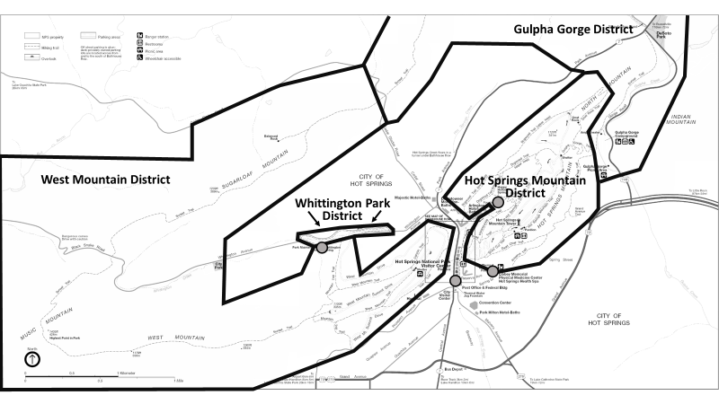

DEST7:
14. Did or will you visit the following areas of Hot Spring NP today? Please indicate the mode(s) of travel used within each area by marking (●) all that apply. (See map for reference)

Areas of Hot Springs NP | Private Vehicle | Bicycle | Foot
Gulpha Gorge District | O | O | O
Hot Springs Mountain District | O | O | O
West Mountain District | O | O | O
Whittington Park District | O | O | O

DEST7:
15. Did or will you visit at least one jug fountain within Hot Spring NP today? Please mark (●) one. (See map for reference)
O Yes O No

DEST7:
16. Did or will you attend or participate in a special event (e.g., concert, parade, large-group activity) within Hot Spring NP today? Please mark (●) one.
O Yes (Please specify): ___________________________________________________________
O No

SECTION 4
Background Information

AGE1:
17. What is your age? _________

GEND1:
18. What is your gender? Please mark (●) one.
O Male
O Female

RES2:
19. Where do you live?
US ZIP ____________
Country (if not US) _______________________

RACE/ETH1:
20. Are you Hispanic or Latino? Please mark (●) one.
O Yes
O No
O I prefer not to answer.

RACE/ETH2:
21. Which of these categories best indicates your race? Please mark (●) all that apply.
O | American Indian or Alaska Native | O | Native Hawaiian or other Pacific Islander
O | Asian | O | White
O | Black or African American | O | I prefer not to answer.

EDUC1:
22. What is the highest level of formal education you have completed? Please mark (●) one.
O | Less than high school e | O | College, business, or trade school graduate
O | Some high school | O | Some graduate school
O | High school graduate or GED | O | Master’s, doctoral, or professional degree
O | Some college, business, or trade school | O | I prefer not to answer

ECON12:
23. Which category best represents your annual household income? Please mark (●) one.
O | Less than $24,999 | O | $75,000-$99,999
O | $25,000-$34,999 | O | $100,000-$149,999
O | $35,000-$49,999 | O | $150,000-$199,999
O | $50,000-$74,999 | O | $200,000 or more
 |  | O | I prefer not to answer.

LANG1:
24. When visiting an area such as Hot Springs NP, what language do you personally prefer to use? Please mark (●) one for speaking and one for reading.

 | Speaking | Reading
English | O | O
Spanish | O | O
Other (Please specify): | O | O

Thank you for your help!
Please return the survey to the administrator.

APPENDIX

There are seven distinct questionnaires proposed for this collection. Sampling for this collection will occur at six locations and at special events in the Park during the sampling period.

The following inserts will be replaced in Sections 2 and 3 (above) for each version of the questionnaire.

SECTION 2
Location 2 – Gulpha Gorge District of Hot Springs National Park

Questions in the following section of the questionnaire are about your visit today to the Gulpha Gorge District of Hot Springs NP. The Gulpha Gorge District includes the Gulpha Gorge campground and picnic area, as well as the Stonebridge road area and the Sunset Trail east of Cedar Glades Road. The Gulpha Gorge District is highlighted in grey in the map below.

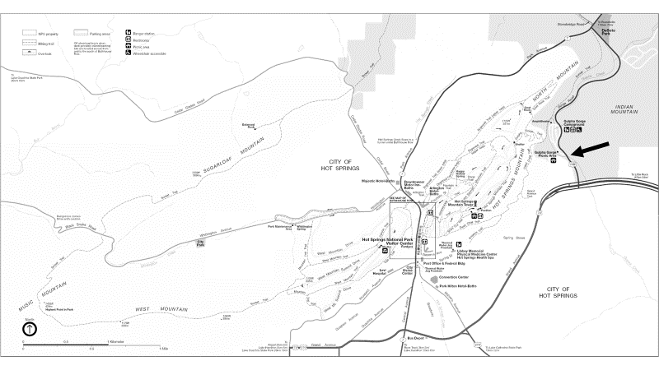

DEST9:
11. How many hours did or will you spend within the Gulpha Gorge District of Hot Springs NP today? Please list partial hours as ¼, ½, or ¾. (See map for reference)
Number of hours

DEST8:
12. Did or will you drive in a private vehicle on State Highway 7 past the location indicated by the arrow on the map today? Please mark (●) one. (See map for reference)
O Yes
O No (SKIP TO QUESTION 15)

TRANSMODE4:
13. How many people were or will be in the vehicle, including yourself, when you drove or will drive on State Highway 7 past the location indicated by the arrow on the map today? (See map for reference)
Number of people

DEST7:
14. How many times did or will you drive in a private vehicle on State Highway 7 past the location indicated by the arrow on the map today? Please specify the number of times by direction of travel. (See map for reference)
Number of times northbound
Number of times southbound

DEST8:
15. Did or will you drive in a private vehicle into the Gulpha Gorge campground and picnic area today? Please mark (●) one. (See map for reference)
O Yes
O No (SKIP TO QUESTION 18)

DEST7:
16. How many times did or will you drive in a private vehicle into the Gulpha Gorge campground and picnic area today? (See map for reference)
Number of times
TRANSMODE4:
17. How many people were or will be in the vehicle, including yourself, when you drove or will drive into the Gulpha Gorge campground and picnic area today? (See map for reference)
Number of people

SECTION 3 - Park Visit.
Location 2 - Gulpha Gorge District of Hot Springs National Park -

Questions in the following section of the questionnaire are about your visit today to areas of Hot Springs NP other than the Gulpha Gorge District, as well as your use of Hot Spring NP’s jug fountains and attendance to or participation in special events within Hot Springs NP. The map below provides a reference for these other areas, as well as the locations of Hot Springs NP’s jug fountains, including:
- The Downtown District, which includes Bathhouse Row, as well as the sidewalk in front of Bathhouse Row, Arlington Lawn, and the Grand Promenade.
- The Hot Springs Mountain District, which includes the roads, trails, and picnic areas on Hot Springs Mountain, as well as the Hot Springs Mountain Tower.
- The West Mountain District, which includes the roads, trails, and picnic areas on West Mountain, as well as the Sunset Trail west of Cedar Glades Road.
- The Whittington Park District, which includes the paths and facilities in Whittington Park.
- The jug fountains within Hot Springs NP, marked on the map ( ) include the cold water fountains at Whittington Park and Happy Hollow Spring; and the hot water fountains at Libbey Memorial Physical Medicine Center and the Hot Springs NP headquarters building.
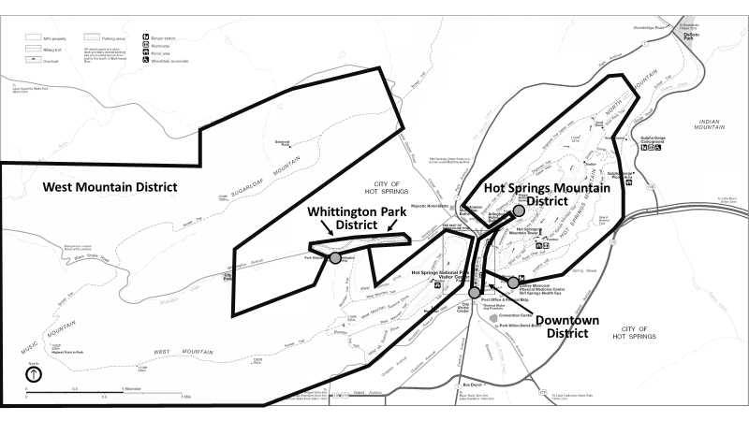

DEST7:
18. Did or will you visit the following areas of Hot Spring NP today? Please indicate the mode(s) of travel used within each area by marking (●) all that apply. (See map for reference)

Areas of Hot Springs NP | Private Vehicle | Bicycle | Foot
Downtown District | O | O | O
Hot Springs Mountain District | O | O | O
West Mountain District | O | O | O
Whittington Park District | O | O | O

DEST7:
19. Did or will you visit at least one jug fountain within Hot Spring NP today? Please mark (●) one. (See map for reference)
O Yes
O No

DEST7:
20. Did or will you attend or participate in a special event (e.g., concert, parade, large-group activity) within Hot Spring NP today? Please mark (●) one.
O Yes (Please specify): ___________________________________________________________
O No

SECTION 2
Location 3 - Hot Springs Mountain District of Hot Springs National Park

Questions in the following section of the questionnaire are about your visit today to the Hot Springs Mountain District of Hot Springs NP. The Hot Springs Mountain District includes the roads, trails, and picnic areas on Hot Springs Mountain, as well as the Hot Springs Mountain Tower. The Hot Springs Mountain District is highlighted in dark grey in the map below.

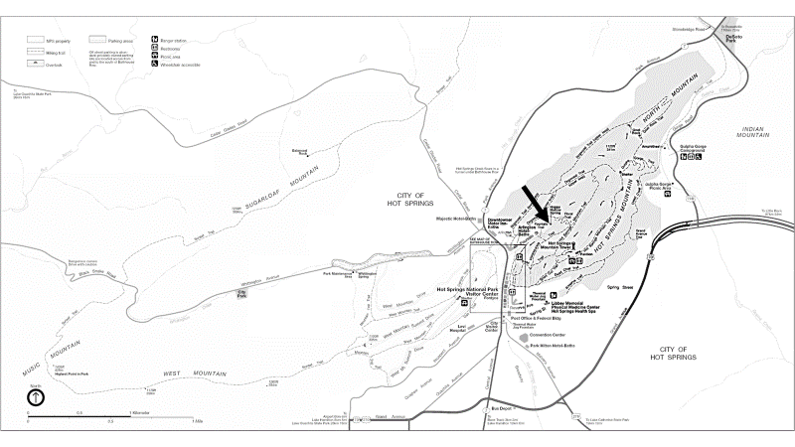

DEST9:
11. How many hours did or will you spend within the Hot Springs Mountain District of Hot Springs NP today? Please list partial hours as ¼, ½, or ¾. (See map for reference)
Number of hours

DEST8:
12. Did or will you drive in a private vehicle on Fountain Street past the location indicated by the arrow on the map today? Please mark (●) one. (See map for reference)
O Yes
O No (SKIP TO QUESTION 15)

TRANSMODE4:
13. How many people were or will be in the vehicle, including yourself, when you drove or will drive on Fountain Street past the location indicated by the arrow on the map today? (See map for reference)
Number of people

DEST7:
14. How many times did or will you drive in a private vehicle on Fountain Street past the location indicated by the arrow on the map today? (See map for reference)
Number of times

SECTION 3 - Park Visit
Location 3 - Hot Springs Mountain District of Hot Springs National Park

Questions in the following section of the questionnaire are about your visit today to areas of Hot Springs NP other than the Hot Springs Mountain District, as well as your use of Hot Spring NP’s jug fountains and attendance to or participation in special events within Hot Springs NP. The map below provides a reference for these other areas, as well as the locations of Hot Springs NP’s jug fountains, including:
- The Downtown District, which includes Bathhouse Row, as well as the sidewalk in front of Bathhouse Row, Arlington Lawn, and the Grand Promenade.
- The Gulpha Gorge District, which includes the Gulpha Gorge Campground and picnic area, as well as the Stonebridge road area and the Sunset Trail east of Cedar Glades Road.
- The West Mountain District, which includes the roads, trails, and picnic areas on West Mountain, as well as the Sunset Trail west of Cedar Glades Road.
- The Whittington Park District, which includes the paths and facilities in Whittington Park.
- The jug fountains within Hot Springs NP, marked on the map ( ) include the cold water fountains at Whittington Park and Happy Hollow Spring; and the hot water fountains at Libbey Memorial Physical Medicine Center and the Hot Springs NP headquarters building.
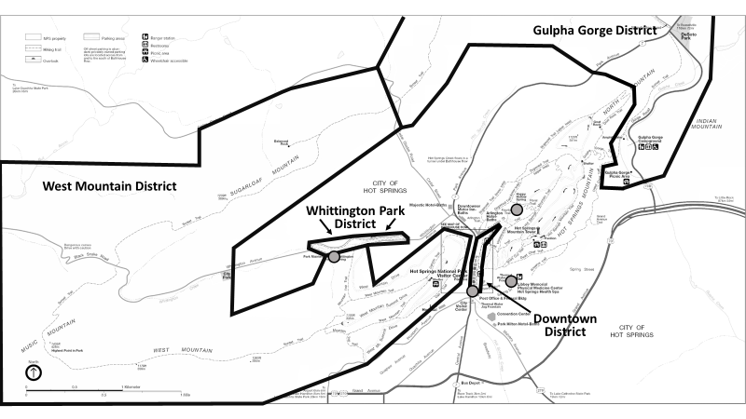

DEST7:
15. Did or will you visit the following areas of Hot Spring NP today? Please indicate the mode(s) of travel used within each area by marking (●) all that apply. (See map for reference)

Areas of Hot Springs NP | Private Vehicle | Bicycle | Foot
Downtown District | O | O | O
Gulpha Gorge District | O | O | O
West Mountain District | O | O | O
Whittington Park District | O | O | O

DEST7:
16. Did or will you visit at least one jug fountain within Hot Spring NP today? Please mark (●) one. (See map for reference)
O Yes
O No

DEST7:
17. Did or will you attend or participate in a special event (e.g., concert, parade, large-group activity) within Hot Spring NP today? Please mark (●) one.
O Yes (Please specify): ___________________________________________________________
O No

SECTION 2
Location 4 - West Mountain District of Hot Springs National Park

Questions in the following section of the questionnaire are about your visit today to the West Mountain District of Hot Springs NP. The West Mountain District includes the includes the roads, trails, and picnic areas on West Mountain, as well as the Sunset Trail west of Cedar Glades Road. The West Mountain District is highlighted in dark grey in the map below.

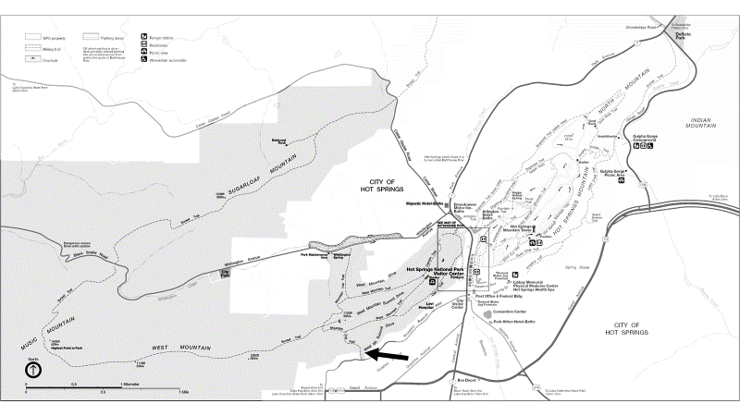

DEST9:
11. How many hours did or will you spend within the West Mountain District of Hot Springs NP today? Please list partial hours as ¼, ½, or ¾.
Number of hours

DEST8:
12. Did or will you drive in a private vehicle on West Mountain Drive past the location indicated by the arrow on the map today? Please mark (●) one. (See map for reference)
O Yes
O No (SKIP TO QUESTION 15)

TRANSMODE4:
13. How many people were or will be in the vehicle, including yourself, when you drove or will drive on West Mountain Drive past the location indicated by the arrow on the map today? (See map for reference)
Number of people

DEST7:
14. How many times did or will you drive in a private vehicle on West Mountain Drive past the location indicated by the arrow on the map today? Please specify the number of times by direction of travel. (See map for reference)
Number of times northbound
Number of times southbound

SECTION 3 - Park Visit
Location 4 - West Mountain District of Hot Springs National Park

Questions in the following section of the questionnaire are about your visit today to areas of Hot Springs NP other than the West Mountain District, as well as your use of Hot Spring NP’s jug fountains and attendance to or participation in special events within Hot Springs NP. The map below provides a reference for these other areas, as well as the locations of Hot Springs NP’s jug fountains, including:
- The Downtown District, which includes Bathhouse Row, as well as the sidewalk in front of Bathhouse Row, Arlington Lawn, and the Grand Promenade.
- The Gulpha Gorge District, which includes the Gulpha Gorge Campground and picnic area, as well as the Stonebridge road area and the Sunset Trail east of Cedar Glades Road.
- The Hot Springs Mountain District, which includes the roads, trails, and picnic areas on Hot Springs Mountain, as well as the Hot Springs Mountain Tower.
- The Whittington Park District, which includes the paths and facilities in Whittington Park.
- The jug fountains within Hot Springs NP, marked on the map ( ) include the cold water fountains at Whittington Park and Happy Hollow Spring; and the hot water fountains at Libbey Memorial Physical Medicine Center and the Hot Springs NP headquarters building.
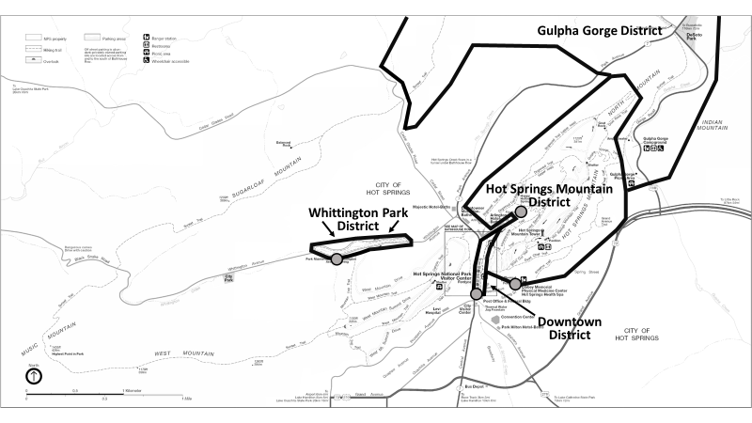

DEST7:
15. Did or will you visit the following areas of Hot Spring NP today? Please indicate the mode(s) of travel used within each area by marking (●) all that apply. (See map for reference)

Areas of Hot Springs NP | Private Vehicle | Bicycle | Foot
Downtown District | O | O | O
Gulpha Gorge District | O | O | O
Hot Springs Mountain District | O | O | O
Whittington Park District | O | O | O

DEST7:
16. Did or will you visit at least one jug fountain within Hot Spring NP today? Please mark (●) one. (See map for reference)
O Yes
O No

DEST7:
17. Did or will you attend or participate in a special event (e.g., concert, parade, large-group activity) within Hot Spring NP today? Please mark (●) one.
O Yes (Please specify): ___________________________________________________________
O No

SECTION 2
Location 5 - Whittington Park District of Hot Springs National Park

Questions in the following section of the questionnaire are about your visit today to the Whittington Park District of Hot Springs NP. The Whittington Park District includes the includes the paths and facilities in Whittington Park. The Whittington Park District is highlighted in dark grey in the map below.

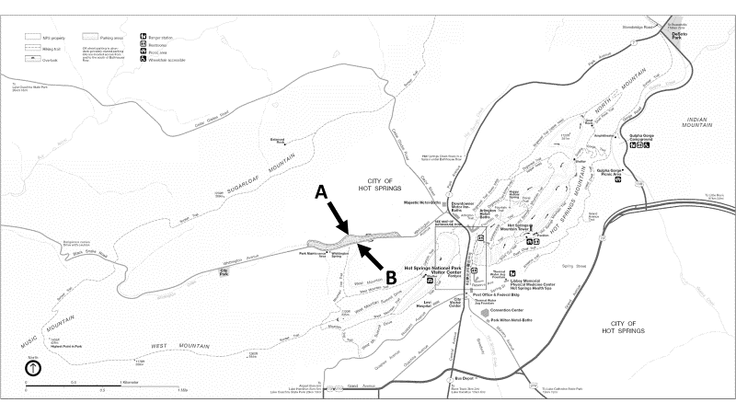

DEST9:
11. How many hours did or will you spend within the Whittington Park District of Hot Springs NP today? Please list partial hours as ¼, ½, or ¾.
Number of hours

DEST8:
12. Did or will you pass the locations along the Whittington Trail indicated by the arrows on the map today? Please mark (●) one. (See map for reference)
O Yes, Location A
O Yes, Location B
O Yes, Location A and B
O No (SKIP TO QUESTION 14)

DEST7:
13. How many times did or will you pass the locations along the Whittington Trail indicated by the arrows on the map today? Please specify the number of times by location. (See map for reference)
Number of times past Location A
Number of times past Location B

SECTION 3 - Park Visit
Location 5 - Whittington Park District of Hot Springs National Park

Questions in the following section of the questionnaire are about your visit today to areas of Hot Springs NP other than the Whittington Park District, as well as your use of Hot Spring NP’s jug fountains and attendance to or participation in special events within Hot Springs NP. The map below provides a reference for these other areas, as well as the locations of Hot Springs NP’s jug fountains, including:
- The Downtown District, which includes Bathhouse Row, as well as the sidewalk in front of Bathhouse Row, Arlington Lawn, and the Grand Promenade.
- The Gulpha Gorge District, which includes the Gulpha Gorge Campground and picnic area, as well as the Stonebridge road area and the Sunset Trail east of Cedar Glades Road.
- The Hot Springs Mountain District, which includes the roads, trails, and picnic areas on Hot Springs Mountain, as well as the Hot Springs Mountain Tower.
- The West Mountain District, which includes the roads, trails, and picnic areas on West Mountain, as well as the Sunset Trail west of Cedar Glades Road.
- The jug fountains within Hot Springs NP, marked on the map ( ) include the cold water fountains at Whittington Park and Happy Hollow Spring; and the hot water fountains at Libbey Memorial Physical Medicine Center and the Hot Springs NP headquarters building.
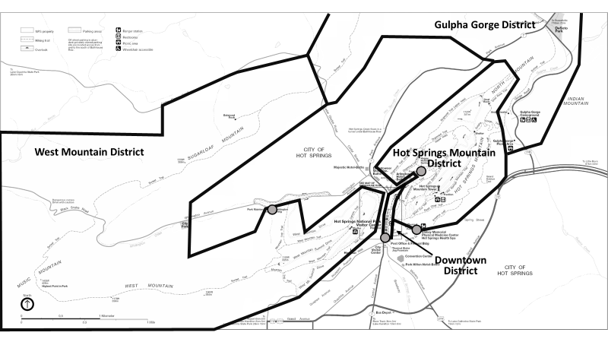

DEST7:
14. Did or will you visit the following areas of Hot Spring NP today? Please indicate the mode(s) of travel used within each area by marking (●) all that apply. (See map for reference)

Areas of Hot Springs NP | Private Vehicle | Bicycle | Foot
Downtown District | O | O | O
Gulpha Gorge District | O | O | O
Hot Springs Mountain District | O | O | O
West Mountain District | O | O | O

DEST7:
15. Did or will you visit at least one jug fountain within Hot Spring NP today? Please mark (●) one. (See map for reference)
O Yes
O No

DEST7:
16. Did or will you attend or participate in a special event (e.g., concert, parade, large-group activity) within Hot Spring NP today? Please mark (●) one.
O Yes (Please specify): ___________________________________________________________
O No

SECTION 2
Location 6 - Jug Fountains in Hot Springs National Park

Questions in the following section of the questionnaire are about your visit today to the jug fountains in Hot Springs NP. Four jug fountains are located within Hot Springs National Park, including the cold water fountains at Whittington Park and Happy Hollow Spring, and the hot water fountains at Libbey Memorial Physical Medicine Center and the Hot Springs NP headquarters building. The locations of the jug fountains in Hot Springs NP are marked on the map below by gray dots ( ).

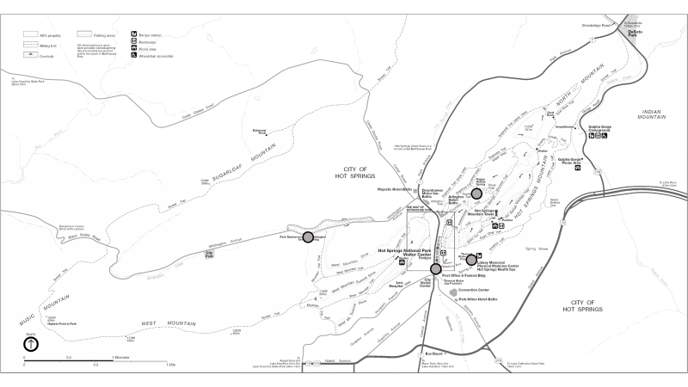

DEST9:
11. How many hours did or will you spend at the jug fountains in of Hot Springs NP today? Please list partial hours as ¼, ½, or ¾.
Number of hours

DEST7:
12. How many gallons of spring water did you or will you bottle, in total, from the jug fountains in Hot Springs NP today? Please list partial gallons as ¼, ½, or ¾; please list “0” (zero) if you did not and will not bottle water from the jug fountains today.
Number of gallons

SECTION 3 - Park Visit
Location 6 - Jug Fountains in Hot Springs National Park

Questions in the following section of the questionnaire are about your visit today to areas of Hot Springs NP other than the jug fountains, as well as your attendance to or participation in special events within Hot Springs NP. The map below provides a reference for these other areas including:
- The Downtown District, which includes Bathhouse Row, as well as the sidewalk in front of Bathhouse Row, Arlington Lawn, and the Grand Promenade.
- The Gulpha Gorge District, which includes the Gulpha Gorge Campground and picnic area, as well as the Stonebridge road area and the Sunset Trail east of Cedar Glades Road.
- The Hot Springs Mountain District, which includes the roads, trails, and picnic areas on Hot Springs Mountain, as well as the Hot Springs Mountain Tower.
- The West Mountain District, which includes the roads, trails, and picnic areas on West Mountain, as well as the Sunset Trail west of Cedar Glades Road.
- The Whittington Park District, which includes the paths and facilities in Whittington Park.
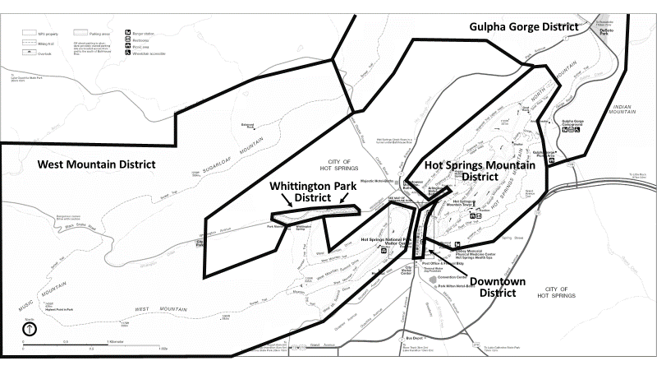

DEST7:
13. Did or will you visit the following areas of Hot Spring NP today? Please indicate the mode(s) of travel used within each area by marking (●) all that apply. (See map for reference)

Areas of Hot Springs NP | Private Vehicle | Bicycle | Foot
Downtown District | O | O | O
Gulpha Gorge District | O | O | O
Hot Springs Mountain District | O | O | O
West Mountain District | O | O | O
Whittington Park District | O | O | O

DEST7:
14. Did or will you attend or participate in a special event (e.g., concert, parade, large-group activity) within Hot Spring NP today? Please mark (●) one.
O Yes (Please specify): ___________________________________________________________
O No

-SECTION 2
“Location” 7 - Special Events in Hot Springs National Park

Questions in the following section of the questionnaire are about attendance to or participation in the special event at which you are being contacted during your visit to Hot Springs NP today.

DEST9:
11. How many total hours will you spend attending or participating in the special event at which you are being contacted during your visit to Hot Spring NP today? Please list partial hours as ¼, ½, or ¾.
Number of hours

SECTION 3 - Park Visit
“Location” 7 - Special Events in Hot Springs National Park

Questions in the following section of the questionnaire are about your visit today to Hot Springs NP other than your attendance at or participation in a special event. The map below provides a reference for areas you may have visited or plan to visit within Hot Springs NP including:
- The Downtown District, which includes Bathhouse Row, as well as the sidewalk in front of Bathhouse Row, Arlington Lawn, and the Grand Promenade.
- The Gulpha Gorge District, which includes the Gulpha Gorge Campground and picnic area, as well as the Stonebridge road area and the Sunset Trail east of Cedar Glades Road.
- The Hot Springs Mountain District, which includes the roads, trails, and picnic areas on Hot Springs Mountain, as well as the Hot Springs Mountain Tower.
- The West Mountain District, which includes the roads, trails, and picnic areas on West Mountain, as well as the Sunset Trail west of Cedar Glades Road.
- The Whittington Park District, which includes the paths and facilities in Whittington Park.
- The jug fountains within Hot Springs NP, marked on the map ( ) include the cold water fountains at Whittington Park and Happy Hollow Spring; and the hot water fountains at Libbey Memorial Physical Medicine Center and the Hot Springs NP headquarters building.
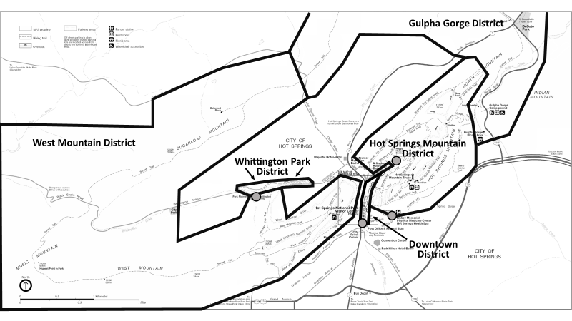

DEST7:
12. Did or will you visit the following areas of Hot Spring NP today other than to attend or participate in a special event? Please indicate the mode(s) of travel used within each area by marking (●) all that apply. (See map for reference)

Areas of Hot Springs NP | Private Vehicle | Bicycle | Foot
Downtown District | O | O | O
Gulpha Gorge District | O | O | O
Hot Springs Mountain District | O | O | O
West Mountain District | O | O | O
Whittington Park District | O | O | O

DEST7:
13. Did or will you visit at least one jug fountain within Hot Spring NP today other than to attend a special event? Please mark (●) one. (See map for reference)
O Yes
O No

