 | National Park Service  U.S. Department of the Interior  OMB Approval XXXX-XXXX  Current Expiration Date: X-XX-XXXX

Angels Landing
Visitor Study
Zion National Park

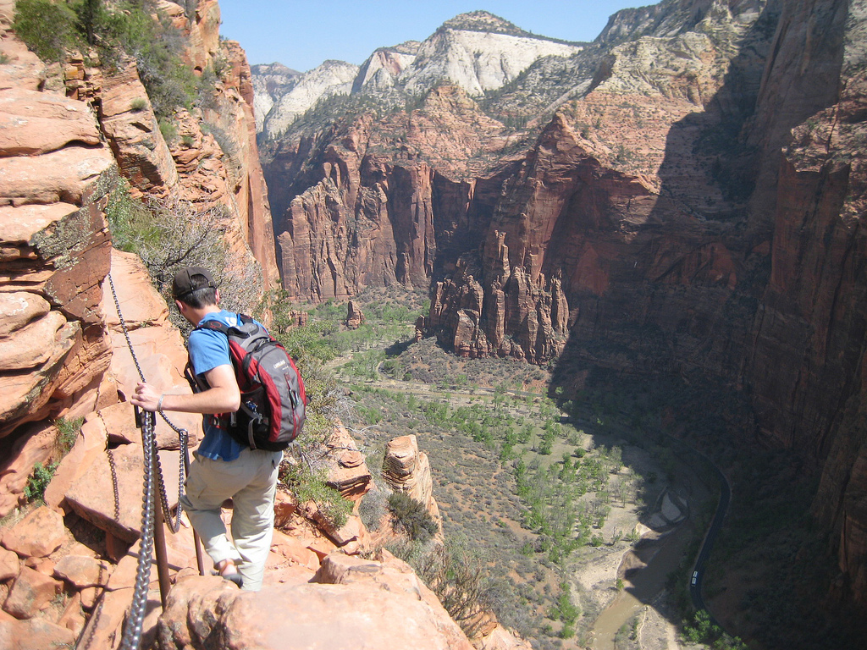

2017

ID: Date:

Time: : AM PM Location: ________________________

Weather: Sunny Partly Cloudy Overcast/Rain Storm

Special Event: No Yes (Specify) ________________________________________

Binder #: _______

Paperwork Reduction and Privacy Act Statements: The Paperwork Reduction Act requires us to tell you why we are collecting this information, how we will use it, and whether or not you have to respond. This information will be used by the National Park Service as authorized by 54 USC 100702. We will use this information to evaluate visitors’ perceptions of crowding, safety, and overall experiences on the Angels Landing Trail. Your responses are voluntary and anonymous. Your name and address will not be collected. At the completion of this collection all personal information will be destroyed and in no way be connected with the results of this survey. A Federal agency may not conduct or sponsor and you are not required to respond to, a collection of information unless it displays a currently valid OMB Control Number.

Burden Estimate: We estimate that it will take an average of 12 minutes to complete this questionnaire. You may send comments concerning the burden estimates or any aspect of this information collection to the Social Science Program Chief, National Park Service, 1201 Oakridge Drive, Fort Collins, CO, 80525-5596; nps_nrss_social_science@nps.gov (email).

Thank you for agreeing to complete this survey, your responses to the questions will provide information that will help Zion National Park! The questions in this survey ask about your hike on the Angels Landing Trail today. The Angels Landing trail is the half mile trail from Scout Lookout to the top of Angels Landing (see the surveyors map).

Topic Area 1 – GROUP5
- Including yourself, how many people were in your personal group during your hike on the Angels Landing Trail today?
Number of adults (18 years or older)
Number of children (under 18 years)

Topic Area 1 – GROUP4
- Which of the following best describes your personal group? Please mark (●) one.
O Alone
O Family
O Friends
O Family and friends
O Other (Please specify): ____________________________

Topic Area 1 – GROUP1
- Which of the following best describes your hike on the Angels Landing Trail today? Please mark (●) one.
O Day hike from Zion Canyon
O Day hike from Lava Point, Wildcat Canyon, or Hop Valley Trailhead
O Part of an overnight backpacking trip
O Other (Please specify):__________________________________

Topic Area 10 – ECON5
- How much total time did you spend hiking on the Angels Landing Trail today? Please list partial hours as ¼, ½, or ¾.
Number of hours
Topic Area 4 – DEST3
- Did you hike to the top of Angels Landing today?
O Yes
O No
If you did not hike to the top of Angels Landing today, which of the following reasons best explain why? Please mark
(●) all that apply.
O I was too tired.
O I was too hot.
O I didn’t have enough water.
O I didn’t have enough time.
O I didn’t have proper footwear for the terrain.
O I was uncomfortable with the sharp drop-offs/exposure.
O Others on the trail were behaving dangerously.

O The number of people on the trail made me feel unsafe.
O It was taking too long due to the number of people on the trail.
O Other member(s) of my group wanted to turn around (Please specify reason):
________________________________________________________________________________
O A weather event occurred (e.g., thunder, lightning, high winds).
O Other (Please specify):_____________________________________________________________

Topic Area 4 – VISHIS3
- Including this hike today, approximately how many times have you hiked the Angels Landing Trail?

In the last 12 months: ____________ times, including this hike today

In your lifetime: ____________ times, including this hike today

Topic Area 4 – VISHIS3
- Including this hike today, approximately how many hikes (day and overnight) have you taken in the past 12 months in Zion National Park or other parks and outdoor recreation areas?

____________ hikes (day and overnight), including this hike today

Topic Area 2 – ITIN2
- When did you decide to take this hike on the Angels Landing Trail? Please mark (●) one.
O Today
O In the last week
O More than a week ago, but in the last month
O More than a month ago, but in the last year
O More than a year ago
O Don’t know/can’t recall

Topic Area 2 – INFOSOURCE9
- Prior to your hike today, how did you obtain information about the Angels Landing Trail? Please mark (●) all that apply.
O Previous visit
O Friends/relatives/word of mouth
O Inquiry to park via phone, mail, or email
O Zion National Park website (nps.gov/ZION)
O Other website (Please specify):
O Local businesses (hotels, motels, restaurants, etc.)
O The Mighty 5 advertisements
O Maps/brochures
O Newspaper/magazine articles
O Other units of the National Park System (NPS)
O School class/program
O Social media (such as Facebook, Twitter, etc.)
O State welcome center/visitors bureau/chamber of commerce
O Television/radio programs/DVDs
O Travel guides/tour books (such as AAA, etc.)
O Other (Please specify):

OR

O Did not obtain information prior to this visit

Topic Area 12 – SAFPREP4
- Now that you have completed the hike on the Angels Landing Trail, how prepared did you feel like you were for the hike today? Please mark (●) one.
O Not at all prepared
O Not very prepared
O Moderately prepared
O Very prepared
O Extremely prepared

Topic Area 6 – PERSAFE6
- On this hike on the Angels Landing Trail today, did you feel prepared for the following common safety situations that you may have encountered? Please mark (●) one for each row.

 | Yes | No
Exposure to sun | O | O
Heat | O | O
Adequate drinking water | O | O
Steep sections of trail | O | O
Proper footwear for the terrain | O | O

NOTE TO REVIEWER: For Question 12, respondents will be asked to review a series of six photographs used to depict various levels of crowding on the top of Angels Landing. Respondents will be shown one photograph at a time in a pre-determined order. For Question 12a, the respondent will be asked to view each photo and indicate (yes or no) if they would feel crowded with the number of people in the photographed area. The respondent will then reference the photographs to answer Questions 12b, 12c, 12d, 12e, and 12f.
Topic Area 6 – CROWD35
- We would like to know how many other hikers you think it is acceptable to see on the top of Angels Landing without it being too crowded. To help judge this, we have a series of photographs that show different numbers of hikers in this area. Please ask the survey administrator to show you these photos to answer the following questions.

- For each photograph, please tell us if you would feel crowded if you were on the top of Angels Landing with the number of people depicted in the photograph. Please mark (●) one for each photograph.

 | …I would feel crowded
 | Yes | No
Photo 1 | O | O
Photo 2 | O | O
Photo 3 | O | O
Photo 4 | O | O
Photo 5 | O | O
Photo 6 | O | O

Topic Area 6 – CROWD35
- Which photograph shows the number of people you would prefer to see on the top of Angels Landing?

Photo number: ________

Topic Area 6 – CROWD36
- Which photograph shows the maximum number of people you think Zion National Park should allow? In other words, at what point should people be restricted from hiking the Angels Landing Trail? If you think use should not be restricted at any point represented in the photographs, or not restricted at all, you may indicate that.

Photo number: ________ GO ON TO PART D

OR

O None of the photographs show a high enough number of people to restrict people from hiking on the Angels Landing Trail. GO ON TO PART D

OR

O The number of people allowed to hike on the Angels Landing Trail should not be restricted regardless of the number of people on the trail. GO ON TO PART E

Topic Area 6 – CROWD7
- Should the number of people allowed to hike on the Angels Landing trail each day be limited if it is needed for any of the following reasons, even if it limits when you can hike Angels Landing? (Check one box for each reason.)

Should the number of hikers
per day be limited?
Reason for Limit | Yes | No | Don’t Know/ Not Sure
To protect the quality of visitors’ experiences  (i.e., prevent crowding) | O | O | O
To protect visitors’ safety | O | O | O
To reduce environmental impacts | O | O | O

Topic Area 6 – CROWD38 (Variation) – This variation asks the respondent to indicate which photo they find unacceptable, as opposed to the respondent writing in a number of people that would represent the maximum number of visitors that would be so unacceptable to cause them to delay or discontinue their planned hike to the top of Angles Landing.
- Which photograph shows the number of people that would be so unacceptable you would not want to hike to the top of Angels Landing because of crowding? If none of the photographs represent this condition, you may indicate that.

Photo number: ________

OR

O None of the photographs are so unacceptable that I would not want to hike to the top of Angels Landing because of
crowding.

Topic Area 6 – CROWD37
- Which photograph looks most like the number of people you typically saw today on the top of Angels Landing?

Photo number: ________

OR

O I did not hike to the top of Angels Landing today.

Topic Area 6 – CROWD37
- How crowded did you feel at each of the following locations? Please mark (●) one for each row.

 | …I felt crowded
 | Yes | No | Did not  visit today
At Scout Lookout | O | O
On the Angels Landing Trail as a whole | O | O
On sections of the Angels Landing Trail with chains | O | O | O
On exposed sections of the Angels Landing Trail | O | O | O
On top of Angels Landing | O | O | O

Topic Area 6 – CROWD16
- To what extent do you agree or disagree with each of the following statements about the Angels Landing Trail?

 | Highly Disagree | Slightly Disagree | Neither Agree or Disagree | Slightly Agree | Highly Agree
The Angels Landing Trail is dangerous. | -2 | -1 | 0 | +1 | +2
It’s not likely that I would have an accident on the Angels Landing Trail. | -2 | -1 | 0 | +1 | +2
Bypassing the chains is not a safe way to get by slower hikers on the Angels Landing Trail. | -2 | -1 | 0 | +1 | +2
The Angels Landing Trail is depicted as being more difficult than it really is. | -2 | -1 | 0 | +1 | +2
Hiking the Angels Landing Trail is more dangerous than hiking other trails. | -2 | -1 | 0 | +1 | +2
The likelihood of the average person having an accident on the Angels Landing Trail is high. | -2 | -1 | 0 | +1 | +2
If an accident happens to me on the Angels Landing Trail, rangers will be able to help me back to safety. | -2 | -1 | 0 | +1 | +2
The number of people using the Angels Landing Trail is about right. | -2 | -1 | 0 | +1 | +2
The likelihood of a serious injury occurring from an accident on the Angels Landing Trail is high. | -2 | -1 | 0 | +1 | +2
Hiking the Angels Landing Trail requires special physical conditioning. | -2 | -1 | 0 | +1 | +2
Hiking the Angels Landing Trail requires special caution. | -2 | -1 | 0 | +1 | +2

Topic Area 6 – PERSAFE15
- How much did you worry during your hike on the Angels Landing Trail today about each of the following risks? Please mark (●) one for each row.

 | …I was worried about
 | Yes | No
Slipping while hiking on the trail | O | O
Losing my grip on the chains | O | O
Falling all the way to the canyon floor from the trail | O | O
Someone falling into me while hiking the trail | O | O
Seeing someone fall from the trail | O | O
Unsafe/risky behavior of others threatening my safety | O | O
Being unable to get back down the trail | O | O
Being injured while hiking the trail | O | O
Freezing (being unable to move) on the trail due to fear | O | O

Topic Area 9 – OPMGMT13
- To what extent would you support or oppose each of the following potential management practices for the Angels Landing Trail? Please circle one for each row.
 | Strongly Oppose | Slightly Oppose |  | Neither Support or Oppose | Slightly Support |  | Strongly Support
Increase informational signs regarding potential safety/crowding/natural hazards of the trail | -2 |  | -1 | 0 | +1 | +2
Require an orientation (e.g., a short video) that reinforces safety and Leave No Trace principles | -2 |  | -1 | 0 | +1 | +2
Implement a mandatory use etiquette education program regarding use of the trail | -2 |  | -1 | 0 | +1 | +2
Limit the number of visitors allowed to use the trail each day by means of first come, first served permit system | -2 |  | -1 | 0 | +1 | +2
Limit the number of visitors allowed to use the trail each day by means of a reserve in advance permit system | -2 |  | -1 | 0 | +1 | +2
Hourly limits of people allowed to use the trail, to ensure the number of people on the trail does not exceed a certain number | -2 |  | -1 | 0 | +1 | +2
Provide more rangers along the trail to enforce Leave No Trace principles, rules, and regulations | -2 |  | -1 | 0 | +1 | +2
Require all hikers on the trail to use proper footwear for the terrain | -2 |  | -1 | 0 | +1 | +2
Require all hikers to be of a certain age to hike the trail | -2 |  | -1 | 0 | +1 | +2
Limit promotion of the trail (remove interpretive photos, work with the concessionaire and interpretive association to minimize related souvenir sales, reduce tourism marketing, etc.) | -2 |  | -1 | 0 | +1 | +2
Topic Area 7 – EVALSERV4
- Please rate the Angels Landing Trail on the following. Please circle one for each row.

 | Extremely Poor | Somewhat Poor | Neither Good nor Poor | Somewhat Good | Extremely Good
Availability of information | -2 | -1 | 0 | +1 | +2
Safety and security | -2 | -1 | 0 | +1 | +2
Your overall satisfaction | -2 | -1 | 0 | +1 | +2
Level of crowding on the Angels Landing Trail | -2 | -1 | 0 | +1 | +2
Level of crowding at the top of Angels Landing | -2 | -1 | 0 | +1 | +2
Presence of rangers | -2 | -1 | 0 | +1 | +2

Topic Area 2 – INFOSOURCE14
- a. Did you encounter a ranger on the hike today?
O Yes
O No

b. If YES, did you gain information regarding the Angels Landing Trail from them?
O Yes
O No

Topic Area 5 – RecBACK18
- Did you encounter any of the following on the Angels Landing Trail today? Please mark (●) one for each row.

 | No | Yes, Some | Yes, A Lot
Graffiti | O | O | O
Litter | O | O | O
Visible human waste | O | O | O
Human waste odor | O | O | O
Dangerous behavior | O | O | O
Falling rocks | O | O | O
Individuals frozen on the trail due to fear | O | O | O
Individuals you believe were unprepared for the hike | O | O | O
Individuals you believe were not fit enough for the hike | O | O | O
Individuals walking off trail | O | O | O
Loud noise created by other visitors | O | O | O

Topic Area 6 – PERSAFE4
- Are there any safety issues that need to be addressed concerning the Angels Landing hike, and if so, what are they?
___________________________________________________________________________________________________
___________________________________________________________________________________________________
___________________________________________________________________________________________________
___________________________________________________________________________________________________
Topic Area 5 – RecACT17
- What did you like most about the Angels Landing hike today?

___________________________________________________________________________________________________
___________________________________________________________________________________________________
___________________________________________________________________________________________________
___________________________________________________________________________________________________

Topic Area 5 – RecACT18
- What did you like least about the Angels Landing hike today?

___________________________________________________________________________________________________
___________________________________________________________________________________________________
___________________________________________________________________________________________________
___________________________________________________________________________________________________

Topic Area 4 – DEST5
- Have you hiked or do you plan to hike any of these other trails in the park today? Please mark (●) all that apply.
O Riverside Walk
O The Narrows
O Hidden Canyon
O Upper Emerald Pools
O Observation Point
O Watchman
O Other (Please specify): ____________________________

O R

O Angels Landing is my only hike today.

Topic Area 10 – ECON5
- On this trip, how much total time do you plan to spend visiting Zion National Park? For this question, a visit is defined as the day in which you were contacted to complete this questionnaire. A trip is defined as the total extent of time away from your personal residence that could include multiple visits to Zion National Park.
Number of hours, if a day trip to the park
Number of days, if greater than 1-day trip to the park

Topic Area 1 – AGE1
- What is your age? _________

Topic Area 1 – GEND1
- What is your gender? Please mark (●) one.
O Male
O Female

Topic Area 1 – RES2
- Where do you live?
US ZIP ____________
Country (if not US) _______________________

Topic Area 1 – RACE/ETH1
- Are you Hispanic or Latino? Please mark (●) one.
O Yes
O No
O I prefer not to answer.

Topic Area 1 – RACE/ETH2
- What is your race? Please mark (●) all that apply.
O American Indian or Alaska Native
O Asian
O Black or African American
O Native Hawaiian or other Pacific Islander
O White
O I prefer not to answer.

Topic Area 1 – EDUC1
- What is the highest level of formal education you have completed? Please mark (●) one.
O Less than high school
O Some high school
O High school graduate or GED
O Some college, business, or trade school
O College, business, or trade school graduate
O Some graduate school
O Master’s, doctoral, or professional degree
O I prefer not to answer.

Topic Area 9 – OPMGMT10
- Is there anything else you would like to tell us about your visit to Zion National Park?

Thank you for your help! Please return the survey to the administrator.

