“Hello, I am conducting a survey for [Park Name] to better understand your opinions about the transportation, programs and services here. Your participation is voluntary and all responses will be kept anonymous. Would you be willing to complete this questionnaire (show packet) and mail it back?”

If YES – then ask, “has any member of your group already participated in this survey?”
If “YES” (previously agreed to participate) then, “Thank you for agreeing to participate in this study, we hope that you will return the questionnaire soon, if you have not already. Have a great day.”
If “NO” (have not previously agreed to participate and there is only one adult in the group) then,
Thank you! [hand respondent packet; point to stamp]. Here’s the questionnaire. You can mail it back in the same envelope. We need your address to send you a replacement if we don’t hear from you in two weeks [hand address card], and I have a few quick questions. [The surveyor will ask them to start the process by answering the non-response bias questions (listed below) after they have completed the address card. The responses will be recorded in spaces provided on the survey log and non-response bias form. The surveyor will hand them a survey packet including the questionnaire and a self-addressed stamped envelope].

If “NO” (have not previously agreed to participate and there is more than one adult in the group) then,
Thank you! We can only have one adult respondent per group. Whose birthday is next? [wait for response]. You’ll be our respondent [hand respondent packet; point to stamp]. Here’s the questionnaire. You can mail it back in the same envelope. We need your address to send you a replacement if we don’t hear from you in two weeks [hand address card], and I have a few quick questions. [The surveyor will ask them to start the process by answering the non-response bias questions (listed in item 9e) after they have completed the address card. The responses will be recorded in spaces provided on the survey log and non-response bias form. The surveyor will hand them a survey packet including the questionnaire and a self-addressed stamped envelope].

If NO– (soft refusal) then, “No problem. Instead, I have a few quick questions I’d like to ask you now that would really help the park.” [The surveyor will record responses in spaces provided on the tracking sheet and then thank them for their time]
.
If NO– (hard refusal) – “No problem. Thank you for your time.”

- How many adults, 18 and older, and children are in your personal group?
- What is your state of residence (if you live in the US) or country of residence (if you do not live in the US)?
- Did you experience any traffic or transportation difficulties getting to the park today?
- Did you (or anyone in your group) encounter barriers or challenges with park activities due to any physical conditions you may have?

Or if the group has just entered the park:

Do you anticipate that you (or anyone in your group) will encounter barriers or challenges with park activities due to any physical conditions you may have?
  - If YES, is the barrier related to mobility, communication, or something else?

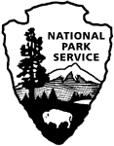 | OMB Control Number: 1024-0224  National Park Service  U.S. Department of the Interior
National Capital Region
National Park Service Sites
[Park Name]
Visitor Study

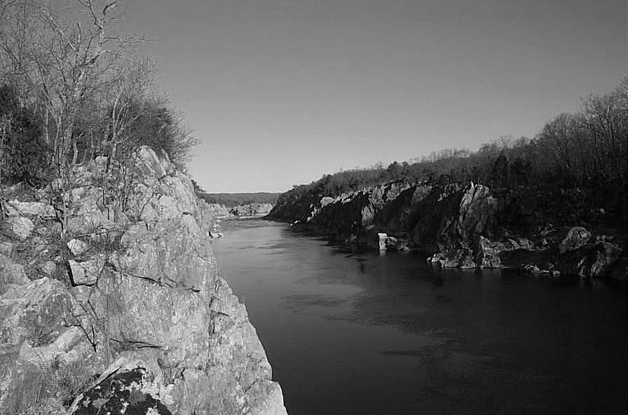

2018

Paperwork Reduction and Privacy Act Statements: The Paperwork Reduction Act requires us to tell you why we are collecting this information, how we will use it, and whether or not you have to respond. The National Park Service is authorized by the NPS Research Mandate (54 USC 100702) to collect this information. We will use this information to evaluate visitors’ use and visitor experience of transportation within and among National Capital Region park units. Your responses are voluntary and anonymous. Your name and address have been requested for follow-up purposes only. At the completion of this collection all contact information will be destroyed and in no way be connected with the results of this survey. A Federal agency may not conduct or sponsor and you are not required to respond to, a collection of information unless it displays a currently valid OMB Control Number.

Burden Estimate: We estimate that it will take an average of 20 minutes to complete this questionnaire. You may send comments concerning the burden estimates or any aspect of this information collection to the Social Science Program Chief, National Park Service, 1201 Oakridge Drive, Fort Collins, CO, 80525-5596; nps_nrss_social_science@nps.gov (email).

 | United States Department of the Interior  NATIONAL PARK SERVICE  1849 C Street, N.W.  Washington, DC 20240

Spring/Summer, 2018

Dear [Park Name] Visitor:

Thank you for participating in this study. Our goal is to learn about the expectations, opinions, and interests of visitors to [Park Name]. This information will assist us in our efforts to better manage this park and to serve you.

This questionnaire is only being given to a select number of visitors, so your participation is very important. It should take about 20 minutes to complete after your trip.

When your trip is over, the adult in your group who will have the next birthday should complete this questionnaire. Seal it in the postage-paid envelope provided and drop it in any U.S. Postal Service mailbox.

If you have any questions, please contact RSG, Inc., 55 Railroad Row, White River Junction, VT 05001; ellen.rovelstad@rsginc.com (email).

We appreciate your help.

Sincerely,

Bob Vogel
National Capital Region
Regional Director

RETURN PROCEDURE

At the end of your trip:

1. Please have the adult in your group (at least 18 years old) who has the next birthday complete this questionnaire. That will help give us a statistically reliable sample.

2. For questions that use circles (O), please mark your answer by filling in the circle with black or blue ink. Please do not use pencil.

3. Seal it in the postage-paid envelope provided.

4. Drop it in a U.S. Postal Service mailbox.

DIRECTIONS
Please have the adult in your group (at least 18 years old) having the next birthday complete this questionnaire.
In this questionnaire, your personal group is defined as you and anyone with whom you visited [Park Name} on this trip, such as a spouse, family, friends, etc. This does not include the larger group that you might have traveled with, such as a school, church, scout, or tour group.
A visit is defined as a time you traveled to [Park Name]. A trip is defined as the total extent of time away from your personal residence that could include multiple visits to [Park Name].

A. Trip Description

Topic Area 1 – GROUP5
- Including yourself, how many people were in your personal group during your visit to [Park Name] on the day you were contacted for this survey?
Number of adults (18 years or older)
Number of children (under 18 years old)

Topic Area 1 – GROUP4
- What type of group were you with during your visit to [Park Name] on the day you were contacted for this survey? Please mark (●) one.
O Alone
O Friends
O Family
O Family and friends
O Commercial guided tour group
O Outfitter/guide
O Other organized group (such as business group, scout group, school group, etc.)
O Other (Please specify):

B. Trip Planning

Topic Area 2 – ITIN13
- About how long ago did you plan your trip to [Park Name]? Please mark (●) one.
O Within the past month
O 2-3 months ago
O 4-5 months ago
O 6 months ago or more

Topic Area 2 – ITIN1
- How would you describe your planning for this trip to [Park Name]? Please mark (●) one.
O Carefully planned
O Some pre-planning
O Very little pre-planning
O Spontaneous; no planning

C. Park Activities, Programs, and Services

Topic Area 5 – RecACT15
- On this trip, in which of the following activities did you personally participate within [Park Name]? Please mark (●) all that apply.

O | Viewing wildlife, natural features, scenery, wildflowers, etc. | O | Creative arts (photography/drawing/  painting/writing)
O | Picnicking | O | Camping
O | Visiting a cultural or historic site | O | Participating in ranger-led programs/tours
O | Nature study | O | Participating in fitness activities
O | Driving for pleasure | O | Visiting playgrounds
O | Walking/short hike (less than 1 hour) | O | Boating
O | Day hiking (1 hour or more) | O | Canoeing/kayaking
O | Bicycling | O | Horseback riding
O | Running/jogging | O | Seeing a performance
O | Fishing | O | Participating in sports activities
O | Family gathering/reunion | O | Roller skating/rollerblading
O | Foraging/collecting edibles (e.g., mushrooms, truffles) | O | Other (Please specify): ______________________
Topic Area 5 – RecACT15
- Of the activities listed in Question 12, which was your primary activity during your visit to [Park Name] on the day you were contacted for this survey?

OR

O I did not have a primary activity on this visit to [Park Name].

Topic Area 2 – ACCOM3
7. a. On this trip, did you and your personal group plan to stay overnight away from your permanent residence either inside [Park Name] or within the nearby area (within a 1-hour drive/50 miles of [Park Name])?
O Yes
O No -> Skip to Question 8

Topic Area 2 – ACCOM4
b. Please list the number of nights you and your personal group planned to stay either inside [Park Name] or in the nearby area (within one hour).

______Number of nights inside [Park Name]

______Number of nights in the nearby area outside [Park Name]
D. Transportation and Travel

Topic Area 3 – TRANSEVAL2
- These questions ask for your opinion about management and conditions within [Park Name]. Please indicate the extent to which you agree or disagree with each of the following statements. If the statement is not applicable, select N/A. (Please mark (●) one response for each item.)

 | Strongly disagree | Disagree | Neither agree or disagree | Agree | Strongly agree | N/A
There is enough parking | O | O | O | O | O | O
There are enough road signs | O | O | O | O | O | O
There are enough trail signs | O | O | O | O | O | O
There are enough rules | O | O | O | O | O | O
There are enough trails | O | O | O | O | O | O
There is enough accessibility for people with disabilities | O | O | O | O | O | O
Visitors should be required to use a shuttle bus (parking their private vehicles at park entrances) | O | O | O | O | O | O
Parks should be accessible by regional transit | O | O | O | O | O | O
Limits should be placed on the number of people who can use certain trails at one time | O | O | O | O | O | O
Limits should be placed on the number of people who can visit certain historic and cultural sites at one time | O | O | O | O | O | O
Limits should be placed on the maximum size of a group that can use certain trails | O | O | O | O | O | O

Topic Area 6 – PERSAFE1
- Prior to your visit, did you or anyone in your personal group seek out or obtain any information regarding safety at [Park Name]? Please mark (●) one.

O No
O Yes - What information did you search for? (Please describe):

Topic Area 6 – PERSAFE34
- Did you encounter any transportation-related safety issues during your visit to [Park Name]? Please mark (●) one.

O No
O Yes. Please describe the transportation-related safety issue(s):

Topic Area 3 – TRANSEVAL6
- To what extent did the following factors impact your visit to [Park Name]? If the statement is not applicable, mark N/A. (Please mark (●) one response for each item.)
 | Not  at all | Very little | Somewhat | To a great extent | N/A
Traffic congestion on roads leading to [Park Name] | O | O | O | O | O
Traffic congestion at entrance stations | O | O | O | O | O
Lack of a sense of arrival/visual indication of arrival to sites | O | O | O | O | O
Traffic congestion on roads within [Park Name] | O | O | O | O | O
Parking congestion/shortages | O | O | O | O | O
Traffic congestion at roadside pullouts | O | O | O | O | O
Crowding at scenic overlooks | O | O | O | O | O
Crowding at historic and cultural sites | O | O | O | O | O
Lack of advanced trip planning information | O | O | O | O | O
Lack of real-time information about traffic and parking | O | O | O | O | O
Wayfinding difficulty leading to or within [Park Name] | O | O | O | O | O
Passenger crowding on public transit | O | O | O | O | O
Parking in unendorsed areas | O | O | O | O | O
Intersection and roadway safety | O | O | O | O | O
Accessibility barriers for people with disabilities | O | O | O | O | O
Pedestrian/vehicle conflicts | O | O | O | O | O
Wildlife/vehicle conflicts | O | O | O | O | O
Bicycle/vehicle conflicts | O | O | O | O | O
Pedestrian/bicycle/equestrian conflicts | O | O | O | O | O
Congestion at water access points | O | O | O | O | O
Other (Please specify):  ______________________________________________ | O | O | O | O | O

Topic Area 2 – ITIN22
- Prior to your trip to [Park Name], how did you and your personal group obtain information to plan the transportation and travel-related details of your trip? (Please mark (●) all that apply in the left hand column). For each source used, how helpful was the information you received? (Please mark (●) one response for each source used).

Used to  Plan Trip |  | Not at all  Helpful | Slightly  Helpful | Moderately Helpful | Very  Helpful | Extremely Helpful
O | National Park Service websites | O | O | O | O | O
O | Federal or State websites | O | O | O | O | O
O | Other websites (Please specify);___________________ | O | O | O | O | O
O | Social media (e.g., Facebook, Twitter, etc.) | O | O | O | O | O
O | State welcome center/visitors bureau/ chamber of commerce | O | O | O | O | O
O | Travel apps | O | O | O | O | O
O | Maps, brochures or pamphlets | O | O | O | O | O
O | Previous visits | O | O | O | O | O
O | Travel guides and tour books | O | O | O | O | O
O | Newspaper/magazine article | O | O | O | O | O
O | Radio/TV broadcasts | O | O | O | O | O
O | Package tour companies | O | O | O | O | O
O | Word of mouth (e.g., Friends or relatives) | O | O | O | O | O
O | Other (Please specify): _________________ | O | O | O | O | O

Topic Area 3 – TRANSEVAL3
- Thinking about your trip, would you have liked to have seen more of, the same, or less of each of the following facilities in [Park Name]? Please mark (●) one response for each item.

 | Less | Same | More
Trails for hiking, biking, or horseback riding | O | O | O
Parking at key attractions | O | O | O
Trails for all-terrain vehicles | O | O | O
Roads for passenger vehicles | O | O | O
Primitive roads that require high clearance | O | O | O
Boat launches, moorings and/or docks | O | O | O
Accessible (e.g., For wheelchairs) sites and facilities for people with disabilities | O | O | O
Public transportation stops close to park entrances | O | O | O
Other (please specify): __________________________ | O | O | O
Topic Area 4 – DEST1
- Upon arrival to [Park Name], were you able to find your destination(s) using the road signs and maps posted? Please mark (●) one.
O Yes, I found my destination(s) easily
O Yes, I found my destination(s) but it took some time
O No, I was unable to find my destination(s) with road signs and maps
O No, I didn’t use road signs and/or posted maps

Topic Area 3 – TRANSMODE2
- How did you get to [Park Name] on this trip? Please mark (●) all that apply.

 | Transportation to [Park Name] in the National Capital Region
Walk/hike | O
Bicycle - Personal | O
Bicycle – Bike share | O
Park shuttle bus | O
Public transportation - Bus | O
Public transportation – Subway/Metro | O
Personal vehicle | O
Rented vehicle | O
Taxi or similar transportation | O
Motorcycle | O
Train | O
Commercial aircraft | O
Other (Please specify): ___________________ | O

Topic Area 3 – TRANSMODE9
- Below are different alternative transportation options offered at some NPS sites. Considering your visit to [Park Name], please tell us how likely you would be to consider using each transportation option. Please mark (●) one response for each item.
 | Would not consider | Might or might not consider | Would consider
A bus or tram that takes passengers to different points in the park (such as the Visitor Center/overlooks, and special areas)? | O | O | O
A bike that was offered through a Bike Share Program for use while in the park? | O | O | O
A bus or tram that provides a guided tour of the park with information about the park and its resources? | O | O | O

Topic Area 3 – TRAFFIC3
- Please mark (●) one response for each statement that describes how problematic each of the following issues was for you while visiting [Park Name].

 | Not a problem | Small problem | Moderate problem | Big problem
Condition of roads | O | O | O | O
Condition of trails and walkways | O | O | O | O
Residential development of the surrounding area | O | O | O | O
Commercial development of the surrounding area | O | O | O | O
Availability of parking | O | O | O | O
People walking on, across, or along the road | O | O | O | O
Too many people | O | O | O | O
Accessibility barriers for people with disabilities | O | O | O | O
Road traffic noise that interferes with enjoyment of natural sounds and quiet | O | O | O | O
Lack of transportation options to the sites I want to visit | O | O | O | O
Lack of signs on highways directing you to NPS sites | O | O | O | O
Lack of signs directing you around park roads | O | O | O | O
Lack of signs directing you on trails and walkways | O | O | O | O
Traffic congestion | O | O | O | O
Cars parked illegally (e.g., on road shoulders) | O | O | O | O
Interactions between motorized and non-motorized forms of transportation | O | O | O | O
Lack of accessibility for people with physical disabilities or who have difficulty walking | O | O | O | O
Lack of public transportation options to get to NPS sites | O | O | O | O
Lack of transportation between public transportation stops and NPS site entrances | O | O | O | O
Lack of transportation options to access NPS sites without a personal automobile | O | O | O | O
Use of multiple modes of transportation on the same facilities (e.g., bicycles, buses, and pedestrians on the same roads) | O | O | O | O

Topic Area 3 – TRANSERV9
- How well did your overall travel experience to [Park Name] live up to your expectations? Please mark (●) one.

O Significantly above my expectations
O Above my expectations
O Met my expectations
O Below my expectations
O Significantly below my expectations

E. Transportation and Travel in the National Capital Region

The next group of questions asks about your visitation and experiences in parks managed by the National Park Service (NPS sites) within the National Capital Region. The map below depicts the National Capital Region and associated parks. Please refer to this map when answering the questions in this section.

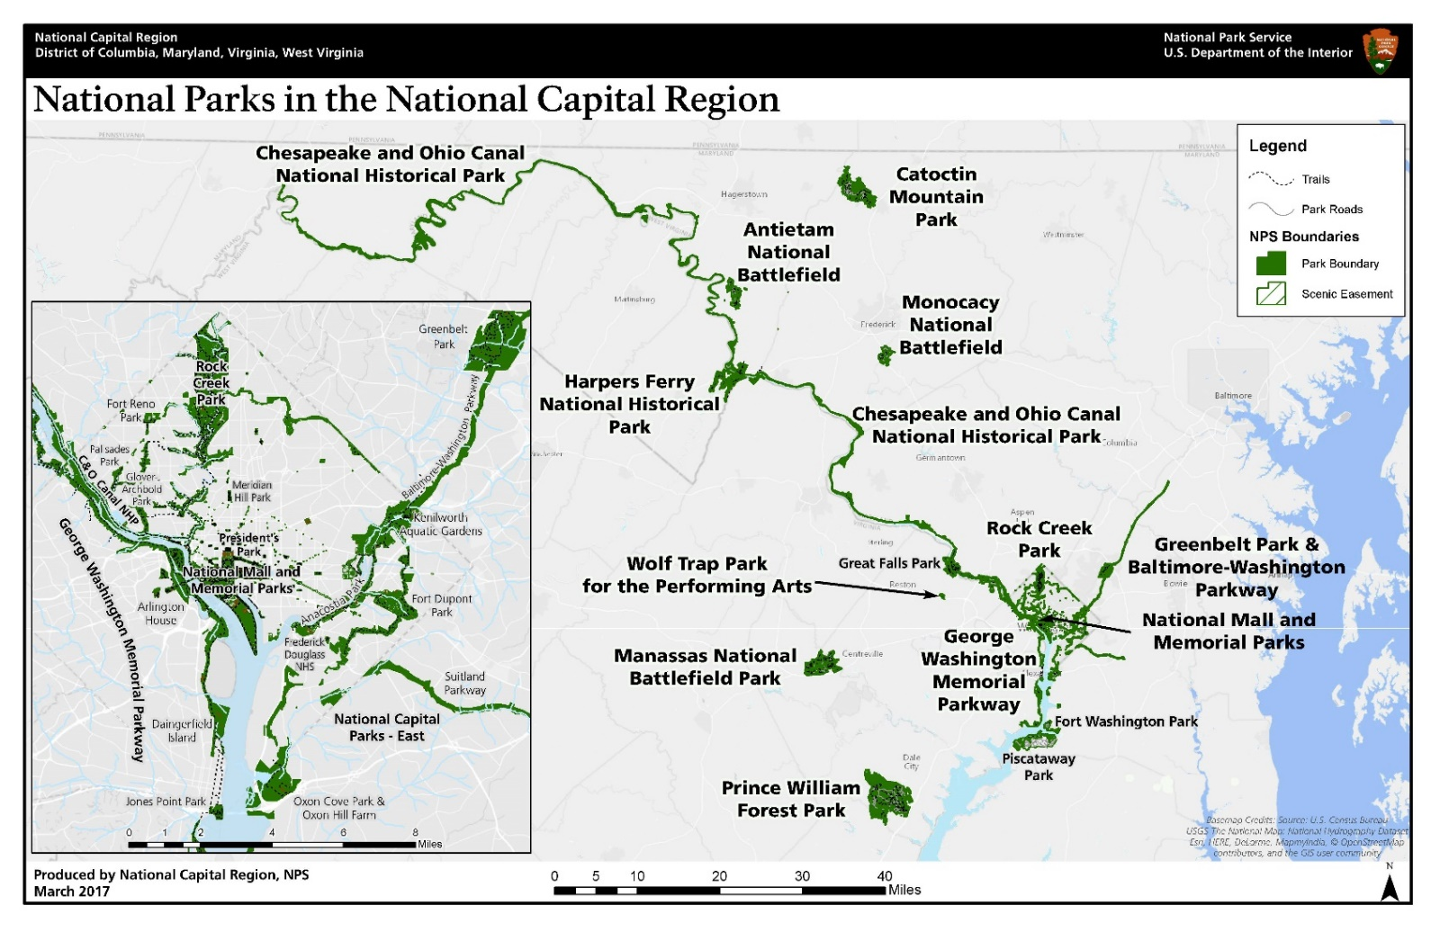

Topic Area 4 – DEST18
- On the trip when you were contacted for this survey, which other National Park Service (NPS) sites in the National Capital Region did you and your personal group visit? Please mark (●) all that apply.

O | Anacostia Park | O | Baltimore-Washington Parkway
O | Antietam National Battlefield | O | Greenbelt Park
O | Catoctin Mountain Park | O | Carter G. Woodson Home National Historic Site
O | Chesapeake & Ohio Canal National Historical Park | O | Chesapeake & Ohio Canal National Historical Park
O | Arlington House | O | Frederick Douglass National Historical Site
O | Clara Barton National Historic Site | O | Kenilworth Park and Aquatic Gardens
O | George Washington Memorial Parkway | O | Mary McLeod Bethune Council House National Historic Site
O | Glen Echo Park | O | Pennsylvania Avenue National Historic Site
O | Jones Point Park | O | Belmont-Paul Women’s Equality National Monument
O | Theodore Roosevelt Island | O | Ford’s Theatre National Historic Site
O | Harpers Ferry National Historical Park | O | Prince William Forest Park
O | Manassas National Battlefield Park | O | Rock Creek Park
O | Monocacy National Battlefield | O | Wolf Trap National Park for the Performing Arts
O | Fort Washington Park | O | White House
O | Oxon Hill Farm | O | National Mall and Associated Monuments/Memorials
O | Fort Circle Parks | O | Old Post Office Tower
O | Piscataway Park | O | Dyke Marsh

Topic Area 4 – VISHIS6
- How often do you generally visit NPS sites in the National Capital Region? Please mark (●) one.

O Not at all
O Once or twice per year
O Several times per year
O Not sure

Topic Area 4 – DEST3
- On the trip when you were contacted for this survey, were you and your personal group able to visit all the NPS sites in the National Capital Region that you planned to? Please mark (●) one.

O Yes -> Skip to Question 24
O No

Topic Area 4 – DEST4
- If you were unable to visit a NPS site in the National Capital Region, what reasons prevented you from visiting those sites? Please mark (●) all that apply.

O Not enough time
O Trail closure
O Road closure
O Inadequate display of safety information
O Bad weather
O Inadequate display of road signs/maps
O Too crowded
O Unsafe road
O Public transportation to the site was not available
O Too much parking congestion
O Too much traffic congestion
O Accessibility barriers for disabled visitors (Please specify):
O Other (Please specify):

Topic Area 3 – TRANSERV1
- Does lack of public transportation prevent you from visiting NPS sites in the National Capital Region as often as you would like? Please mark (●) one.

O Yes
O No

Topic Area 2 – INFOSOURCE13
- Did you and your personal group have the type of information about NPS Sites in the National Capital Region you needed during your trip? Please mark (●) one.
O Yes
O No (Please specify information you needed but didn’t have on your trip):

Topic Area 3 – TRANSERV8
- How would you rate the overall travel experience in the National Capital Region on your trip? Please mark (●) one.

O Excellent
O Good
O Fair
O Poor
O Very poor
Topic Area 9 – OPMGMT10
- Is there anything else you would like to tell us about NPS sites’ facilities, services, or recreational opportunities in the National Capital Region?

E. Background

Topic Area 1 – GROUP7
- Did anyone in your personal group have disabilities that made it difficult to access or participate in park activities or services in [Park Name]? Please mark (●) one.
O No -> Skip to Question 28
O Yes
a. If Yes, on the visit where you were contacted to participate in this survey, what activities or services did the person(s) have difficulty accessing or participating in? (Please describe):

b. Which barriers did the individual experience? Please mark (●) all that apply.
O Difficulty hearing ranger programs, bus drivers, audio-visual exhibits or programs, or information desk staff even with hearing aid
O Hearing devices not available
O Hearing devices that did not work
O Difficulty seeing exhibits, directional signs, visual aids that are part of programs, even with prescribed glasses or due to blindness
O Difficulty accessing facilities, services, or programs even with walking aid and/or wheelchairs
O Difficulty accessing National Park Service websites
O The [Park Name] website was not fully accessible
O The [Park Name] website did not provide enough information to prepare for a visit to the park
O The [Park Name] website did not provide information about accessibility of programs and visiting the park
O Other (Please specify):

Topic Area 1 – GROUP3 & Topic Area 1 – RES2
- For your personal group during your visit to [Park Name] on the day you were contacted for this survey, please provide the following information. (If you don’t know the answer, enter “DK.”)

 | Current Age | U.S. ZIP code or name of country other than U.S.
Yourself
Member #2
Member #3
Member #4
Topic Area 1 – GEND1 & Topic Area 1 – RACE/ETH1
- For your personal group during your visit to [Park Name] on the day you were contacted for this survey, please provide the following information. Please mark (●) one for each group member, including yourself, for gender and Hispanic or Latino. (If you don’t know the answer, mark (●) “Don’t know.”)

 | Yourself | Member #2 | Member #3 | Member #4
Male | O | O | O | O
Female | O | O | O | O
Hispanic or Latino | O | O | O | O
Not Hispanic or Latino | O | O | O | O
Don’t know | --- | O | O | O

Topic Area 1 – RACE/ETH3
- For your personal group during your visit to [Park Name] on the day you were contacted for this survey, please provide the following information. Please mark (●) one or more for each group member, including yourself. (If you don’t know the answer, mark (●) “Don’t know.”)

 | Yourself | Member #2 | Member #3 | Member #4
American Indian or Alaska Native | O | O | O | O
Asian | O | O | O | O
Black or African American | O | O | O | O
Native Hawaiian or other Pacific Islander | O | O | O | O
White | O | O | O | O
Don’t know | --- | O | O | O

Topic Area 1 – EDUC1
- For your personal group during your visit to [Park Name] on the day you were contacted for this survey, what is the highest level of formal education completed by each member of your group? Please mark (●) one for each group member, including yourself. (If you don’t know the answer, mark (●) “Don’t know.”)
 | Yourself | Member #2 | Member #3 | Member #4
Less than high school | O | O | O | O
Some high school | O | O | O | O
High school graduate or GED | O | O | O | O
Some college, business, or trade school | O | O | O | O
College, business, or trade school graduate | O | O | O | O
Some graduate school | O | O | O | O
Master’s, doctoral, or professional degree | O | O | O | O
Don’t know | --- | O | O | O

Topic Area 10 – ECON12
- Which category best represents your annual household income? Please mark (●) one.
O Less than $25,000
O $25,000 to $34,999
O $35,000 to $49,999
O $50,000 to $74,999
O $75,000 to $99,999
O $100,000 to $149,999
O $150,000 to $199,999
O $200,000 or more

