OMB Control Number 1024-0224
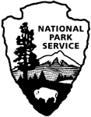 | National Park Service  U.S. Department of the Interior

Death Valley National Park
Frontcountry Road Noise Visitor Survey – 2018

PAPERWORK REDUCTION and PRIVACY ACT STATEMENT: The Paperwork Reduction Act requires us to tell you why we are collecting this information, how we will use it, and whether or not you have to respond. We are authorized by the National Park Service Protection Interpretation and research in System (54 USC §100702) to collect this information. The routine uses of this information will be for the benefit of NPS Managers and planning staff of Death Valley National Park (DEVA) in future initiatives related to the visitor use and resource management of the soundscapes within the site. The data collected will be summarized to evaluate visitor uses and expectations during their visit at DEVA. Your responses are voluntary and anonymous. You can end the process at any time and will not be penalized in any way for choosing to do so. All data from this collection will be aggregated so that no responses will be individually identifiable. A Federal agency may not conduct or sponsor, and you are not required to respond to, a collection of information unless it displays a currently valid OMB Control Number (1024-0224). We estimate that it will take about 16 minutes to complete and return. You may send comments concerning the burden estimates or any aspect of this information collection to: Phadrea Ponds NPS Information Collection Coordinator at pponds@nps.gov (email).

SOUND19

- Instructions: For the next set of questions, we would like you to listen to five short recordings of sounds that are typically heard in Death Valley’s front-country.
Please place the headphones on your head. We will ask you to listen to five brief recordings of sounds. As you listen to each recording, imagine how you would have felt if you had heard the sounds in the recording during your visit to Death Valley’s front country (only).
Please listen to each recording in its entirety; the computer will automatically advance to a page with questions after each recording is finished playing.
You can expect the following steps:
Step 1: The listening portion of this survey will be led by a survey administrator. Remember that all sounds are included, both human and natural.
Step 2: Relax and please listen to the first audio clip
Step 3: Now, please take a moment to fill out the attached sheet for Sound #1
Step 4: Under the ACCEPTABILITY OF SOUND AT THIS LOCATION column, please circle one number which best describes how unacceptable or acceptable the sound was for this location in the park.
Step 6: Under the PERSONAL INTERPRETATION OF THIS SOUND column, please circle one number which best describes how pleasing or annoying the sound was to you.
Step 7: Repeat Steps 3-6 for Clips #2-#5

 | ACCEPTABILITY OF SOUND AT THIS LOCATION |  |  |  |  |  |  |  |  | PERSONAL INTERPRETATION OF THIS SOUND
Clip | Very unacceptable |  | Slightly unacceptable |  | Neutral |  | Slightly acceptable |  | Very acceptable | Very annoying |  | Slightly annoying |  | Neutral |  | Slightly pleasing |  | Very pleasing
#1 | -4 | -3 | -2 | -1 | 0 | +1 | +2 | +3 | +4 | -4 | -3 | -2 | -1 | 0 | +1 | +2 | +3 | +4
#2 | -4 | -3 | -2 | -1 | 0 | +1 | +2 | +3 | +4 | -4 | -3 | -2 | -1 | 0 | +1 | +2 | +3 | +4
#3 | -4 | -3 | -2 | -1 | 0 | +1 | +2 | +3 | +4 | -4 | -3 | -2 | -1 | 0 | +1 | +2 | +3 | +4
#4 | -4 | -3 | -2 | -1 | 0 | +1 | +2 | +3 | +4 | -4 | -3 | -2 | -1 | 0 | +1 | +2 | +3 | +4
#5 | -4 | -3 | -2 | -1 | 0 | +1 | +2 | +3 | +4 | -4 | -3 | -2 | -1 | 0 | +1 | +2 | +3 | +4

RecEXP6
- Below is a list of statements related to your visit to Death Valley National Park. Please rate how true the following statements are according to your visit today. (Please select only one response for each of the following items)
During my visit to Death Valley National Park, I am motivated to… | Not at all True | Slightly True | Moderately True | Very True | Completely True
- …learn about the cultural history of Death Valley. | 1 | 2 | 3 | 4 | 5
- …engage with historical sites. | 1 | 2 | 3 | 4 | 5
- …learn about the geologic history of Death Valley. | 1 | 2 | 3 | 4 | 5
- …experience extreme heat. | 1 | 2 | 3 | 4 | 5
- …experience a different temperature than I am used to. | 1 | 2 | 3 | 4 | 5
- …experience more agreeable temperatures. | 1 | 2 | 3 | 4 | 5
- …view scenic beauty. | 1 | 2 | 3 | 4 | 5
- …be close to nature. | 1 | 2 | 3 | 4 | 5
- …view wildlife. | 1 | 2 | 3 | 4 | 5
- ...experience tranquility. | 1 | 2 | 3 | 4 | 5
- ...feel independent from rest of society. | 1 | 2 | 3 | 4 | 5
- ...be away from crowds of people. | 1 | 2 | 3 | 4 | 5
- …physically relax. | 1 | 2 | 3 | 4 | 5
- ...have my mind move at a slower pace. | 1 | 2 | 3 | 4 | 5
- ...get away from the noise back home. | 1 | 2 | 3 | 4 | 5
- ...enjoy the sounds of nature. | 1 | 2 | 3 | 4 | 5
- ...experience natural quiet. | 1 | 2 | 3 | 4 | 5
- ...take risks. | 1 | 2 | 3 | 4 | 5
- ...have thrills. | 1 | 2 | 3 | 4 | 5
- ...experience a sense of exploration. | 1 | 2 | 3 | 4 | 5
- ...gain a sense of self-confidence. | 1 | 2 | 3 | 4 | 5
- ...learn what I am capable of. | 1 | 2 | 3 | 4 | 5
- ...show others my abilities. | 1 | 2 | 3 | 4 | 5
- ...share photos on social media. | 1 | 2 | 3 | 4 | 5
- ...tell others about my trip. | 1 | 2 | 3 | 4 | 5
- ...have others know that I have been here. | 1 | 2 | 3 | 4 | 5

SOUND1
- How important is natural quiet to you?
Not at all important | Slightly Important | Moderately Important | Very Important | Extremely Important
1 | 2 | 3 | 4 | 5

SOUND16 & RecEXP9
- During your time in this area of Death Valley National Park, what percentage of time did you hear road noise? Please provide an estimate below.

______________ percent

Would you be willing to hike further to reduce that percentage by one half?
No | YES

If YES, how far would you hike to reduce that percentage by one half? (Please list partial miles as 1/4, 1/2, or 3/4.)

______________ miles
SOUND15
- Did the amount of road noise you experienced at Death Valley National Park detract from your experience? (Please select yes or no)
No | YES

If you answered YES to the question above, how did you respond to the amount of road noise? (Please select only one response for each of the following items)
 | I DID NOT do this | I DID NOT do this, but I thought about doing this | I DID do this
- I changed my direction of travel | 1 | 2 | 3
- I moved to quieter parts of the park | 1 | 2 | 3
- I chose more remote areas | 1 | 2 | 3
- I used headphones or ear plugs | 1 | 2 | 3
- I ended activity earlier than planned | 1 | 2 | 3
- I planned my visit for times early or late in the day | 1 | 2 | 3
- Other (please specify) __________________________ | 1 | 2 | 3

RES2
- Are you a permanent resident or citizen of the United States? (Please select only one response)
No – What is your country of origin?
________________
Yes – What is your zip code?
________________

RES12
- In what type of community do you now live? (Please select only one response)
on a farm or ranch
rural or small town (under 1000 population)
town (1000 to 5000 population)
small city (5000 to 50,000 population)
medium city (50,000 to 1 million population)
in a major city or metropolitan area (over 1 million population)

TRANSMODE2
- By what means did you enter Death Valley National Park during this trip? (Please select only one response)

Walking
Motorcycle
Hiking
All-Terrain Vehicle
Bicycle
Tour Bus
Public Transportation
Aircraft
Personal or Rental Vehicle
Other (please specify):__________________

RecACT6
- During this visit to Death Valley National Park, have you gone or do you plan to go hiking? (Please select only one response)
NO | YES

SOUND 10
- Did you make a conscious effort to limit the amount of noise you made in the park today? (Choose one and explain why or why not)
NO | YES
Why or Why Not______________________

If you responded yes to the above question, how did you limit the amount of noise you made in the park today?
____________________________________

AGE1
- In what year were you born? (Please insert your birth year below)
________________
RecEXP14
NOTE: Each respondent will be given seven randomly selected scenarios (each with a different random combination of attributes). 12a-12g represent possible random outputs of scenario choices.

- In this section there are a series of diagrams to depict the extent to which road noise disperses in the park. These maps show the volume and extent of road noise across the landscape, from the road and into other areas of the park. The yellow area represents the areas with higher levels of road noise and red represents areas with the lower levels of road noise. Each question below has two hypothetical management scenarios related to road noise. We would like you to select one scenario in each question that you would most prefer to experience during a visit to Death Valley National Park.

(a) Which scenario best describes the experience you would most prefer while in Death Valley National Park?
Scenario 1 | Scenario 2
Noise Dispersion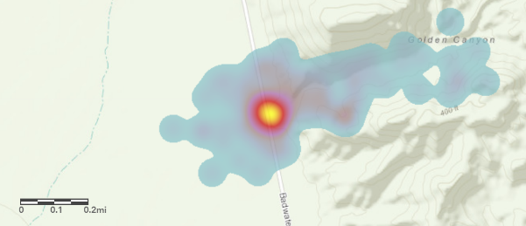 | Noise Dispersion  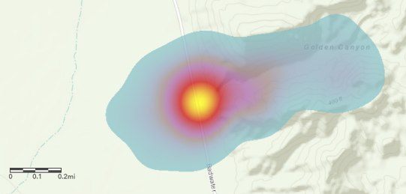
- Road Noise reduced by 20% | - Road Noise reduced by 5%
- 35 mile per hour speed limit on major park roads | - 45 mile per hour speed limit on major park roads
- A mandatory shuttle system transports visitor along major park roads with parking on either end to reduce road noise | - A noise-reducing pavement is installed on major park roads to reduce road noise

(b) Which scenario best describes the experience you would most prefer while in Death Valley National Park?
Scenario 1 | Scenario 2
Noise Dispersion  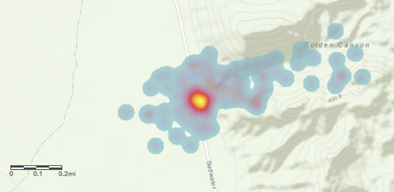 | Noise Dispersion
- Road Noise reduced by 10% | - Road Noise reduced by 5%
- 35 mile per hour speed limit on major park roads | - 60 mile per hour speed limit on major park roads
- A noise-reducing pavement is installed on major park roads to reduce road noise | - A quota on the amount of vehicles allowed on major park roads at one time is implemented to reduce road noise

(c) Which scenario best describes the experience you would most prefer while in Death Valley National Park?
Scenario 1 | Scenario 2
Noise Dispersion | Noise Dispersion
- Road Noise reduced by 5% | - Road Noise reduced by 10%
- 45 mile per hour speed limit on major park roads | - 60 mile per hour speed limit on major park roads
- A quota on the amount of vehicles allowed on major park roads at one time is implemented to reduce road noise | - A mandatory shuttle system transports visitor along major park roads with parking on either end to reduce road noise

(d) Which scenario best describes the experience you would most prefer while in Death Valley National Park?
Scenario 1 | Scenario 2
Noise Dispersion | Noise Dispersion
- Road Noise reduced by 20% | - Road Noise reduced by 10%
- 35 mile per hour speed limit on major park roads | - 60 mile per hour speed limit on major park roads
- A quota on the amount of vehicles allowed on major park roads at one time is implemented to reduce road noise | - A noise-reducing pavement is installed on major park roads to reduce road noise

(e) Which scenario best describes the experience you would most prefer while in Death Valley National Park?
Scenario 1 | Scenario 2
Noise Dispersion | Noise Dispersion
- Road Noise reduced by 20% | - Road Noise reduced by 5%
- 35 mile per hour speed limit on major park roads | - 60 mile per hour speed limit on major park roads
- A mandatory shuttle system transports visitor along major park roads with parking on either end to reduce road noise | - A quota on the amount of vehicles allowed on major park roads at one time is implemented to reduce road noise

(f) Which scenario best describes the experience you would most prefer while in Death Valley National Park?
Scenario 1 | Scenario 2
Noise Dispersion | Noise Dispersion
- Road Noise reduced by 20% | - Road Noise reduced by 10%
- 35 mile per hour speed limit on major park roads | - 45 mile per hour speed limit on major park roads
- A quota on the amount of vehicles allowed on major park roads at one time is implemented to reduce road noise | - A noise-reducing pavement is installed on major park roads to reduce road noise

(g) Which scenario best describes the experience you would most prefer while in Death Valley National Park?
Scenario 1 | Scenario 2
Noise Dispersion | Noise Dispersion
- Road Noise reduced by 20% | - Road Noise reduced by 5%
- 35 mile per hour speed limit on major park roads | - 60 mile per hour speed limit on major park roads
- A noise-reducing pavement is installed on major park roads to reduce road noise | - A mandatory shuttle system transports visitor along major park roads with parking on either end to reduce road noise

This is the end of the survey.
Thank you for your time and participation.

