Joshua Tree National Park
General Visitor Survey
2019
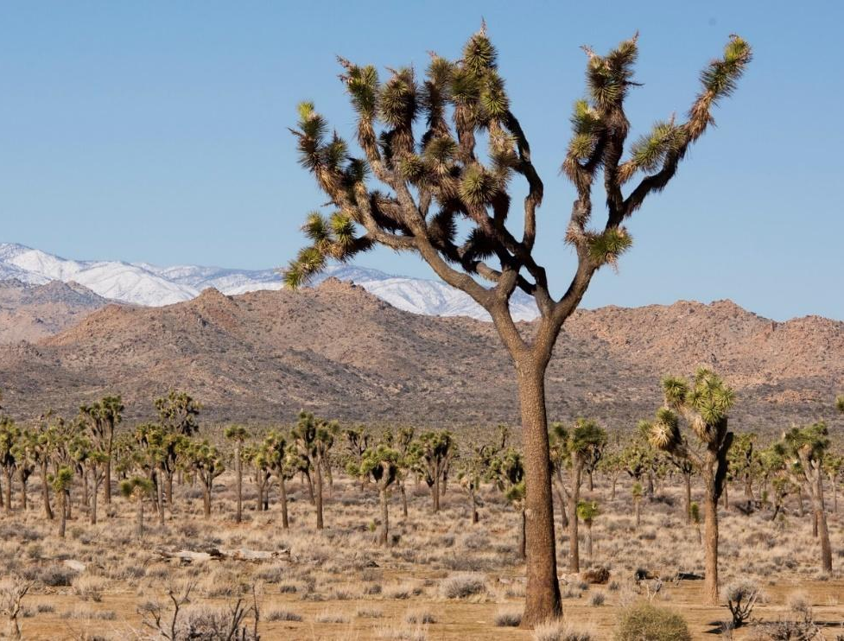

To be completed by field staff:

ID ______ Time ________ Location__________Tracker number ________ Date _____
Field staff____________

PAPERWORK REDUCTION and PRIVACY ACT STATEMENT: The Paperwork Reduction Act requires us to tell you why we are collecting this information, how we will use it, and whether or not you have to respond. We are authorized by the National Park Service Protection Interpretation and research in System (54 USC §100702) to collect this information. The data collected in this study will assist managers in understanding how the recent increase in visitation to Joshua Tree National Park may be impacting the visitor experience. Your responses to this collection are completely voluntary and will remain anonymous. You can end the process at any time and will not be penalized in any way for choosing to do so. All contact information collected for the purpose of the follow-up survey will be destroyed at the end of the collection period and no personal identifiable records will be maintained or stored for any purposes. Data collected will only be reported in aggregates and no individually identifiable responses will be reported. A Federal agency may not conduct or sponsor, and you are not required to respond to, a collection of information unless it displays a currently valid OMB Control Number (1024-0224). We estimate that it will take about 11 minutes to complete and return this on-site questionnaire. You may send comments concerning the burden estimates or any aspect of this information collection to: Dr. Ryan Sharp, Assistant Professor, Park Management and Tourism, 221 Throckmorton, Manhattan, KS 66506, Kansas State University (address) or ryansharp@ksu.edu (email); or Phadrea Ponds NPS Information Collection Coordinator at pponds@nps.gov (email).
SECTION 1: YOUR PAST AND CURRENT VISIT TO
JOSHUA TREE NATIONAL PARK
NOTE: In this questionnaire, “personal group” is defined as anyone that you are visiting the park with, such as spouse, family, friends, etc. This does not include the larger group that you might be traveling with, such as school, church, scouts, or tour group.

- Please tell us about your past visitation to Joshua Tree National Park (referred to as “the park” below).
- Including today, how many days in the last month (30 days) have you visited the park? ___________
- Including today, how many days in the last year (12 months) have you visited the park? ___________
- Including today, how many years (total) have you visited the park? _____________

- On this trip, how long did you and your personal group spend visiting Joshua Tree NP? Please list partial hours / days as ¼, ½, ¾.
________ | Number of hours, if fewer than 24 hours
 | OR
________ | Number of days, if 24 hours or more

❑ | Joshua Joshua Tree NP was the primary destination
❑ | Joshua Joshua Tree NP was one of several destinations
❑ | Joshua Joshua Tree NP was not a planned destination

- For this trip, please mark the locations in Joshua Tree NP that you and your personal group visited. Please mark all that apply.

❑ North Entrance Station | ❑ Bajada Nature Trail
❑ West Entrance Station | ❑ Barker Dam
❑ Indian Cove Ranger Station | ❑ Cholla Cactus Garden
❑ Cottonwood Visitor Center | ❑ Cottonwood Spring
❑ Joshua Tree Visitor Center | ❑ Covington Flats
❑ Oasis Visitor Center | ❑ Fortynine Palms Oasis
❑ Black Rock Nature Center | ❑ Geology Tour Road
❑ Belle Campground | ❑ Keys Ranch
❑ Black Rock Campground | ❑ Keys View
❑ Cottonwood Campground | ❑ Lost Horse Mine
❑ Indian Cove Campground | ❑ Lost Palms Oasis
❑ Jumbo Rocks Campground | ❑ Pinto Basin Road
❑ Hidden Valley Campground | ❑ Quail Springs
❑ White Tank Campground | ❑ Ryan Mountain
❑ Sheep Pass Group Camp
❑ Other (Please specify) ____________________________________________________

SECTION 2: YOUR MOTIVATIONS AND ACTIVITIES

- On this trip, what was the primary reason that you and your personal group came to the Joshua Tree NP area (Yucca Valley, Joshua Tree, Twentynine Palms)? Please mark one.
❑ | Resident of the area (Yucca Valley, Joshua Tree, Twentynine Palms, Indio)
❑ | Visit Joshua Tree NP
❑ | Visit other attractions in the area
❑ | Visit friends / relatives at the Twentynine Palms U.S. Marine Corps base
❑ | Visit friends / relatives in the area (other than the Marine Corps base)
❑ | Traveling through – unplanned visit
❑ | Business
❑ | Other (Please specify) ________________________________________

- On this visit, in which activities did you and your personal group participate within Joshua Tree NP? Please mark all that apply.
❑ Attended ranger-led programs | ❑ Stargazing / viewing night sky
❑ Attended field classes or other guided activities | ❑ Camping
❑ Visited historical or archeological sites | ❑ Backpacking overnight
❑ Visited visitor center(s)  ❑ Family/friend gathering or celebration | ❑ Walking self-guided nature trails (with brochures / signs)  ❑ Day hiking
❑ Sightseeing | ❑ Picnicking
❑ Bouldering (using pads and bouldering guides) | ❑ Trail running
❑ Rock scrambling (without specialized gear or skills) | ❑ Bicycling
❑ Technical climbing (with specialized gear or skills) | ❑ Horseback riding
❑ Slacklining | ❑ Viewed plants and/or wildlife
❑ Seeking spiritual connection | ❑ Enjoyed nature
❑ Exercised to promote physical fitness | ❑ Created content for social media/blogs
❑ Photography/videos
❑ Other (Please specify) ____________________________________________________

  - Which one of the above activities was the primary activity in which you and your personal group participated at Joshua Tree NP on this visit?
________________________________________________________________

  - Did anyone in your personal group participate in rock climbing in Joshua Tree NP on this visit or past visit(s)? Please mark one.
❑ | No, have not participated in climbing activities. Go to Question 6d
❑ | Climbed on both this visit and past visit(s)
❑ | This is our first time climbing here
❑ | Have climbed in the past, but not on this visit

  - Where is your personal group’s preferred area to climb in Joshua Tree NP?
❑ | Don’t have a preferred area
OR | List one area ________________________________________

  - Has anyone in your personal group ever installed or replaced a fixed anchor in Joshua Tree NP?
❑ Yes ❑ No
  - Did anyone in your personal group participate in bouldering in Joshua Tree NP on this visit or past visit(s)? Please mark one.
❑ | No, have not participated in bouldering activities. Go to Question 8
❑ | Bouldered on both this visit and past visit(s)
❑ | This is our first time bouldering here
❑ | Have bouldered in the past, but not on this visit

  - Where is your personal group’s preferred area to boulder in Joshua Tree NP?
❑ | Don’t have a preferred area
OR | List one area ________________________________________

SECTION 3: YOUR LODGING AND RESERVATIONS

  - Did you or members of your personal group attempt to make reservations for campsites at Joshua Tree NP for this trip?
❑ Yes ❑ No Go to Question 9

  - Were you able to make campsite reservations at Joshua Tree NP for this trip?
❑ Yes ❑ No

- On this visit, how many nights, if any, did you and your personal group camp overnight within Joshua Tree NP?
________ | Number of nights inside Joshua Tree NP

- On this visit, how many nights, if any, did you and your personal group stay overnight away from home in the area surrounding Joshua Tree NP (Yucca Valley, Joshua Tree, Twentynine Palms)?
________ | Number of nights in the surrounding area

- In what type of lodging did you and your personal group spend the night(s) inside the park? Please check all that apply in Column A.
- In what type of lodging did you and your personal group spend the night(s) outside the park in the surrounding area (Yucca Valley, Joshua Tree, Twentynine Palms)? Please check all that apply in Column B.

Column A  (inside the park) |  | Lodging type | Column B (outside the park)
 | Lodge, motel, cabin, rented condo/home, or bed & breakfast |  |  | ❑
❑ | RV / trailer camping |  |  | ❑
❑ | Tent camping in developed campground |  |  | ❑
❑ | Backcountry campsite |  |  | ❑
 | Personal seasonal residence |  |  | ❑
 | Residence of friends or relatives |  |  | ❑
❑ | Other (Please specify) ________________________________________________________ |  |  | ❑

SECTION 4: INFORMATION AND AWARENESS

- Prior to this visit, how did you and your personal group obtain information about the park? Please mark all that apply in Column A. If you were to visit Joshua Tree NP in the future, how would you and your personal group prefer to obtain information about the park? Please mark all that apply in Column B.

Column A (prior to this visit) |  | Source of information | Column B (preferred for future visits)
❑ | Did not obtain information prior to visit |  |  | ❑
❑ | Joshua Tree NP website: www.nps.gov/jotr |  |  | ❑
❑ | Social media – Which one(s)? |  |  | ❑
 | ❑ Facebook ❑ Twitter ❑ Instagram ❑ Reddit ❑ Flickr ❑ Other
❑ | Other websites (Trip Advisor, Hotels.com, Expedia, etc.) |  |  | ❑
❑ | Friends / relatives / word of mouth |  |  | ❑
❑ | Highway signs |  |  | ❑
❑ | Inquiry to park via phone, mail, or email |  |  | ❑
❑ | Local businesses (hotels, motels, restaurants, etc.) |  |  | ❑
❑ | Maps / brochures |  |  | ❑
❑ | Newspaper / magazine articles |  |  | ❑
❑ | Other National Park Service sites / units |  |  | ❑
❑ | Previous visits |  |  | ❑
❑ | School class / program |  |  | ❑
❑ | State or local welcome center / visitors bureau / chamber of commerce |  |  | ❑
❑ | Television / radio programs / DVDs |  |  | ❑
❑ | Travel guides / tour books (AAA, Fodor’s, Lonely Planet, etc.) |  |  | ❑
❑ | Other (Please specify) ________________________________________ |  |  | ❑

- From the sources marked in Column A, did you and your personal group receive the type of information about the park that you needed?
❑ No ❑ Yes Go to Question 11

- If NO, what type of park information did you and your personal group need that was not available? Please be specific.
________________________________________________________________________

- How far in advance, if at all, did you begin planning your most recent visit to Joshua Tree NP?

________ Days ________ Weeks ________ Months

- Please mark all the information services and facilities that you or your personal group used during this visit to Joshua Tree NP
- Next, for only those services and facilities that you or your personal group used, please rate their importance from 1-5.
- Finally, for only those services and facilities that you or your personal group used, please rate their quality from 1-5.

a) Information services /  facilities used |  | b) If used, how important?  1=Not important  2=Somewhat important  3=Moderately important  4=Very important  5=Extremely important | c) If used, what quality?  1=Very poor  2=Poor  3=Average  4=Good  5=Very good
❑ | No information services / facilities used | n/a | n/a
❑ | Assistance from visitor center staff | ________ | ________
❑ | Assistance from entrance station staff | ________ | ________
❑ | Assistance from roving rangers | ________ | ________
❑ | Bulletin boards | ________ | ________
❑ | Joshua Tree NP website: www.nps.gov/jotr  (used before or during visit) | ________ | ________
❑ | Park brochure / map | ________ | ________
❑ | Park newspaper | ________ | ________
❑ | Ranger-led programs (walks, talks, etc.) | ________ | ________
❑ | Roadside exhibits | ________ | ________
❑ | Sales items in visitor center (selection, price, etc.) | ________ | ________
❑ | Trailside exhibits / signs | ________ | ________
❑ | Visitor center exhibits | ________ | ________
❑ | Other park publications (plant lists, dog information, camping brochure, etc.) | ________ | ________

SECTION 5: ABOUT YOU

  - What is your zip code? ____________

  - What year were you born? ________________

- What is your gender? (select one) ❑ Male ❑ Female ❑ Other ❑ Do not wish to answer

- What is the highest level of school you have completed? (select one)
❑ Less than high school | ❑ Some college | ❑ Graduate or professional degree
❑ Some high school | ❑ Two-year college graduate | ❑ Do not wish to answer
❑ High school graduate | ❑ Four-year college graduate
- Are you Hispanic or Latino? | ❑ Yes ❑ No

- What is your race? (select all that apply)
❑ American Indian or Alaska Native | ❑ Hawaiian or Pacific Islander
❑ Asian | ❑ White
❑ Black or African American | ❑ Do not wish to answer

- Which category best describes your total household income in U.S. dollars during 2018 before taxes? (select one)
❑ Less than $24,999 | ❑ $50,000 to $74,999 | ❑ $150,000 to $199,999
❑ $25,000 to $34,999 | ❑ $75,000 to $99,999 | ❑ $200,000 or more
❑ $35,000 to $49,999 | ❑ $100,000 t $149,999 | ❑ Do not wish to answer

Thank you for your help with this survey!
Please return it to the person who gave it to you.
PRIVACY ACT and PAPERWORK REDUCTION ACT statement:
16 U.S.C. 1a-7 authorizes collection of this information. This information will be used by park managers to better serve the public. Response to this request is voluntary and anonymous. Your name will never be associated with your answers, and all contact information will be destroyed when the data collection is concluded. No action may be taken against you for refusing to supply the information requested. An agency may not conduct or sponsor, and a person is not required to respond to, a collection of information unless it displays a currently valid OMB control number.
BURDEN ESTIMATE STATEMENT: Public reporting burden for this form is estimated to average 10 minutes per response. Direct comments regarding the burden estimate or any other aspect of this form to:

