OMB Number: XXXX-XXXX
Expiration Date: XX/XX/20XX

Tallgrass Prairie National Preserve
Visitor Survey
2019
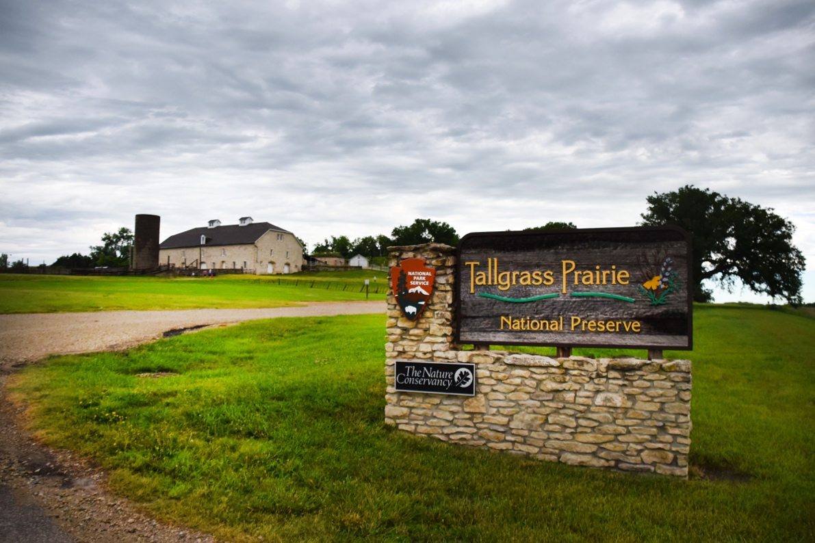

To be completed by field staff:

ID ______ Time ________ Tracker number ________ Date _____Field staff____________

Paperwork Reduction and Privacy Act Statements: The Paperwork Reduction Act requires us to tell you why we are collecting this information, how we will use it, and whether or not you have to respond. The data collected in this study will assist mangers in understanding visitor’s level of satisfaction with current amenities and opportunities at Tallgrass Prairie National Preserve. Additional your input will be critical in understand possible future management scenarios at the park. Your responses are voluntary and anonymous. Your name and address will not be collected. At the completion of this collection all personal information will be destroyed and in no way be connected with the results of this survey. A Federal agency may not conduct or sponsor and you are not required to respond to, a collection of information unless it displays a currently valid OMB Control Number.

Burden Estimate: We estimate that it will take an average of 10 minutes to complete this questionnaire. You may send comments concerning the burden estimates or any aspect of this information collection to: Dr. Ryan Sharp, Assistant Professor, Park Management and Tourism, 221 Throckmorton, Manhattan, KS 66506, Kansas State University (address) or ryansharp@ksu.edu (email) or the Social Science Branch, National Park Service, 1201 Oakridge Drive, Fort Collins, CO, 80525-5596; nps_nrss_social_science@nps.gov (email).
SECTION 1: YOUR PAST AND CURRENT VISIT TO
TALLGRASS PRAIRIE NATIONAL RESERVE
NOTE: In this questionnaire, “personal group” is defined as anyone that you are visiting the park with, such as spouse, family, friends, etc. This does not include the larger group that you might be traveling with, such as school, church, scouts, or tour group.
- Please tell us about your past visitation to Tallgrass Prairie National Preserve (referred to as “the park” below).
- Is this your first visit to the park? ___________
- If not, including today, how many days in the last month (30 days) have you visited the park? ___________
- If not, including today, how many days in the last year (12 months) have you visited the park? ___________
- If not, including today, how many years (total) have you visited the park? _____________

- Did you go to the Visitor Center? ___Yes ___No

- On this trip, how long did you and your personal group spend visiting the park? Please list partial hours / days as ¼, ½, ¾.

________ | Number of hours, if fewer than 24 hours
 | OR
________ | Number of days, if 24 hours or more
- For this trip, please mark the locations in in the park that you and your personal group visited. Please mark all that apply.

❑ Park Visitor Center | ❑ Prairie via the bus tour
❑ Historic ranch buildings | ❑ Hiking trails on west side
❑ One-room schoolhouse | ❑ Hiking trails on east side
❑ Fishing ponds | ❑ Bison
❑ Other (Please specify) ____________________________________________________

  - Was there a primary activity that you came to the park specifically for? ___Yes ___No
  - If yes, what was this primary activity? ________________

SECTION 2: YOUR MOTIVATIONS AND ACTIVITIES

- On this trip, what was the primary reason that you and your personal group came to the park? Please mark one.

❑ | Resident of the area (Strong City, Manhattan, etc.)
❑ | Visit the park
❑ | Visit other attractions in the area
❑ | Visit friends / relatives in the area
❑ | Traveling through – unplanned visit
❑ | Business
❑ | Other (Please specify) ________________________________________

- On this visit, in which activities did you and your personal group participate within the park? Please mark all that apply.

❑ Attending ranger-led programs, e.g. bus tour | ❑ Stargazing / viewing night sky
❑ Attending field classes or other guided activities | ❑ Walking self-guided nature trails (with brochures, signs)
❑ Visiting historical buildings | ❑ Day hiking
❑ Visiting visitor center(s) | ❑ Picnicking
❑ Sightseeing | ❑ Viewing plants and/or wildlife
❑ Trail running | ❑ Enjoying nature
❑ Taking photographs/videos | ❑ Creating content for social media/blogs
❑ Seeking physical fitness | ❑ Bison viewing
❑ Seeking spiritual connection | ❑ Attending special events
❑ Other (Please specify) ____________________________________________________

  - Which one of the above activities was the primary activity in which you and your personal group participated at the park on this visit?
________________________________________________________________

SECTION 3: INFORMATION AND AWARENESS

- Please mark all the information services and facilities that you or your personal group used during this visit to the park
- Next, for only those services and facilities that you or your personal group used, please rate their importance from 1-5.
- Finally, for only those services and facilities that you or your personal group used, please rate their quality from 1-5.

a) Information services / facilities used |  | b) If used, how important?  1=Not important  2=Somewhat important  3=Moderately important  4=Very important  5=Extremely important | c) If used, what quality?  1=Very poor  2=Poor  3=Average  4=Good  5=Very good
❑ | No information services / facilities used | n/a | n/a
❑ | Assistance from visitor center staff | ________ | ________
❑ | Assistance from roving rangers | ________ | ________
❑ | Bulletin boards | ________ | ________
❑ | Park website: www.nps.gov/tapr (used before or during visit) | ________ | ________
❑ | Bus tour | ________ | ________
❑ | Park brochure / map | ________ | ________
❑ | Cell phone tour | ________ | ________
❑ | Ranger-led programs (walks, talks, etc.) | ________ | ________
❑ | Sales items in visitor center (selection, price, etc.) | ________ | ________
❑ | Trailside exhibits / signs / waysides | ________ | ________
❑ | Visitor center exhibits | ________ | ________
❑ | Picnic Areas | ________ | ________
❑ | Hiking trails | ________ | ________
❑ | Restrooms | ________ | ________
❑ | Water fountains | ________ | ________
❑ | Handicap parking areas at the visitor center | ________ | ________
❑ | Handicap parking areas near the barn | ________ | ________
❑ | Handicap trail (Bottomland Trail) | ________ | ________

d. How important are the following services to the enjoyment of your visit to the park? Please mark one answer for each question.
Service | Not important | Somewhat important | Moderately important | Very important | Extremely important
Availability of park employees and volunteers | ❑ | ❑ | ❑ | ❑ | ❑
Internet / Wi-Fi at visitor centers | ❑ | ❑ | ❑ | ❑ | ❑
Availability to ranger-led tours | ❑ | ❑ | ❑ | ❑ | ❑
Accessibility to prairie via guided bus tour program | ❑ | ❑ | ❑ | ❑ | ❑
Availability of kids programming | ❑ | ❑ | ❑ | ❑ | ❑
Availability of special events | ❑ | ❑ | ❑ | ❑ | ❑
Availability to fishing pond | ❑ | ❑ | ❑ | ❑ | ❑
Interpretive waysides and signs | ❑ | ❑ | ❑ | ❑ | ❑
Cell phone tours | ❑ | ❑ | ❑ | ❑ | ❑
On-line downloadable publications | ❑ | ❑ | ❑ | ❑ | ❑
Orientation film | ❑ | ❑ | ❑ | ❑ | ❑

- Please provide your level of agreement for the following items:
Service | Strongly Disagree | Somewhat Disagree | Neither Agree nor Disagree | Somewhat Agree | Strongly Agree
Upon your arrival to the park did you have a sense of knowing where to begin? | ❑ | ❑ | ❑ | ❑ | ❑
Was there anything that confused you during your visit to the park? If so what? ___________________ | ❑ | ❑ | ❑ | ❑ | ❑
Did you have a sense of knowing what there was to do at the park? | ❑ | ❑ | ❑ | ❑ | ❑
Was signage adequate? | ❑ | ❑ | ❑ | ❑ | ❑
Was signage confusing? | ❑ | ❑ | ❑ | ❑ | ❑
When you exited the Visitor Center, you knew how to begin your visit? | ❑ | ❑ | ❑ | ❑ | ❑

SECTION 4: OPINIONS ABOUT THE PARK

- Below is a list of possible detractions you may have experienced while visiting Tallgrass Prairie National Preserve. Please look over the list and for each possible detraction indicate how much it detracted from your experience during your current visit to the park. (select one box for each row)
 | Did not detract at all | Slightly detracted | Moderately detracted | Seriously detracted | Very seriously detracted | Did not experience
Too few parking spaces at trailheads | ❑ | ❑ | ❑ | ❑ | ❑ | ❑
Not enough restrooms | ❑ | ❑ | ❑ | ❑ | ❑ | ❑
Too little directional signage on park trails | ❑ | ❑ | ❑ | ❑ | ❑ | ❑
Too few parking spaces at visitor centers | ❑ | ❑ | ❑ | ❑ | ❑ | ❑
Congestion in the historic area (e.g. barn and house) | ❑ | ❑ | ❑ | ❑ | ❑ | ❑
Congestion in the visitor center | ❑ | ❑ | ❑ | ❑ | ❑ | ❑
Congestion in the visitor center parking lot | ❑ | ❑ | ❑ | ❑ | ❑ | ❑
Too little signage on backcountry trails in the park | ❑ | ❑ | ❑ | ❑ | ❑ | ❑
Too many signs | ❑ | ❑ | ❑ | ❑ | ❑ | ❑
Too few interpretative signs | ❑ | ❑ | ❑ | ❑ | ❑ | ❑
Not enough ranger-led activities | ❑ | ❑ | ❑ | ❑ | ❑ | ❑
Conflicts with other visitors park trails | ❑ | ❑ | ❑ | ❑ | ❑ | ❑
Not enough staff to assist you | ❑ | ❑ | ❑ | ❑ | ❑ | ❑

SECTION 5: YOUR PREFERENCES FOR POTENTIAL SCENARIOS

- Please indicate your level of opposition or support for the following scenarios at Tallgrass Prairie National Preserve. The list of items below are not necessarily scenarios that are definitely going to occur at the park. However, we are interested in your opinions about these potential scenarios (select one box for each row)

 |  | Strongly Oppose | Oppose | Somewhat Oppose | Neither Oppose or Support | Somewhat Support | Support | Strongly Support | I don’t know or need more information
General | Historic house only available via a guided tour to limit resource damage | ❑ | ❑ | ❑ | ❑ | ❑ | ❑ | ❑ | ❑
General | Develop horseback riding interpretive programing | ❑ | ❑ | ❑ | ❑ | ❑ | ❑ | ❑ | ❑
General | Add a bus tour fee to help pay for this service | ❑ | ❑ | ❑ | ❑ | ❑ | ❑ | ❑ | ❑
General | More concessions available on site (e.g. food, activities such as horseback riding) | ❑ | ❑ | ❑ | ❑ | ❑ | ❑ | ❑ | ❑
General | Alternative locations to view the bison | ❑ | ❑ | ❑ | ❑ | ❑ | ❑ | ❑ | ❑
General | Provide interpretive programs and demonstrations for visitors exhibiting the growing of historic crops, gardens, and orchards in their original locations | ❑ | ❑ | ❑ | ❑ | ❑ | ❑ | ❑ | ❑
Developed Camping | Develop campsites in the park | ❑ | ❑ | ❑ | ❑ | ❑ | ❑ | ❑ | ❑
Developed Camping | Work with surrounding communities to develop private campgrounds | ❑ | ❑ | ❑ | ❑ | ❑ | ❑ | ❑ | ❑
Trails | Increase the networked trail system in the park | ❑ | ❑ | ❑ | ❑ | ❑ | ❑ | ❑ | ❑
Trails | Provide more trail infrastructure around sensitive resources, such as boardwalks and steps | ❑ | ❑ | ❑ | ❑ | ❑ | ❑ | ❑ | ❑
Trails | Provide more technological opportunities on the trails (e.g., phone apps) | ❑ | ❑ | ❑ | ❑ | ❑ | ❑ | ❑ | ❑
Trails | Make it easier to get from the visitor center/developed areas to the prairies | ❑ | ❑ | ❑ | ❑ | ❑ | ❑ | ❑ | ❑
Trails | Allow biking on certain trails | ❑ | ❑ | ❑ | ❑ | ❑ | ❑ | ❑ | ❑

- Using the same list from the previous question, please select the top three possible management actions that you prefer more than other scenarios (select three). The list of items below are not necessarily scenarios that will occur at the park.
  - Action 1_______________________________
  - Action 2_______________________________
  - Action 3_______________________________

❑ I am choosing not to select any items from the list above, because I oppose all scenarios
SECTION 6: ABOUT YOU

- What is your zip code? ____________

- What year were you born? ________________

- What is your gender? (select one) ❑ Male ❑ Female ❑ Do not wish to answer

- What is the highest level of school you have completed? (select one)

❑ Less than high school | ❑ Some college | ❑ Graduate or professional degree
❑ Some high school | ❑ Two-year college graduate | ❑ Do not wish to answer
❑ High school graduate | ❑ Four-year college graduate

- Are you Hispanic or Latino? ❑ Yes ❑ No
- What is your race? (select all that apply)

❑ American Indian or Alaska Native | ❑ Hawaiian or Pacific Islander
❑ Asian | ❑ White
❑ Black or African American | ❑ Do not wish to answer

- Which category best describes your total household income in U.S. dollars during 2018 before taxes? (select one)

❑ Less than $24,999 | ❑ $50,000 to $74,999 | ❑ $150,000 to $199,999
❑ $25,000 to $34,999 | ❑ $75,000 to $99,999 | ❑ $200,000 or more
❑ $35,000 to $49,999 | ❑ $100,000 t $149,999 | ❑ Do not wish to answer

Is there anything you would like to tell us that would make your visit more enjoyable?
Thank you for your help with this survey!

