Identifying Climate Change and Cross-seasonal Research Priorities for Waterfowl

Privacy and Paper Reduction Statements: OMB 1028-NEW, Expires: xx/xx/xxx

OMB 1028-NEW Expires: xx/xx/xxxx

Privacy Act Statement: Your business contact information will not be shared with any other organization and will only be used to initiate follow-up communication with you if needed and to notify you regarding the progress of this project. The records for this collection will be maintained in the appropriate Privacy Act System of Records identified as [DOI Social Networks (Interior/USGS-8) published at 76 FR 44033, 7/22/2011].

Paperwork Reduction Act statements [16 U.S.C. 1a7]: The Migratory Bird Treaty Act of 1918, 19 USC 703, authorized collection of this information. This information will be used by the U.S. Geological Survey to prioritize climate-related research topics on migratory waterfowl. Response to this request is voluntary. We estimate that it will take 20 minutes to prepare and respond to this collection if one of the four species of interest is the focus of your research or management activities. If your research or management activities also focus on a second species in the list, responding for the second species is expected to take an additional 10 minutes. You will not be asked to respond for more than two species. We will not distribute responses associated with you as an individual. We ask you for some basic organizational information to help us interpret the results.

The PRA of 1995 (44 U.S.C. 3501), states that an agency may not conduct or sponsor, and you are not required to respond to a collection of information unless it displays a currently valid OMB control number and expiration date. You may submit comments on any aspect of this collection. Please note that comments submitted in response to this collection are public record. Comments on this collection should be sent to the Clearance Office at gs-info_collections@usgs.gov.

Next

Identifying Climate Change and Cross-seasonal Research Priorities for Waterfowl

Thank you for participating

The U.S. Geological Survey, Alaska Climate Science Center (CSC) seeks to develop a framework for prioritizing research topics within the Alaska CSC and among other CSCs in order to more quickly and efficiently incorporate potential effects of a changing climate into a cross-seasonal and continental-scale approach to managing waterfowl populations (e.g., Mattsson et al. 2012; Ecol Modelling 225: 146-158).

Through this questionnaire, we draw upon the expertise of managers and researchers to identify factors (e.g., habitat conditions) that affect population size, the demographic rates affected by these factors and the effects of climate change on these factors for key waterfowl species that breed in Alaska. Your identification of key linkages between climate, factors, and demographic rates will be used to establish research priorities such as improving quantification of these linkages for incorporation into annual life cycle population models. We also seek to identify cross-seasonal information needs to enhance information transfer among managers/researchers who focus on different phases of the annual cycle. This information will be used to promote integration of regional habitat management and continental-scale population goals.

We focus on four species or groups of species that breed in Alaska, each of which may be affected by both climate and non-climate stressors during any of the four phases of their annual cycle (breeding, fall migration, wintering, spring migration). The selected species represent a range of life history strategies (i.e., diving and dabbling ducks) and diverse historical population trends. The species include:

· Greater and lesser scaup, diving ducks with declining continental population trends

· Canvasback, a diving duck with increasing continental population trends

· Pintail, a dabbling duck with declining continental population trends

· Mallard, a dabbling duck with increasing continental population trends

Scaup, pintail and mallard have also been identified by the NAWMP Science Support Team’s Demographic Objectives Committee as priority species for the development of annual life cycle models. By including species with a range of life history strategies and population trajectories, the results of this work may have broader applicability to other species, such as data-poor unharvested species that are often underrepresented in research and management priorities.

The results will be summarized and presented at a national conference where we will facilitate a more in-depth discussion of the current state of knowledge of the effects of climate change on each phase of the waterfowl annual cycle and ways that this information may be incorporated into continental-scale metapopulation models. A peer-reviewed publication documenting this process and conclusions will be the final product of this work. You will be notified of the national conference venue and date and the citation for the published work

Please complete the survey within 2 weeks of receipt.

There are five introductory questions, four wrap-up questions and 13 questions per waterfowl species. In the interest of brevity, we only seek your input on a maximum of two species from our four-species focal group.

Your responses will be saved once you move to the next page. You can return to the questionnaire to complete sections or change responses at any time until the questionnaire closes.

We will contact you via your business email or phone to remind you to complete the questionnaire before the closing date. SurveyMonkey will not sell or use your business email addresses except to send out the questionnaire and reminders. Once you complete the questionnaire, you will no longer receive any communication from SurveyMonkey.

We hope that you will participate in this survey as it is a very efficient way to get a lot of information from individuals representing a range of management goals, geographic regions, and research needs in a short period of time. Your feedback will be very important for the development of future research programs.

Previous Next

Identifying Climate Change and Cross-seasonal Research Priorities for Waterfowl

Background Information

1. Who is your employer?

State government Federal government University
Non-governmental Organization

Other (please specify)

2. What is your primary work objective?

Research

Land management

Harvest management

Other (please specify)

3. Estimate the proportion of your time in research or management activities that is spent considering climate effects?

0-25% 25-50% 50-75% 75-100%

4. Do you think there should be more, less, or the same amount of emphasis on climate change in your work?
Choices are: more, less, same amount
5. Which of the following species or group of species is the greatest priority of your research/management activities?

Greater and/or lesser scaup

Canvasback

Pintail

Mallard

None of these species are priorities of my research/management activities
Note: in the questions that follow, information is carried forward to remind the responder of their previous answer. For example, the [Q5] below would indicate that the species name chosen in question 5 would be carried forward to this position.

Identifying Climate Change and Cross-seasonal Research Priorities for Waterfowl

[Q5]: Identification of two factors currently influencing population size

On this page, we ask you to identify the two unique combinations of factors and phases of the annual life cycle that currently have the greatest effect on [Q5] population size.
On the next page, we ask you to identify any specific geographic locations that may be associated with these factors.
We will then ask you to identify the two demographic rates most affected by each of the two factors. We also ask you to consider how population size will respond to the effects of climate change on
the factors.

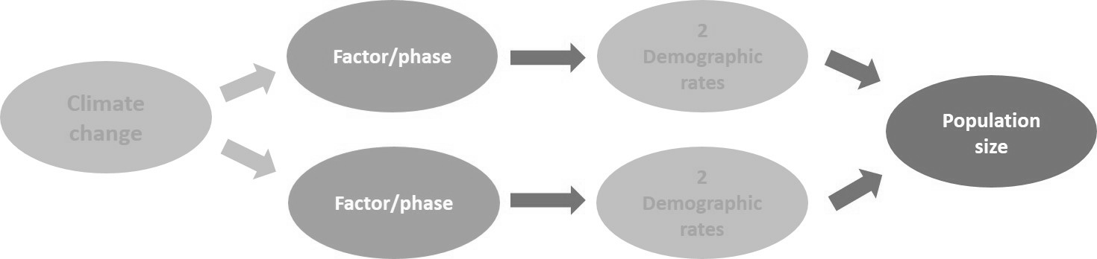

6. Which one of the following factors do you think currently has the greatest effect on [Q5] population size?

Pond/wetland size

Number of ponds/wetlands

Pond/wetland depth and permanence

Water characteristics (e.g., temperature, nutrients)

Wetland vegetation type and structure

Upland vegetation type and structure

Development impacts to wetlands (e.g., impounding, drainage)

Development impacts to uplands (e.g., agriculture)

Contaminants

Food availability

Other (please specify)
Mismatch between phenology of seasonal habitats and duck movements among phases of the annual cycle

Range shifts Harvest rate Predation
Parasites/disease

Air temperature (i.e., thermal stress)

Inter-specific competition

Population distribution among breeding grounds/flyways

Density-dependence

7. During which phase of the annual cycle does this factor have the greatest influence on [Q5] population size?
Phase choices are: Breeding, Fall migration, Winter and Spring migration

8. Which one of the following factors do you think currently has the second greatest effect on [Q5] population size?
Note: You can select the same factor you identified as having the greatest effect on scaup population size if it applies to a different season (e.g., food availability during breeding has the greatest effect and food availability during spring migration has the second greatest effect)

Pond/wetland size

Number of ponds/wetlands

Pond/wetland depth and permanence

Water characteristics (e.g., temperature, nutrients)

Wetland vegetation type and structure

Upland vegetation type and structure

Development impacts to wetlands (e.g., impounding, drainage)

Development impacts to uplands (e.g., agriculture)

Contaminants

Food availability

Other (please specify)
Mismatch between phenology of seasonal habitats and duck movements among phases of the annual cycle

Range shifts Harvest rate Predation
Parasites/disease

Air temperature (i.e., thermal stress)

Inter-specific competition

Population distribution among breeding grounds/flyways

Density-dependence
9. During which phase of the annual cycle does this factor have the second greatest influence on [Q5] population size?
Phase choices are: breeding, fall migration, winter and spring migration

Previous Next

Identifying Climate Change and Cross-seasonal Research Priorities for Waterfowl

SCAUP: Geographic regions associated with the factors currently influencing population size

10. Enter any specific geographic regions (e.g., Prairie pothole, Pacific flyway) that are associated with the two factors you identified as the most influential to [Q5] population size. If all geographic regions of the phase (e.g., all breeding grounds) are relevant then write 'ALL'.

[Q6] during [Q7]

[Q8] during [Q9]

Previous Next

Identifying Climate Change and Cross-seasonal Research Priorities for Waterfowl

[Q5]: Relationships between 2 factors, climate change, demography, & population size

On this page, we ask you to identify the two demographic rates most affected by each of the two factors you identified as having the greatest effect on [Q5] population size.
We also ask you to consider how on [Q5] population size may respond to the effects of climate change on the two factors you identified.

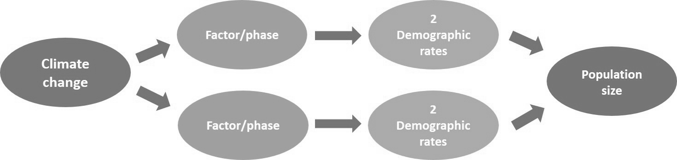

11. Select the two demographic rates that are most affected by '[Q6] during [Q7]'.
Note: A factor may influence a demographic parameter 1) directly within the same season/location as the factor (e.g., the number of ponds on a breeding ground may affect breeding season production) or 2) indirectly in a different season/location than the factor (e.g., food availability during spring migration may affect breeding season production).

Demographic Rate

Most affected demographic rate

Second most affected demographic rate

Demographic rate choices are:
Production
Adult female probability of breeding
Adult female survival during breeding season
Adult male survival during breeding season
Adult female survival during fall migration
Adult male survival during fall migration
Juvenile survival during fall migration
Adult survival during winter
Juvenile survival during winter
Adult male survival during spring migration
Adult female survival during spring migration
Juvenile survival during spring migration
Unsure

12. Select the expected population response to the effects of increasing temperature and decreasing precipitation on '[Q6] during [Q7]'.
Note: for the opposite scenario of increasing precipitation, we will assume that the population response will be opposite of that indicated

for the decreasing precipitation scenario.

Population Response

Population response to effects of increasing temperature on
'[Q6] during [Q7]'

Population response to effects of decreasing precipitation on
'[Q6] during [Q7]'

Population Response choices are:
direction of response is expected to vary spatially
increase in population size
decrease in population size
population size will be unaffected
unsure

13. Select the two demographic rates that are most affected by '[Q8] during [Q9]'.
Note: A factor may influence a demographic parameter 1) directly within the same season/location as the factor (e.g., the number of ponds on a breeding ground may affect breeding season production) or 2) indirectly in a different season/location than the factor (e.g., food availability during spring migration may affect breeding season production).

Demographic Rate

Most affected demographic rate

Second most affected demographic rate

Demographic Rate choices are:
Production
Adult female probability of breeding
Adult female survival during breeding season
Adult male survival during breeding season
Adult female survival during fall migration
Adult male survival during fall migration
Juvenile survival during fall migration
Adult survival during winter
Juvenile survival during winter
Adult male survival during spring migration
Adult female survival during spring migration
Juvenile survival during spring migration
Unsure

14. Select the expected population response to the effects of increasing temperature and decreasing precipitation on '[Q8] during [Q9]'.
Note: for the opposite scenario of increasing precipitation, we will assume that the population response will be opposite of that indicated

for the decreasing precipitation scenario.

Population Response

Population response to effects of increasing temperature on
'[Q8] during [Q9]'

Population response to effects of decreasing precipitation on
'[Q8] during [Q9]'

Population Response choices are:
direction of response is expected to vary spatially
increase in population size
decrease in population size
population size will be unaffected
unsure

Previous Next

Identifying Climate Change and Cross-seasonal Research Priorities for Waterfowl

Identifying Climate Change and Cross-seasonal Research Priorities for Waterfowl

[Q5]: Factors influencing population size in a future climate

15. If the climate changes in the future, would your identification and/or ranking of the 2 most important factors affecting [Q5] population size change?
i.e., will a factor that is not important to population size now become more important in a future climate?

Choices are: Yes, No, Unsure

Previous Next

Identifying Climate Change and Cross-seasonal Research Priorities for Waterfowl

[Q5]: Density-dependence

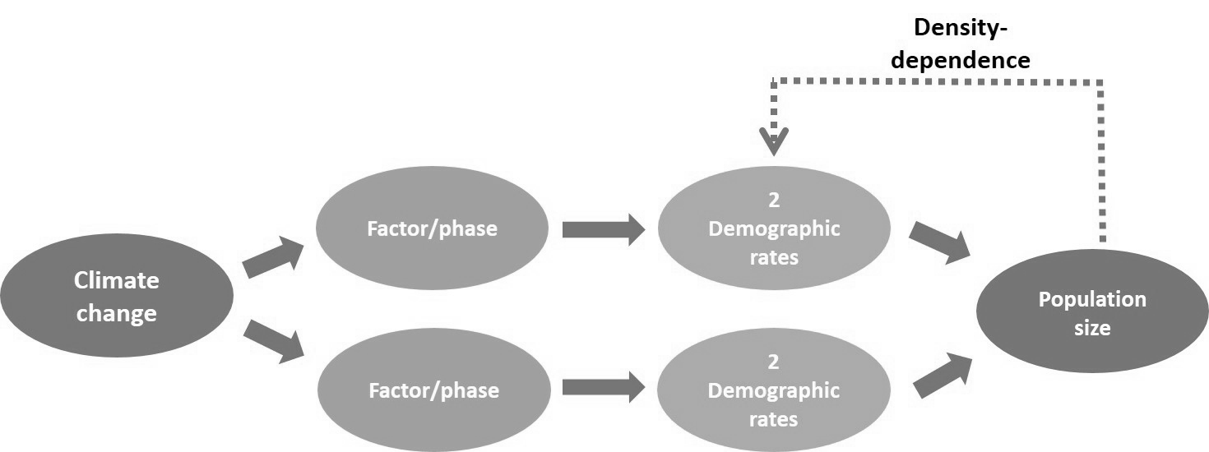
16. Indicate whether the following density-dependent relationships (Mattsson et al. 2012) have an effect on [Q5] population dynamics.
In the last row, fill in any other density-dependent relationships between demographic rates and population size which may be important

but are not listed.

As breeding population increases, production decreases

As mid-winter population increases, post-harvest survival decreases

As mid-winter population increases, the proportion that flyover to more northern breeding areas increases.

Other (please specify)

Density Dependence choices are:
This relationship has been explicitly quantified in peer-reviewed literature
There is empirical evidence that the relationship exists but it has not been quantified
It is generally believed among experts in the field that the relationship influences population dynamics
The relationship does not affect population dynamics
Unable to judge

Previous Next

Identifying Climate Change and Cross-seasonal Research Priorities for Waterfowl

Identifying Climate Change and Cross-seasonal Research Priorities for Waterfowl

[Q5]: Identification of seasonal and cross-seasonal information needs

17. Which of the following phases are primary responsibilities of your work with [Q5]? You may choose more than one.

Breeding

Fall migration

Winter

Spring migration

18. Given what is already known, what is your highest priority information need for [Q5] during each phase? If a phase is not your primary responsibility, indicate the piece of information, if any, that you would most like to receive from those whose work does focus on this phase. Lastly, rank order the phases/information needs based on their relative influence on population size with '1' being the most influential. You may need to scroll over to see the rank column.

Information need Rank

Breeding

Fall migration

Winter

Spring migration

Other information need (please be phase-specific)

Information Need choices are:
Kill rates
Crippling rates
Density-dependent relationships: identification and quantification
Pond/wetland size and/or effects on demographic rates
Number of ponds/wetlands and/or effects on demographic rates
Pond/wetland depth and permanence and/or effects on demographic rates
Water characteristics (e.g. temp, nutrients) and/or effects on demographic rates
Wetland/upland vegetation type and structure and/or effects on demographic rates
Wetland/upland development (e.g. agriculture) and/or effects on demographic rates
Contaminants: amount and uptake and/or effects on demographic rates
Food availability and/or effects on demographic rates
Mismatch between phenology of habitats and duck movements among phases
Range shifts and/or effects on demographic rates
Population distribution among different breeding/wintering grounds or flyways
Predation and/or effects on demographic rates
Parasites/disease and/or effects on demographic rates
Air temperature (i.e., thermal stress) and/or effects on demographic rates
Inter-specific competition and/or effects on demographic rates
Baseline estimates of survival rates
Baseline estimates of production
Baseline estimates of breeding probability
None
Other

Rank choices are: 1, 2, 3, 4; there can be ties

Previous Next

Identifying Climate Change and Cross-seasonal Research Priorities for Waterfowl

19. Have you completed questions for two species?

We are asking this question to ensure proper branching either to the next species or to the wrap-up section of the questionnaire.

Yes

No

If YES, directed to Wrap-up, question #21
If NO directed question #20 to make another species choice

Previous Next

Identifying Climate Change and Cross-seasonal Research Priorities for Waterfowl

20. Which of the following species or group of species is the second greatest priority of your research/management activities?

Greater and/or lesser scaup

Canvasback

Pintail

Mallard

None of these species are priorities of my research/management activities

If an additional species is selected, respondent is directed to a set of questions that duplicate questions 6-19 for the second species.

If “None of these species….” is selected, then the respondent is directed to Wrap-up question #21.

Previous Next

Identifying Climate Change and Cross-seasonal Research Priorities for Waterfowl

Identifying Climate Change and Cross-seasonal Research Priorities for Waterfowl

Wrap-up

21. Is there a waterfowl species that breeds in Alaska and winters in the continental United States besides the four addressed here (scaup, canvasback, pintail, mallard) that you think should be a top research priority due to abundance, conservation status, lack of information, or any other reason? For each species
listed, indicate the reason for prioritization.

22. Please prioritize the following based on their feasibility and your research/management needs:

Feasibility Research/management need

Development of effective guild-based continental population models

Adaptation of existing single-species continental
population models (e.g., Mattsson et al. 2012) for additional species of dabblers and divers

Feasibility choices are: Feasible, Not feasible, Unsure

Research/Management need choices are: High Priority, Low Priority, Unsure

23. Having completed this questionnaire, do you think there should be more, less, or the same amount of emphasis on climate change in your work?
Choices are: More, Less, Same

24. Having completed this questionnaire, do you think your work should involve more, less, or the same amount of cross-seasonal information?
Choices are: More, Less, Same

Previous Done

