PPSR 3- Progress Report Performance Metrics Screen

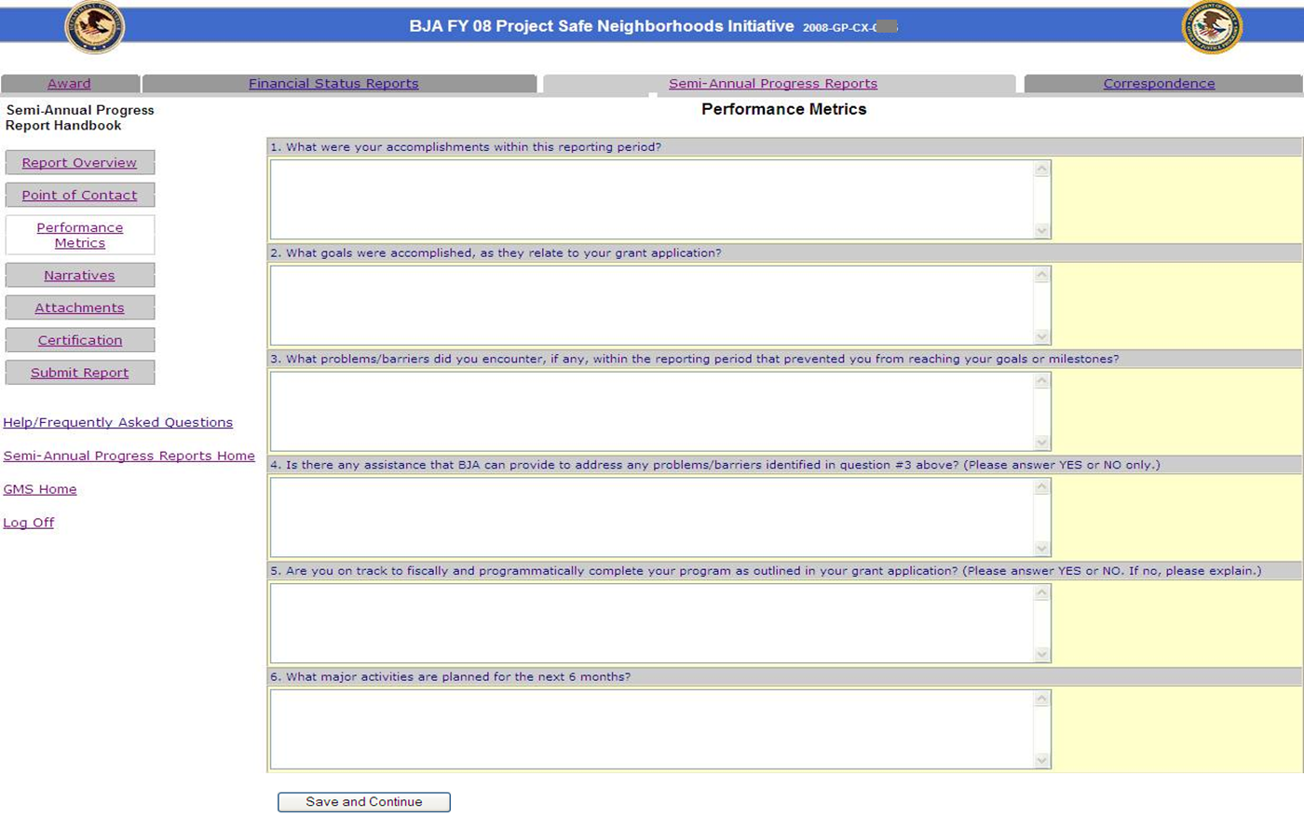

PM 1- OVC Performance Reporting Section I Screen

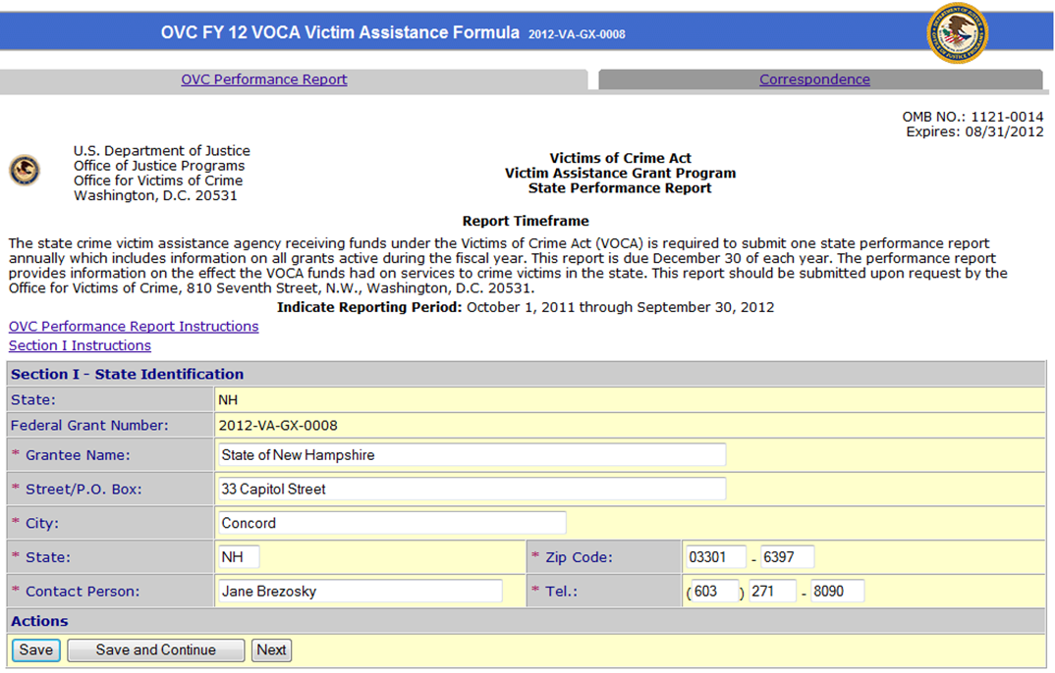

PM 2- OVC Performance Reporting Section II Screen

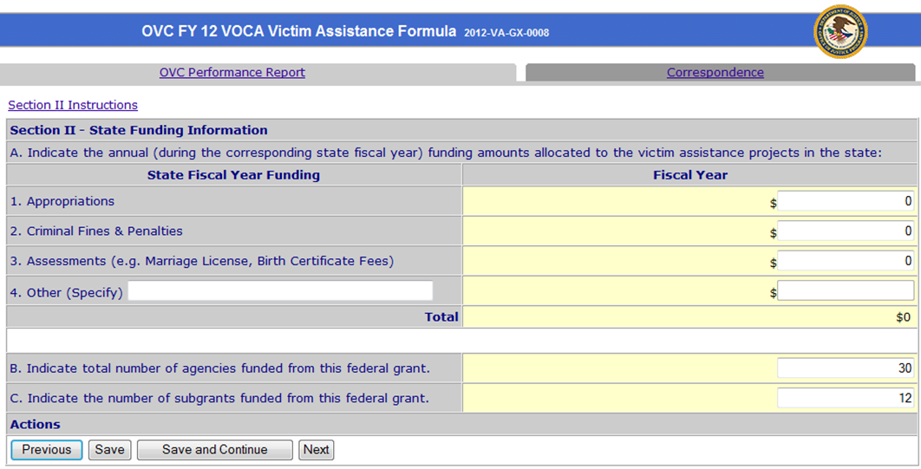

PM 3- OVC Performance Reporting Section III Screen

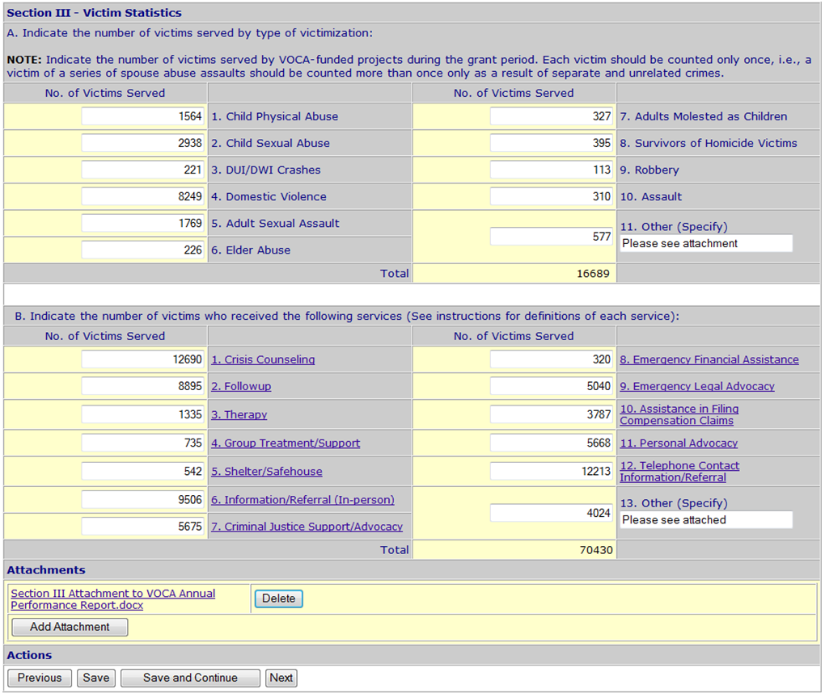

PM 4- OVC Performance Reporting Section IV Screen
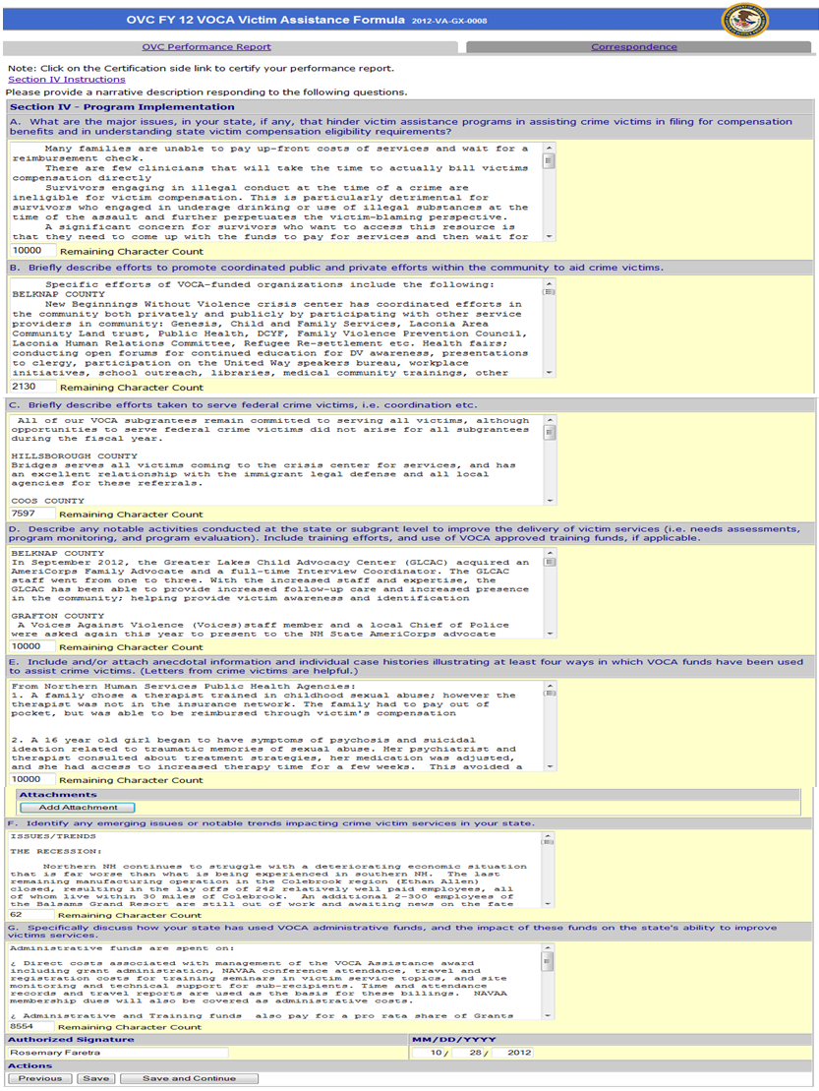

PM 5- OVC Performance Reporting Certification Screen

