Proposed Page Feedback Functionality for FinancialAidToolkit.ed.gov

Image of the page feedback tile:

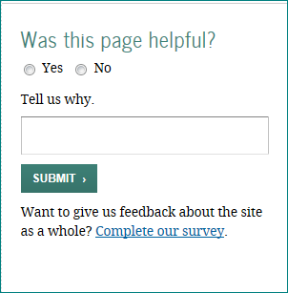

The respondent will select “Yes” or “No” and will have the option of providing comments in the text field. When the respondent clicks on the “SUBMIT” button, the feedback will be collected for later review via Excel file.

The “Complete our survey.” link will send the site visitor to the Financial Aid Toolkit’s full-site survey, which asks questions about the site as a whole (as opposed to this page feedback tile, which asks about the specific page the site visitor is currently reading). The full-site survey was previously approved.

Example of what a page would look like with the page feedback tile incorporated:

