OMB Approval No.: 1845-0045
Expires: 8/31/2016

TASK 2.2B: RESEARCH AND EVALUATE EDUCATIONAL POLICY CHANGES
SURVEY PROTOCOL
###SURVEY PAGE 1####

PRA Burden Statement
According to the Paperwork Reduction Act of 1995, no persons are required to respond to a collection of information unless such collection displays a valid OMB control number. The valid OMB control number for this information collection is 1845-0045. Public reporting burden for this collection of information is estimated to average 25 min per response for the survey including time for reviewing instructions, searching existing data sources, gathering and maintaining the data needed, and completing and reviewing the collection of information. The obligation to respond to this collection is voluntary. If you have comments or concerns regarding the status of your individual submission of this survey, please contact Christopher Lemmie at the Federal Student Aid Customer Experience Group Office, 830 First St. N.E., Washington, DC 20202, Telephone: 202-377-3225, Email: Christopher.Lemmie@ed.gov directly.
Note: Please do not return the completed survey to this address.
This survey is being conducted to assess the extent to which MSIs understand the educational policy changes and the impact of these changes on their Institutions and students in order to identify best practices that help schools respond to policy changes proactively and effectively. The specific goals of the study include: the extent to which MSIs understand the education policy changes; the updated reporting requirements necessary to address the changes; the personnel and business process shifts that have impacted the financial aid offices; and the extent to which the changes directly affect the students at MSIs. Please respond to all the questions.
Thank you for your participation!

The following policies were amended and/or passed in 2014 and 2015: Free Application for Federal Student Aid (FAFSA) Early Submission policy, Gainful Employment (GE), Enrollment Reporting, and User-Selected Federal Student Aid Identification (FSA ID). Please provide a response to the following questions for each of the policies.

1. I understand ALL new provisions set by the policy.

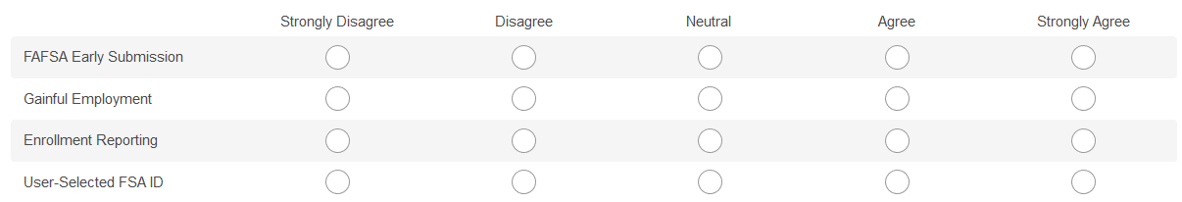

2. My institution has taken steps (or is taking steps) to comply with all provisions of the policy since it was passed.
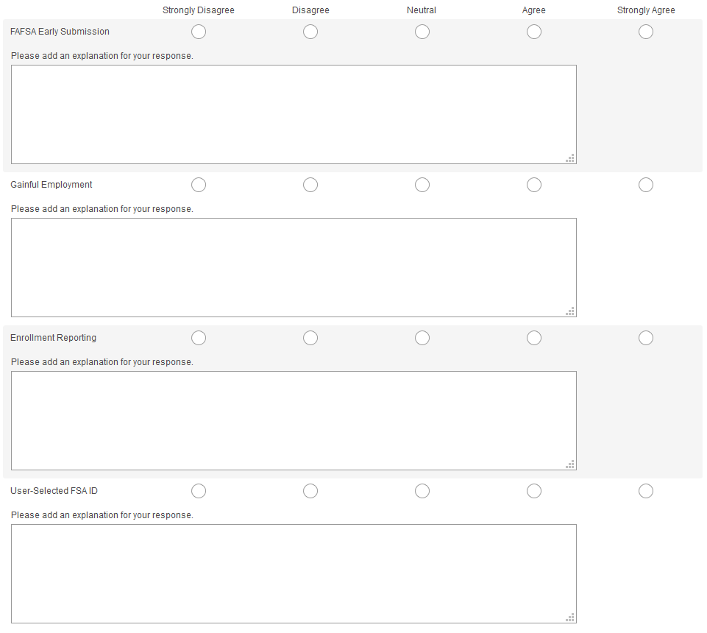

3. The policy required my institution to update business processes and reporting requirements.

4. The policy simplified the financial aid process for the Financial Aid Office.

5. The policy has simplified the financial aid application process for students.

*** PAGE BREAK***

6. When will the FAFSA for the 2017-2018 award cycle be available to students/families?
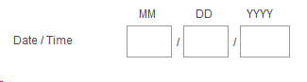
7. Students/parents are required to submit income tax information from which calendar year for the 2017-2018 award cycle?
2014
2015
2016
2017
2018
*** PAGE BREAK***
8. The three main provisions for the Gainful Employment policy are: Loan Repayment Rate, Debt-to-Earnings Annual Ratio, and Debt-to-Discretionary-Earnings Ratio. Please select the appropriate percent cut-off value for each of these provisions.
- Loan Repayment Rate- at least ____% of the program's former students are repaying their loans.
- Debt-to-Earnings Annual Ratio- The estimated annual loan payment of a typical graduate does not exceed ___ % of his or her total earnings
- Debt-to-Discretionary-Earnings Ratio -The estimated annual loan payment of a typical graduate does not exceed ___ % of his or her discretionary income.
40%, 12%, 35%
35%, 12%, 30%
40%, 12%, 30%
35%, 12%, 35%

9. A college academic program can lose eligibility for federal financial aid if they fail for ___ out of ___ consecutive years or are in a warning zone for ___ years. Please select the correct answer from the choices below.
2, 3, 4
2, 4, 5
3, 4, 4
3, 4, 5

*** PAGE BREAK***
10. What information are schools required to report in the National Student Loan Data System (NSLDS) as stipulated by the Enrollment Reporting Policy guidelines? (Select ALL that apply).
Student Information: Name, social security number, address, email address, and phone number.
Campus Level Enrollment for the student: Data related to the student’s overall enrollment at the campus, including enrollment Status and effective Date, anticipated completion date, and certification date.
Program(s) of Attendance for the Student: Classification of instructional programs (CIP) code, Program credential level, program length, program enrollment status, and other data about the program.
11. Which of the following would be considered program-level enrollment data (not campus-level)? (Select all the apply)
Student Name
CIP Code
Weeks in Title IV
Published Program Length
*** PAGE BREAK***

12. An FSA ID is a username and password that you must use to log into certain U.S. Department of Education (ED) websites. It is also used to sign legally binding documents electronically and has the same legal status as a written signature. Where can you use your FSA ID? (Select ALL that apply).
Free Application for Federal Student Aid (FAFSA®) at fafsa.gov
My Federal Student Aid at StudentAid.gov/login
The National Student Loan Data System (NSLDS®) at www.nslds.ed.gov
StudentLoans.gov
Agreement to Serve (ATS) at www.teach-ats.ed.gov

13. What type of information is required in order to create an FSA ID? (Select ALL that Apply).
Log-in information which includes your e-mail address, a unique username, and password, and verification that you are at least 13 years old.
Personal information which includes your Social Security number, name, and date of birth.
Mailing address, e-mail address, telephone number, and language preference.
For security purposes, answers to five challenge questions.
*** PAGE BREAK***
14. Which of the following best characterizes your institution type?
2 year Public
2 year, Private
4 year, Public
4 year, Private
15. What is your MSURSD cluster category?
Asian American and Native American Pacific Islander Serving Institutions (AANAPISI)
Alaska Native and Native Hawaiian Serving Institutions (ANNH)
Historically Black Colleges and Universities (HBCU)
Hispanic Serving Institutions (HSI)
Tribal Colleges and Universities (TCU)
Predominantly Black Institutions (PBI)
Not sure
Other (please specify)

16. What is your IPEDS geographic region?
New England (CT, ME, MA, NH, RI, VT)
Mid-East (DE, DC, MD, NJ, NY, PA)
Great Lakes (IL, IN, MI, OH, WI)
Plains (IA, KS, MN, MO, NE, ND, SD)
Southeast (AL, AR, FL, GA, KY, LA, MS, NC, SC, TN, VA, WV)
Southwest (AZ, NM, OK, TX)
Rocky Mountains (CO, ID, MT, UT, WY)
Far West (AK, CA, HI, NV, OR, WA)
Outlying areas (AS, FM, GU, MH, MP, PR, PW, VI)

17. What is your job title?
Financial Aid Director
Associate/Assistant Director
Financial Aid Advisor/Counselor/Specialist
Financial Aid Support Staff
University Leadership (Provost, Vice-Provost, President, Vice-President, Chief Executive Officer (CEO), Program Director)
Other (Please specify)________________________________

