Changes to the AmeriCorps Paper Application

Page 1
- Added: Preferred Name
- Added: Citizenship Disclaimer.
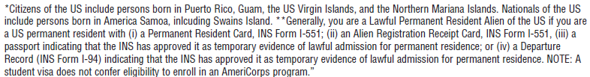
- Added: Latest Date Available.
- Changed Emergency Contact/Permanent Address to Permanent address in Question 8.

Page 2:
- Changed the following in Question 12.
  - Some high school to less than high school
  - High School diploma or GED to high School Diploma
  - Associate’s Degree to Associate’s Degree (AA)
  - Bachelor’s Degree to College Graduate
- Added the following to Question 12:
  - Added GED
  - Added Some Graduate School
  - Added Professional Degree (Medical, Law)

Page 3:
- Changed Questions 14’s directions to:
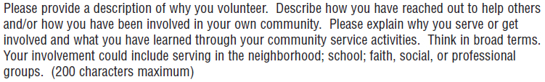

Page 4:
- Change Question 15’s directions to

Page 5:
- Changed Question 17’s directions from “Explain any period of time greater..” to “Please explain any gap in employment greater..”
- Added the following to Question 18:
  - Environment
  - Non-Profit Management
  - Social Services
  - Urban Planning
  - Disaster Services
  - Veterans
  - Teamwork

Page 6:
- Changed Question 19 to:
- Added Question: List all current certificates along with their expiration dates. Example: EMT-Expires 12/31/2012
- Changed Question 21: Do you have a valid government issued driver’s license?

Page 7:
- Changed the explanation on the page to the following:
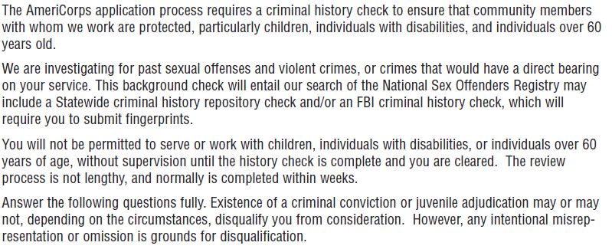
- Changed question 22 to “Have you ever been convicted as an adult, or adjudicated as a juvenile offender, of at least one criminal offense by either a civilian or military court?”

Page 8:
- Changed Privacy act notice

Page 9 and 12:
- Made the sentence “You should not ask..” bold.

Page 15:
- Added the following checkboxes to the question “How did you hear about AmeriCorps?”
  - Social Media
- Removed the following checkboxes from the question “How did you hear about AmeriCorps?”
  - Listserv
  - Newspaper/Magazine Advertisement
  - Television Advertisement
  - Department of Education
  - Peace Corps
  - Television News Story
- Added the following question

