Initial Screen

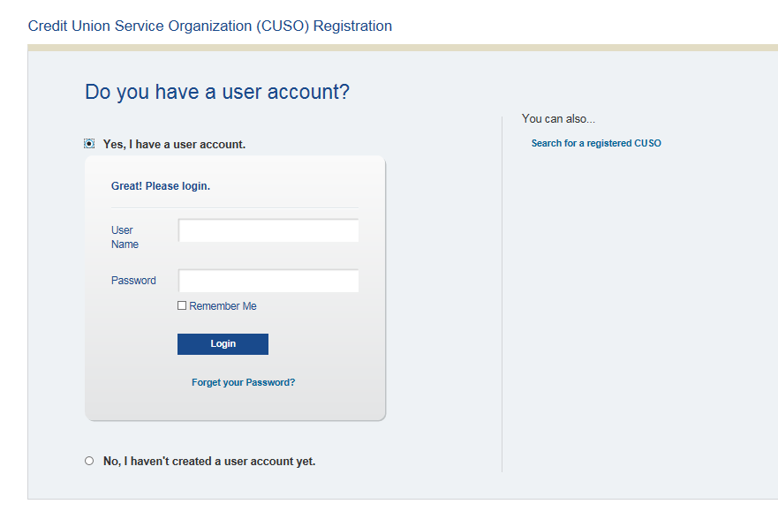

Screening Page

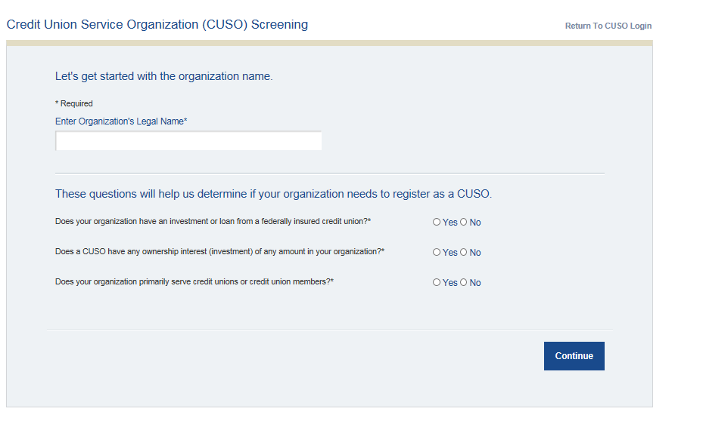

Screening Page to Initially Register CUSO- Information is carried forward to the General Tab in Registry

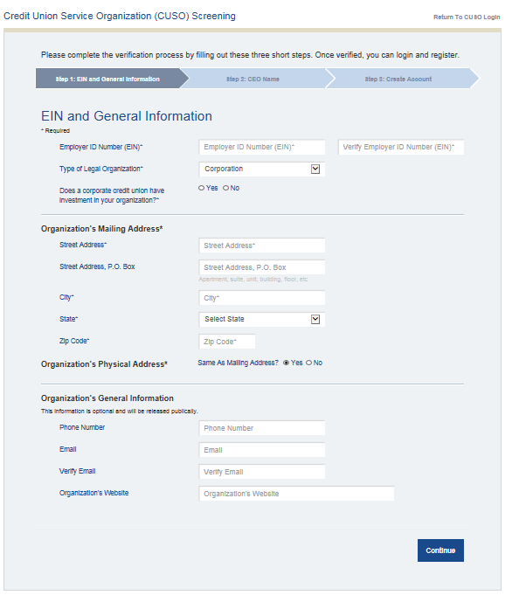

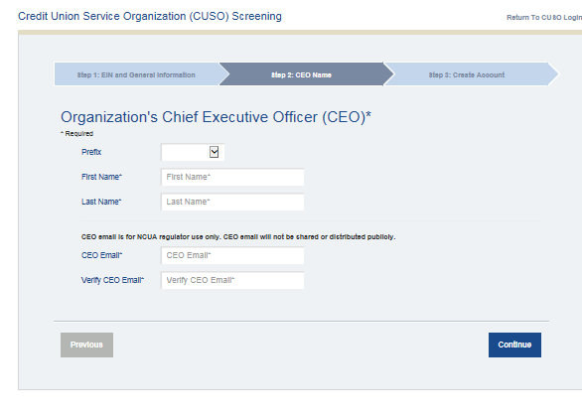

General Tab- Additional Information not captured during Sign Up Process

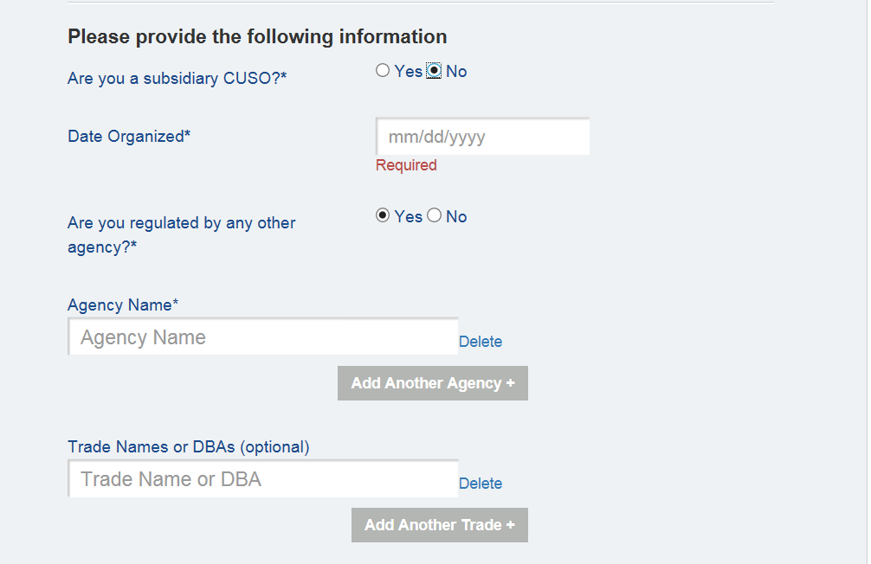

Administrator Account Information

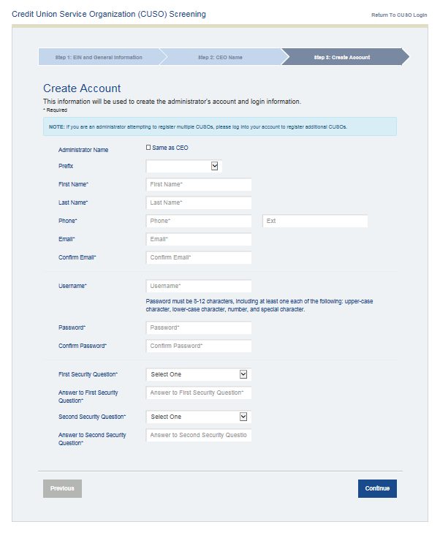

Corporate CUSO Services

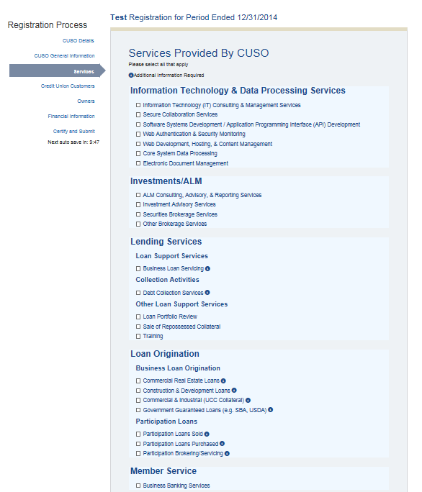

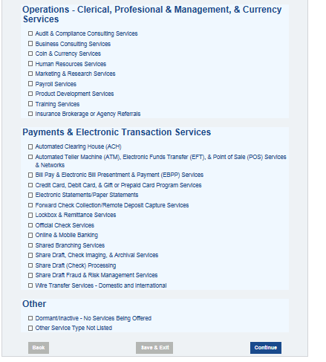

Corporate CUSO Additional Information- Loan Support Services & Collection Activities

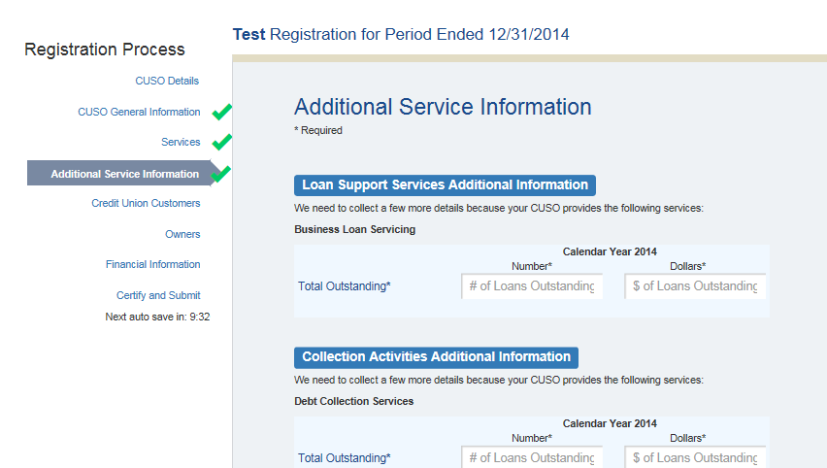

Corporate CUSO Additional Information- Business Loan Origination

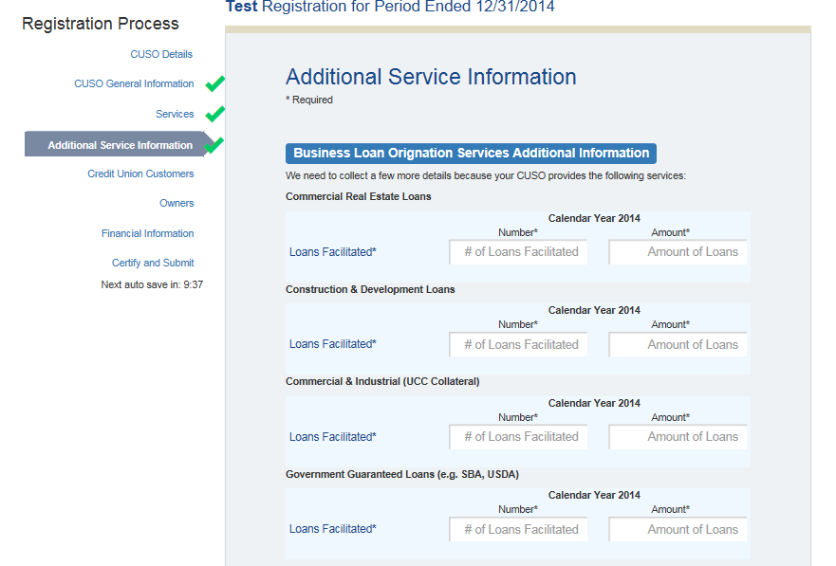

Corporate CUSO Additional Information- Participation Loan Services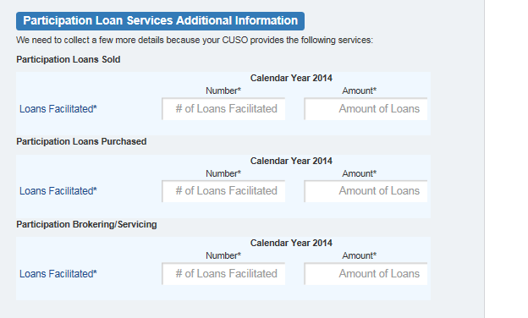

Corporate CUSO Expanded Customer List- Information Technology & Data Processing Services

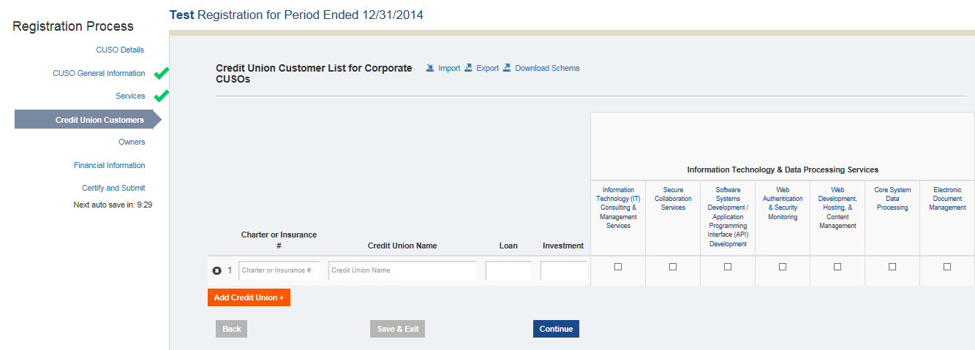

Corporate CUSO Expanded Customer List- Investment/ALM Services

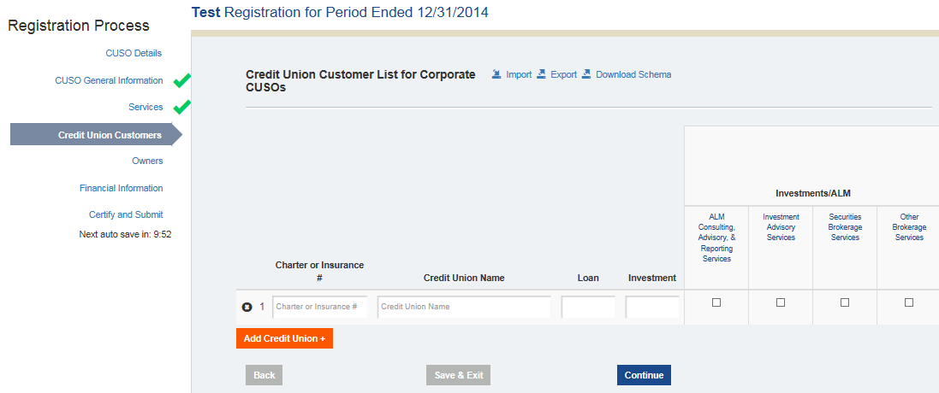

Corporate CUSO Expanded Customer List- Lending Services

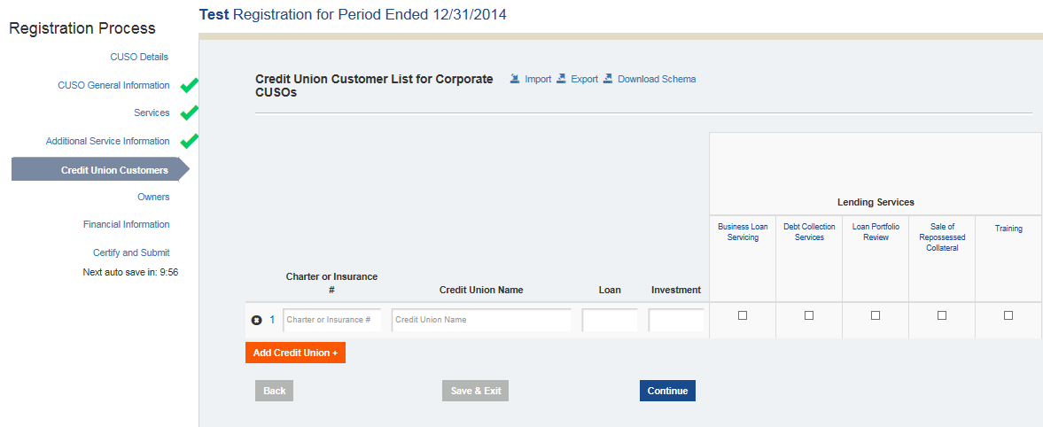

Corporate CUSO Expanded Customer List- Loan Origination

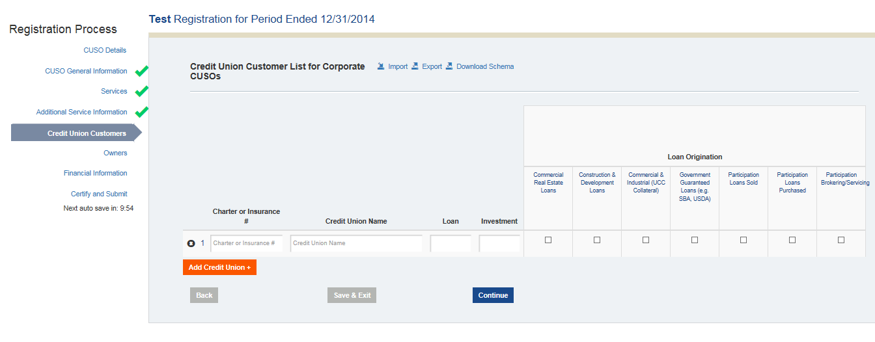

Corporate CUSO Expanded Customer List- Member Service

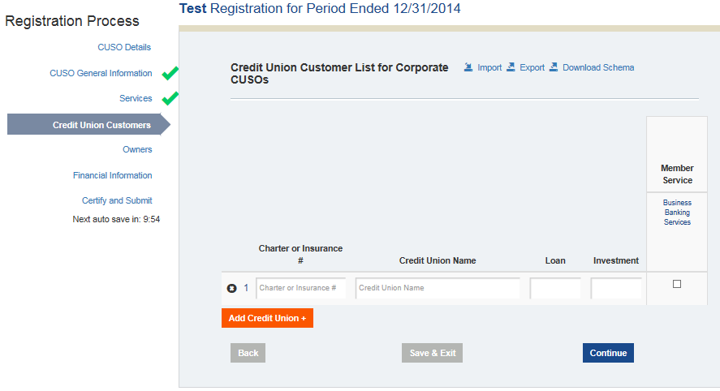

Corporate CUSO Expanded Customer List- Operations, Clerical, Professional, Management & Currency Services

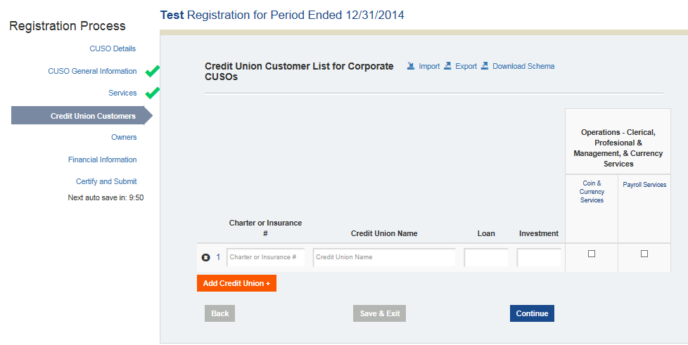

Corporate CUSO Expanded Customer List- Payment & Electronic Transaction Services

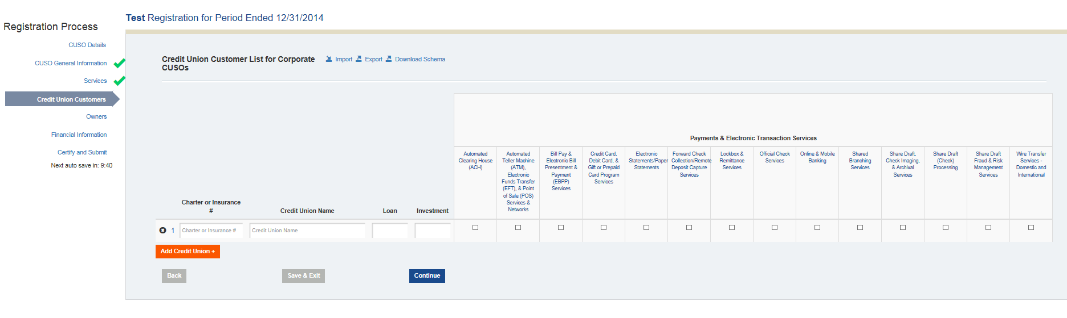

Natural Person CUSO Services

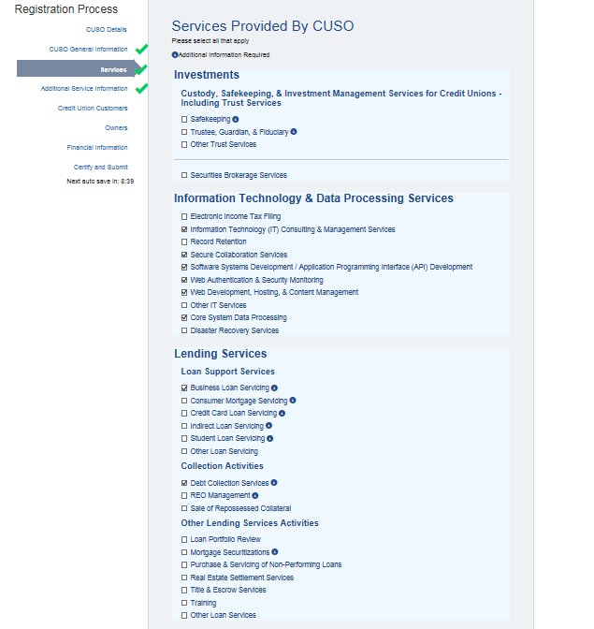

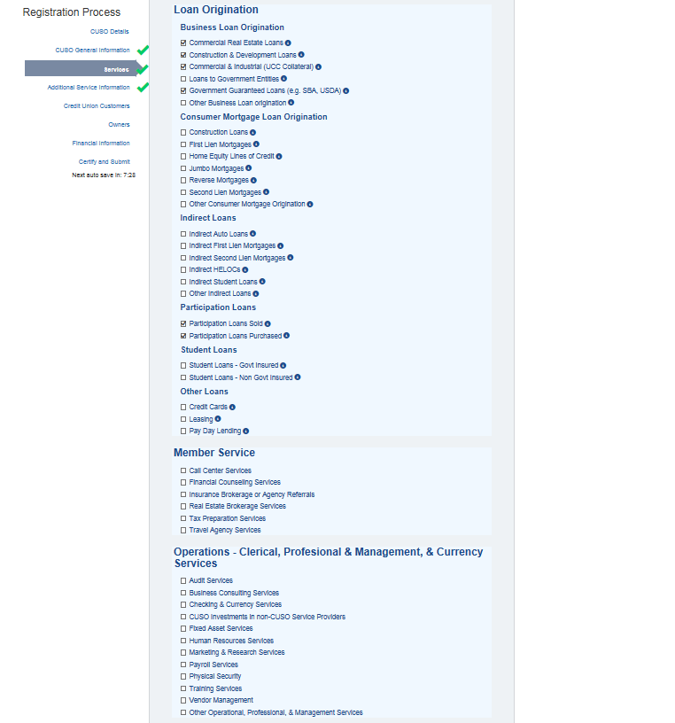

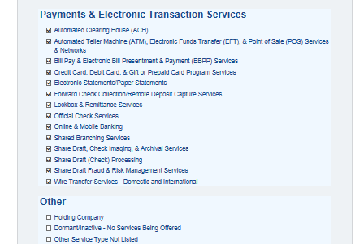

Natural Person CUSO Additional Information- Investment Services

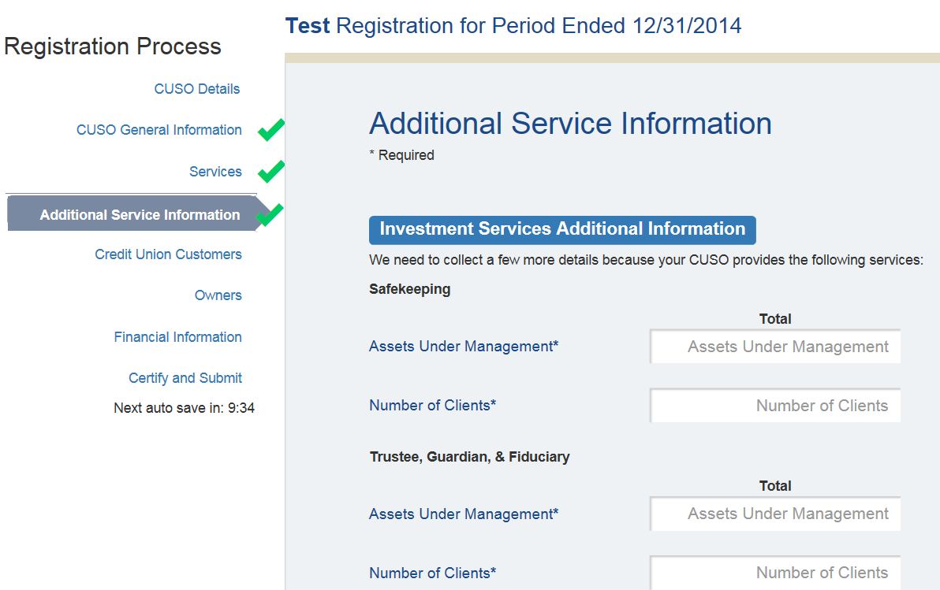

Natural Person CUSO Additional Information- Loan Support Services

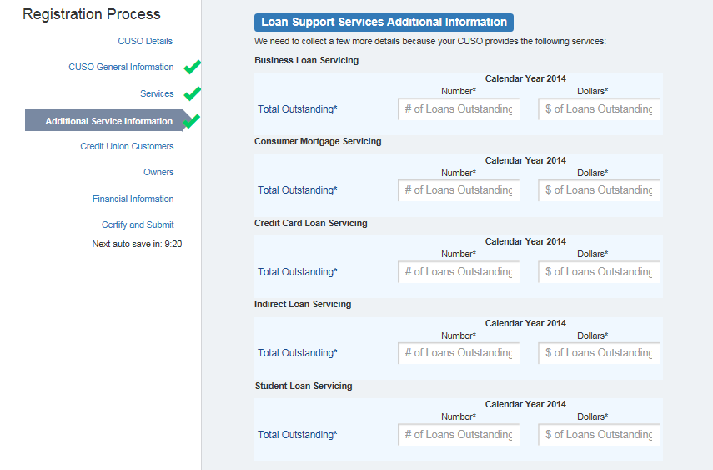

Natural Person CUSO Additional Information- Other Lending Services & Collection Activities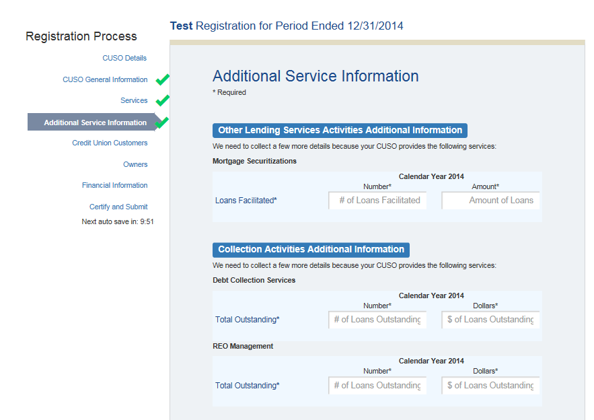

Natural Person CUSO Additional Information- Business Loan Origination 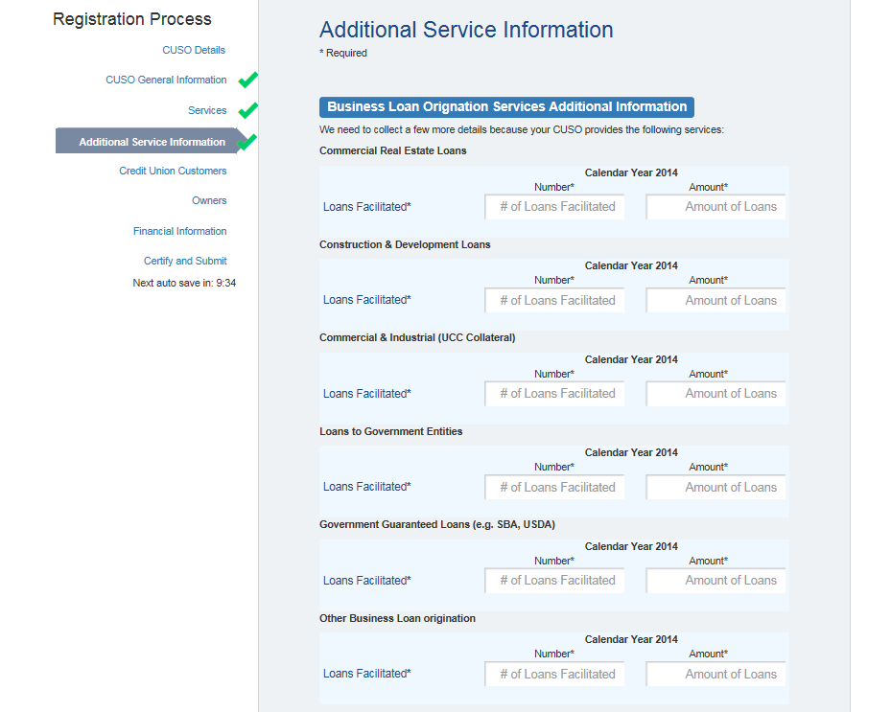

Natural Person CUSO Additional Information- Consumer Mortgage Services

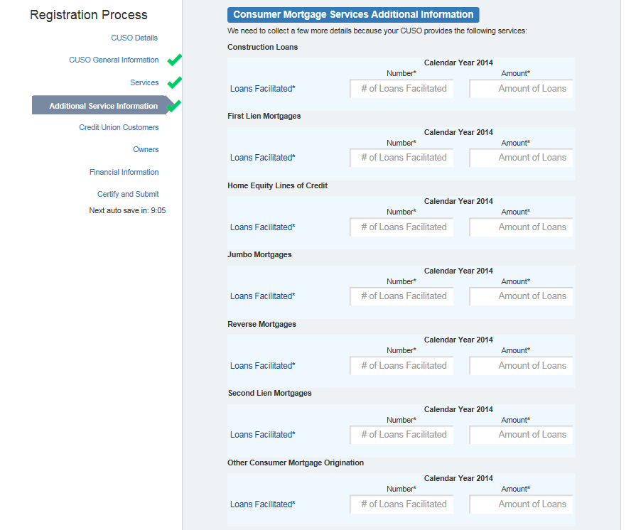

Natural Person CUSO Additional Information- Indirect Loan Services

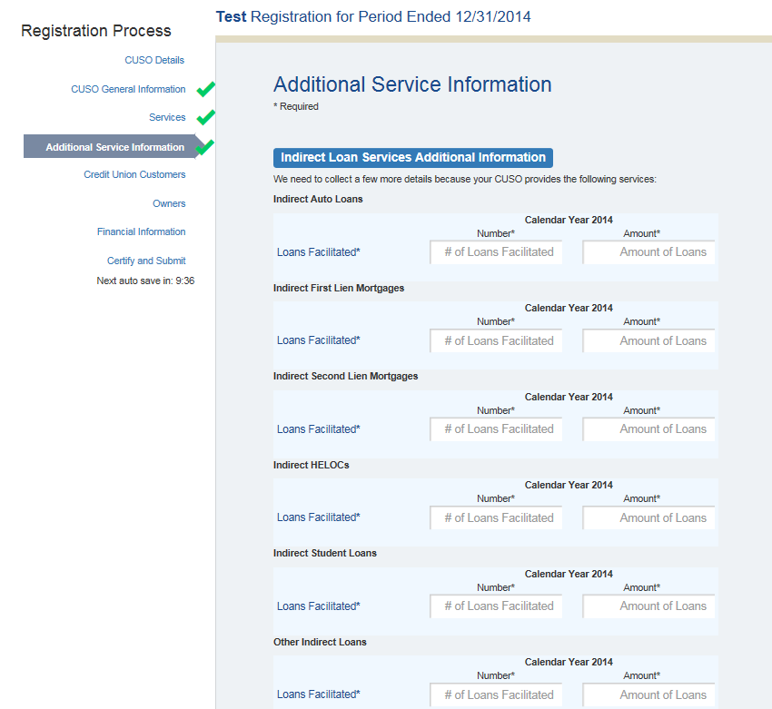

Natural Person CUSO Additional Information- Student Loan & Participation Loan Services

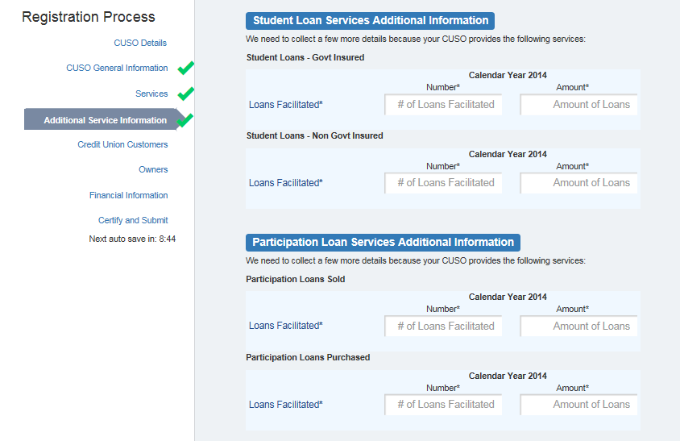

Natural Person CUSO Additional Information- Other Loans

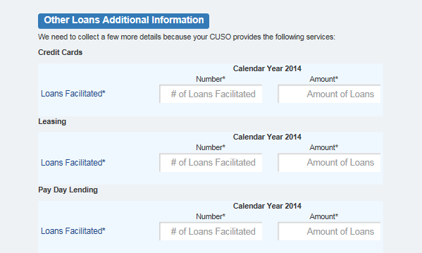

Natural Person CUSO Expanded Customer Lists- Information Technology & Data Processing Services

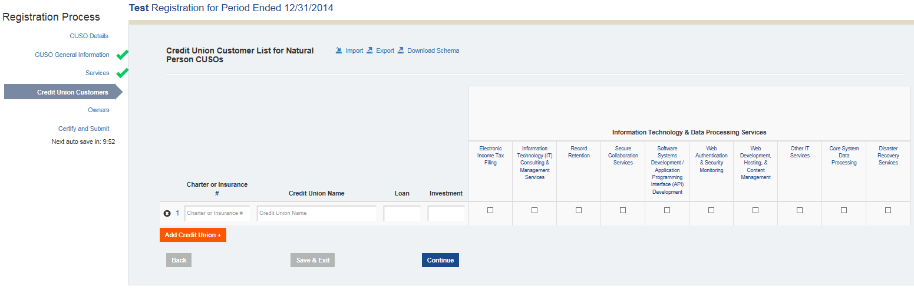

Natural Person CUSO Expanded Customer Lists- Lending Services

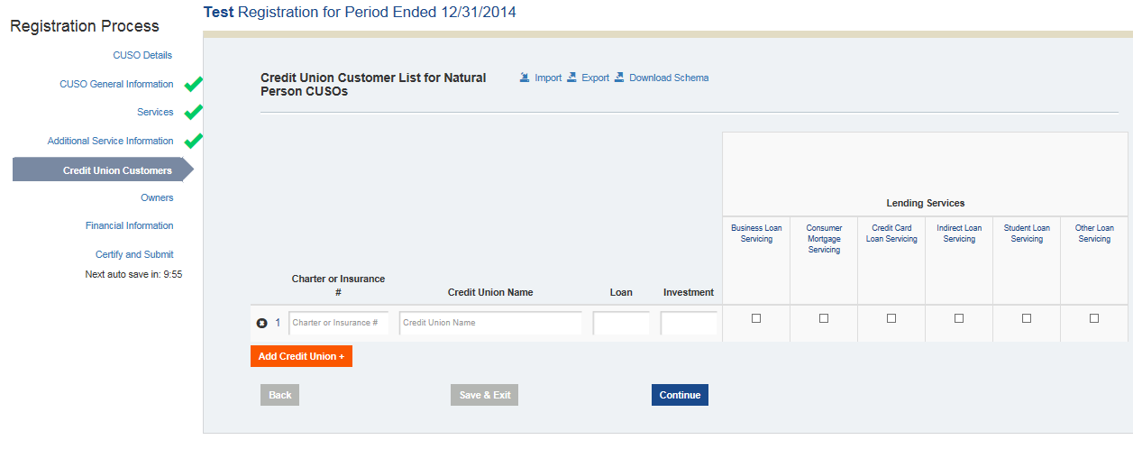

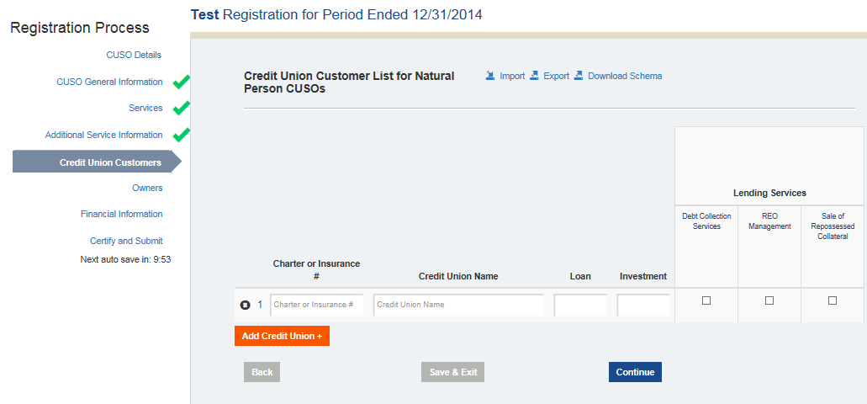

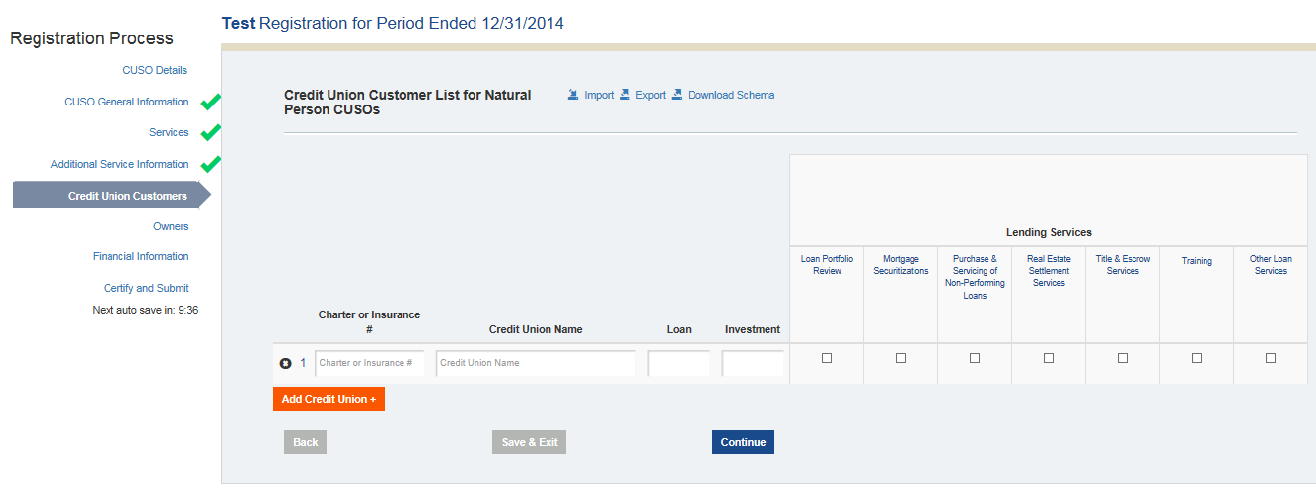

Natural Person CUSO Expanded Customer Lists- Loan Origination

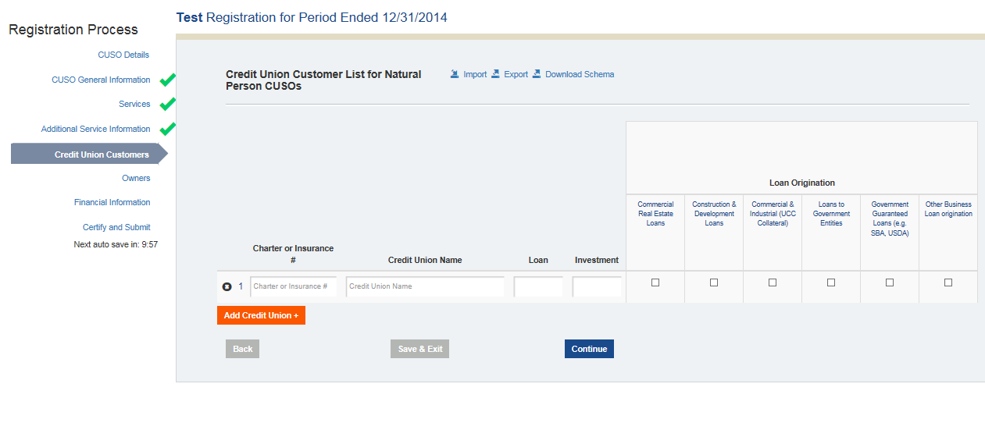

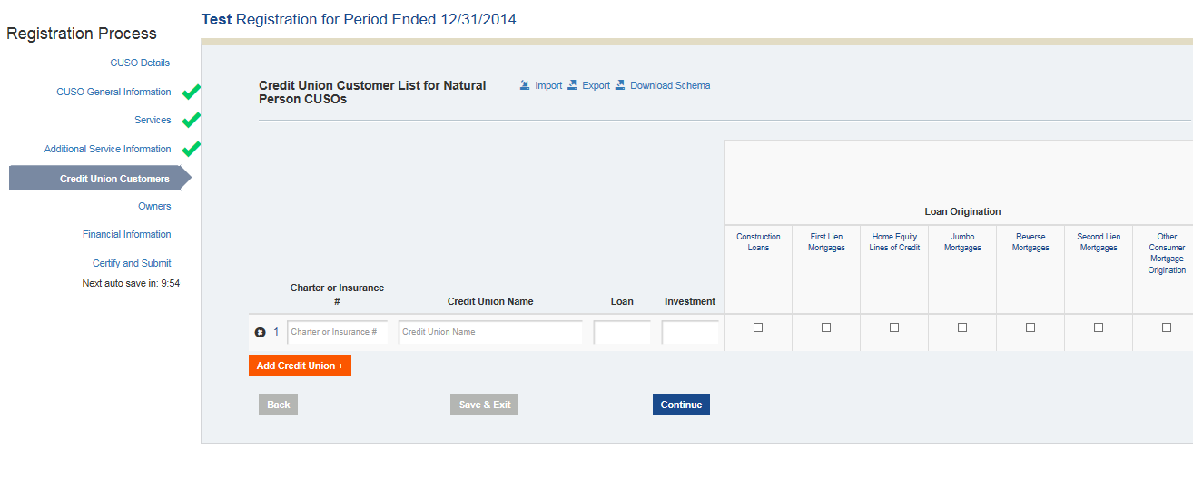

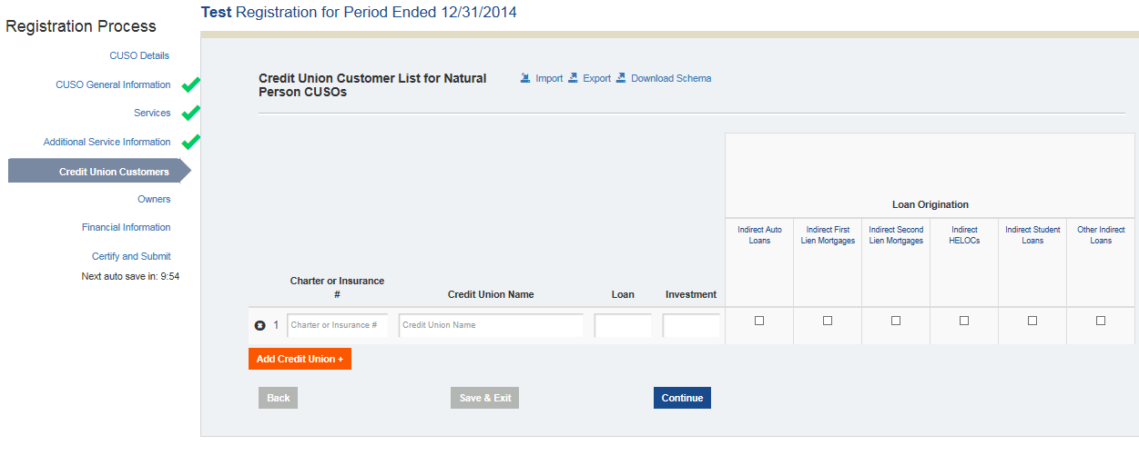

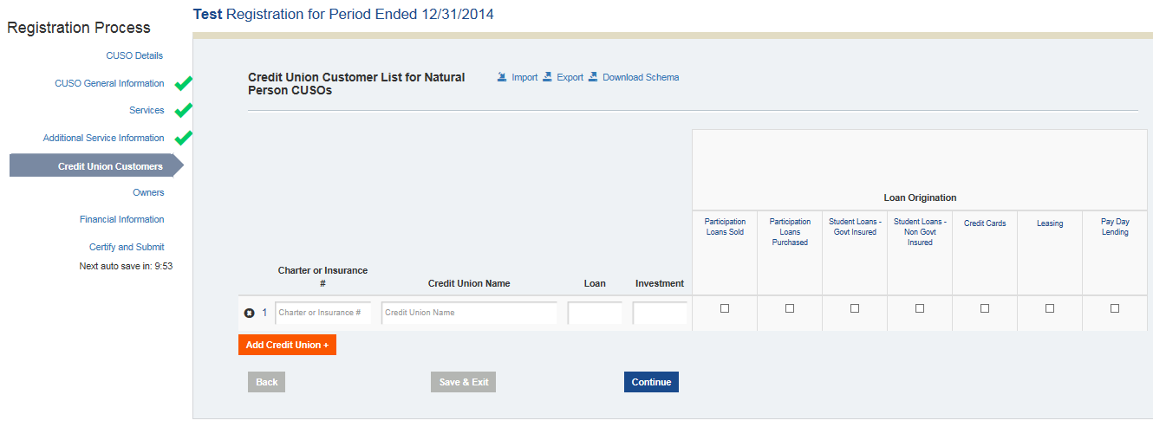

Natural Person CUSO Expanded Customer Lists- Operations- Clerical, Professional & Management & Currency Services

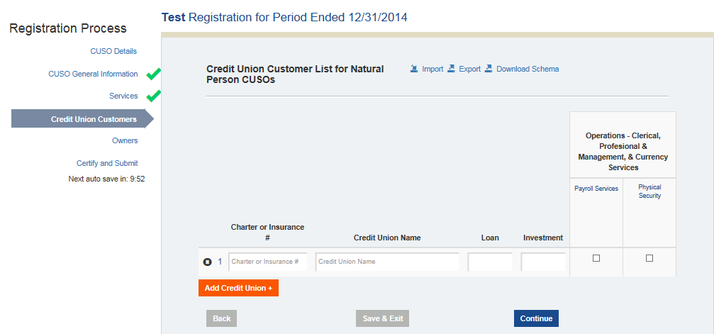

Natural Person CUSO Expanded Customer Lists- Payment & Electronic Transaction Services

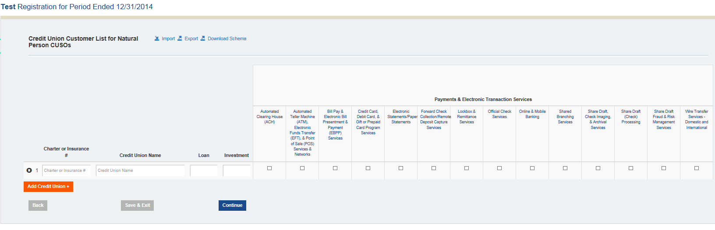

Basic Customer List for Both Types of CUSOs

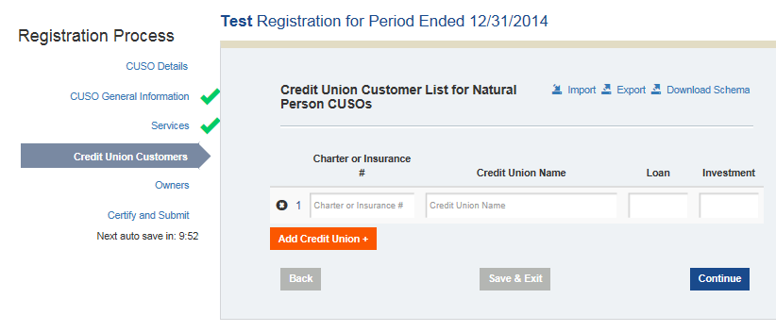

Owner Information

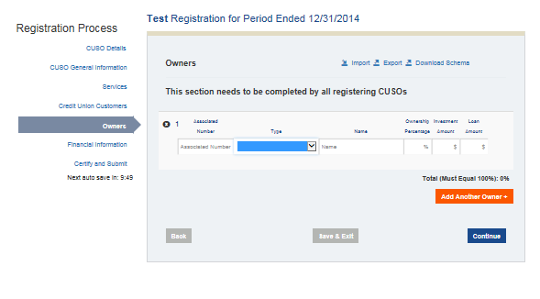

Financial Information

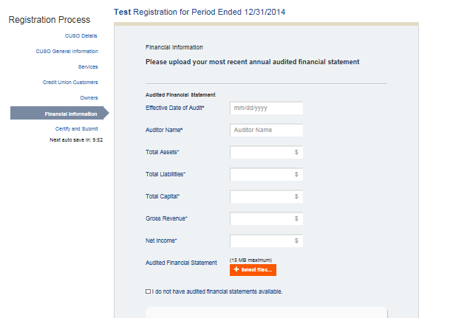

**ADDITIONAL UPLOADS FOR CORPORATE CUSOs (based on services as required by NCUA Rules & Regulations Part 704)**

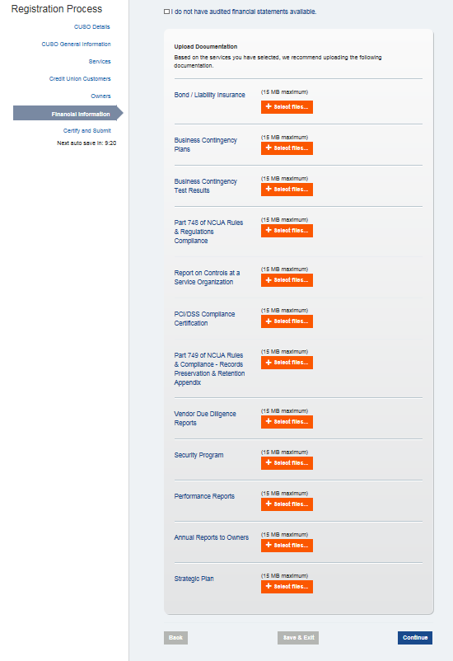

Certification

