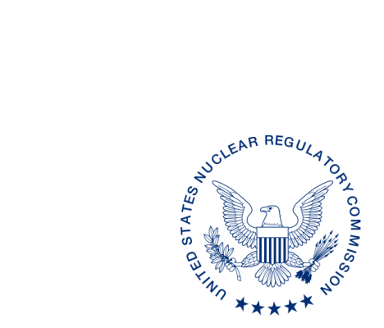
UNITED STATES
NUCLEAR REGULATORY COMMISSION
WASHINGTON, D.C. 20555-0001

ALL AGREEMENT STATES, WYOMING, VERMONT

PROJECTED INTEGRATED MATERIALS PERFORMANCE EVALUATION PROGRAM SCHEDULES FOR FISCAL YEARS 2017–2019 (STC-16-XXX)

Purpose: To inform Agreement State program staff of upcoming Integrated Materials
Performance Evaluation Program (IMPEP) reviews.

Background: Annually, the U.S. Nuclear Regulatory Commission provides the projected IMPEP schedule to the Agreement States to ensure that Agreement State personnel have advanced notice of upcoming IMPEP reviews.

Discussion: We would appreciate receiving any comments* regarding the timing of an IMPEP review projected for fiscal year (FY) 2017, as listed in the enclosure, within 30 days from the date of this letter. Once we have received any comments on the proposed schedule for FY 2017, we will issue a more complete draft schedule that includes designation of team members and estimated dates for Management Review Board meetings.

If you have any questions regarding this communication, please contact me at (301) 415-3340 or the individual named below:

POINT OF CONTACT: Lisa Dimmick E-MAIL: Lisa.Dimmick@nrc.gov
TELEPHONE: (301) 415-0694

Dan S. Collins, Director
Division of Material Safety, State, Tribal
and Rulemaking Programs
Office of Nuclear Material Safety
and Safeguards

Enclosure:
Projected IMPEP Schedules
for Fiscal Years 2017-2019

* This information request has been approved by OMB 3150-0029 expiration 1/31/2019. The estimated burden per response to comply with this voluntary collection is approximately 20 minutes. Send comments regarding the burden estimate to the FOIA, Privacy, and Information Collections Branch, U.S. Nuclear Regulatory Commission, Washington, DC 20555-0001, or by e-mail to infocollects.resource@nrc.gov, and to the Desk Officer, Office of Information and Regulatory Affairs, NEOB-10202 (3150-0029), Office of Management and Budget, Washington, DC 20503. If a means used to impose an information collection does not display a currently valid OMB control number, the NRC may not conduct or sponsor, and a person is not required to respond to, the information collection.

PROJECTED IMPEP SCHEDULE
FY 2017 | FY 2018 | FY2019
Minnesota* | Illinois*  ilinois | Ohio*
South Carolina* | Washington* | Pennsylvania*
Iowa* | Arkansas | NRC RIV*
New Hampshire | North Carolina | Wisconsin*
NRC RIII* | New York | Alabama
Mississippi | Colorado | Florida
Nevada | Texas | New Jersey
New Mexico | Kansas | Maine
Oregon | Massachusetts | North Dakota
Utah (follow-up) | Oklahoma
* Received one year extension per IMPEP Self-Assessment Recommendation.

DRAFT SCHEDULE FOR IMPEP REVIEWS FY 2017
Program | Proposed Date
Minnesota | October 2016
New Hampshire | October 2016
Mississippi | April 2017
South Carolina | May 2017
New Mexico | June 2017
Nevada | July 2017
Utah (follow-up) | July 2017
Iowa | August 2017
Oregon | August 2017
NRC RIII | September 2017

