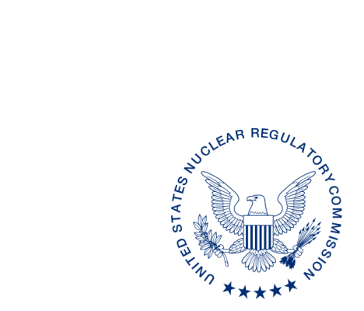
UNITED STATES
NUCLEAR REGULATORY COMMISSION
WASHINGTON, D.C. 20555-0001

ALL AGREEMENT STATES, VERMONT, WYOMING
STATE LIAISON OFFICERS

OPPORTUNITY TO COMMENT ON DRAFT REVISION TO THE OFFICE OF NUCLEAR MATERIAL SAFETY AND SAFEGUARDS PROCEDURE SA-801, AGREEMENT STATE PARTICIPATION IN WORKING GROUPS (STC-16-XXX)

Purpose: To provide the Agreement States, Vermont, Wyoming, and State Liaison Officers an opportunity to comment on Office of Nuclear Material Safety and Safeguards (NMSS) Procedure SA-801, Agreement State Participation in Working Groups (MLXXXXXXXXX).

Background: This is a new procedure developed from the handbook which used to be part of NRC Management Directive (MD) 5.3, Agreement State Participation in Working Groups.

Discussion: Enclosed for your review and comment is a new procedure NMSS Procedure SA-801, Agreement State Participation in Working Groups. A U.S. Nuclear Regulatory Commission office (headquarters or regional) or the Organization of Agreement States (OAS) Executive Board may recommend the establishment of an NRC/Agreement State working group to address a wide range of issues and to develop a variety of different products. Working groups provide a means for NRC and Agreement State staff to work cooperatively in the development of a rule, policy, directive, or guidance document; or to participate in a special study. These working groups enhance the partnership between the NRC and the Agreement States, facilitate the utilization of the centers of expertise that exist in the NRC regions and the Agreement States, and support the National Materials Program (NMP). Other Federal agency representatives may also participate as necessary, depending on the purpose and scope of the working group. All requests for Agreement State participation on working groups will be coordinated by the Office of Nuclear Material Safety and Safeguards (NMSS).

Please provide any comments on SA-801. We would appreciate receiving your comments¹ within 30 days from the date of this letter.

If you have any questions regarding this correspondence, please contact me at (301) 415-3340 or the individual named below:

POINT OF CONTACT: Joe O’Hara E-MAIL: Joe.OHara@nrc.gov
TELEPHONE: (301) 415-6854

Daniel S. Collins, Director
Division of Material Safety, State, Tribal
and Rulemaking Programs
Office of Nuclear Material Safety
and Safeguards

Enclosure:
Draft NMSS SA-801, Agreement
State Participation in Working Groups (MLXXXXXXXXX)

_____________________________
¹This information request has been approved by OMB 3150-0029 (expiration 1/31/2019) and 3150-0200 (expiration 10/31/2018). The estimated burden per response to comply with this voluntary collection is approximately 60 minutes per response. Send comments regarding the burden estimate to the FOIA, Privacy, and Information Collections Branch, U.S. Nuclear Regulatory Commission, Washington, DC 20555-0001, or by e-mail to infocollects.resource@nrc.gov, and to the Desk Officer, Office of Information and Regulatory Affairs, NEOB-10202 (3150-0029), Office of Management and Budget, Washington, DC 20503. If a means used to impose an information collection does not display a currently valid OMB control number, the NRC may not conduct or sponsor, and a person is not required to respond to, the information collection.
Please provide any comments on SA-801. We would appreciate receiving your comments¹ within 30 days from the date of this letter.

If you have any questions regarding this correspondence, please contact me at (301) 415-3340 or the individual named below:

POINT OF CONTACT: Joe O’Hara E-MAIL: Joe.OHara@nrc.gov
TELEPHONE: (301) 415-6854

Daniel S. Collins, Director
Division of Material Safety, State, Tribal
and Rulemaking Programs
Office of Nuclear Material Safety
and Safeguards

Enclosure:
Draft NMSS SA-801, Agreement
State Participation in Working Groups (MLXXXXXXXXX)

DISTRIBUTION:
MSTR r/f

MLXXXXXXXXX
OFC | NMSS/ASPB | NMSS/ASPB | NMSS/MSTR
NAME | JOHara | PMichalak | DCollins
DATE | 5/20/16 | 5/ /16 | 5/ /16
OFFICIAL RECORD COPY

