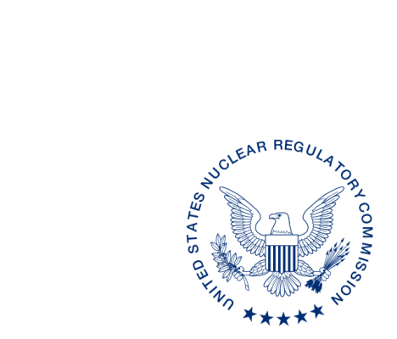
UNITED STATES
NUCLEAR REGULATORY COMMISSION
WASHINGTON, D.C. 20555-0001

ALL AGREEMENT STATE RADIATION CONTROL PROGRAM DIRECTORS, WYOMING, VERMONT

REQUEST FOR ASSISTANCE: “DESTINATION OF RELEASED PATIENTS FOLLOWING TREATMENT WITH IODINE-131, AND ESTIMATION OF DOSES TO MEMBERS OF THE PUBLIC AT LOCATIONS OTHER THAN CONVENTIONAL RESIDENCES RECEIVING SUCH PATIENTS”

Purpose: To request each Agreement State to provide the NRC and its technical contractor, SC&A, with a contact list of licensees who might use iodine-133 therapeutically to treat patients so that SC&A can survey the licensees in connection with the abovementioned NRC study.

Background: The NRC, assisted by its contractor SC&A, Inc. (www.scainc.com), a radiological consulting firm, is conducting a study to determine the destinations of patients immediately following release after I-131 therapy. Several tens of thousands of patients per year in the United States undergo diagnostic or treatment procedures with I-131 radioiodine, primarily for the treatment of thyroid cancer and hyperthyroidism. Treatment may occur at a hospital, outpatient medical clinic, practitioner’s office, or other medical facility. Previous evidence indicates that most patients return to their homes after treatment, but a significant minority may stay at other locations for as long as several days following treatment. Concern has been raised that hotel, nursing home, and other institutional staff may inadvertently be receiving significant radiation exposure from patients treated with unsealed radioactive sources such as I-131. This project is intended to provide reliable data on the fraction of patients treated with I-131 residing in locations other than their homes following treatment, and, in a planned follow-up study, on the potential doses received by non-medical personnel working at those locations.

Discussion: The NRC believes that the results of the survey will be of interest to the entire nuclear medicine and health physics communities and, ultimately of benefit to the public. We would greatly appreciate your support and participation in this important study and, through SC&A, Inc. (Project Manager, Dr. Stephen L. Ostrow), would like to distribute a questionnaire (copy attached for your information) to your licensees. SC&A is sending the same questionnaire to NRC licensees as well. As a first step, we would appreciate your furnishing a contact list of your licensees to the NRC and SC&A so that they can distribute the questionnaire and receive responses electronically.

Please note that any published data will be suitably redacted in compliance with applicable HIPAA and Privacy Act requirements.

Contact: If you have any questions or comments regarding this correspondence, please contact the NRC Project Officer, Mohammad Saba, at Mohammad.Saba@nrc.gov. Please send the requested list to both Mr. Saba and Dr. Ostrow (sostrow@scainc.com).

POINT OF CONTACT: Mohammad Saba E-MAIL: Mohammad.Saba@nrc.gov
TELEPHONE: (301) 415-1953

Daniel S. Collins, Director
Division of Material Safety, State, Tribal
and Rulemaking Programs
Office of Nuclear Material Safety
and Safeguards

Attach: Questionnaire

This information request has been approved by OMB 3150-0029 expiration 1/31/2019. The estimated burden per response to comply with this voluntary collection is approximately 1 hour. Send comments regarding the burden estimate to the FOIA, Privacy, and Information Collections Branch, U.S. Nuclear Regulatory Commission, Washington, DC 20555-0001, or by e-mail to infocollects.resource@nrc.gov, and to the Desk Officer, Office of Information and Regulatory Affairs, NEOB-10202 (3150-0029), Office of Management and Budget, Washington, DC 20503. If a means used to impose an information collection does not display a currently valid OMB control number, the NRC may not conduct or sponsor, and a person is not required to respond to, the information collection.

