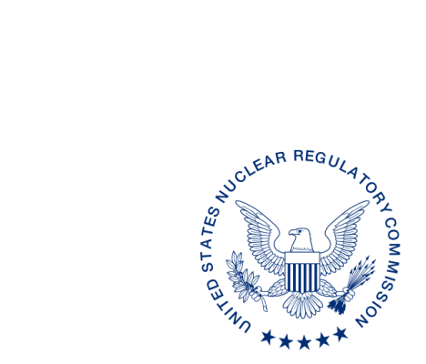
UNITED STATES
NUCLEAR REGULATORY COMMISSION
WASHINGTON, D.C. 20555-0001

ALL AGREEMENT STATES, VERMONT, WYOMING
STATE LIAISON OFFICERS

OPPORTUNITY TO COMMENT ON DRAFT REVISION TO THE OFFICE OF NUCLEAR MATERIAL SAFETY AND SAFEGUARDS PROCEDURE SA-103, REVIEWING THE COMMON PERFORMANCE INDICATOR, TECHNICAL STAFFING AND TRAINING (STC-16-XXX)

Purpose: To provide the Agreement States, Vermont, Wyoming, and State Liaison Officers an opportunity to comment on the proposed revisions to the Office of Nuclear Material Safety and Safeguards (NMSS) Procedure SA-103, Reviewing the Common Performance Indicator, Technical Staffing and Training.

Background: This procedure is being revised to update current practices and guidance and to address organizational changes.

Discussion: Enclosed for your review and comment is the draft revision to NMSS Procedure SA-103, Reviewing the Common Performance Indicator, Technical Staffing and Training. This document describes the process used to conduct an analysis and review of an Agreement State program’s ability to recruit and retain qualified staff and maintain staff levels sufficient for the number and type of licensees within their jurisdiction. The ability to conduct effective licensing and inspection programs is largely dependent on having a sufficient number of experienced, knowledgeable, and well-trained technical personnel. Under certain conditions, staff turnover could have an adverse effect on the implementation of these programs, and thus could affect public health and safety.

Please provide any comments on SA-103. We would appreciate receiving your comments¹ within 30 days from the date of this letter.

If you have any questions regarding this correspondence, please contact me at (301) 415-3340 or the individual named below:

POINT OF CONTACT: Joe O’Hara E-MAIL: Joe.OHara@nrc.gov
TELEPHONE: (301) 415-6854

Daniel S. Collins, Director
Division of Material Safety, State, Tribal
and Rulemaking Programs
Office of Nuclear Material Safety
and Safeguards

Enclosure:
Draft NMSS SA-103, Reviewing the Common Performance Indicator,
Technical Staffing and Training

______________________________
¹This information request has been approved by OMB 3150-0029 expiration 1/31/2019. The estimated burden per response to comply with this voluntary collection is approximately 3 hours. Send comments regarding the burden estimate to the FOIA, Privacy, and Information Collections Branch, U.S. Nuclear Regulatory Commission, Washington, DC 20555-0001, or by e-mail to infocollects.resource@nrc.gov, and to the Desk Officer, Office of Information and Regulatory Affairs, NEOB-10202 (3150-0029), Office of Management and Budget, Washington, DC 20503. If a means used to impose an information collection does not display a currently valid OMB control number, the NRC may not conduct or sponsor, and a person is not required to respond to, the information collection.

