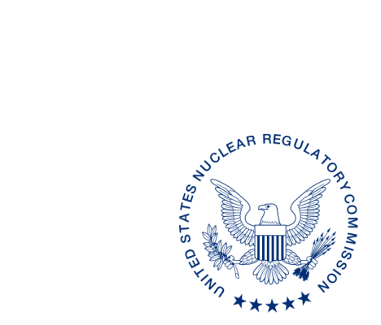
UNITED STATES
NUCLEAR REGULATORY COMMISSION
WASHINGTON, D.C. 20555-0001

ALL AGREEMENT STATES, VERMONT, WYOMING

OPPORTUNITY TO COMMENT ON DRAFT U.S. NUCLEAR REGULATORY COMMISSION’S INSPECTION MANUAL CHAPTER 2800, “MATERIALS INSPECTION PROGRAM” (STC-17-XXX)

Purpose: To provide Agreement States the opportunity to comment on the draft revisions of the Office of Nuclear Material Safety and Safeguards draft Inspection Manual Chapter (IMC) 2800, “Materials Inspection Program.”

Background: In June 8, 2015, the Commission issued Staff Requirement Memorandum (SRM) SECY-15-0015, “Project Aim 2020 and Recommendations,” directing the staff to perform a prioritization of all work activities across the agency and a one-time re-baselining of this work. The Commission noted that the staff should prioritize and re-baseline the agency’s work in an integrated manner, consistent with the agency’s mission, values, and the Principles of Good Regulations. In January 31, 2016, the NRC staff submitted to the Commission SECY-16-0009, “Recommendations Resulting from the Integrated Prioritization and Re-Baselining of Agency Activities.” Enclosure 1 (ML16028A212) to SECY-16-009 includes a list of the NRC work activities that could be shed, deprioritized, or completed with fewer resources. The majority of the items were targeted for completion within 6 months of the SRM issuance, with the remaining to be completed within 12 or 18 months of the SRM issuance. In April 13, 2016, the Commission approved the staff’s recommendations, with exception of delaying the Dodd-Frank Rulemaking. Item 110 of Enclosure 1 of SECY-16-009, directs NRC staff to revise IMC 2800 to allow for the addition of more flexibility and common-sense extensions to the inspection intervals of material licenses.

Discussion: On August 2016, a working group (WG) composed of NRC and Agreement State inspection staff was formed and tasked to address Item 110. The WG objectives where divided in two phases as follows: (1) Phase One: to conduct a limited revision of IMC 2800 to allow for more flexibility and logical extensions to the inspection intervals and to complete the Commission directed task by October 13, 2017, and (2) Phase Two: to conduct a full revision of IMC 2800 after the completion of Phase One.

The WG is currently working on addressing the tasking on Phase One. The enclosed revisions to IMC 2800 have no adverse impact on the health and safety of the public, but enhances the ability to plan and conduct inspection activities in the most efficient way possible, consistent with NRC’s mission, values, and the Principles of Good Regulation. A summary of the proposed revisions that were incorporated include: (1) changing to the current 25 percent buffer to 50 percent for inspection timeliness, (2) extending the initial inspection period if licensees are not in possession of material, and (3) allowing for extensions based on good performance on a case-by-case basis.
Enclosed for your review and comment is a redline copy of the WG’s proposed revisions to
IMC 2800. The draft document is also available in the NRC’s Agencywide Documents Access Management System using Accession No. ML17062A547. Please note, only comments that pertains to the Commission direction directed in SECY16-009 will be addressed in Phase One due to the limited scope of the revision, other comments will be addressed during Phase Two.

The comment period for this document, which was developed following consultation with the Organization of Agreement States, ends on [Month] xx, 2017. Please provide comments to the individuals named below:

POINT OF CONTACT: María Arribas-Colón E-MAIL: Maria.Arribas-Colon@nrc.gov
TELEPHONE: (301) 415-6026

POINT OF CONTACT: Celimar Valentín-Rodríguez E-MAIL:Celimar.Valentin-Rodriguez@nrc.gov
TELEPHONE: (301) 415-7124

Enclosure:
Draft Inspection Manual Chapter 2800

Daniel S. Collins, Director
Division of Material Safety, State, Tribal
and Rulemaking Programs
Office of Nuclear Material Safety
and Safeguards

This information request has been approved by OMB under clearance number 3150-0029 expiration 10/31/2018. The estimated burden per response to comply with this voluntary collection is approximately 8 hours. Send comments regarding the burden estimate to the Information Services Branch (T-2 F43), U.S. Nuclear Regulatory Commission, Washington, DC 20555-0001, or by e-mail to infocollects.resource@nrc.gov, and to the Desk Officer, Office of Information and Regulatory Affairs, NEOB-10202 (3150-0029), Office of Management and Budget, Washington, DC 20503. If a means used to impose an information collection does not display a currently valid OMB control number, the NRC may not conduct or sponsor, and a person is not required to respond to, the information collection.

