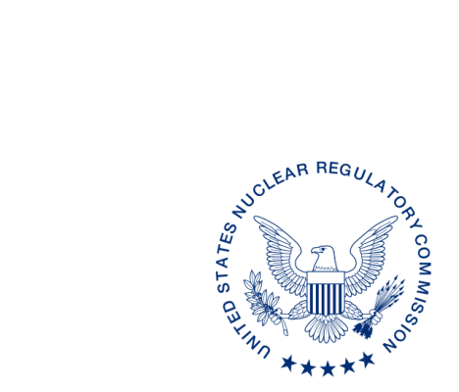
UNITED STATES
NUCLEAR REGULATORY COMMISSION
WASHINGTON, D.C. 20555-0001

ALL AGREEMENT STATES, VERMONT, WYOMING

OPPORTUNITY TO COMMENT ON DRAFT REVISION TO THE OFFICE OF NUCLEAR MATERIAL SAFETY AND SAFEGUARDS PROCEDURE SA-100, IMPLEMENTATION OF THE INTEGRATED MATERIALS PERFORMANCE EVALUATION PROGRAM (IMPEP)
(STC-17-XXX)

Purpose: To provide the Agreement States with an opportunity to comment on the proposed revisions to the Office of Nuclear Material Safety and Safeguards (NMSS) Procedure
SA-100, Implementation of the Integrated Materials Performance Evaluation Program (IMPEP).”

Background: This procedure is being revised to update current practices for implementing the Integrated Materials Performance Evaluation Program review.

Discussion: Enclosed for your review and comment is a draft revision to NMSS Procedure
SA-100, Implementation of the Integrated Materials Performance Evaluation Program (IMPEP). The current draft revision is provided in red line strikeout format from the last revision in February 2007 and a clean (readable) copy. We would appreciate receiving your comments within 60 days from the date of this letter.

If you have any questions regarding this correspondence, please contact me at (301) 415-3340 or the individual named below:

POINT OF CONTACT: Lizette Roldán-Otero, Ph.D. E-MAIL: Lizette.Roldan@nrc.gov
TELEPHONE: (817) 200-1596

Daniel S. Collins, Director
Division of Material Safety, State, Tribal
and Rulemaking Programs
Office of Nuclear Material Safety
and Safeguards
Enclosures:
As stated

This information request has been approved by OMB 3150-0029 expiration 1/31/2019. The estimated burden per response to comply with this voluntary collection is approximately 3 hours. Send comments regarding the burden estimate to the Information Services Branch (T-2 F43), U.S. Nuclear Regulatory Commission, Washington, DC 20555-0001, or by e-mail to infocollects.resource@nrc.gov, and to the Desk Officer, Office of Information and Regulatory Affairs, NEOB-10202 (3150-0029), Office of Management and Budget, Washington, DC 20503. If a means used to impose an information collection does not display a currently valid OMB control number, the NRC may not conduct or sponsor, and a person is not required to respond to, the information collection.

