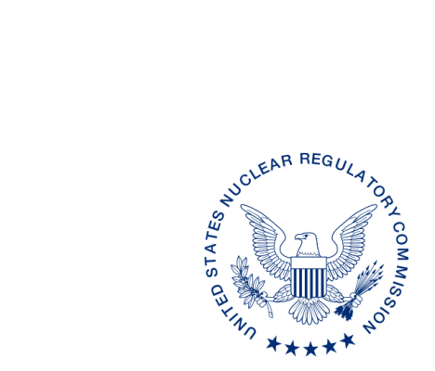
UNITED STATES
NUCLEAR REGULATORY COMMISSION
WASHINGTON, D.C. 20555-0001

XXXX, XX, 2017

ALL AGREEMENT STATES, VERMONT, WYOMING

OPPORTUNITY TO COMMENT ON DRAFT REVISION TO OFFICE OF NUCLEAR MATERIAL SAFETY AND SAFEGUARDS PROCEDURES MANAGEMENT DIRECTIVE 5.9 “ADEQUACY AND COMPATIBILITY OF PROGRAM ELEMENTS FOP AGREEMENT STATE PROGRAMS” (STC-XX-XXX)

Purpose: To provide the Agreement States with an opportunity to comment on the proposed revisions to the Office of Nuclear Material Safety and Safeguards (NMSS) (formerly the Office of Federal and State Materials and Environmental Management (FSME) Programs) Management Directive (MD) 5.9, “Adequacy and Compatibility of Program Elements for Agreement State Programs.”

Background: On February 27, 1998, the U.S. Nuclear Regulatory Commission (NRC) staff issued MD 5.9. This MD establishes the process, and describes the criteria, the NRC staff will use to determine when a proposed or final NRC regulation or program element is required for compatibility, or health and safety. The NRC staff is conducting a periodic update of MD 5.9 and identifying changes that would be needed to align with the Agreement State Program Policy Statement being considered by the Commission. Updates to the draft revision to MD 5.9 include (1) changes to the title of the MD, (2) changes to the NRC organization, (3) merger and revision of the Agreement State Program Policy Statement, (4) changes to Compatibility Category B, (5) update of the compatibility review process to incorporate Standing Committee on Compatibility, and (6) added three new definitions.

Discussion: Enclosed for your review and comment is a draft revision to MD 5.9, “Adequacy and Compatibility of Program Elements for Agreement State Programs.” The current draft revision to MD 5.9 is provided in red line strikeout format from the last revision in February 1998 and also a clean (readable) copy. We would appreciate receiving your comments by MMMM DD, 2017.

If you have any questions regarding this correspondence, please contact me at (301) 415-3340, your respective Regional State Agreement Officer, or the individual named below:

POINT OF CONTACT: Kathy Dolce Modes E-MAIL: Kathy.Modes@nrc.gov
TELEPHONE: (215) 872-5804

Daniel S. Collins, Director
Division of Material Safety, State, Tribal
and Rulemaking Programs
Office of Nuclear Material Safety
and Safeguards

Enclosures:
As stated
If you have any questions regarding this correspondence, please contact me at (301) 415-3340, your respective Regional State Agreement Officer, or the individual named below:

POINT OF CONTACT: Kathy Dolce Modes E-MAIL: Kathy.Modes@nrc.gov
TELEPHONE: (215) 872-5804

Daniel S. Collins, Director
Division of Material Safety, State, Tribal
and Rulemaking Programs
Office of Nuclear Material Safety
and Safeguards

Enclosures:
As stated

DISTRIBUTION:
MSTR r/f
ML
OFC | NMSS/MSTR/ASPB | NMSS/MSTR/ASPB | NMSS/MSTR/ASPB | NMSS/MSTR
NAME | KModes | SPoy | PMichalak | DCollins
DATE
OFFICIAL RECORD COPY

This information request has been approved by OMB 3150-0029 expiration 1/31/2019. The estimated burden per response to comply with this voluntary collection is approximately 3 hours. Send comments regarding the burden estimate to the FOIA, Privacy, and Information Collections Branch, U.S. Nuclear Regulatory Commission, Washington, DC 20555-0001, or by e-mail to infocollects.resource@nrc.gov, and to the Desk Officer, Office of Information and Regulatory Affairs, NEOB-10202 (3150-0029), Office of Management and Budget, Washington, DC 20503. If a means used to impose an information collection does not display a currently valid OMB control number, the NRC may not conduct or sponsor, and a person is not required to respond to, the information collection.

