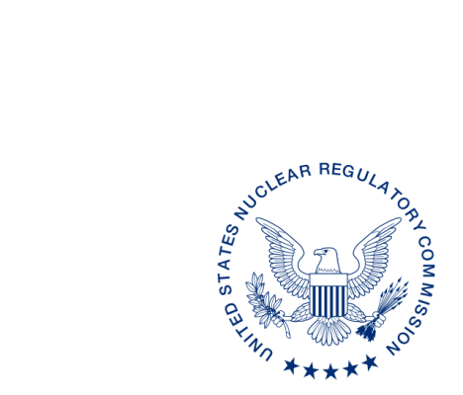
UNITED STATES
NUCLEAR REGULATORY COMMISSION
WASHINGTON, D.C. 20555-0001

XXXX, XX, 2017

ALL AGREEMENT STATES, VERMONT, WYOMING

OPPORTUNITY TO COMMENT ON DRAFT REVISIONS TO OFFICE OF NUCLEAR MATERIAL SAFETY AND SAFEGUARDS PROCEDURES MANAGEMENT DIRECTIVE 5.7 AND SA-1001, “TECHNICAL ASSISTANCE TO AGREEMENT STATES” (STC-XX-XXX)

Purpose: To provide the Agreement States with an opportunity to comment on the proposed revisions to the Office of Nuclear Material Safety and Safeguards (NMSS) (formerly the Office of Federal and State Materials and Environmental Management (FSME) Programs) Management Directive 5.7 and NMSS Procedure SA-1001, “Technical Assistance to Agreement States.”

Background: This Management Directive and SA procedure are being revised to reflect the current NMSS organization (post FSME merger), and current practices in the request for technical assistance from Agreement States to the U.S. Nuclear Regulatory Commission (NRC). The NMSS SA-1001 procedure is replacing Handbook 5.7 in order to facilitate future revisions more easily and frequently.

Discussion: Enclosed for your review and comment are draft revisions to Management Directive 5.7 and NMSS Procedure SA-1001, “Technical Assistance to Agreement States.” The requirements from Handbook 5.7 were included in SA-1001 since both the Handbook and the SA procedure were titled the same and contained some redundant provisions. The current draft revisions to SA-1001 are provided in red line strikeout format from the last revision in March 2013 and also a clean (readable) copy. We would appreciate receiving your comments by MMMM DD, 2017.

If you have any questions regarding this correspondence, please contact me at (301) 415-3340, your respective Regional State Agreement Officer, or the individual named below:

POINT OF CONTACT: Lizette Roldán-Otero, Ph.D. E-MAIL: Lizette.Roldan@nrc.gov
TELEPHONE: (817) 200-1596

Daniel S. Collins, Director
Division of Material Safety, State, Tribal
and Rulemaking Programs
Office of Nuclear Material Safety
and Safeguards

Enclosures:
As stated
If you have any questions regarding this correspondence, please contact me at (301) 415-3340, your respective Regional State Agreement Officer, or the individual named below:

POINT OF CONTACT: Lizette Roldán-Otero, Ph.D. E-MAIL: Lizette.Roldan@nrc.gov
TELEPHONE: (817) 200-1596

Daniel S. Collins, Director
Division of Material Safety, State, Tribal
and Rulemaking Programs
Office of Nuclear Material Safety
and Safeguards

Enclosures:
As stated

DISTRIBUTION:
MSTR r/f
ML
OFC | NMSS/MSTR/ASPB | NMSS/MSTR/ASPB | NMSS/MSTR
NAME | LRoldan-Otero | PMichalak | DCollins
DATE
OFFICIAL RECORD COPY

This information request has been approved by OMB 3150-0029 expiration 1/31/2019. The estimated burden per response to comply with this voluntary collection is approximately 3 hours. Send comments regarding the burden estimate to the FOIA, Privacy, and Information Collections Branch, U.S. Nuclear Regulatory Commission, Washington, DC 20555-0001, or by e-mail to infocollects.resource@nrc.gov, and to the Desk Officer, Office of Information and Regulatory Affairs, NEOB-10202 (3150-0029), Office of Management and Budget, Washington, DC 20503. If a means used to impose an information collection does not display a currently valid OMB control number, the NRC may not conduct or sponsor, and a person is not required to respond to, the information collection.

