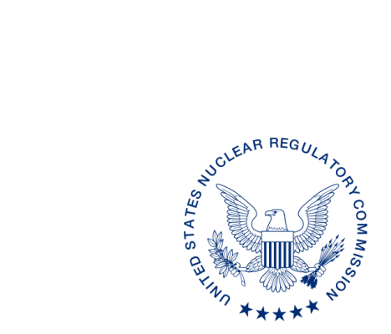
UNITED STATES
NUCLEAR REGULATORY COMMISSION
WASHINGTON, D.C. 20555-0001

April xx, 2017

ALL AGREEMENT STATES, WYOMING, VERMONT

PROJECTED INTEGRATED MATERIALS PERFORMANCE EVALUATION PROGRAM SCHEDULES FOR FISCAL YEARS 2018–2020 (STC-17-xxx)

Purpose: To inform Agreement State program staff of upcoming Integrated Materials
Performance Evaluation Program (IMPEP) reviews.

Background: Annually, the U.S. Nuclear Regulatory Commission provides the projected IMPEP schedule to the Agreement States to ensure that Agreement State personnel have advanced notice of upcoming IMPEP reviews.

Discussion: We would appreciate receiving any comments* regarding the timing of an IMPEP review projected for fiscal year (FY) 2018, as listed in the enclosure, within 30 days from the date of this letter. Once we have received any comments on the proposed schedule for FY 2018, we will issue a more complete draft schedule that includes designation of team members and estimated dates for Management Review Board meetings.

If you have any questions regarding this communication, please contact me at (301) 415-3340 or the individual named below:

POINT OF CONTACT: Lisa Dimmick E-MAIL: Lisa.Dimmick@nrc.gov
TELEPHONE: (301) 415-0694

Daniel S. Collins, Director
Division of Material Safety, State, Tribal
and Rulemaking Programs
Office of Nuclear Material Safety
and Safeguards

Enclosure:
Projected IMPEP Schedules
for Fiscal Years 2018-2020

* This information request has been approved by OMB 3150-0029 expiration 1/31/2019. The estimated burden per response to comply with this voluntary collection is approximately 20 minutes. Send comments regarding the burden estimate to the FOIA, Privacy, and Information Collections Branch, U.S. Nuclear Regulatory Commission, Washington, DC 20555-0001, or by e-mail to infocollects.resource@nrc.gov, and to the Desk Officer, Office of Information and Regulatory Affairs, NEOB-10202 (3150-0029), Office of Management and Budget, Washington, DC 20503. If a means used to impose an information collection does not display a currently valid OMB control number, the NRC may not conduct or sponsor, and a person is not required to respond to, the information collection.

ALL AGREEMENT STATES, WYOMING, VERMONT

PROJECTED INTEGRATED MATERIALS PERFORMANCE EVALUATION PROGRAM SCHEDULES FOR FISCAL YEARS 2018–2020 (STC-17-xxx)

Purpose: To inform Agreement State program staff of upcoming Integrated Materials
Performance Evaluation Program (IMPEP) reviews.

Background: Annually, the U.S. Nuclear Regulatory Commission provides the projected IMPEP schedule to the Agreement States to ensure that Agreement State personnel have advanced notice of upcoming IMPEP reviews.

Discussion: We would appreciate receiving any comments* regarding the timing of an IMPEP review projected for fiscal year (FY) 2018, as listed in the enclosure, within 30 days from the date of this letter. Once we have received any comments on the proposed schedule for FY 2018, we will issue a more complete draft schedule that includes designation of team members and estimated dates for Management Review Board meetings.

If you have any questions regarding this communication, please contact me at (301) 415-3340 or the individual named below:

POINT OF CONTACT: Lisa Dimmick E-MAIL: Lisa.Dimmick@nrc.gov
TELEPHONE: (301) 415-0694

Daniel S. Collins, Director
Division of Material Safety, State, Tribal
and Rulemaking Programs
Office of Nuclear Material Safety
and Safeguards

Enclosure:
Projected IMPEP Schedules
for Fiscal Years 2018-2020

ML
OFFICE | MSTR/ASPB | MSTR/ASPB | OMB | NMSS/MSTR
NAME | LDimmick | PMichalak
DATE
OFFICIAL RECORD COPY

PROJECTED IMPEP SCHEDULE
FY 2018 | FY 2019 | FY2020
Arkansas  ilinois | Ohio* | Virginia*
Utah (followup) | Pennsylvania* | NRC Region I*
Texas | NRC Region IV* | NRC SSD*
North Carolina | Wisconsin* | California
New York | Alabama | Maryland
Illinois* | Florida | Nebraska
Colorado | New Jersey | Rhode Island
Washington* | Maine | Arizona
Kansas | North Dakota | Louisiana
Massachusetts | Utah | Georgia
Oklahoma |  | Kentucky
* Received one year extension for two consecutive IMPEP reviews with all indicators satisfactory.

DRAFT SCHEDULE FOR IMPEP REVIEWS FY 2018
Program | Proposed Date
Arkansas  ilinois | October 2017
Utah (followup) | November 2017
Texas | February 2018
North Carolina | March 2018
New York | March 2018
Illinois | April 2018
Colorado | April 2018
Washington | May 2018
Kansas | June 2018
Massachusetts | July 2018
Oklahoma | August 2018

