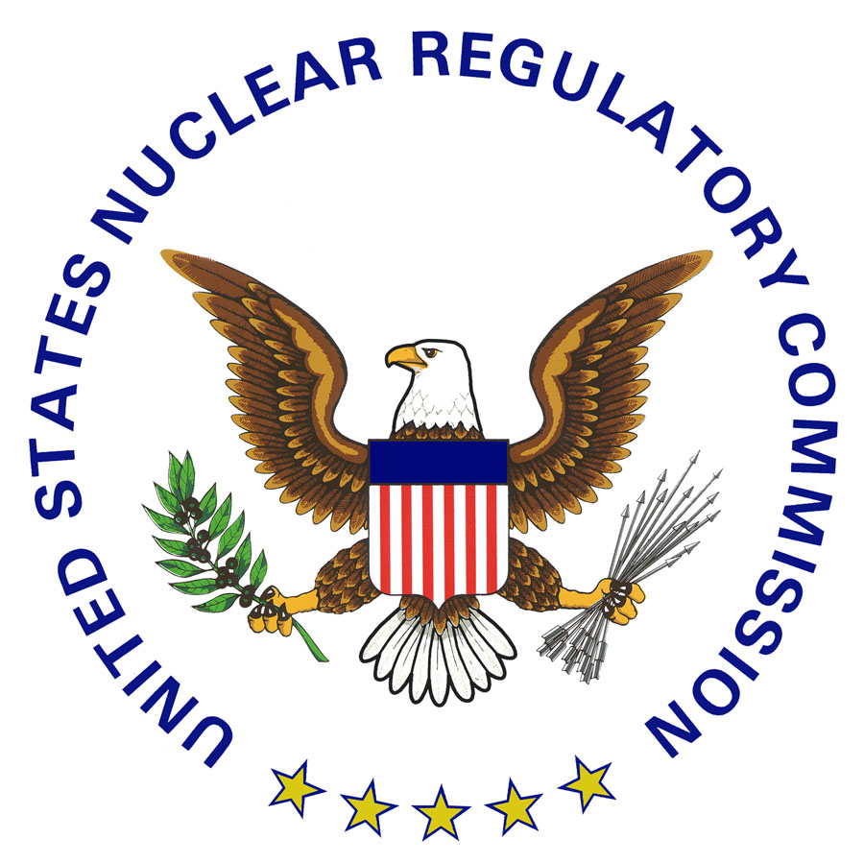

Office of Nuclear Materials Safety and Safeguards
Procedure Approval

Implementation of Management Directive 5.7,
“Technical Assistance to Agreement States”

SA-1001

Issue Date:

Review Date:

Daniel S. Collins, Director
Division of Material Safety, State, Tribal
and Rulemaking Programs
Date:

Paul Michalak, Branch Chief
Agreement State Program Branch
Division of Material Safety, State, Tribal
and Rulemaking Programs
Date:

Lizette Roldán-Otero, Ph.D., Procedure Contact
Agreement State Program Branch
Division of Material Safety, State, Tribal
and Rulemaking Programs
Date:

ML
NOTE
Any changes to the procedure will be the responsibility of the NMSS Procedure Contact. Copies of NMSS procedures are available through the NRC Web site at https://scp.nrc.gov

- INTRODUCTION

This document describes the procedure for implementing U.S. Nuclear Regulatory Commission (NRC) Management Directive (MD) 5.7, “Technical Assistance to Agreement States”. This procedure replaces Handbook 5.7.

- OBJECTIVE

- Provide guidance to NRC and Agreement State management on the submission and review of requests for NRC technical assistance.

- Establish guidance in determining when and if NRC should provide routine, special, or programmatic technical assistance to Agreement States.

- Establish a process for determining the extent and conduct of this assistance.

- BACKGROUND

Technical Assistance to Agreement States may be provided through a formal technical assistance request (TAR). TARs should be submitted from an Agreement State to the appropriate Office of Nuclear Materials Safety and Safeguards (NMSS) Division Director using the form in Appendix A. This procedure should not be used to process TARs between NMSS and the NRC regions or between NMSS divisions. NMSS Policy and Procedure 7-05, “Procedures for Processing of Technical Assistant Requests” should be followed with regard to TARs between NMSS and the NRC regions or between NMSS divisions.

- ROLES AND RESPONSIBILITIES

Director, Office of Nuclear Material Safety and Safeguards (NMSS)

    - Coordinates the review of technical assistance requests from Agreement States with regional administrators and directors of affected program offices.

    - Reviews technical assistance requests to ensure that they are consistent with Commission policy and that they contain:

      - Sufficient information to enable NRC to provide adequate technical response to the issues addressed in the Agreement State’s request, such as an evaluation of the issue and, if appropriate, a proposed resolution.

      - Evidence that the Agreement State had pursued alternative means of addressing the issue on its own, including attempting to obtain assistance from other agencies within the State or Commonwealth, other Agreement States, or independent organizations such as the Conference of Radiation Control Program Directors, the Organization of Agreement States, or procuring consultants or contractors.

    - Coordinates any recommendations on the requests and provides the agency response to the Agreement State, as appropriate.
    - Ensures that appropriate headquarters and regional offices have an opportunity to provide input into the development of the response to the request.

    - Assists office directors and regional administrators in determining the appropriate means for providing the assistance, including the level of staff involvement and the timing of the agency response.

    - Plans, schedules, and arranges meetings with the Agreement State to coordinate the assistance.

On assistance requests, response to the Agreement State, identifies an NRC contact, and provides a schedule for accomplishing the assistance.

- REQUEST FOR TECHNICAL ASSISTANCE FROM AGREEMENT STATES

- General

NRC provides three types of technical assistance to Agreement States: routine, special, and programmatic. Routine technical assistance is provided as part of NRC’s daily interaction with Agreement States, special technical assistance may require specific assignment of NRC staff or consultants for a specified period and for a specific job, and programmatic technical assistance is addressed as part of the Integrated Materials Performance Evaluation Program (IMPEP) process.

- Request for Routine Technical Assistance

- Under usual circumstances, routine technical assistance is provided to Agreement States as a regular part of NRC’s day-to-day interaction with Agreement States. This assistance may include, but is not limited to, the discussion of technical issues regarding licensing, compliance, and security. Routine technical assistance may be discussed as part of routine communication and exchange of information between NRC and the Agreement States, or an Agreement State may submit the request in an e-mail file or in a letter to the appropriate NRC regional Agreement State office or the Director of NMSS.

- Examples of routine technical assistance include requests for and the sharing of information on licensing, inspection, security, and enforcement activities. The information could include provision or clarification of NRC policy and guidance such as regulations, NUREG-series reports, regulatory guides, sealed source and device (SS&D) technical specifications, or licensing and inspection guidance.

- NRC staff may perform confirmatory reviews of portions of completed Agreement State technical assessments, on a case-by-case basis, when resources are available. For example, an Agreement State may have completed an SS&D review that identified unusual specifications. The Agreement State may share the completed review with NRC and may ask if the NRC has any previous experience with the unusual specifications, or an Agreement State may ask NRC to perform a confirmatory review of the Agreement State’s results regarding the unusual specification.

An Agreement State also may make an inquiry regarding its interpretation and implementation of a specific regulation and whether NRC would interpret the equivalent NRC regulation in a similar manner.
- Request for Special Technical Assistance

- Circumstances may arise that require a response above the routine level of interaction with Agreement States. An Agreement State may not have the special technical expertise that is required to address a particular need, or an Agreement State may experience a temporary constraint on resources. Consequently, an Agreement State may request direct special technical assistance from NRC that would involve NRC licensing and inspection staff conducting independent licensing and inspection activities for the Agreement State, for a specified period and for a specific job. Such assistance may also include the services of an NRC consultant.

- Direct technical assistance to an Agreement State in these circumstances will be conducted on a case-by-case basis when NRC believes that such assistance is necessary. The provision of such assistance will be based on the availability of staff resources and any assistance will be cost-reimbursable, with the exception described in C.iv. of this section. The Director of NMSS in coordination with the appropriate regional office will designate projects as special technical projects.

- To request NRC special technical expertise assistance, an Agreement State should submit a letter to the Director of NMSS requesting the specific assistance (specify period and specific job) certified by an Agreement State manager (radiation control program director, agency head, or other equivalent manager) that the necessary resources or technical expertise is not available within the Agreement State. The Agreement State should also include evidence that the Agreement State pursued alternative means of addressing the issue on its own, including attempting to obtain assistance from other agencies within the State or Commonwealth, other Agreement States, or independent organizations, such as the Organization of Agreement States, the Conference of Radiation Control Program Directors, or procuring contractors or consultants.

- An Agreement State may request the use of an NRC medical consultants to evaluate a medical event in their State at no additional cost. The Agreement State should submit the request to NMSS, Division of Material Safety, State, Tribal, and Rulemaking Programs (MSTR), Medical Safety and Events Assessment Branch (MSEB). The Agreement State should develop a draft charter and submit it to the NRC for review. The charter will be reviewed to ensure that it is consistent with Inspection Manual Chapter (IMC) 1360 “Use of Physician and Scientific Consultants in the Medical Consultant Program.” The request will be evaluated and approved by MSEB staff in accordance with the policy section in IMC 1360. If it is approved, MSEB will send the request to the medical consultant. The Agreement State should share the medical consultant final report with the NRC for review and to update the event in the NRC’s Nuclear Material Events Database.

- Request for Programmatic Technical Assistance

- Programmatic issues may arise in an Agreement State that impact resources such as staffing, funding, and equipment, and, as a result, impact the Agreement State’s ability to maintain a program that is adequate and compatible with NRC’s materials program. Under such circumstances, an Agreement State may request NRC technical assistance through the process described above in Section C of this procedure, “Requests for Special Technical Assistance.”
- Direct technical assistance to an Agreement State in these circumstances will be conducted on a case-by-case basis when NRC believes that assistance is necessary because of a lack of adequate resources and to ensure adequate protection of the public health and safety. The provisions of assistance will be based on the availability of staff resources and any assistance will be cost-reimbursable.

- In providing technical assistance to Agreement States, NRC will concentrate its resources on those areas that an Agreement State may not be able to address through its own expertise or contractual support for its program. This assistance may involve support in the licensing or inspection aspects of the Agreement State’s regulatory program.

- Programmatic issues are addressed as part of the IMPEP review process. IMPEP, under which NRC conducts a performance review of each NRC region and each Agreement State on a periodic basis, is described in Management Directive 5.6, “Integrated Materials Performance Evaluation Program (IMPEP).” See also the Commission’s Policy Statements on the Criteria for Guidance of States and NRC in Discontinuance of NRC Regulatory Authority and Assumption Thereof by States through Agreement and the Adequacy and Compatibility of Agreement State Programs.

- An Agreement State may request State specific training as a result of an IMPEP review. In this case, the assigned NMSS division will coordinate with the Regional State Agreement Officer for the scheduling of the training. The provisions of assistance will be based on the availability of staff resources.

- Nothing in this section shall be construed as affecting the authority of any Agreement State. All regulatory decisions remain the responsibility of the Agreement State.

- APPENDICES

Appendix A – Technical Assistance Request Form

- REFERENCES
Nuclear Regulatory Commission Documents
Commission Policy Statements—
Criteria for Guidance of States and NRC in Discontinuance of NRC Regulatory Authority and Assumption Thereof by States through Agreement (46 FR 7540, January 23, 1981, as amended by policy statements at 46 FR 36969, July 16, 1981, and 48 FR 33376, July 21, 1983).
Statement of Principles and Policy for the Agreement State Program; Policy Statement on Adequacy and Compatibility of Agreement State Programs (62 FR 46517, September 3, 1997).
Management Directive 5.6, “Integrated Materials Performance Evaluation Program (IMPEP).”
United States Code
Atomic Energy Act of 1954, as amended (42 U.S.C. 2011 et seq.).
VIII. ADAMS REFERENCE DOCUMENTS

For knowledge management purposes, all previous revisions of this procedure, as well as associated correspondence with stakeholders, that have been entered into the NRC’s Agencywide Document Access Management System are listed below.

No. | Date | Document Title/Description | Accession Number
1 | 03/28/13 | MD and Handbook 5.7 | ML13346A889

Appendix A

TECHNICAL ASSISTANCE REQUEST
Distribute to: (Select Only One Division) MSTR DUWP
Type of Request: |  | Routine Special Programmatic
Issue is: | MSTR | Medical Commercial or Academic Security
- Regulatory interpretation or exemption  - Other | DUWP | - Financial Assurance Reviews Dose Assessments for Decommissioning  - Reviews of Decommissioning Documents
Date:

To: , Director
Division Name, NMSS
From: , Agreement State Program Director, Agreement State
Problem or Issue:

Action Requested:

Recommended Action and Alternatives:

Background Documents:

Reviewer: |  |  |  | Contact number: | ( )
Needed by (date):

