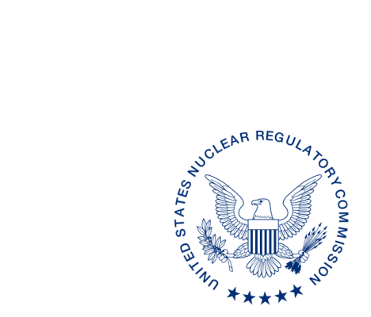
UNITED STATES
NUCLEAR REGULATORY COMMISSION
WASHINGTON, D.C. 20555-0001

DRAFT

ALL AGREEMENT STATES, VERMONT, WYOMING

OPPORTUNITY TO COMMENT ON DRAFT REVISION OF MANAGEMENT DIRECTIVE (MD) 5.6, “INTEGRATED MATERIALS PERFORMANCE EVALUATION PROGRAM (IMPEP)” (STC-17-XXX)

Purpose: To provide the Agreement States with an opportunity to comment on the proposed revisions to Management Directive (MD) 5.6, “Integrated Materials Performance Evaluation Program (IMPEP).”

Background: This MD is being revised to reflect the current NMSS organization (post FSME merger), current policies and procedures, changes resulting from the revised Policy Statement for the Agreement State Program, and the recommendations made in the June 2010 report on the Self-Assessment of the IMPEP (ML102030228). In addition, this revision also incorporates provisions from MD 5.10, “Formal Qualifications for IMPEP Team Members and Team Leaders”, which will be eliminated once MD 5.6 is published.

Discussion: Enclosed for your review and comment are draft revisions to MD 5.6. The current draft revisions to MD 5.6 are provided in red line strikeout format from the last revision in February 2004, and also a clean (readable) copy. We would appreciate receiving your comments by xxx, 2017.

If you have any questions regarding this correspondence, please contact me at (301) 415-3340, your respective Regional State Agreement Officer, or the individual named below:

POINT OF CONTACT: Michelle Beardsley E-MAIL: Michelle.Beardsley@nrc.gov
TELEPHONE: (267) 884-2305

Daniel S. Collins, Director
Division of Material Safety, State, Tribal
and Rulemaking Programs
Office of Nuclear Material Safety
and Safeguards

Enclosures:
As stated

DISTRIBUTION:
MSTR r/f
ML17
OFC | NMSS/MSTR/ASPB | NMSS/MSTR/ASPB | NMSS/MSTR
NAME | MBeardsley | PMichalak | DCollins
DATE
OFFICIAL RECORD COPY

This information request has been approved by OMB 3150-0029 expiration 1/31/2019. The estimated burden per response to comply with this voluntary collection is approximately 3 hours. Send comments regarding the burden estimate to the FOIA, Privacy, and Information Collections Branch, U.S. Nuclear Regulatory Commission, Washington, DC 20555-0001, or by e-mail to infocollects.resource@nrc.gov, and to the Desk Officer, Office of Information and Regulatory Affairs, NEOB-10202 (3150-0029), Office of Management and Budget, Washington, DC 20503. If a means used to impose an information collection does not display a currently valid OMB control number, the NRC may not conduct or sponsor, and a person is not required to respond to, the information collection.

