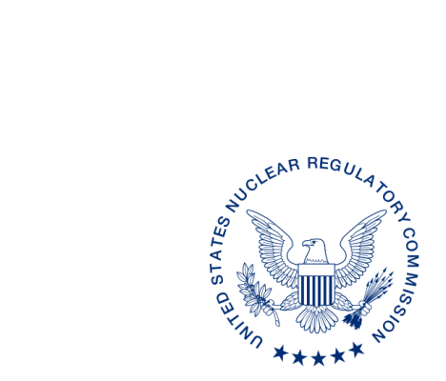
UNITED STATES
NUCLEAR REGULATORY COMMISSION
WASHINGTON, D.C. 20555-0001

ALL AGREEMENT STATES, WYOMING, VERMONT

OPPORTUNITY TO COMMENT ON DRAFT REVISION TO THE OFFICE OF NUCLEAR MATERIAL SAFETY AND SAFEGUARDS STATE PROCEDURE SA-106, The Management Review Board (STC-17-XXX)

Purpose: To provide the Agreement States an opportunity to comment on the proposed revisions to the Office of Nuclear Material Safety and Safeguards (NMSS) State Procedure SA-106, The Management Review Board.

Background: This procedure is being revised to update current practices and organizational changes.

Discussion: Enclosed for your review and comment is the draft revision to NMSS Procedure SA-106, The Management Review Board. This document describes the procedure for the management review board to provide a senior-level review of the Integrated Materials Evaluation Program team’s findings and recommendations and issues of the final U.S. Nuclear Regulatory Commission’s findings to the Region or Agreement State.

Please provide any comments to the contact person listed below. We would appreciate receiving your comments within 30 days from the date of this letter.

If you have any questions regarding this correspondence, please contact me at 301-415-3340 or the individual named below:

POINT OF CONTACT: Karen Meyer INTERNET: karen.meyer@nrc.gov
TELEPHONE: (301) 415-0113

Daniel S. Collins, Director
Division of Material Safety, State, Tribal
and Rulemaking Programs
Office of Nuclear Material Safety
and Safeguards

Enclosures:
1. NMSS SA-106 with tracked changes
2. NMSS SA-106 clean version

This information request has been approved by OMB 3150-0029 expiration 1/31/2019. The estimated burden per response to comply with this voluntary collection is approximately 2 hours. Send comments regarding the burden estimate to the Information Services Branch, U.S. Nuclear Regulatory Commission, Washington, DC 20555-0001, or by e-mail to infocollects.resource@nrc.gov, and to the Desk Officer, Office of Information and Regulatory Affairs, NEOB-10202 (3150-0029), Office of Management and Budget, Washington, DC 20503. If a means used to impose an information collection does not display a currently valid OMB control number, the NRC may not conduct or sponsor, and a person is not required to respond to, the information collection.

