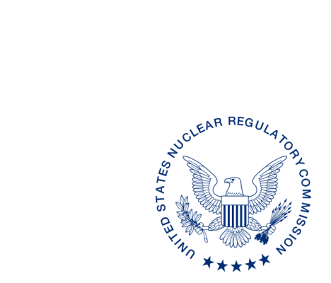
UNITED STATES
NUCLEAR REGULATORY COMMISSION
WASHINGTON, D.C. 20555-0001

XX, 2017

ALL AGREEMENT STATES, VERMONT, WYOMING

OPPORTUNITY TO COMMENT ON OFFICE OF NUCLEAR MATERIAL SAFETY AND SAFEGUARDS PROCEDURES: DRAFT REVISION OF SA-400, “MANAGEMENT OF AGREEMENT STATE PROGRAM PERFORMANCE CONCERNS” AND DRAFT SA-401, “MANAGEMENT OF AGREEMENT STATE LICENSEE CONCERNS” (STC-17-0XX)

Purpose: To provide the Agreement States with an opportunity to comment on two related Office of Nuclear Material Safety and Safeguards (NMSS) (formerly the Office of Federal and State Materials and Environmental Management [FSME] Programs) procedures: (1) proposed revisions to SA-400, “Management of Agreement State Program Performance Concerns,” and (2) Draft SA-401, “Management of Agreement State Licensee Concerns.”

Background: SA-400, “Management of Agreement State Program Performance Concerns,” was revised to update current practices and incorporate lessons learned from the staff’s handling of Agreement State Program performance concerns. SA-400 was originally issued for State comment on April 10, 2015 (see STC-15-026 at https://scp.nrc.gov/asletters/program/sp15026.pdf). As a result of comments, discussion of Agreement State licensee concerns has been removed from SA-400, and a new procedure that focuses only on licensee concerns has been developed: SA-401, “Management of Agreement State Licensee Concerns.” SA-400 and SA-401 are being issued for State comment concurrently.

Discussion: Enclosed for your review and comment are two NMSS procedures, SA-400 and SA-401. Draft revision to SA-400, “Management of Agreement State Program Performance Concerns,” provides guidance on concerns involving the performance of Agreement State programs or their employees. Comments from the April 2015 draft revision of SA-400 were incorporated into the current proposed revision as applicable. The current draft revision of SA-400 is provided in red line strikeout format from the last revision in April 2015, along with a clean copy. Discussion of Agreement State licensee concerns has been removed from SA-400 and they are now covered separately in draft NMSS procedure SA-401, “Management of Agreement State Licensee Concerns.” The comment period for both of these document ends on [THIRTY DAYS FROM ISSUANCE OF STC]. Please e-mail comments to Sarah.Lopas@nrc.gov.
If you have any questions regarding this correspondence, please contact me at (301) 415-3340, your respective Regional State Agreement Officer, or the individual named below:

POINT OF CONTACT: Sarah L. Lopas E-MAIL: Sarah.Lopas@nrc.gov
TELEPHONE: (301) 415-6360

Daniel S. Collins, Director
Division of Material Safety, State, Tribal
and Rulemaking Programs
Office of Nuclear Material Safety
and Safeguards

Enclosures:
1. SA-400, “Management of Agreement State
Program Performance Concerns”
2. SA-400, “Management of Agreement State
Program Performance Concerns” Redline Strikeout
3. SA-401, “Management of Agreement State Licensee Concerns”

SUBJECT: OPPORTUNITY TO COMMENT ON DRAFT REVISION TO OFFICE OF NUCLEAR
MATERIAL SAFETY AND SAFEGUARDS PROCEDURE SA-400, “MANAGEMENT
OF AGREEMENT STATE PERFORMANCE CONCERNS” (STC-17-0XX)

OFC | NMSS/MSTR/ASPB | NMSS/MSTR/ASPB | NMSS/MSTR/ASPB | NMSS/MSTR
NAME | SLopas |  | PMichalak | DCollins
DATE | 5/15/17 | 7/ /17 | 7/ /17 | 7/ /17
OFFICIAL RECORD COPY

This information request has been approved by OMB 3150-0029 expiration 1/31/2019. The estimated burden per response to comply with this voluntary collection is approximately 3 hours. Send comments regarding the burden estimate to the Information Services Branch, U.S. Nuclear Regulatory Commission, Washington, DC 20555-0001, or by e-mail to infocollects.resource@nrc.gov, and to the Desk Officer, Office of Information and Regulatory Affairs, NEOB-10202 (3150-0029), Office of Management and Budget, Washington, DC 20503. If a means used to impose an information collection does not display a currently valid OMB control number, the NRC may not conduct or sponsor, and a person is not required to respond to, the information collection.

