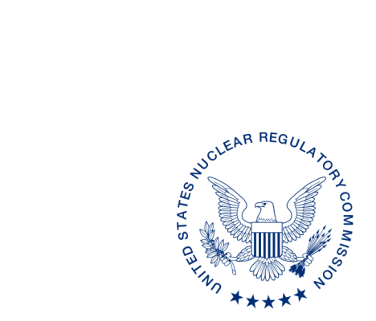**UNITED STATES**

**NUCLEAR REGULATORY COMMISSION**

**WASHINGTON, D.C. 20555-0001**

ALL AGREEMENT STATES, VERMONT, WYOMING

OPPORTUNITY TO COMMENT ON A PROPOSAL TO LIMIT THE NUMBER OF SPECIAL MANAGEMENT REVIEW BOARD MEETINGS (STC-18-XXX)

**Purpose:** To provide the Agreement States an opportunity to comment on the proposed change to limit the number of special management review board meetings (MRBs) to Programs (NRC or Agreement State) with performance issues or when requested. A special MRB is held to discuss the results of the periodic meeting.

**Background:** The discussion of the periodic meetings by the MRB was originally not part of the Integrated Materials Performance Evaluation Program (IMPEP) process but was added in 2006-2007 by then MRB Chair Martin Virgilio to give the Programs an opportunity to interface with NRC senior management between IMPEP reviews and address any performance issues identified during a meeting. Currently special MRB meetings are held with Agreement States and Regions for all periodic meetings.

**Discussion:** The NRC is considering the following criteria:

Special MRBs for periodic meetings would be eliminated unless the Program (NRC or Agreement State) meets one of the following criteria:

* 1. The Program is on monitoring, heighten oversight, or probation.
  2. The Program was found adequate, but needs improvement or not compatible during the last IMPEP review.
  3. The Program and/or the NRC staff attending the periodic meeting identified a performance degradation that could result in the less than satisfactory performance for one or more indicators as compared to the rating criteria established in MD 5.6 “IMPEP.”
  4. The Program specifically requests a special MRB to discuss the periodic meeting.
  5. By special direction of the MRB.

Under this proposal, a special MRB would be scheduled within four to five months of a periodic meeting to ensure timely discussion of program issues with the MRB.

This change would not adversely impact the effectiveness of the IMPEP process. This change would not affect the continued communications between the Regional State Agreements Officers and the Agreement States.

In consideration of this potential change, the benefit to adopting this proposal would allow for:

* + Efficient use of NRC and Agreement State resources by focusing attention on those Programs with known or emergent performance issues.
  + Fewer and shorter special MRBs will increase flexibility in scheduling. This will allow for timely scheduling of the special MRBs closer to the date of the periodic meeting.
  + Efficient use of NRC senior management time.

On the other hand, NRC management might not be able attend every periodic meeting because of the reduction in travel funds and scheduling. The special MRB provides a second opportunity for NRC management to interface with all Agreement States. In addition, executive NRC management would not interface with good performing Programs in-between IMPEP reviews, a gap of four to five years, and potentially miss the opportunity to gain greater perspective of the National Materials Program. [NOTE: Executive NRC management and senior management attend the Organization of Agreement States (OAS) and Conference of Radiation Control Program Directors (CRCPD) meetings. Also OAS and CRCPD visit NRC headquarters for meetings with Executive NRC management and Commissioners.]

The NRC is carefully considering this proposal and would encourage hearing from the Agreement States. We would appreciate receiving your comments on limiting the number of special MRBs within 30 days[1] from the date of this letter.

If you have any questions regarding this correspondence, please contact me at (301) 415-3340, or the individual named below:

POINT OF CONTACT: Kathy Dolce Modes E-MAIL: [Kathy.Modes@nrc.gov](mailto:Kathy.Modes@nrc.gov)

TELEPHONE: (215) 872-5804

Kevin Williams, Acting Director

Division of Materials Safety, Security, State

and Tribal Programs

Office of Nuclear Material Safety

and Safeguards

1. This information request has been approved by OMB 3150-0029 expiration 1/31/2019. The estimated burden per response to comply with this voluntary collection is approximately 1 hour. Send comments regarding the burden estimate to Information Services Branch, U.S. Nuclear Regulatory Commission, Washington, DC 20555-0001, or by e-mail to [infocollects.resource@nrc.gov](mailto:infocollects.resource@nrc.gov), and to the Desk Officer, Office of Information and Regulatory Affairs, NEOB-10202 (3150-0029), Office of Management and Budget, Washington, DC 20503. If a means used to impose an information collection does not display a currently valid OMB control number, the NRC may not conduct or sponsor, and a person is not required to respond to, the information collection.