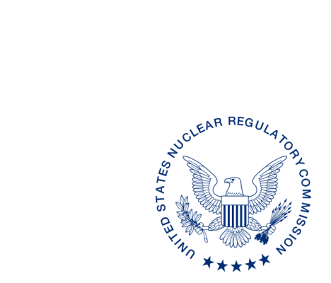**UNITED STATES**

**NUCLEAR REGULATORY COMMISSION**

**WASHINGTON, D.C. 20555-0001**

xx xx, 2016

ALL AGREEMENT STATES, VERMONT, WYOMING

OPPORTUNITY TO COMMENT ON THE PROPOSED REVISIONS TO INSPECTION PROCEDURE 87123: “WELL LOGGING PROGRAMS” AND INSPECTION PROCEDURE 87137: “10 CFR PART 37 MATERIALS SECURITY PROGRAMS” (STC-18-NNN)

**Purpose:** To provide the Agreement States an opportunity to comment on the proposed revisions to the Inspection Procedure (IP) 87123: “Well Logging Programs” and IP 87137: “10 CFR Part 37 Materials Security Programs.”

**Background:** The U.S. Nuclear Regulatory Commission (NRC) is revising Inspection Procedure (IP) 87123, “Well Logging Programs.” The NRC originally issued IP 87123 in November 2003. The NRC is also revising IP 87137, which was originally issued on April 3, 2014.

On June 2014, the Government Accountability Office (GAO) issued an audit report (GAO-14-293) on Actions Needed to Increase Security of U.S. Industrial Radiological Sources. As a response, the NRC committed to evaluating a GAO recommendation to consider whether the definition of collocation should be revised for well logging facilities that routinely keep radiological sources in a single storage area but secured in separate storage containers. The 10 CFR Part 37(Part 37), Program Review Team (PRT) determined that the definition of aggregation, previously referred as collocation, is clear and does not need to be changed. In addition, the PRT determined that the security requirements in Part 37 provide adequate protection for well logging sources in storage. To enhance inspection oversight, the Part 37 Implementation Working Group recommended revisions to IP 87123 and IP 87137 to ensure inspectors assess licensees’ potential to aggregate materials as part of routine inspections.

In addition, IP 87137 is being revised to incorporate text regarding oversight of compliance with trustworthiness and reliability determinations for reviewing officials and correction of an error in existing text.

**Discussion:** Enclosed for your review and comment are the draft procedures. Comments of an editorial nature will be considered; however, the draft text may undergo additional technical editing and formatting by the U.S. Nuclear Regulatory Commission (NRC) prior to publication.

Please provide any comments to the contact person listed below. We would appreciate receiving your comments[1] by July 28, 2018.

If you have any questions regarding this correspondence, please contact me at (301) 415-xxx or the individual named below:

POINT OF CONTACT: Lymari Sepulveda E-MAIL: [Lymari.Sepulveda@nrc.gov](mailto:Lymari.Sepulveda@nrc.gov)

TELEPHONE: (301) 415-5619

Andrea Kock, Acting Director

Division of Materials Safety, Security, State,

and Tribal Programs

Office of Nuclear Material Safety

and Safeguards

Enclosures:

Revised Inspection Procedure 87123: “Well Logging Programs”

Revised Inspection Procedure 87137: “10 CFR Part 37 Materials Security Programs”

1. This information request has been approved by OMB 3150-0029 expiration 1/31/2019. The estimated burden per response to comply with this voluntary collection is approximately 2.5 hours. Send comments regarding the burden estimate to the Information Services Branch, U.S. Nuclear Regulatory Commission, Washington, DC 20555-0001, or by e-mail to [infocollects.resource@nrc.gov](mailto:infocollects.resource@nrc.gov), and to the Desk Officer, Office of Information and Regulatory Affairs, NEOB-10202 (3150-0029), Office of Management and Budget, Washington, DC 20503. If a means used to impose an information collection does not display a currently valid OMB control number, the NRC may not conduct or sponsor, and a person is not required to respond to, the information collection.