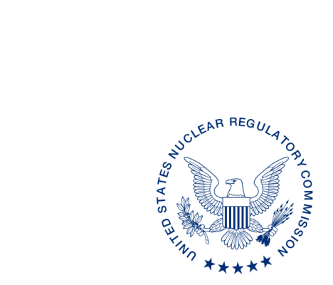
UNITED STATES
NUCLEAR REGULATORY COMMISSION
WASHINGTON, D.C. 20555-0001

ALL AGREEMENT STATES, WYOMING, VERMONT

PROJECTED INTEGRATED MATERIALS PERFORMANCE EVALUATION PROGRAM SCHEDULES FOR FISCAL YEARS 2019–2021 (STC-18-XXX)

Purpose: To inform Agreement State program staff of upcoming Integrated Materials
Performance Evaluation Program (IMPEP) reviews.

Background: Annually, the U.S. Nuclear Regulatory Commission provides the projected IMPEP schedule to the Agreement States to ensure that Agreement State personnel have advanced notice of upcoming IMPEP reviews.

Discussion: We would appreciate receiving any comments* regarding the timing of an IMPEP review projected for fiscal year (FY) 2019, as listed in the enclosure, within 30 days from the date of this letter. Once we have received any comments on the proposed schedule for FY 2019, we will issue a more complete draft schedule that includes designation of team members and estimated dates for Management Review Board meetings.

If you have any questions regarding this communication, please contact me at (301) 415-3340 or the individual named below:

POINT OF CONTACT: Lance Rakovan E-MAIL: Lance.Rakovan@nrc.gov
TELEPHONE: (301) 415-2589

Andrea L. Kock, Acting Director
Division of Materials Safety, Security, State,
and Tribal Programs
Office of Nuclear Material Safety
and Safeguards

Enclosure:
Projected IMPEP Schedules
for Fiscal Years 2019-2021

* This information request has been approved by OMB 3150-0029 expiration 1/31/2019. The estimated burden per response to comply with this voluntary collection is approximately 20 minutes. Send comments regarding the burden estimate to the Information Services Branch, U.S. Nuclear Regulatory Commission, Washington, DC 20555-0001, or by e-mail to infocollects.resource@nrc.gov, and to the Desk Officer, Office of Information and Regulatory Affairs, NEOB-10202 (3150-0029), Office of Management and Budget, Washington, DC 20503. If a means used to impose an information collection does not display a currently valid OMB control number, the NRC may not conduct or sponsor, and a person is not required to respond to, the information collection.

PROJECTED IMPEP
SCHEDULE
FY 2019 | FY 2020 | FY2021
Ohio* | Virginia* | Tennessee*
Pennsylvania* | NRC Region I* | New Hampshire
New Jersey | NRC SS&D* | Mississippi
NRC Region IV* | California | Nevada
North Dakota | Maryland | New Mexico
Florida | Nebraska | Oregon
Alabama | Rhode Island
Maine | Arizona
Arkansas (Follow-up) | Louisiana
Wisconsin* | Georgia
Utah | Kentucky
* Received one year extension for two consecutive IMPEP reviews with all indicators satisfactory.

DRAFT SCHEDULE FOR IMPEP REVIEWS FY 2019
Program | Proposed Date
Ohio* | November 2018
Pennsylvania* | January 2019
New Jersey | March 2019
NRC Region IV* | March 2019
Florida | April 2019
Arkansas (Follow-up) | May 2019
Alabama | May 2019
North Dakota | June 2019
Maine | July 2019
Wisconsin* | July 2019
Utah | August 2019

