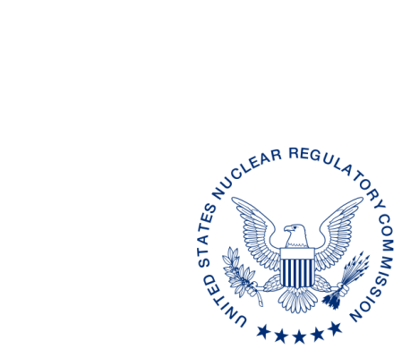
UNITED STATES
NUCLEAR REGULATORY COMMISSION
WASHINGTON, D.C. 20555-0001

ALL AGREEMENT STATES, WYOMING, VERMONT

OPPORTUNITY TO COMMENT ON DRAFT REVISIONS TO THE OFFICE OF NUCLEAR MATERIAL SAFETY AND SAFEGUARDS PROCEDURES: SA-107, “REVIEWING THE
NON-COMMON PERFORMANCE INDICATOR, COMPATIBILITY REQUIREMENTS”, SA-200, “COMPATIBILITY CATEGORIES AND HEALTH AND SAFETY IDENTIFICATION FOR NRC REGULATIONS AND OTHER PROGRAM ELEMENTS”, and SA-201, “REVIEW OF STATE REGULATORY REQUIREMENTS” (STC-17-XXX)

Purpose: To provide the Agreement States an opportunity to comment on the proposed revisions to the Office of Nuclear Material Safety and Safeguards (NMSS) Procedures
SA-107, “Reviewing the Non-Common Performance Indicator, Compatibility Requirements”, SA-200, “Compatibility Categories and Health and Safety Identification for NRC Regulations and Other Program Elements” and SA-201, “Review of State Regulatory Requirements”.

Background: These procedures are being revised to update current practices and organizational changes.

Discussion: Enclosed for your review and comment are the draft revisions to the Office of Nuclear Material Safety and Safeguards (NMSS) Procedures SA-107, “Reviewing the
Non-Common Performance Indicator, Compatibility Requirements”, SA-200, “Compatibility Categories and Health and Safety Identification for NRC Regulations and Other Program Elements” and SA-201, “Review of State Regulatory Requirements”. These procedures provide guidance on the review of a State’s regulatory program for the non-common indicator “Compatibility Requirements” in accordance with Management Directive 5.6, “Integrated Material Performance Evaluation Program”, establish the compatibility and health and safety components assigned to the U.S. Nuclear Regulatory Commission (NRC) regulations and program elements as determined in accordance with Management Directive and Handbook 5.9, “Adequacy and Compatibility of Agreement State Programs”, and describe the process for the NRC staff’s review of a State’s regulations, or other legally binding requirements in accordance with the compatibility categories outlined in SA-200, respectively.

We would appreciate receiving your comments* within 60 days from the date of this letter. _____________________________
*This information request has previously been approved by OMB 3150-01029 and was resubmitted to OMB for review of continued approval of information collection. The estimated burden per response to comply with this voluntary collection is approximately 8 hours. Send comments regarding the burden estimate to the Records and Information Services Branch (T-5F53), U.S. Nuclear Regulatory Commission, Washington, DC 20555-0001, or by Internet e-mail to infocollects.resource@nrc.gov, and to the Desk Officer, Office of Information and Regulatory Affairs, NEOB-10202 (3150-0200), Office of Management and Budget, Washington, DC 20503. If a means used to impose an information collection does not display a currently valid OMB control number, the NRC may not conduct or sponsor, and a person is not required to respond to, the information collection.

If you have any questions regarding this correspondence, please contact me at 301-415-3340 or the individual named below:

POINT OF CONTACT: Michelle Beardsley INTERNET: Michelle.Beardsley@nrc.gov
TELEPHONE: (267) 884-2305 FAX: (301) 415-5955

Daniel S. Collins, Director
Division of Material Safety, State, Tribal
and Rulemaking Programs
Office of Nuclear Material Safety
and Safeguards

Enclosures:
NMSS SA-107
NMSS SA-200
NMSS SA-201

SUBJECT: OPPORTUNITY TO COMMENT ON DRAFT REVISIONS TO THE OFFICE OF NUCLEAR MATERIAL SAFETY AND SAFEGUARDS PROCEDURES: SA-107, “REVIEWING THE NON-COMMON PERFORMANCE INDICATOR, COMPATIBILITY REQUIREMENTS”, SA-200, “COMPATIBILITY CATEGORIES AND HEALTH AND SAFETY IDENTIFICATION FOR NRC REGULATIONS AND OTHER PROGRAM ELEMENTS”, and SA-201, “REVIEW OF STATE REGULATORY REQUIREMENTS” (STC-17-XXX)

DISTRIBUTION: (SP03)
MSTR r/f

ML17
OFC | MSTR/ASPB | MSTR Procedure Coord | ASPB:BC | MSTR:D
NAME | MBeardsley | KMeyer | DWhite | DCollins
DATE
OFFICIAL RECORD COPY

